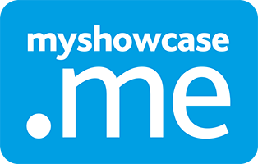

6. Tasks
Tasks are given to personal Myshowcase.me users asking them to do things with their ePortfolio content, such as updating their Standards for review, building showcase or completing a Form.
MKM
MyKnowledgemap/ 20 George Hudson Street, York, Y01 6WR, United Kingdom
Contents
Overview 2
Creating a Task 3
Publishing a Task 11
Sharing a Task 12
Active Tasks 14
Personal user and Tasks 18

Overview
A simplified way to consider what a Myshowcase.me Task is as ‘a request for a personal Myshowcase.me to do something with their ePortfolio account and its contents’.

Using a Task, an administrator could ask some personal users to update a Standard they are working with in preparation for an upcoming review. They could be asked to produce a showcase reflecting on a recent work placement or assignment or to set some personal goals using an attached goal Form

Another way to think of a Task is as a mission, an assignment, a piece of homework or an assessment. They are tremendously flexible and can be used in multiple ways supporting multiple requirements and needs. The key thing is that however you consider them, they are simply asking the personal user to do something with their Myshowcase.me ePortfolio.

Tasks utilise lots of the other functionality available throughout Myshowcase.me: Grading Schemes, Forms, Showcases, Badges.

They can be as lightweight or as heavyweight as you want them to be. You could share a task with a group of users as an introduction to using their Myshowcase.me ePortfolio: Welcome, here are some resource files that explain how to use Myshowcase.me so go ahead and explore it. Alternatively, it could be an end of term reflective Task, that is assessed and graded and counts towards the attainment of some qualification. Tasks can be used in a multitude of different ways.

Creating a Task
To functionality to create a new task is located under the ‘Tasks’ menu item within the Myshowcase.me admin space.

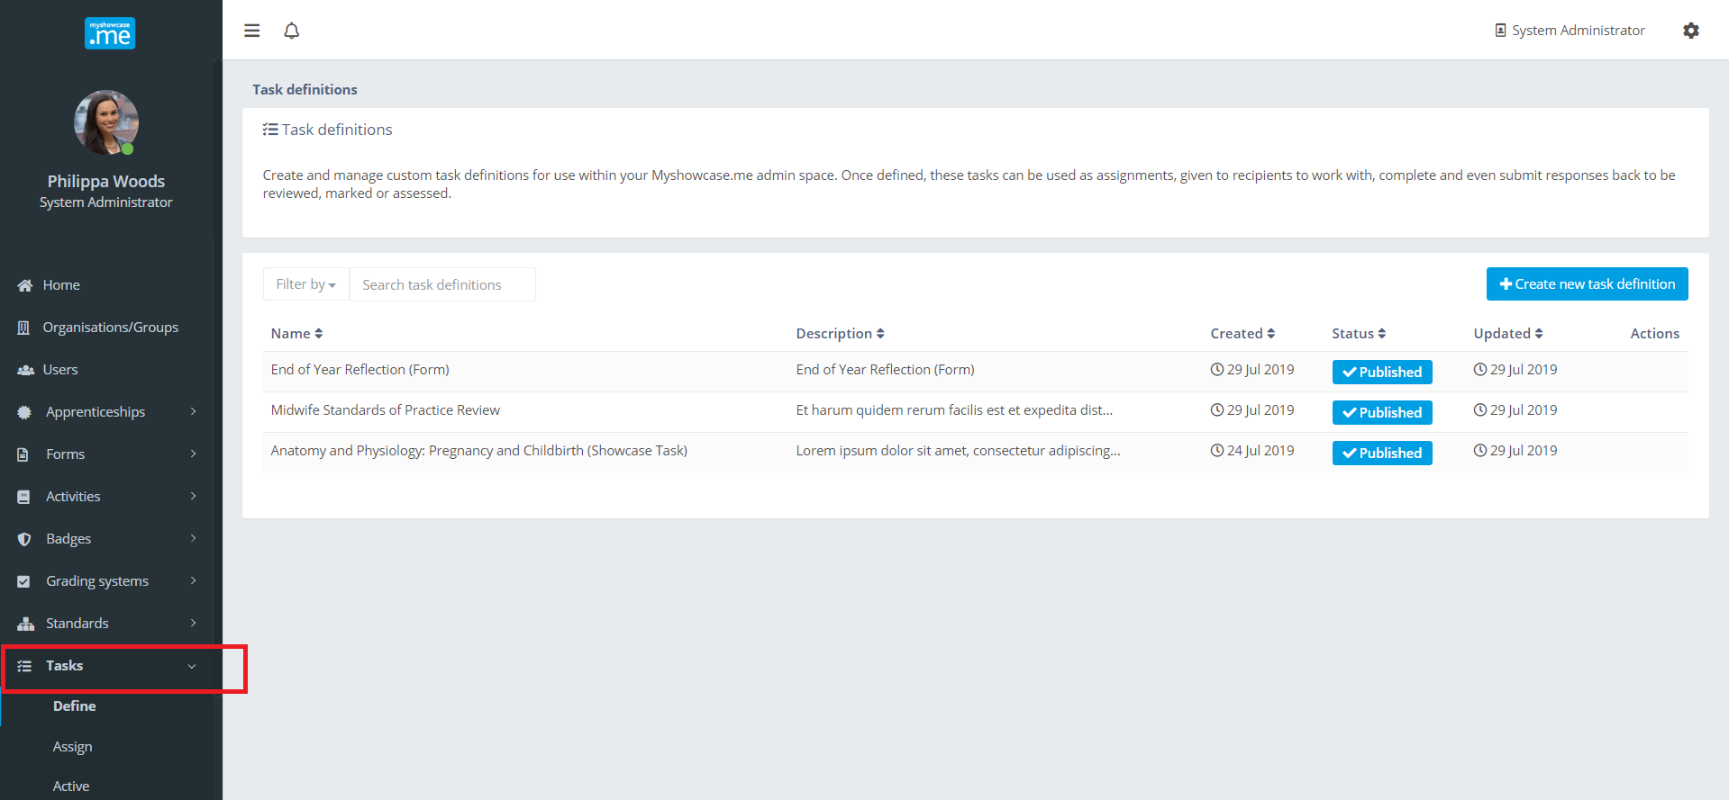
A task definition comprises multiple definition elements, some mandatory and some optional: ‘Details’, ‘Steps’, ‘Response type’, ‘Grading schemes’, ‘Discretionary badges’, ‘Autocomplete’.

Details
Each Task definition requires a name, short description and full description. These are mandatory details. Every task needs them.

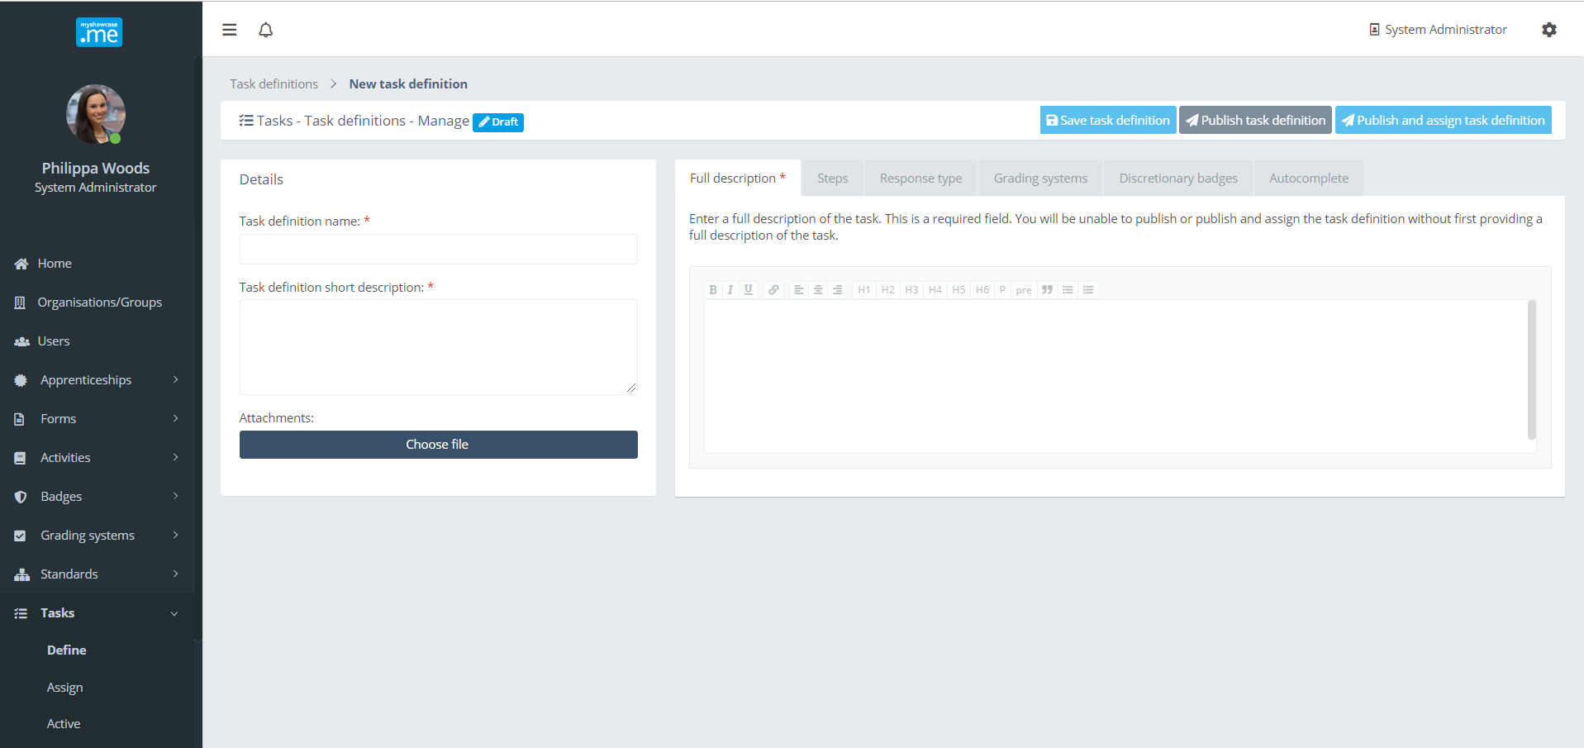

The administrator has the option of attaching multiple files to the Task, possibly to explain the task in more detail or provide supporting materials required to complete or understand the Task.
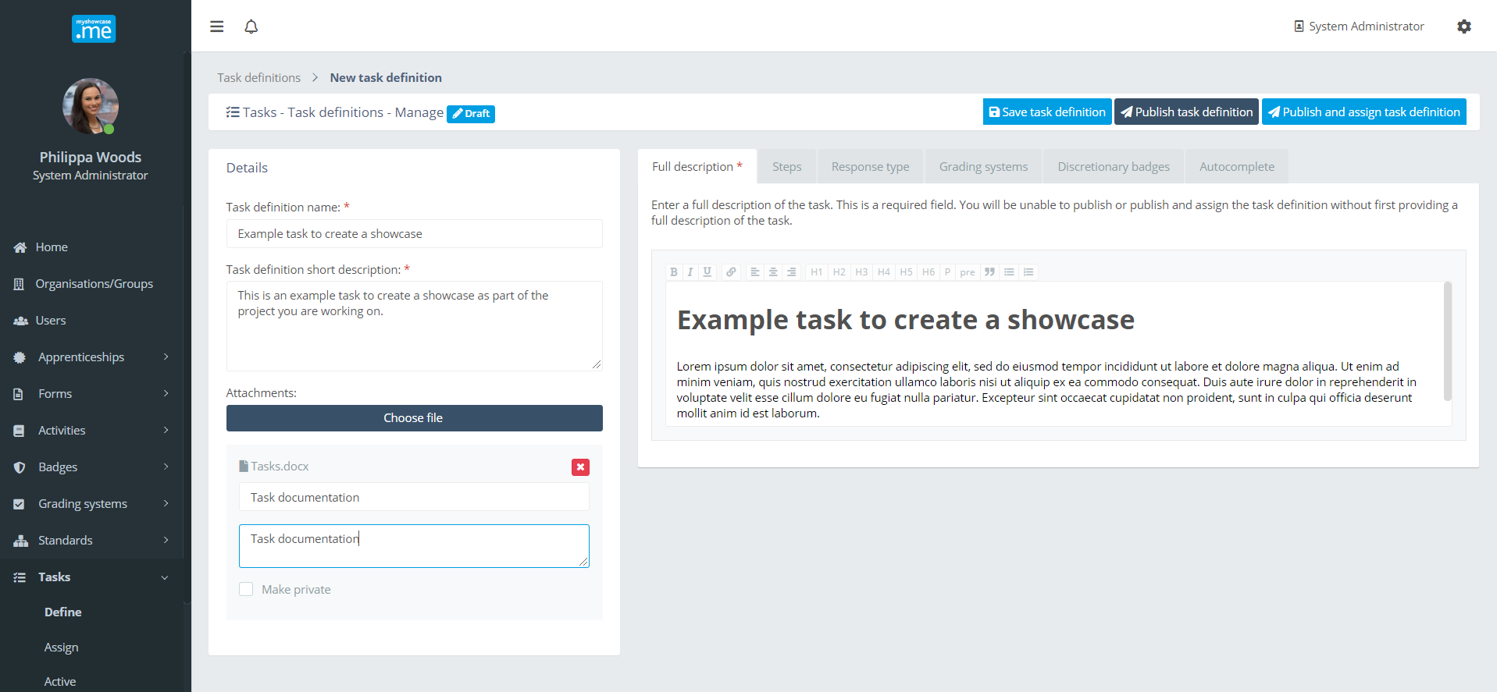

Steps
To further assist working with the Task, the administrator could include a collection of steps, setting out how they think the user should approach the Task.

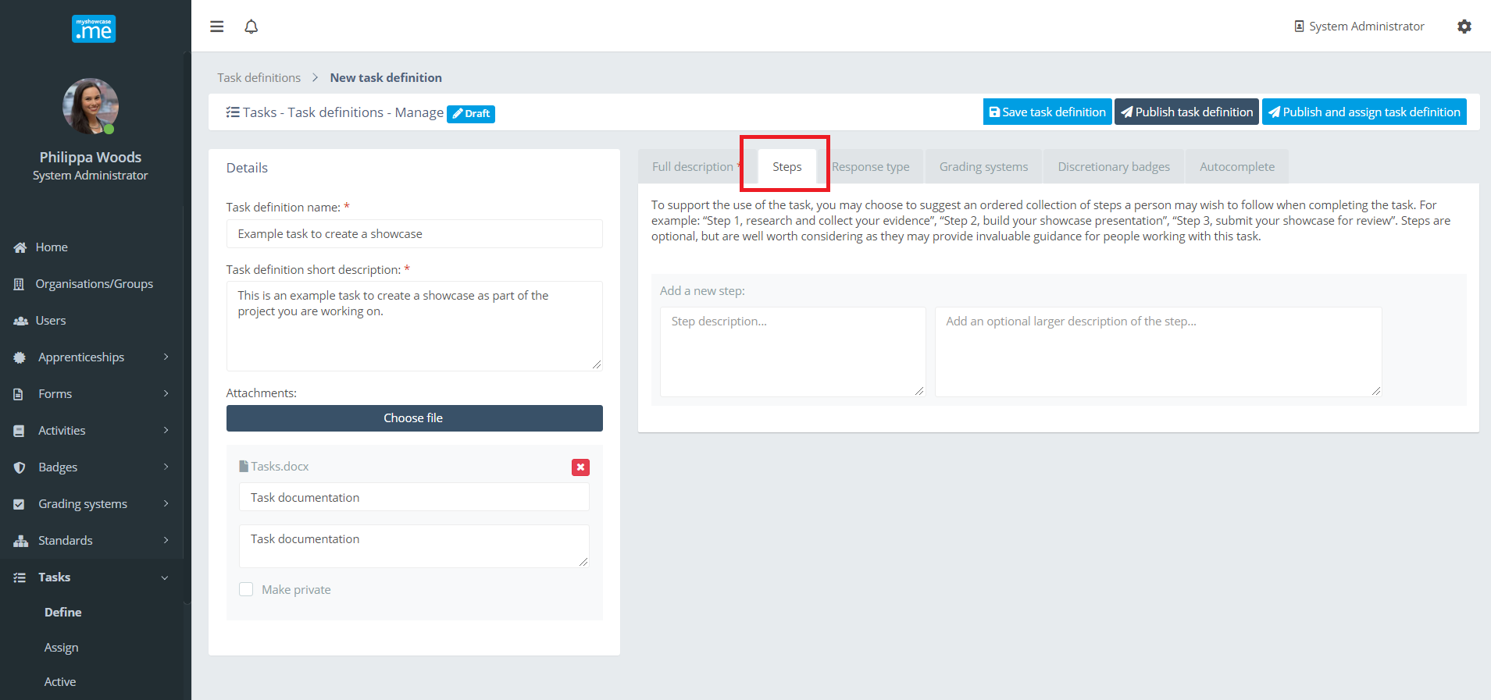

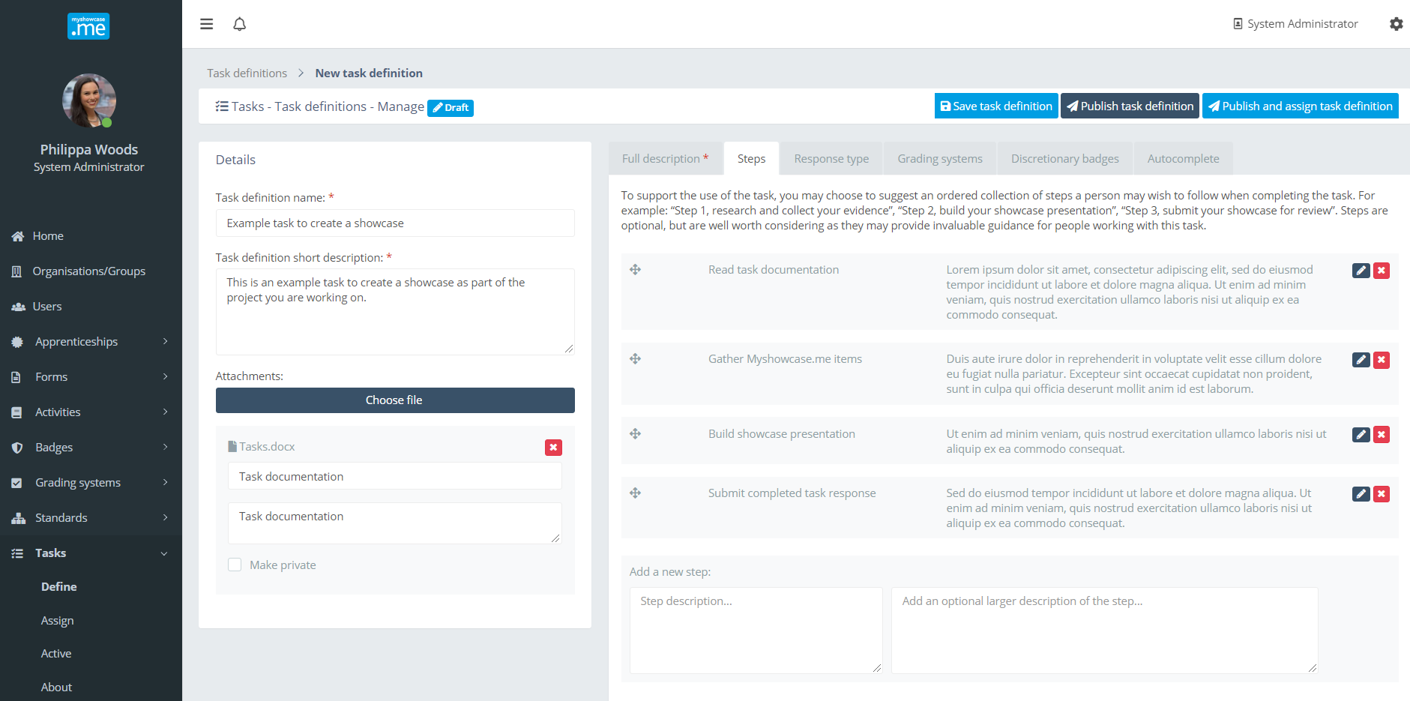
In the example above, the administrator guides the user through the steps to build the showcase needed on the Task response.

Response type
The Task may require a response from the user. This is optional.

The response could be a published Showcase, a completed Myshowcase.me or evidence uploaded from their Myshowcase.me ‘Stuff’ area.

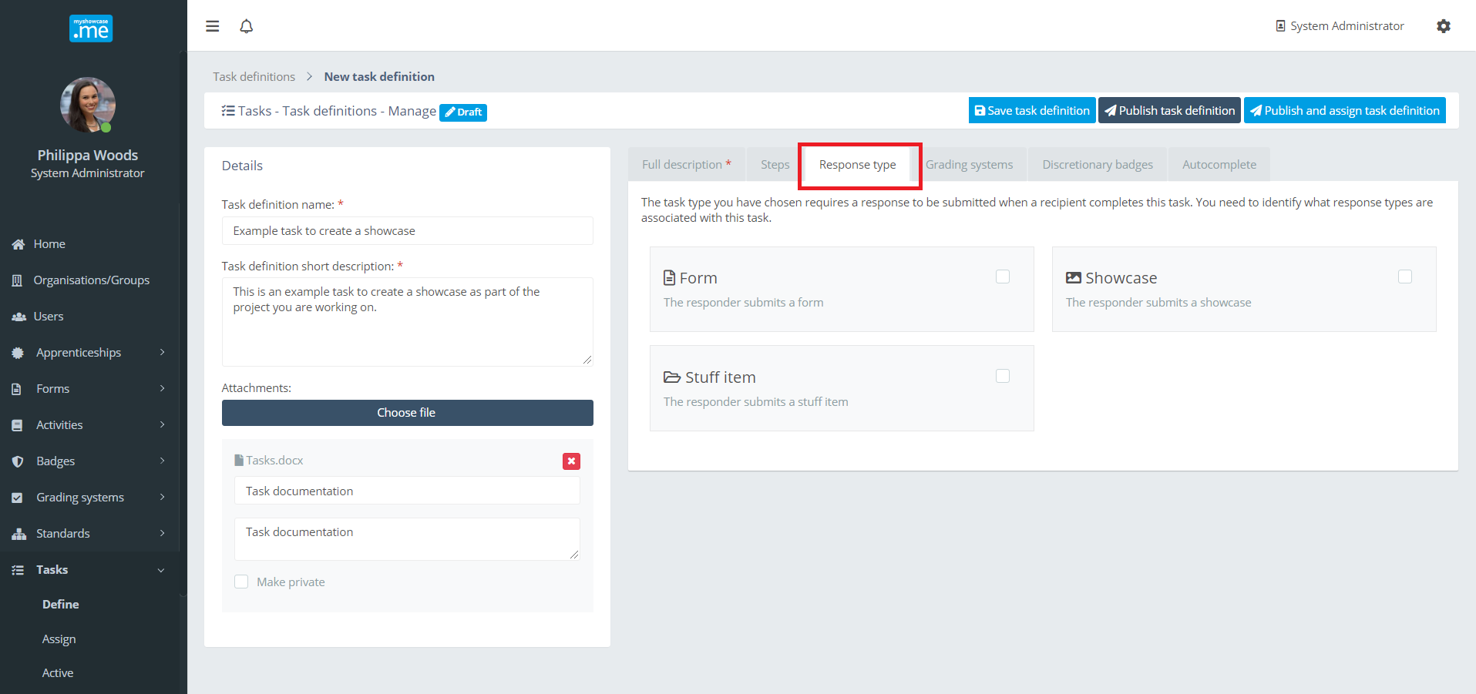

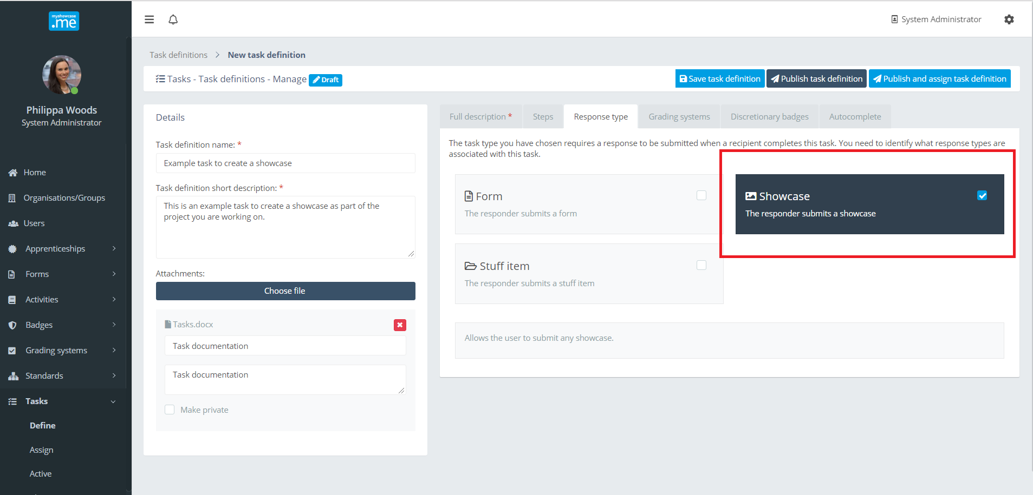

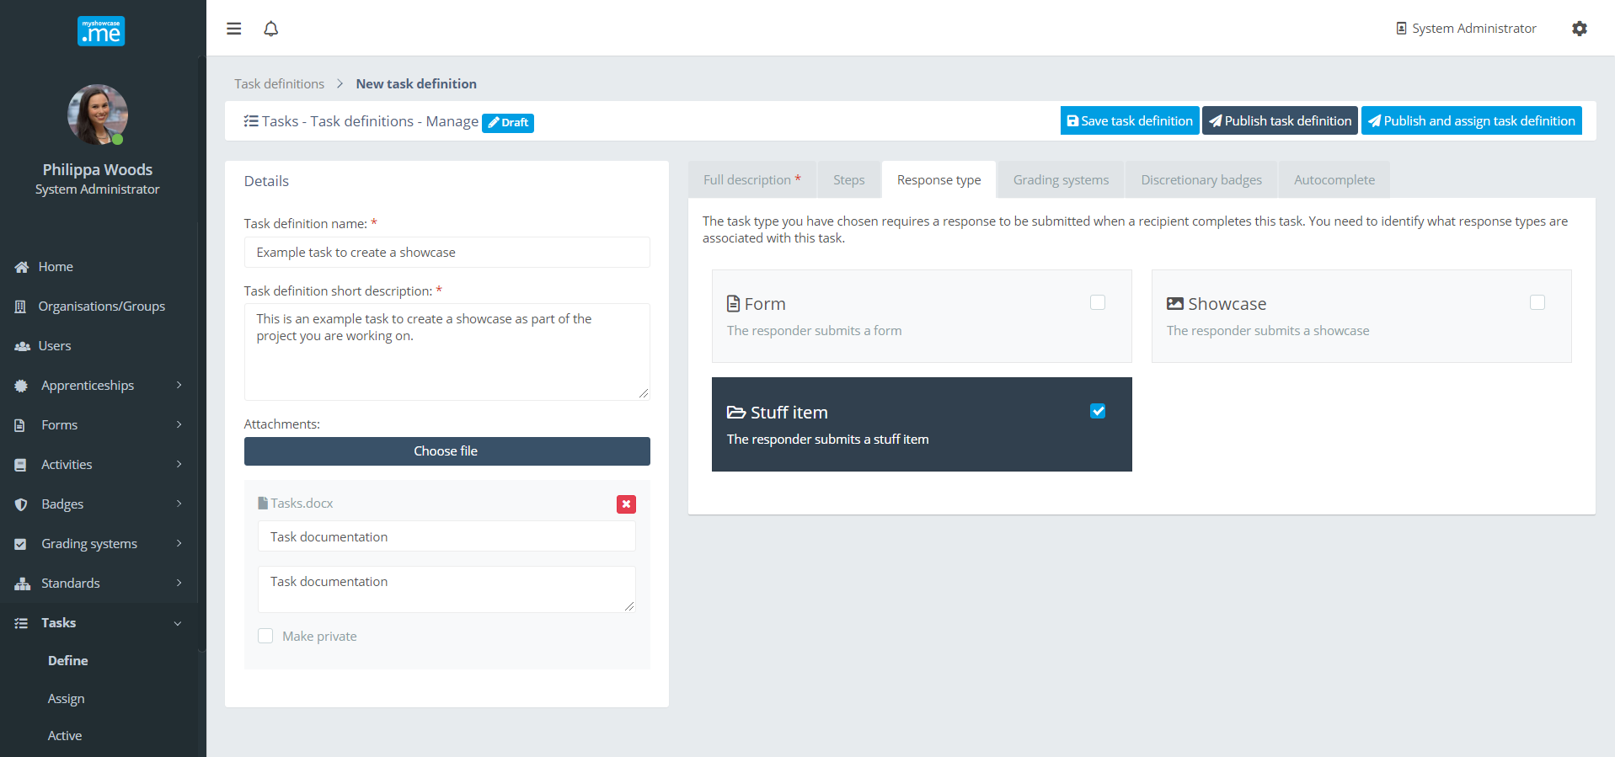

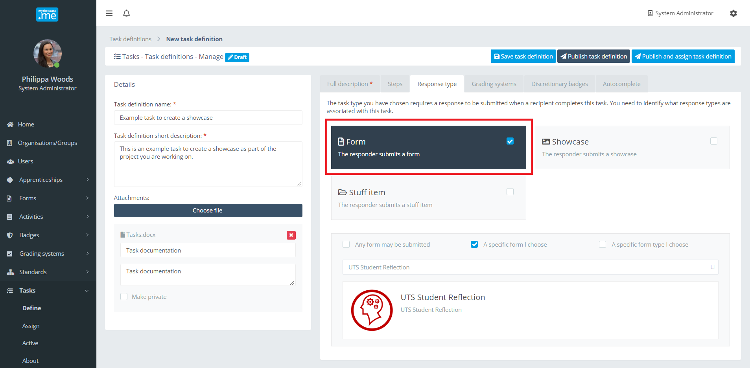
If the required response is a Myshowcase.me Form, the administrator has options to pick a specific Form to complete or suggest a certain type of Form (Reflection, Goal …etc.).

Grading schemes
The administrator may want to grade or mark the Task. To do this, they can attach one or more Grading Schemes to the Task. There could be a Grading System to mark the content of a Showcase, a different Grading Scheme for the presentation style, and one for the overall Task grade. These is no limit on the number of Grading Schemes that can be applied.

Again, the inclusion of any Grading Scheme is optional. Some Tasks may not require grading.
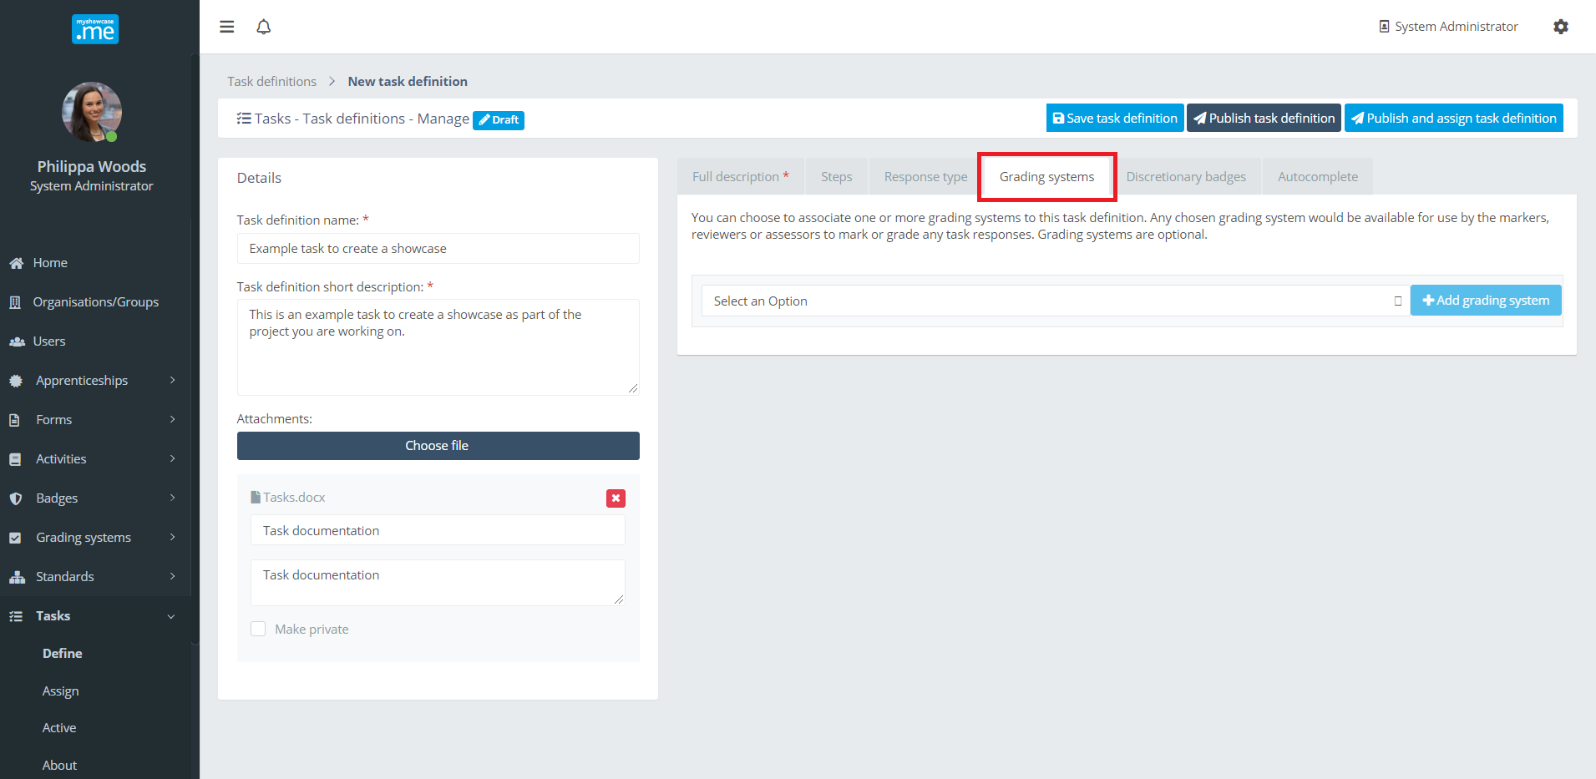

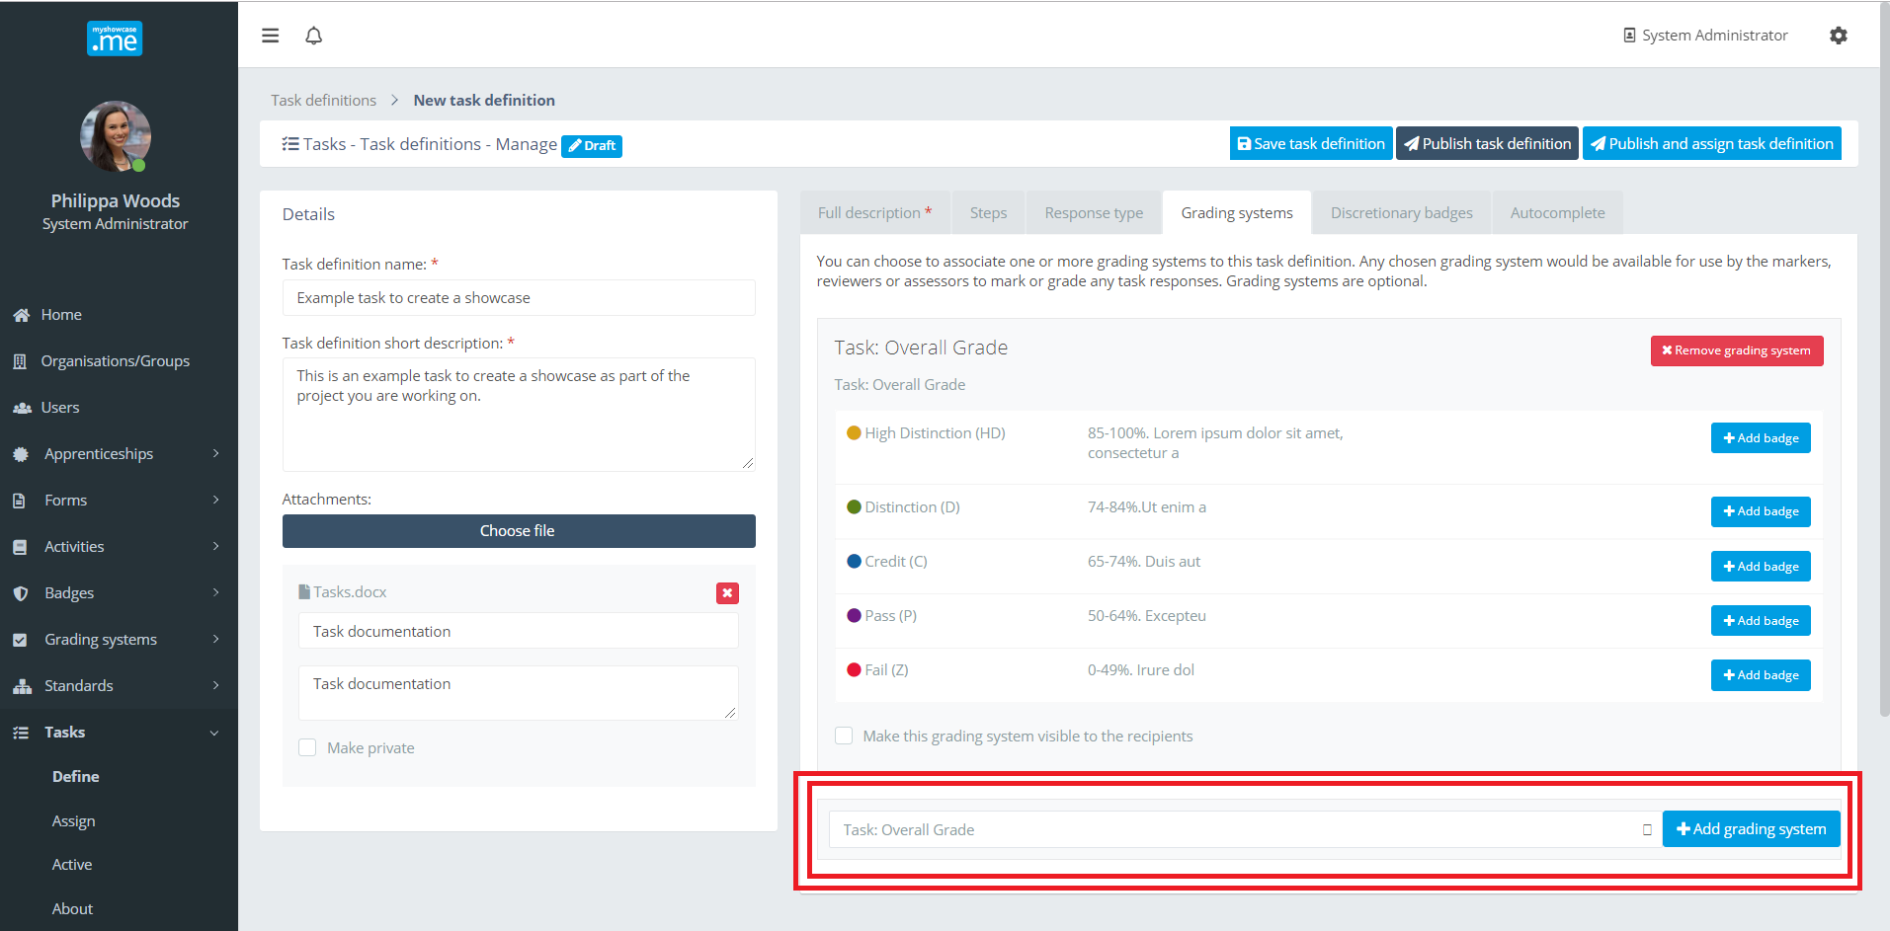

As each Grading Scheme is added, the administrator has the option to introduce Open Badges into the Task. Myshowcase.me has an inclusive Open Badge platform for designing and issuing Open Badges. These badges can be associated with values of the included Grading Scheme.

Linking badges to allocated grades is optional.

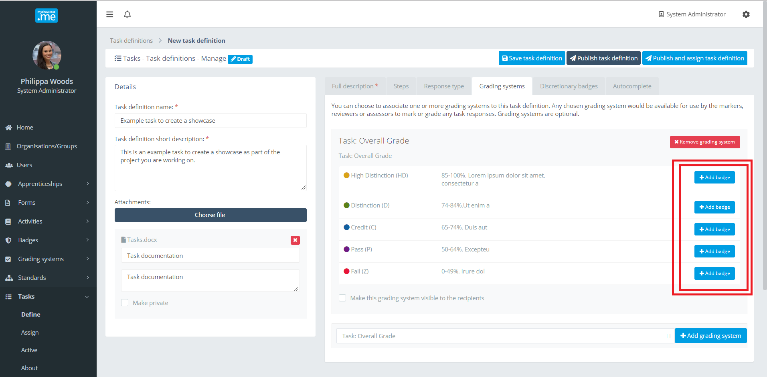

In the example below, if a user is given the overall grade of ‘High Distinction’ they will also be awarded a badge as recognition of their achievement. The same applies if any user is given and overall grade of ‘Distinction’.

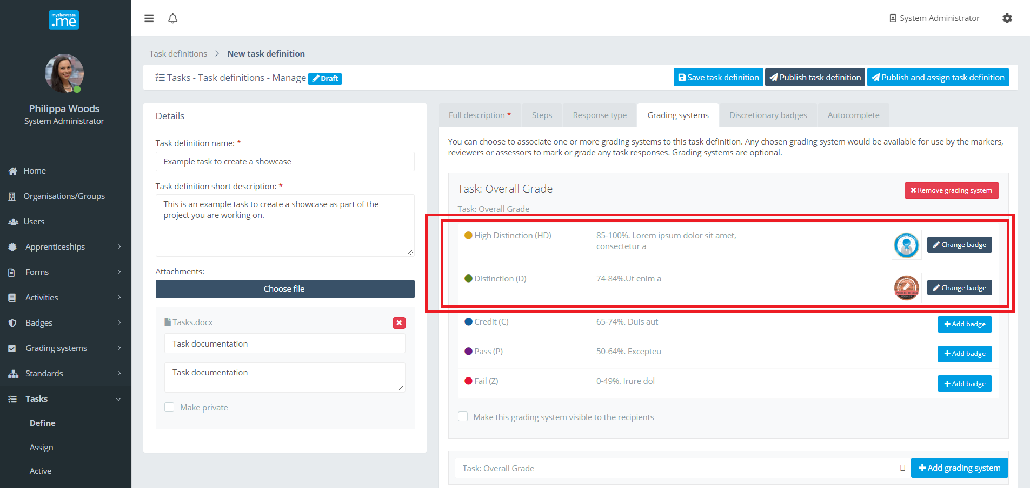

Discretionary badges
Open Badges can be included within the task and not be directly associated grading and marking. A collection of badges can be associated with the task for the review/marker to award at their discretion when that review or mark Task.

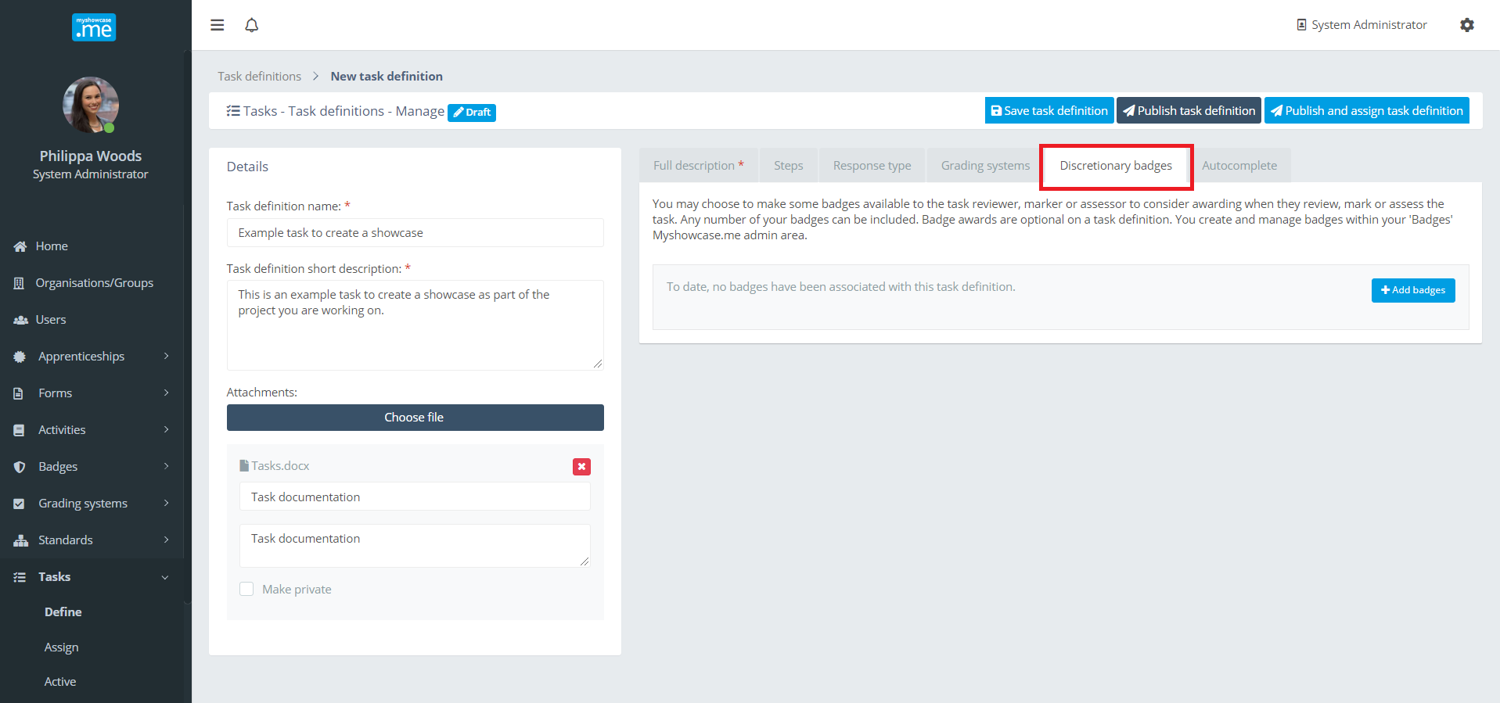

In the example below, a couple of badges have been added into the task, for the Task reviewer or marker to award and issuer at their discretion.

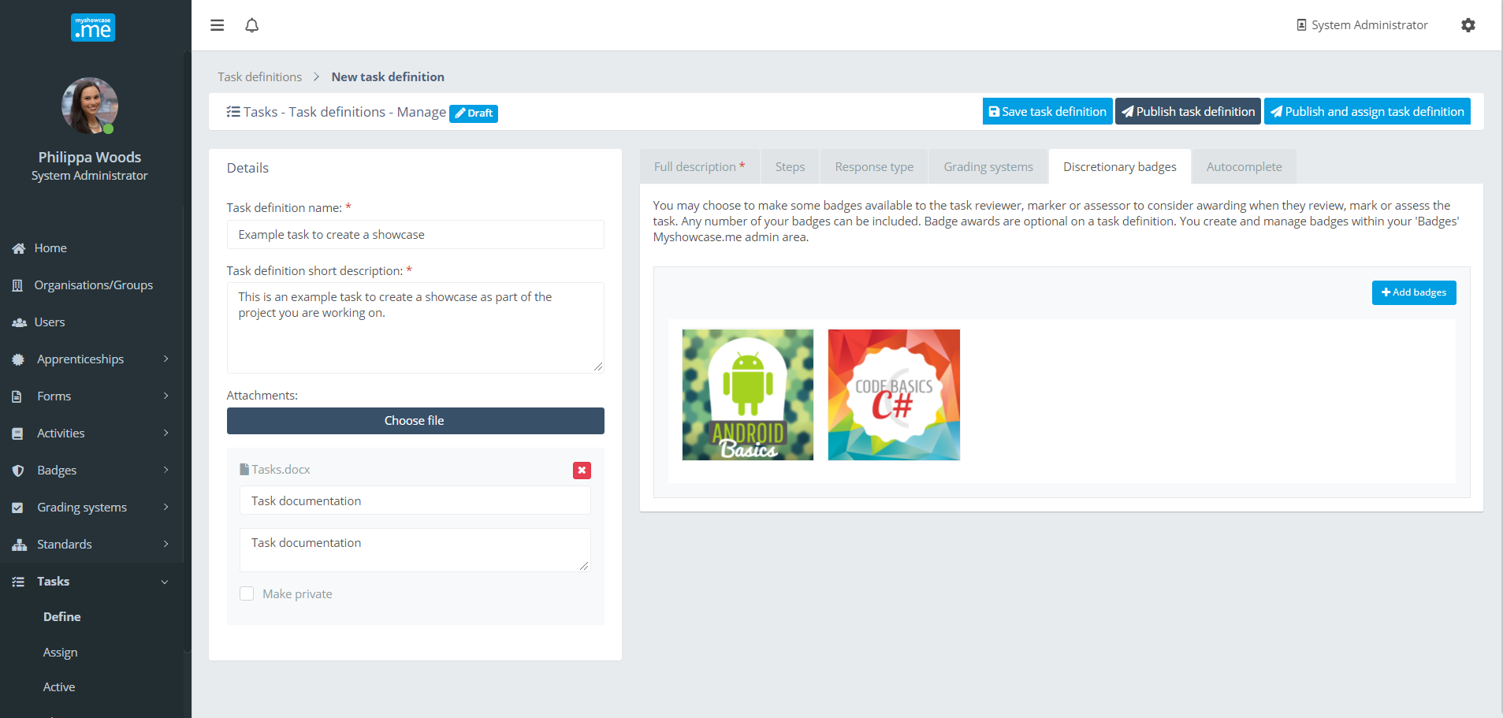

Autocomplete
The autocomplete option on a task is used when the administrator wants the task to be autocompleted when the user submits the task response back. The Task is automatically marked as complete and requires no reviewer or marker involvement. Rules can be associated with the autocomplete process. Currently an Open Badge can be associated with the autocomplete process. When the Task autocompletes, the badge is awarded to the user who submitted the Task response.

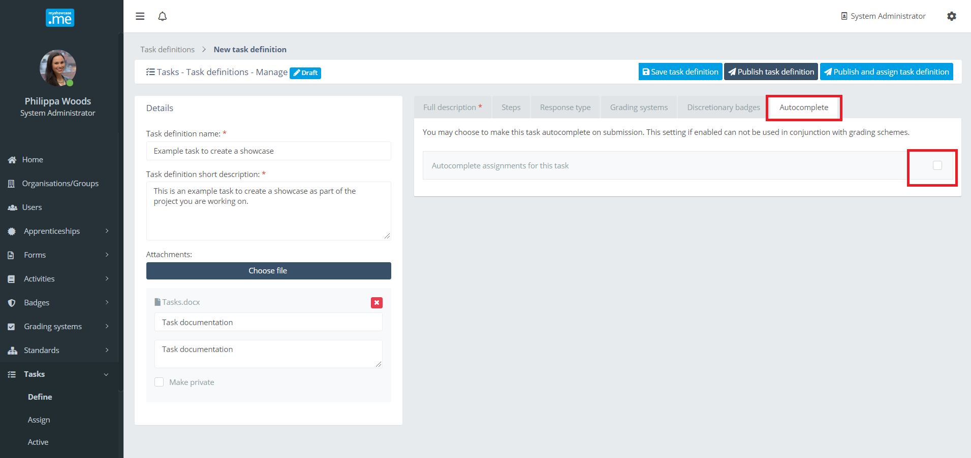

Publishing a Task
While the administrator is defining the Task, they can leave it in a ‘Draft’ state, as they iteratively add detail into the Task definition.

When they are happy with the definition they can ‘Publish’ the Task. A published task is available to be shared with the groups and organisations. Users within these groups and organisations will be assigned the Task to work with inside their Myshowcase.me ePortfolio space.

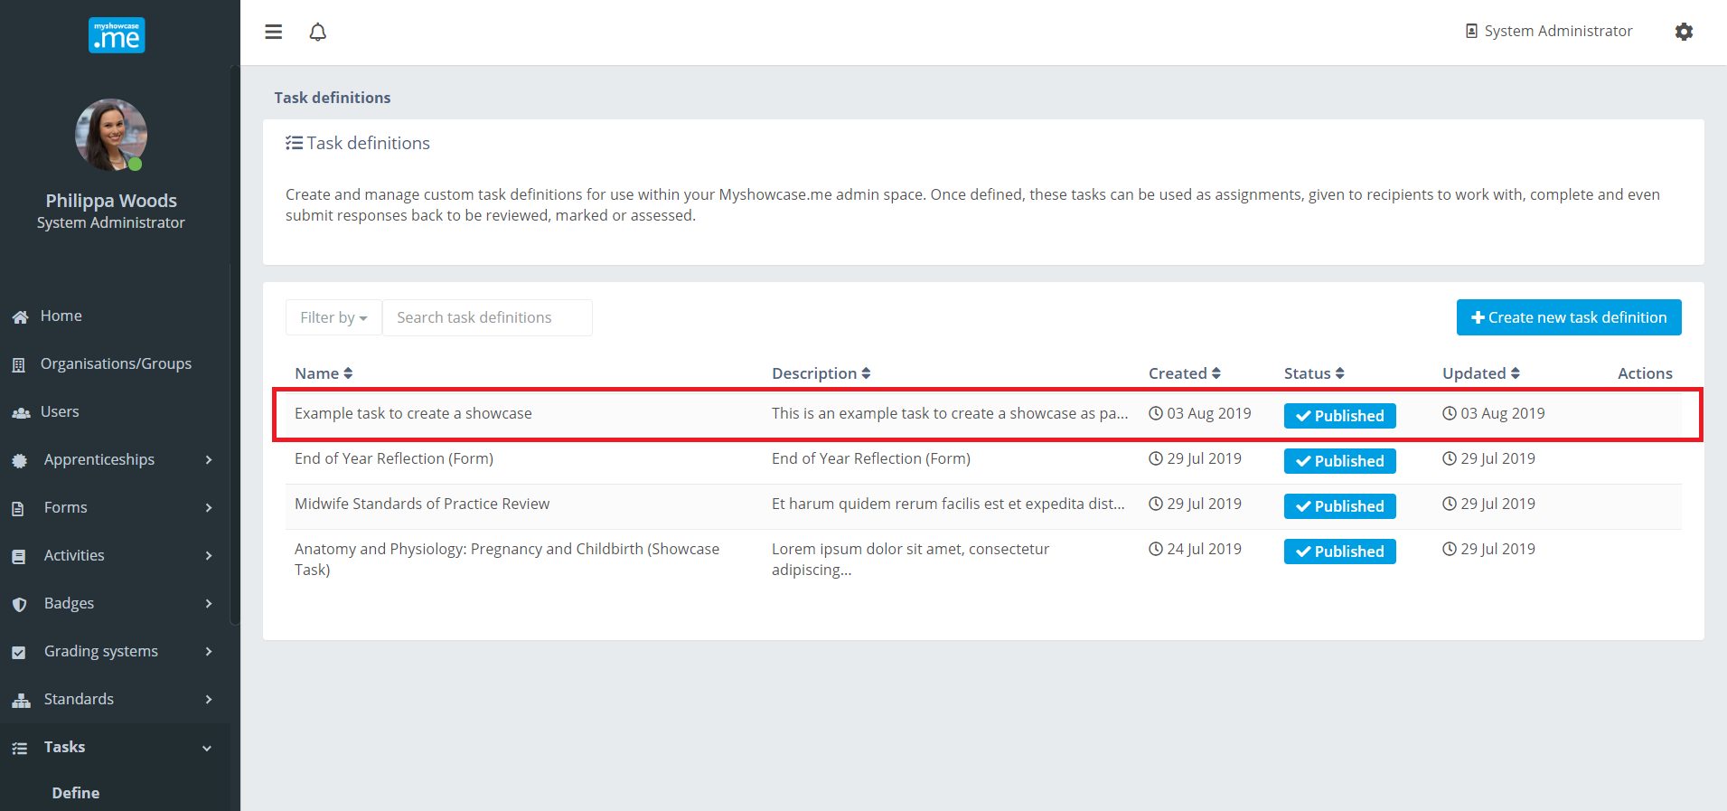

Sharing a Task
To share a Task, the administrator selects the ‘Assign’ option under the ‘Tasks’ menu item within the Myshowcase.me admin area.

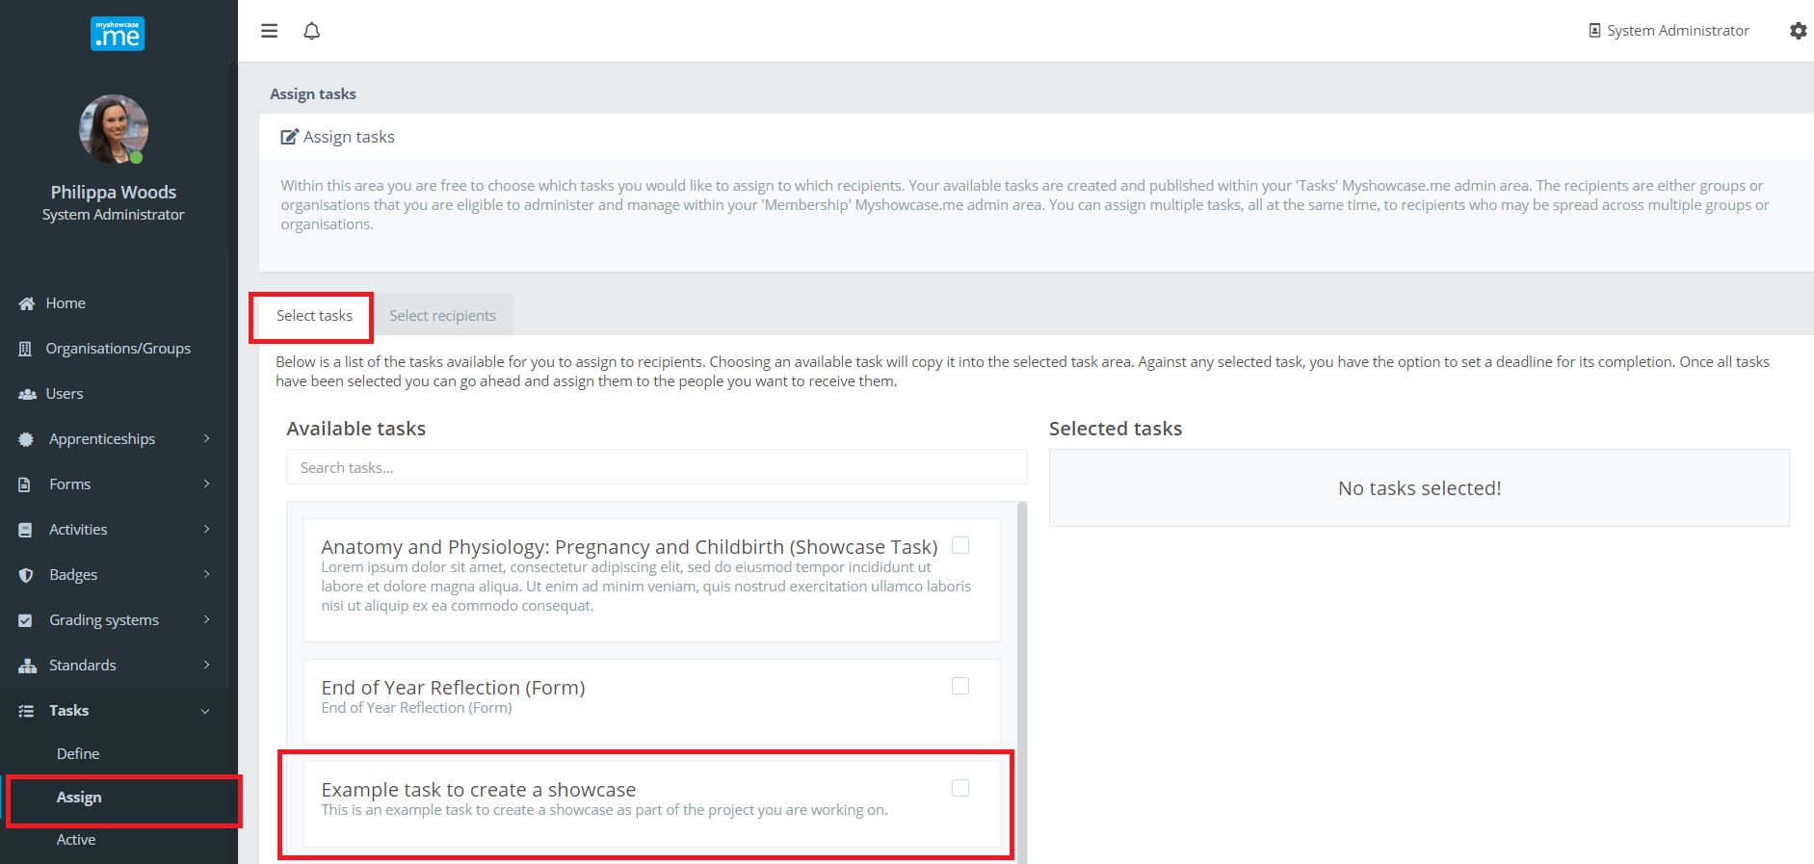

Any number of Tasks can be chosen. In the example below, just the one task ‘Example task to create a showcase’ has been chosen. There is the option to add a deadline to the task. For now, the deadline is used for information purposes only. Firm deadline processing is on the product roadmap but not yet introduced into the product.

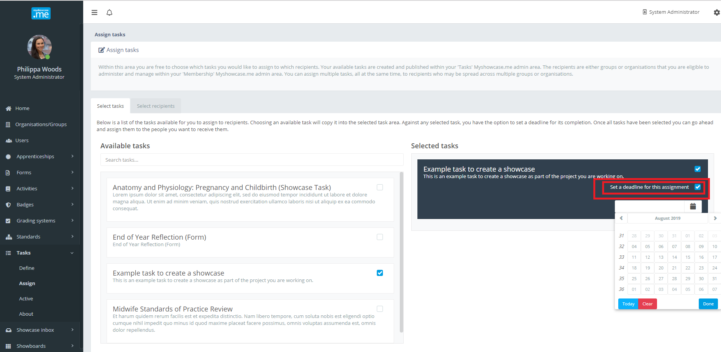

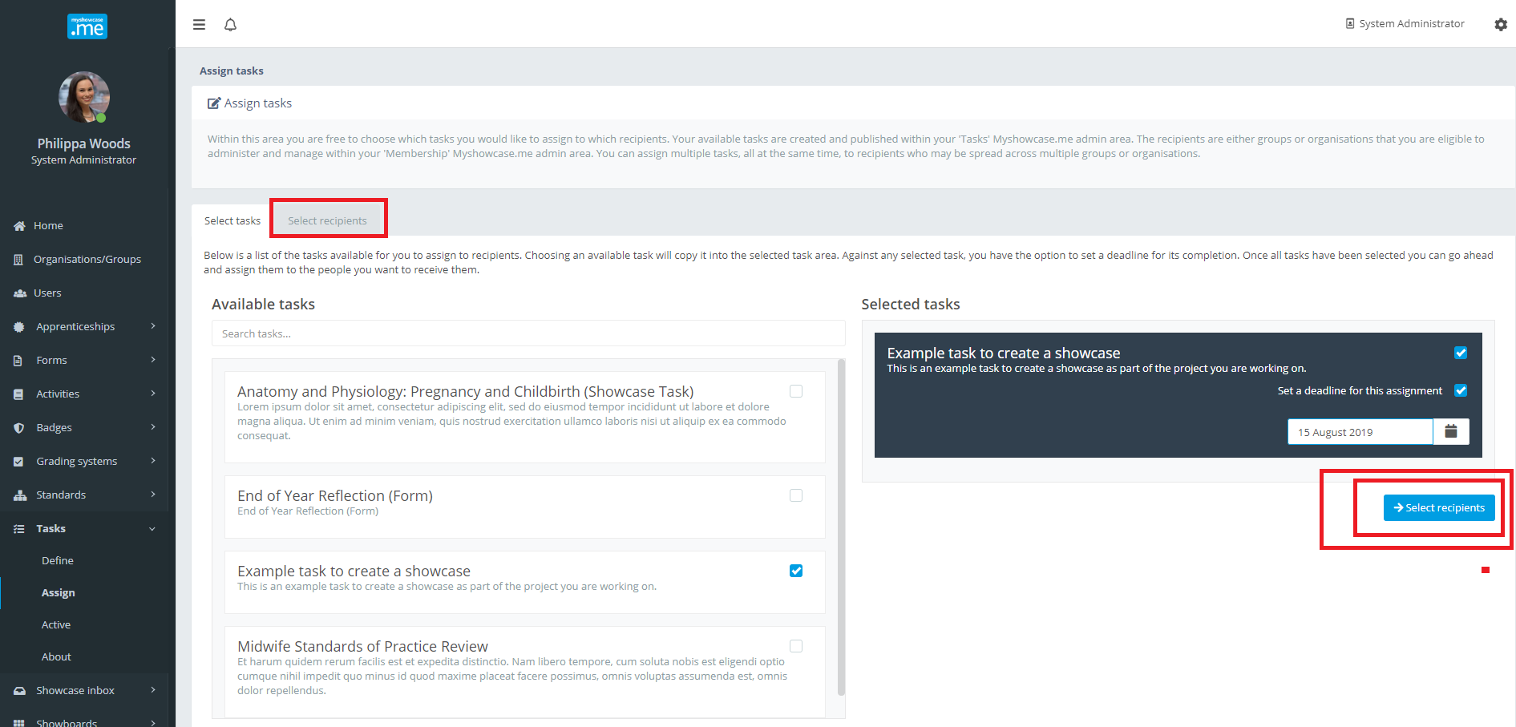

Once the Tasks have been selected, along with any deadlines, the administrator can choose the recipients of the Tasks. The Tasks can be assigned to any number of groups or organisations at the same time. Clicking on the ‘’Assign task’ shares those tasks with the selected recipients.

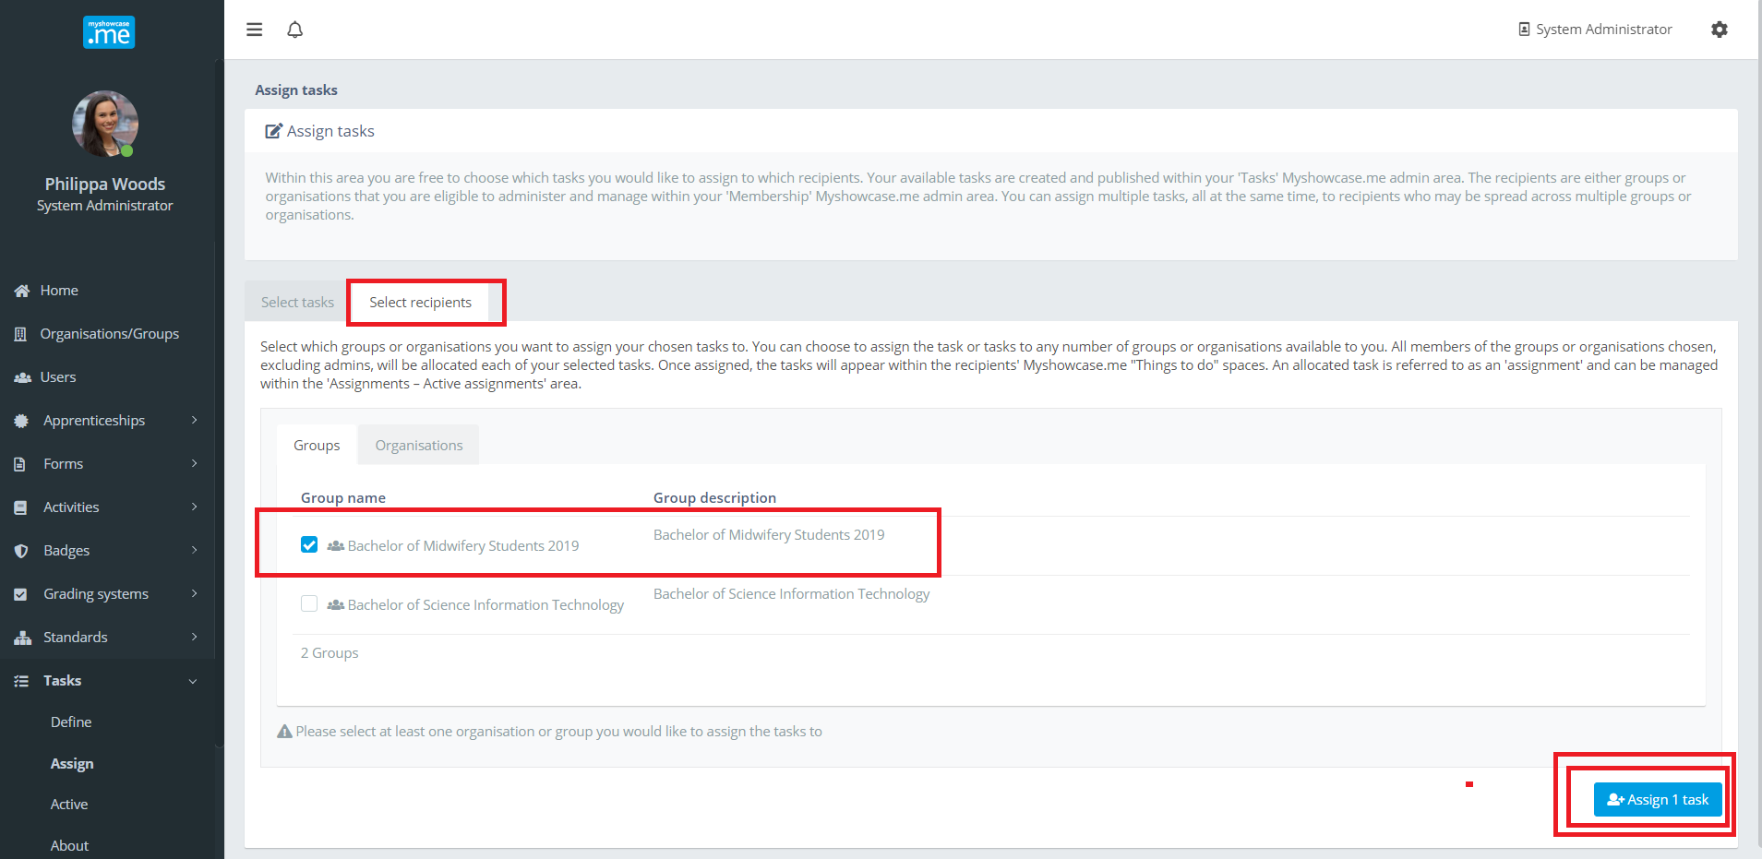

Active Tasks
When a Task has been assigned to a group or organisation it is considered an active Task. Active tasks can be found by selecting the ‘Active’ option under the ‘Tasks’ menu item.

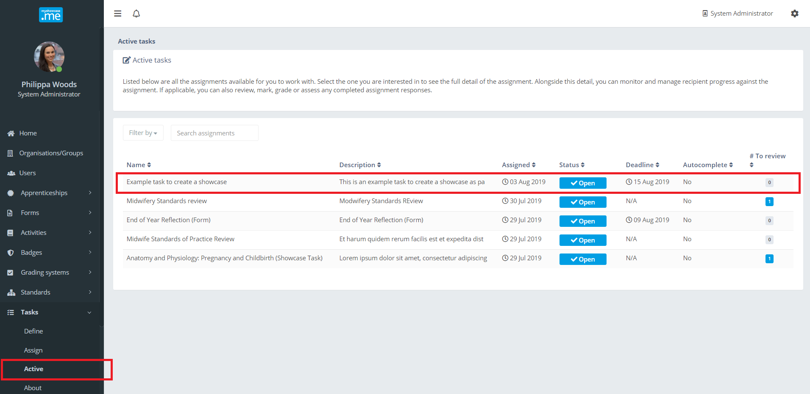

Clicking on one of the listed active Tasks opens it up to the administrator. Here, they can see all the users who have received the Task, along with other metrics, indicators and detail about the active task.

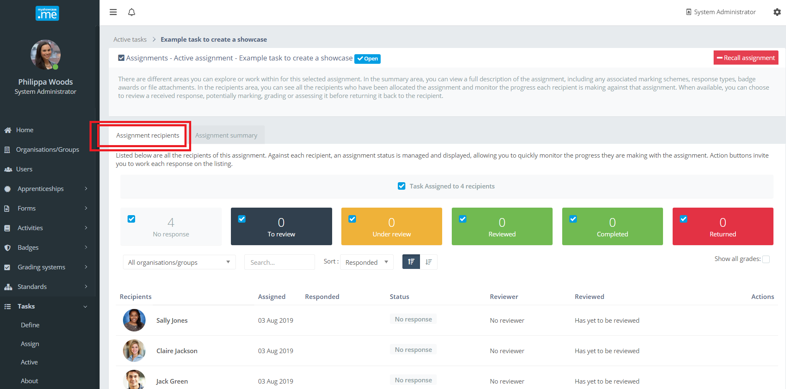

At any point, an authorised administrator can recall the task. This action recalls the Task from all the users it has been assigned to as part of this active Task.

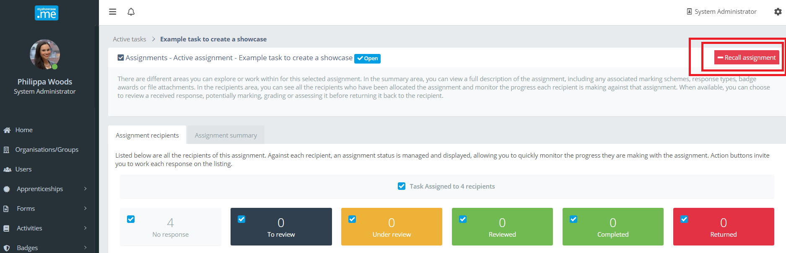

As the users complete their Tasks and submit them back, this detail is reflected within the active task listing. Below we can see that Sally Jones has submitted a response and it needs to be reviewed.

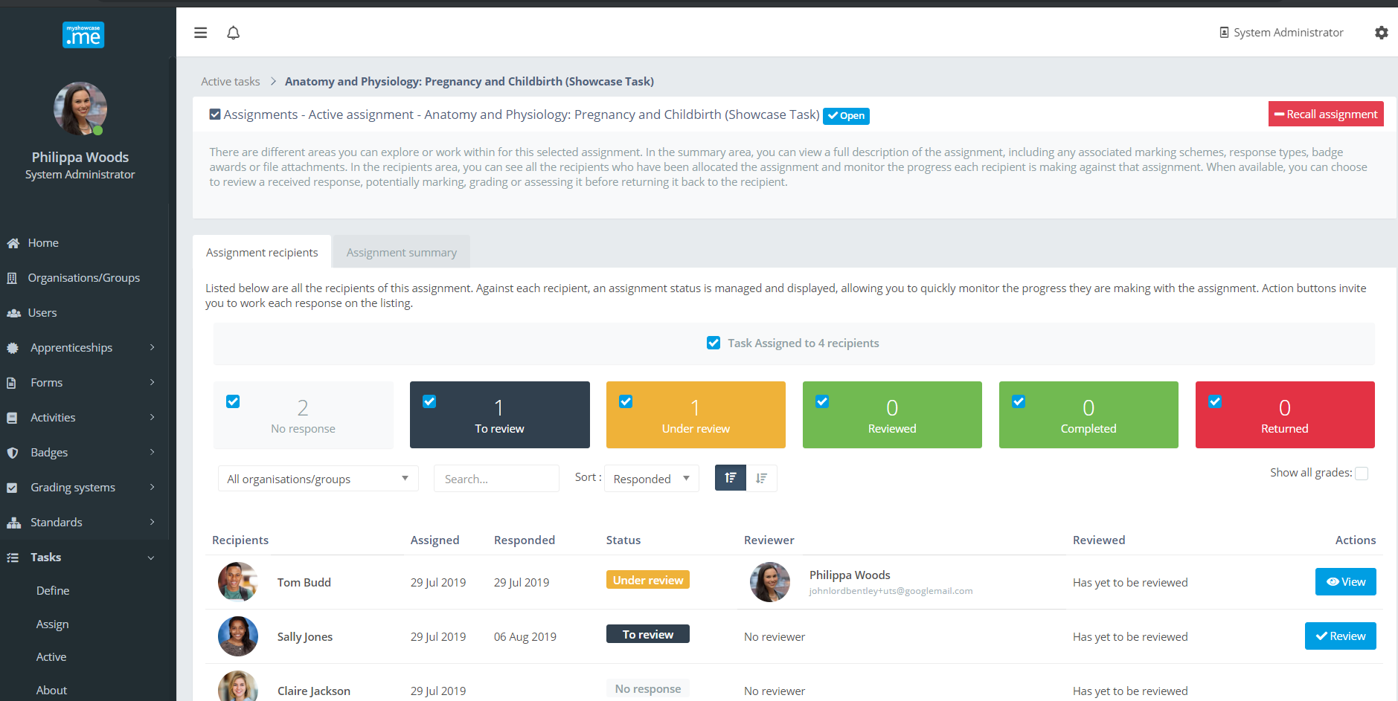

The admin can review the contents of the response by clicking on the entry for Sally Jones.

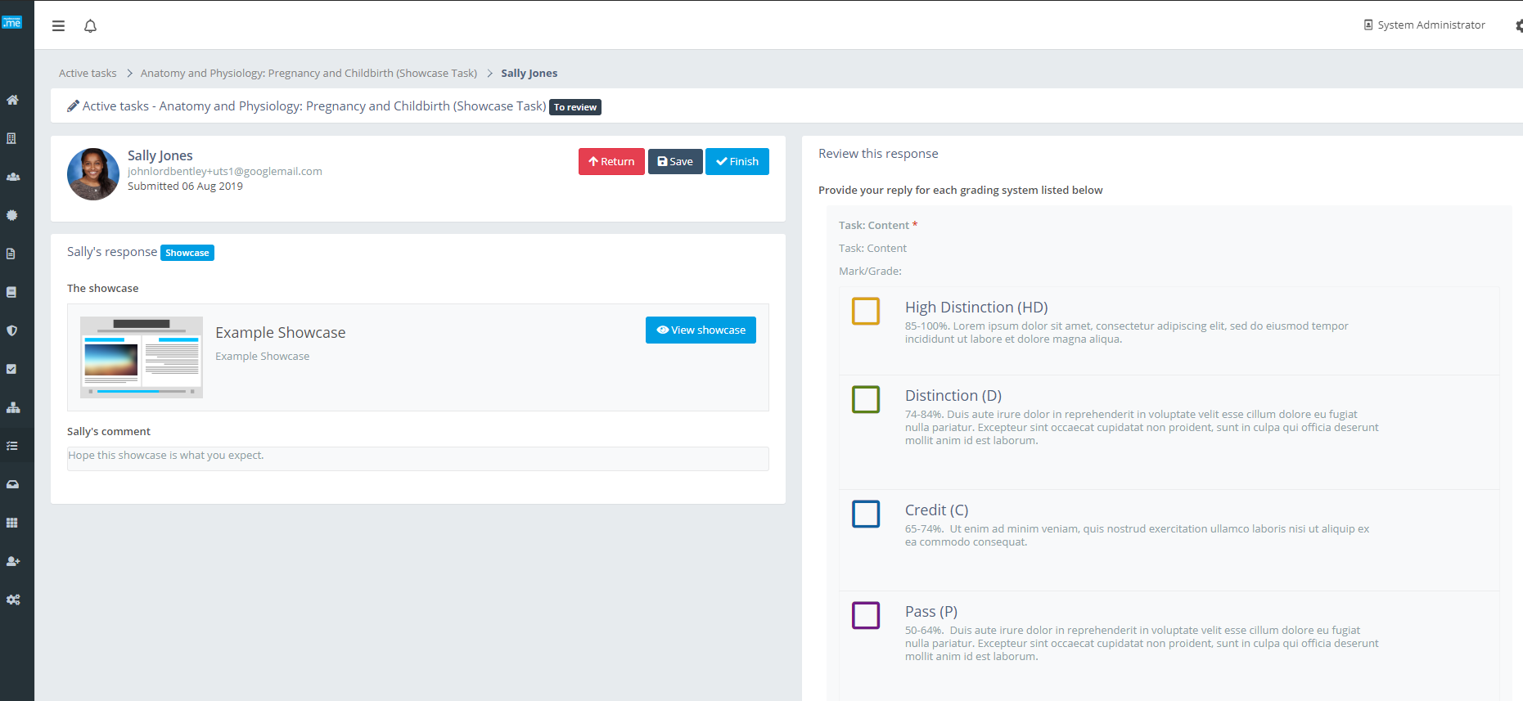

They can choose to ‘Return’ the response back to Sally if they do not think her submission is incomplete, inappropriate or requires more work.

As the admin reviews the response, they can start to apply any associated Grading Schemes to the response. At any point they can ‘Save’ their progress and return later to continue the review.

Once the required grade and marks have been applied, and option feedback comments added, the response review is complete. Clicking the ‘Finish’ action button will inform the user that the task has been reviewed and present them with any grades, marks, badge and feedback the admin may have added.

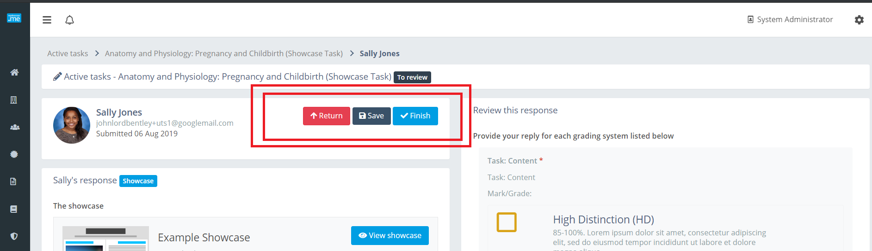

Before being sent to the user, the admin is presented with a summary of their review. If they are happy with it’s content, they click the ‘Submit review’ button to send it back to the user.

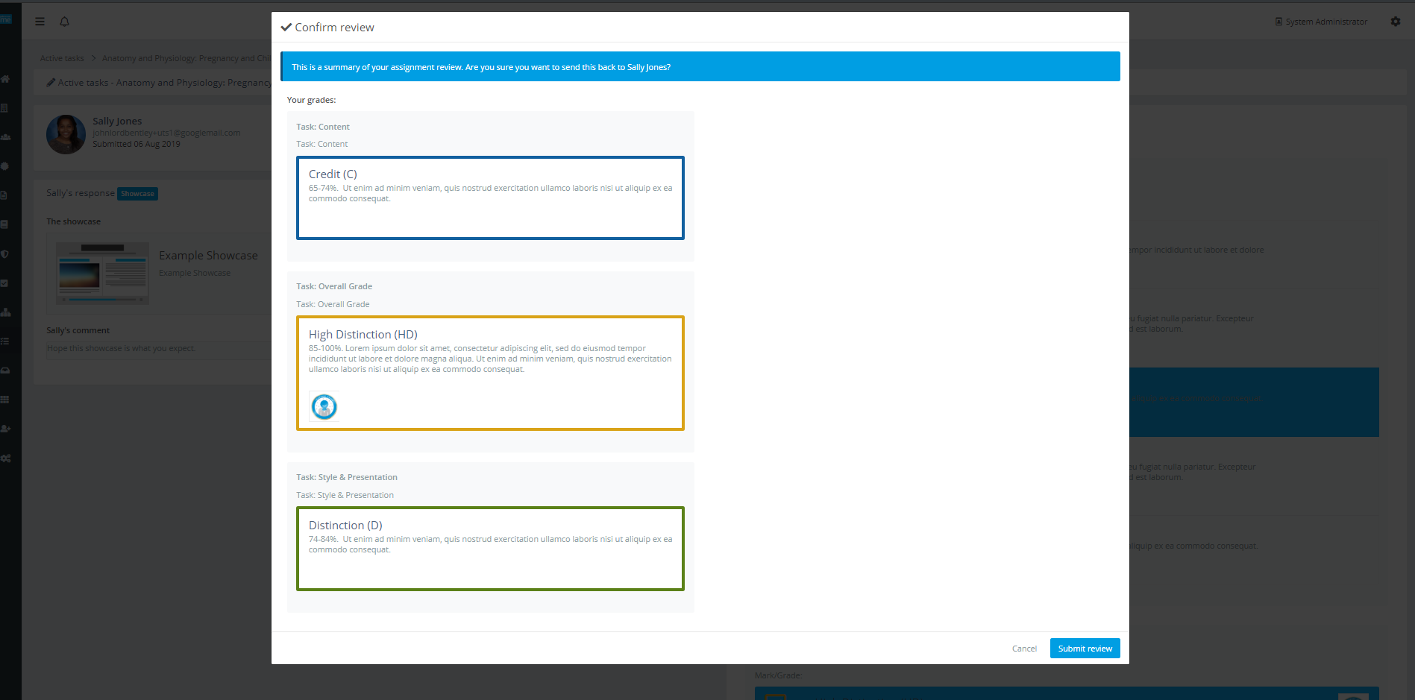

Against the active Task, Sally’s status is now set to ‘Reviewed. A summary of any applied grades can also be added into the display. At any point, a reviewer can return and view Sally’s response again. It can even be reopened and reassessed, with new grades and feedback replacing the old ones.

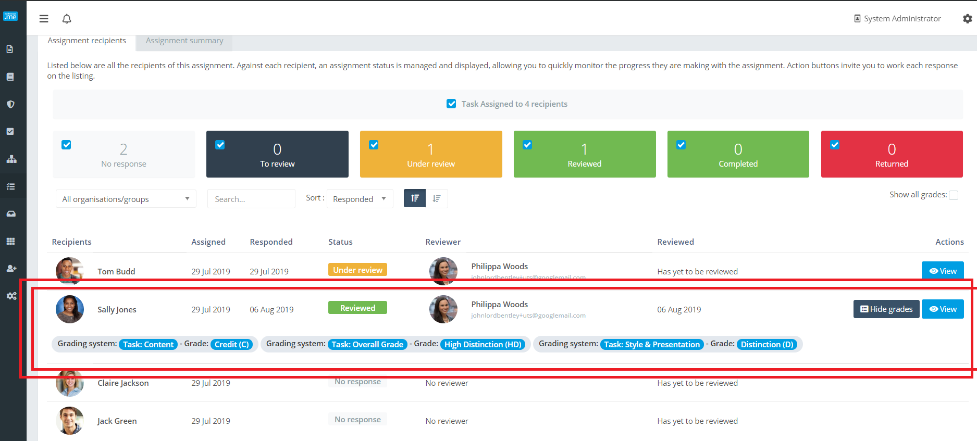

Personal user and Tasks
If a personal user is assigned a Task, a ‘Task’ menu item will appear on the user’s menu bar within their Myshowcase.me space. All shared Tasks and their current status are listed under this menu tab.

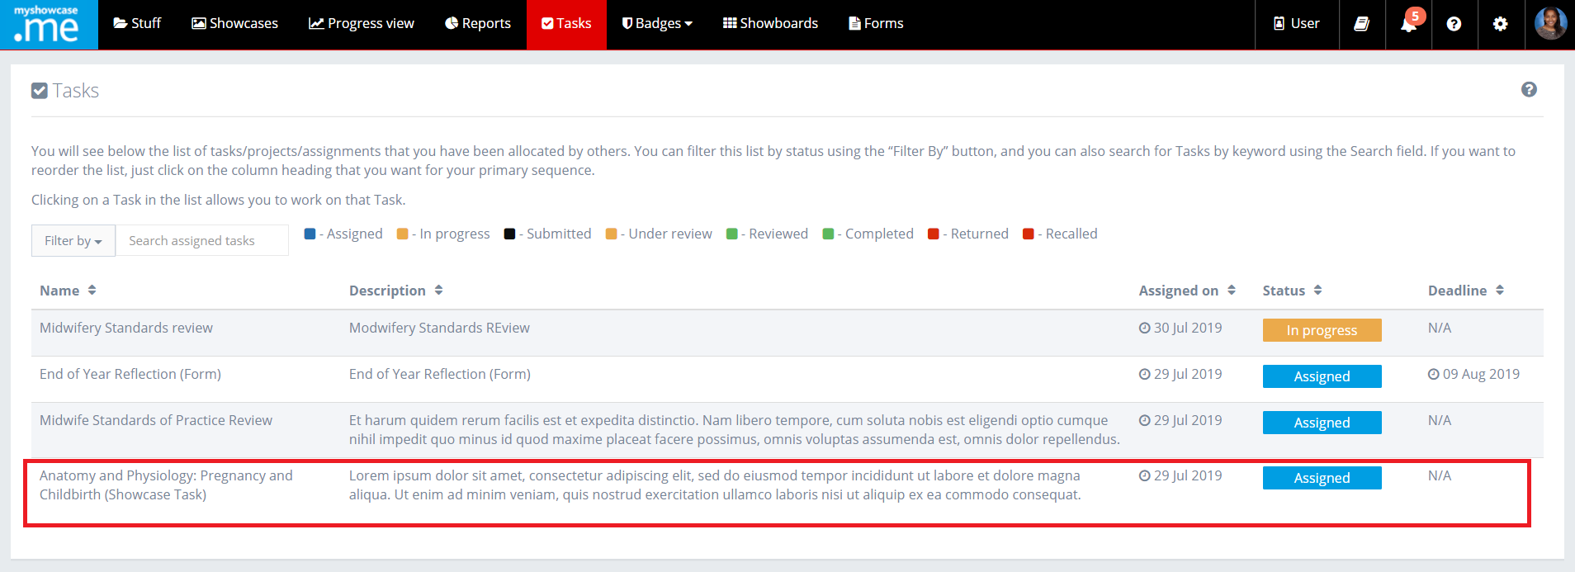

To view the detail of the Task, the user just clicks on the listed Task. In the example below, the user has been asked to provide a showcase in response to the shared Task. Once they have met all the requirements of the Task, the select the ‘Submit response’ action button.

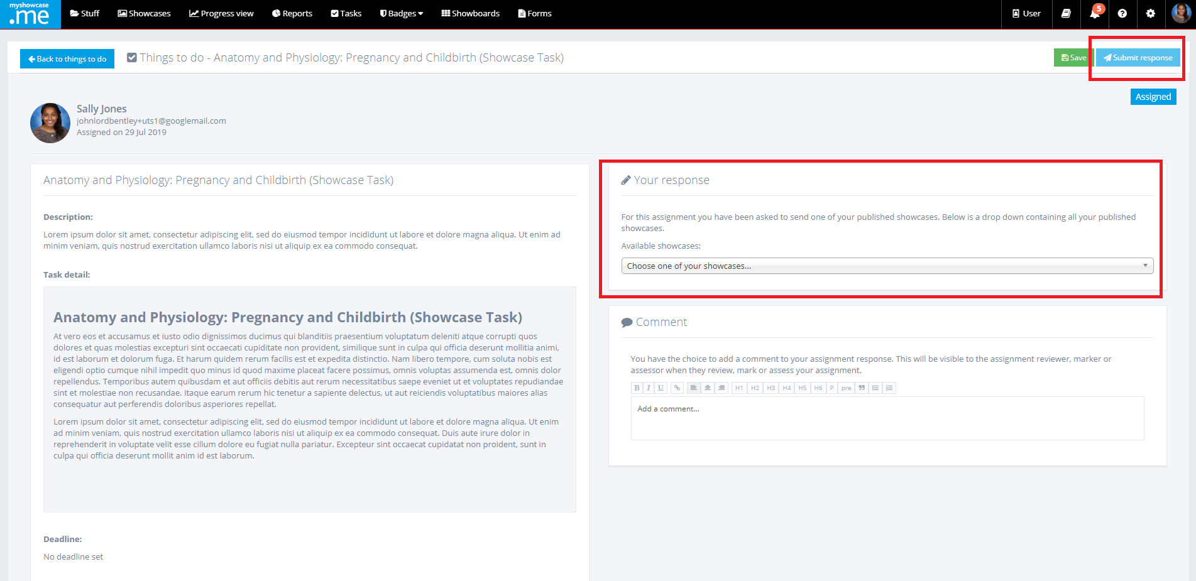

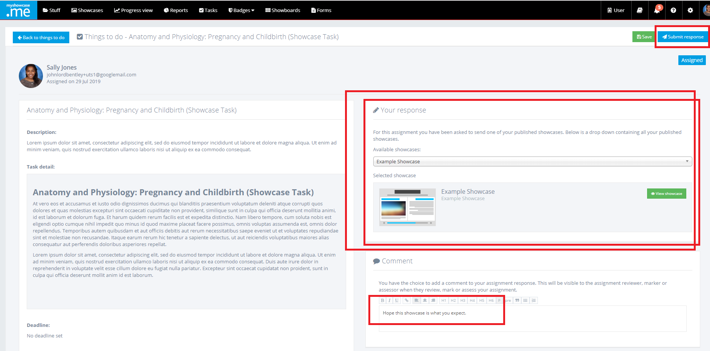

Above, the user has selected a showcase to return as part of their response. Additionally, they have added some optional comments about the Task they have worked on. When happy with everything, the user can submit the response back against that Task.

The status of the Task now updates from ‘assigned’ or ‘In progress’ to ‘Submitted’. Up until the task has been ‘Reviewed’ or is ‘Under review’ by the admin, the user can continue to resubmit the response with any change they may have updated or added.

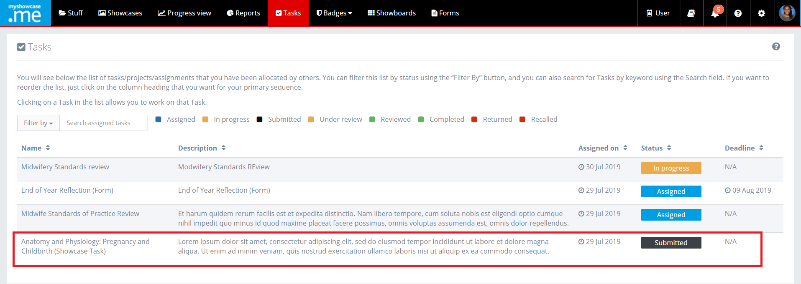

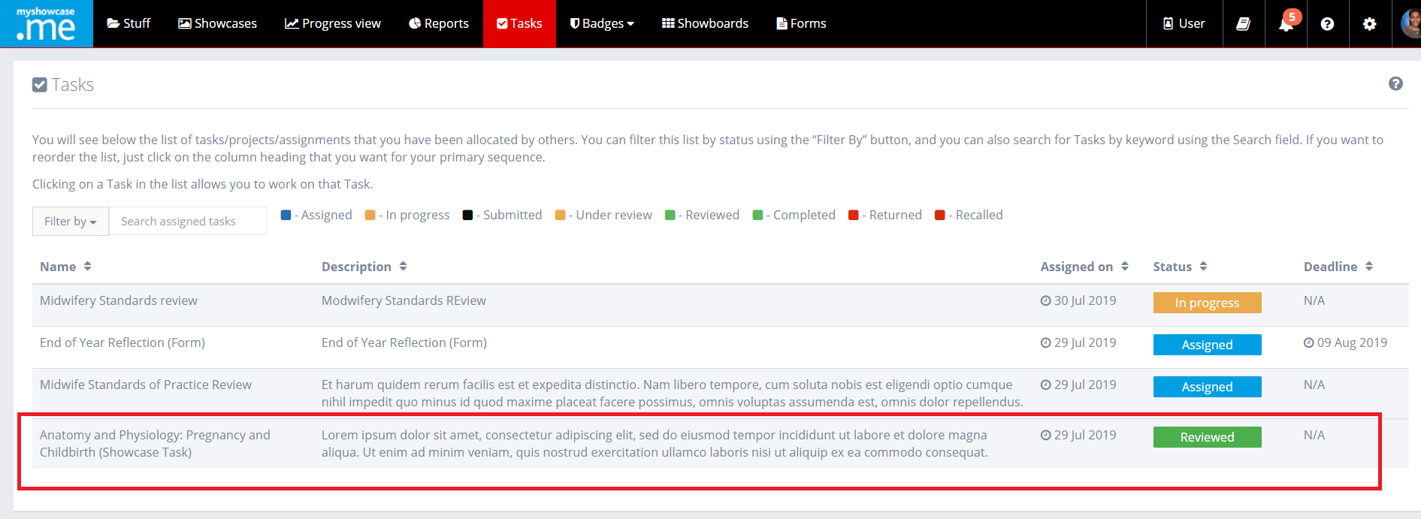

Once a task has been reviewed by an admin the status of the listed Task updates to ‘Reviewed’. The user cannot change or amend anything else on this Task now. It is effectively frozen.

They can open the Task and view any grades, marks or feedback the admin may have applied to their Task.

