

5. Grading Schemes
Grading Schemes are complimentary functionality that allow areas such as Standards and Tasks to be graded or marked by a user to show a measure of progress, achievementor attainment.
MKM
MyKnowledgemap/ 20 George Hudson Street, York, Y01 6WR, United Kingdom
Contents
Overview 2
Creating a Grading Scheme 3
Managing Grading Schemes 7
Using Grading Schemes 9

Overview
Grading Schemes provide a means within the Myshowcase.me for users to review, grade and mark things. This could be to recognise and evaluate progress, achievement, knowledge, skills and behaviours against a Standard. They could be used to assess and grade a Task a group of users may have been asked to perform using the contents of the Myshowcase.me ePortfolio.

The are many flavours of Grading scheme: Feedback, Percentage, Range and Value.
It is a user choice which one best fit what they want to grade or mark. In some circumstances multiple Grading Schemes can be used in the review. For example, when grading a showcase, a reviewer may want to grade the presentation style, its content and the overall impression they could a separate Grading System for each area.

Grading schemes are a complimentary Myshowcase.me function. In themselves they are of no use. They have been designed to work with other Myshowcase.me functionality, such as Tasks, Standards, Progress Views and Showcases.

Creating a Grading Scheme
Creating a Grading Scheme is straight forward. You give it a name and a description. There is the option to upload a files or documents that may describe the Grading Scheme and its use in more detail.


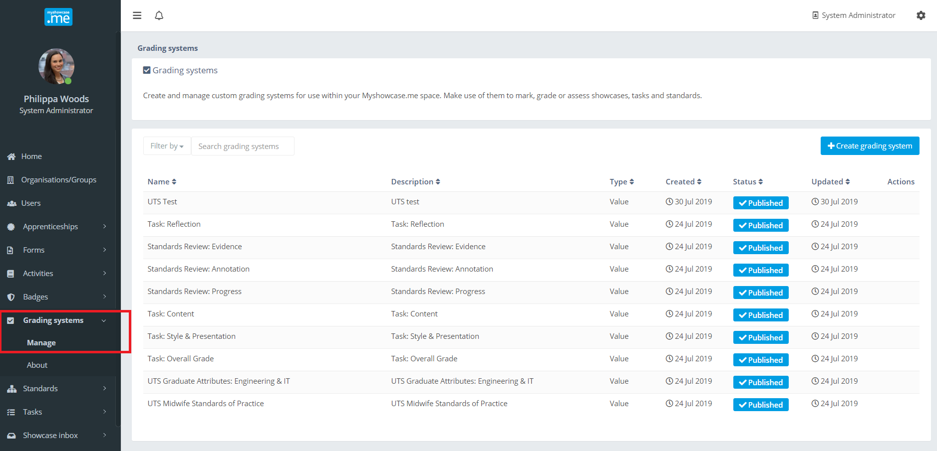

There are many flavours of Grading Scheme. Each Grading Scheme is given a single ‘Type’ descriptor of either: ‘Percentage’, ‘Range’, ‘Feedback’, ‘Value’.

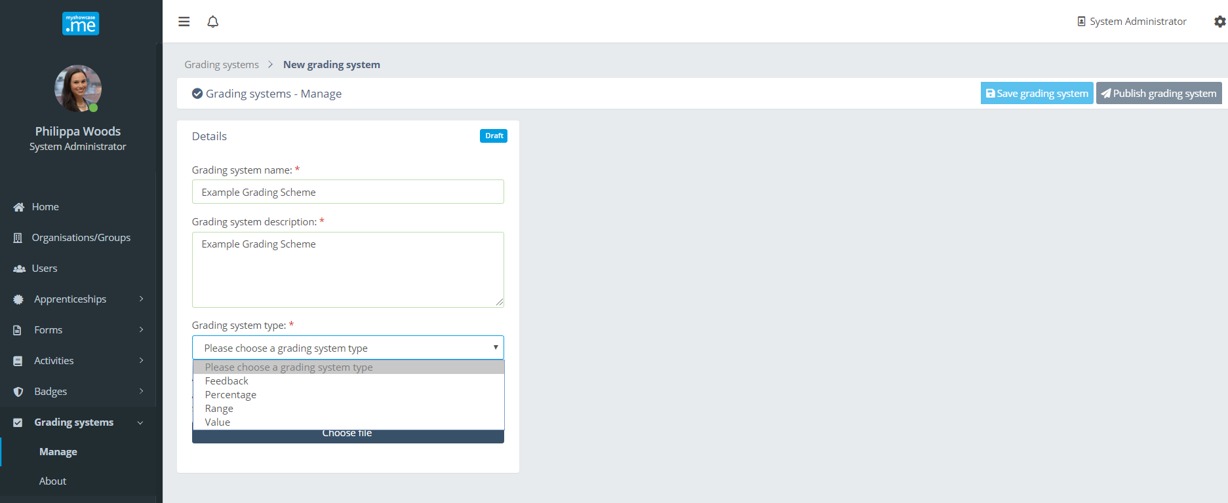

Grading Scheme type: Percentage
A ‘Percentage’ Grading Scheme is one supporting the choice of a numerical value within the range 0-100.

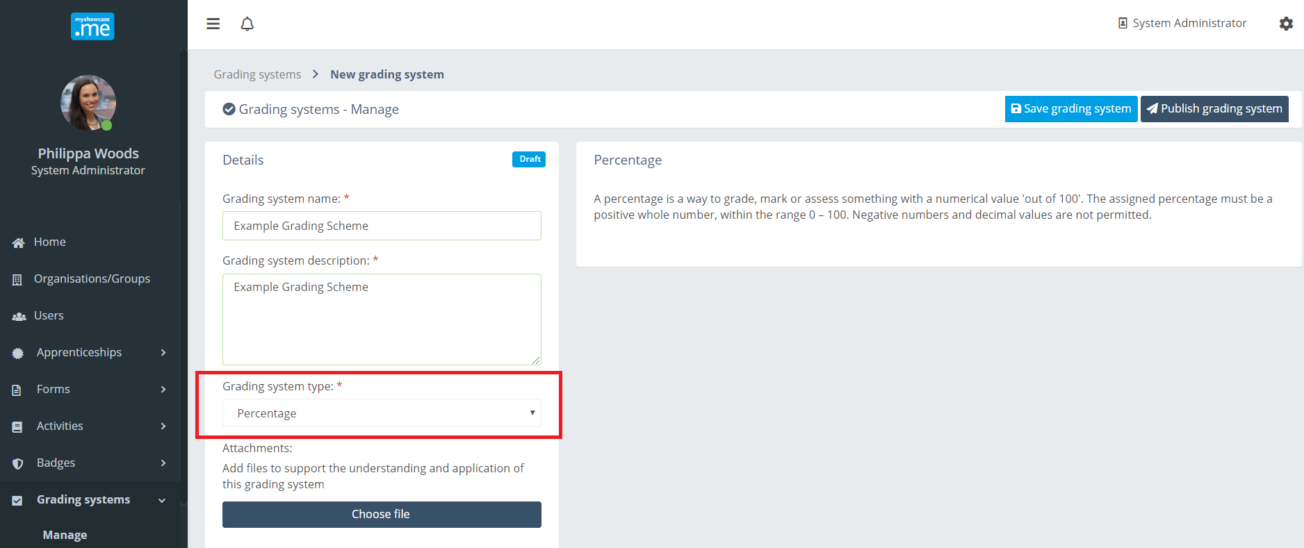

Grading Scheme type: Range
A ‘Percentage’ Grading Scheme is a collection of values, inclusive from a start to end position. The range can be either numeric or alphabetic.
Numeric ranges must be positive whole numbers. Decimals are not supported.

Alphabetical ranges will not support numeric or any special character values. All capitalisation will be ignored.

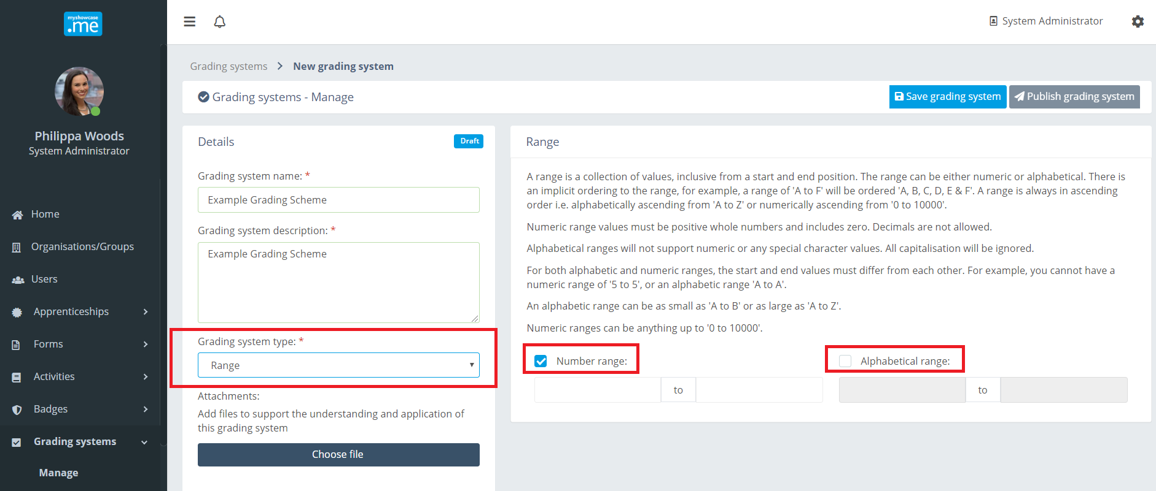

Grading Scheme type: Feedback
A ‘Feedback’ Grading Scheme requires the reviewer/marker to provide some textual feedback, observation or comment for the user to reflect upon.

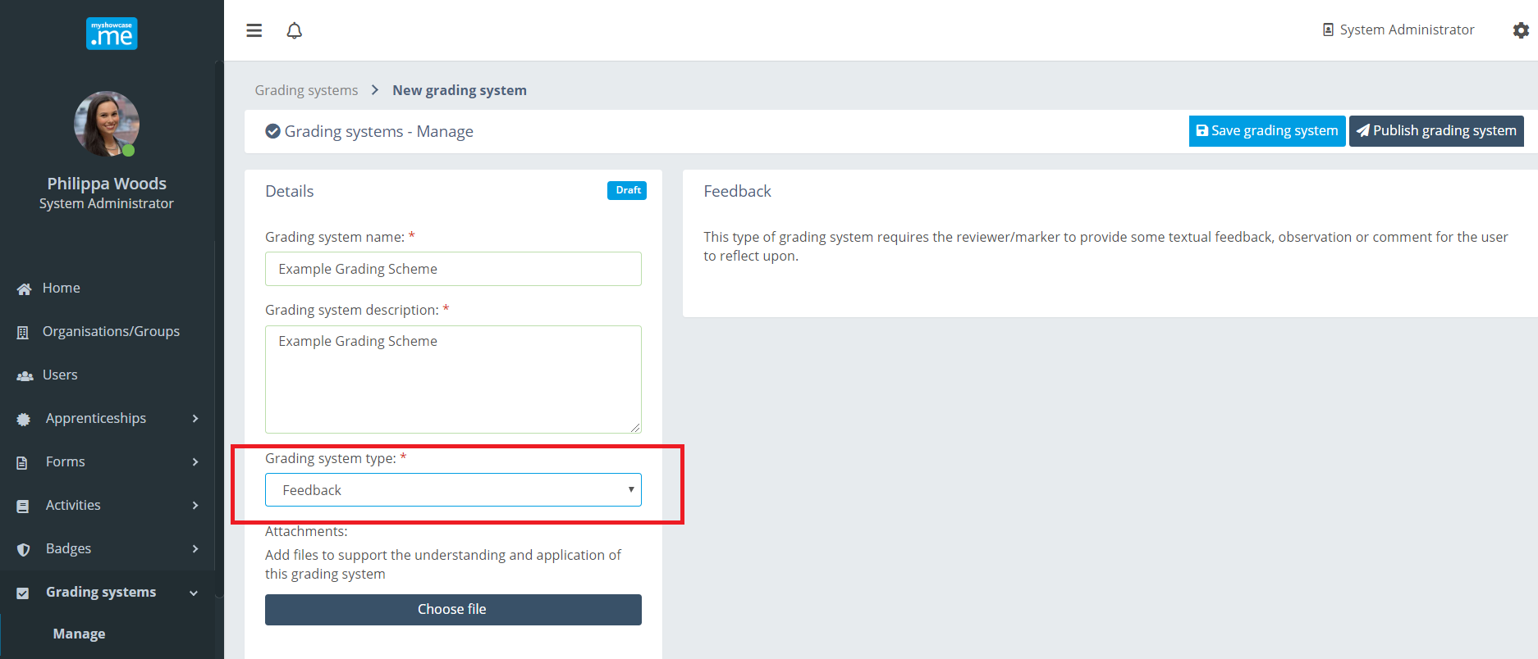

Grading Scheme type: Value
Th reviewer or marker using this Grading Scheme will be required to choose a single value from an ordered collection of possible values.

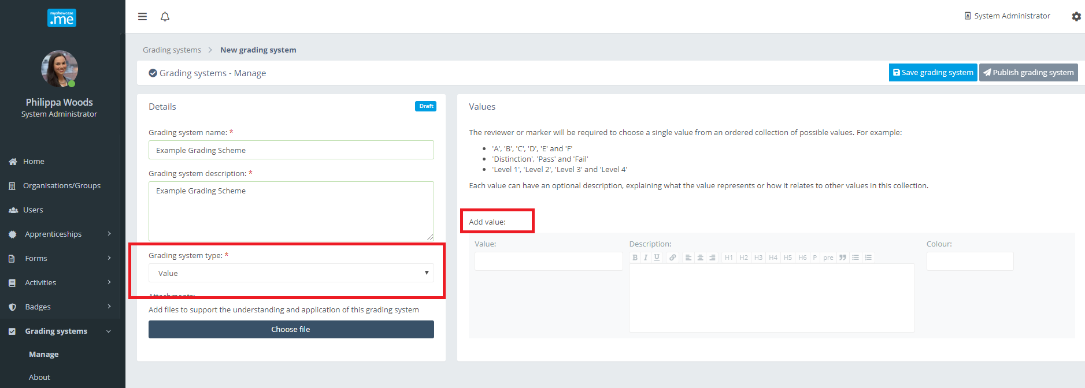

For example:

- ‘A’, ‘B’, ‘C’, ‘D’ and ‘E’
- ‘Distinction’, ‘Pass’, ‘Fail’
- ‘Level 1’, ‘Level 2’, Level 3’

Each value can have an optional description explaining what the values represents or how it relates to the other values in this collection.

In the example below the Grading Scheme has an extensive collection possible values, each with its own descriptor and colour representation. The colour is used throughout the Myshowcase.me when the grade value ids displayed within the user interface. The colour can be updated at any time, even on published Grading Schemes and ones already being used. The changes are immediately reflected, real time, on any chart or Grading Scheme presentation.

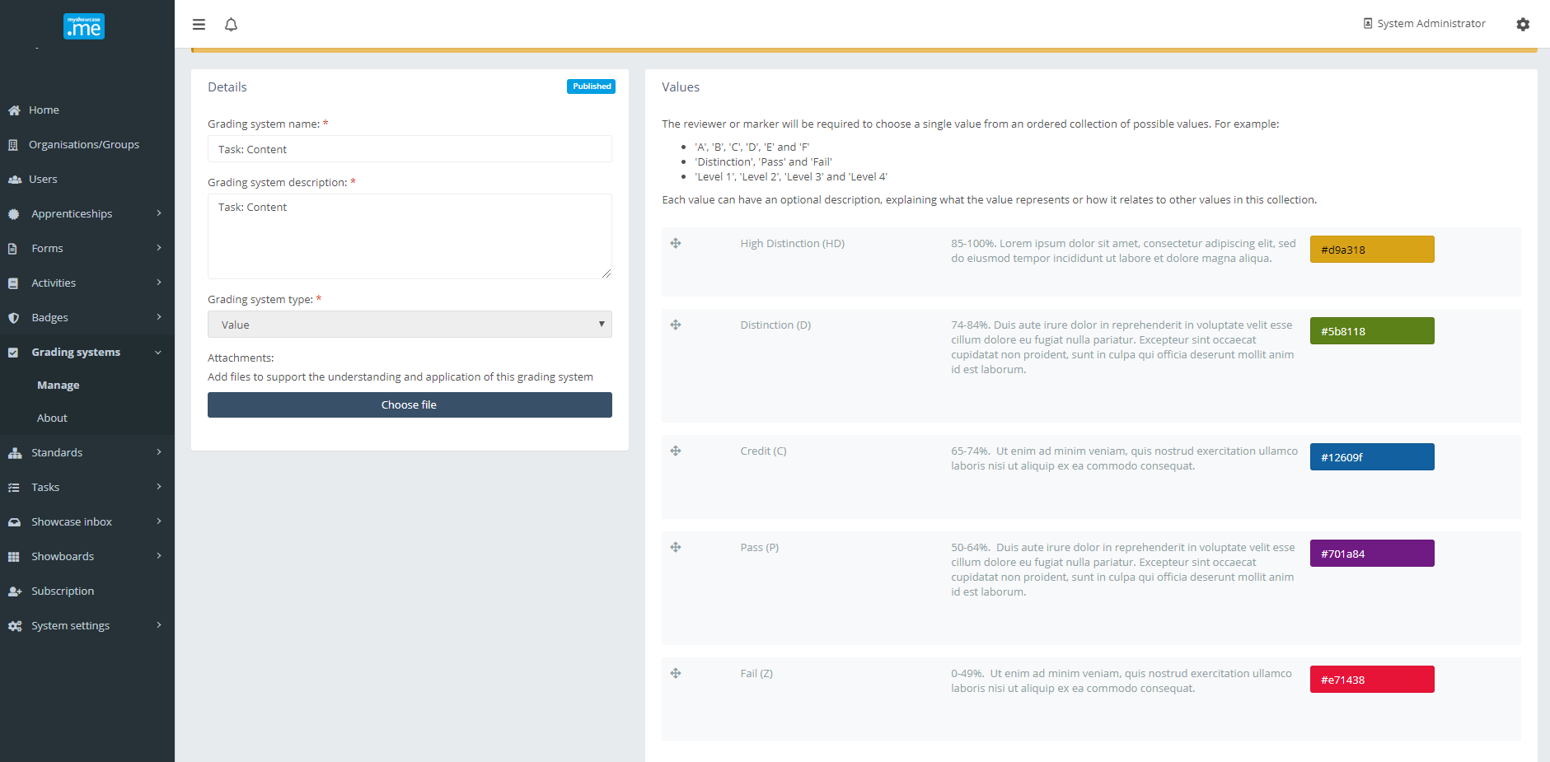

Managing Grading Schemes

Draft
At any point during the authoring of a Grading Scheme, it can be saved as a draft.

Choosing to ‘Save grading System’ will store the Grading Scheme, mark it as a ‘Draft’ and allow the user to revisit it at a later date to continue their work on its development.

Publish
When the author of the Grading Scheme is happy with its content they can ‘Publish’ it.


A published Grading Scheme become available for use in other areas of Myshowcase.me, such as Tasks or Standards.

After publishing, all content of the Grading Scheme can be changed, provided it has not been used against a Task or Standard.

.

If it has been used, only certain parts of the Grading Scheme can be updated: Name, Description and associated colour values.

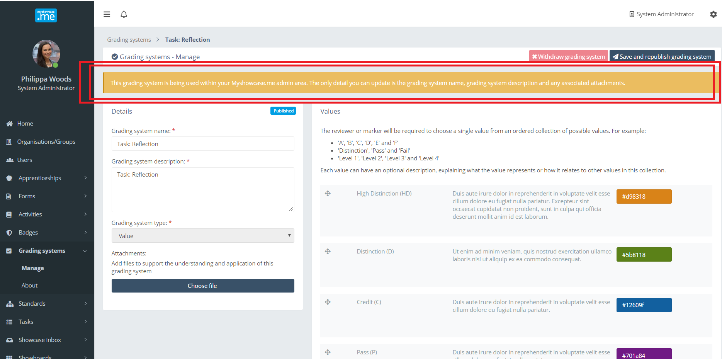

Withdraw
At any point a published Grading Scheme can be ‘Withdrawn’.
.


Withdrawing a Grading Scheme makes it no longer available for any new associations with complimentary Myshowcase.me functionality, like Tasks and Standards. If the Grading Scheme is already in use, it will continue to be so. Withdrawing the Grading Scheme restricts new uses of the Grading Scheme, not existing ones.

Using Grading Schemes
Grading Schemes are used within Myshowcase.me to compliment the other functionality available within the Myshowcase.me space.

They can be layered over a Standard to provide a visual measurement of how a user may be progressing against that standard. In the example below, progress against the ‘Midwife standards for practice’ is being measured using a value Grading Scheme of: ‘Not meeting expectations’, ‘Nearly meeting expectations’, Meeting expectations’ and Exceeding expectations’. Giving each value a colour, allows Myshowcase.me to represent and summarise progress using interactive chart visualisations.

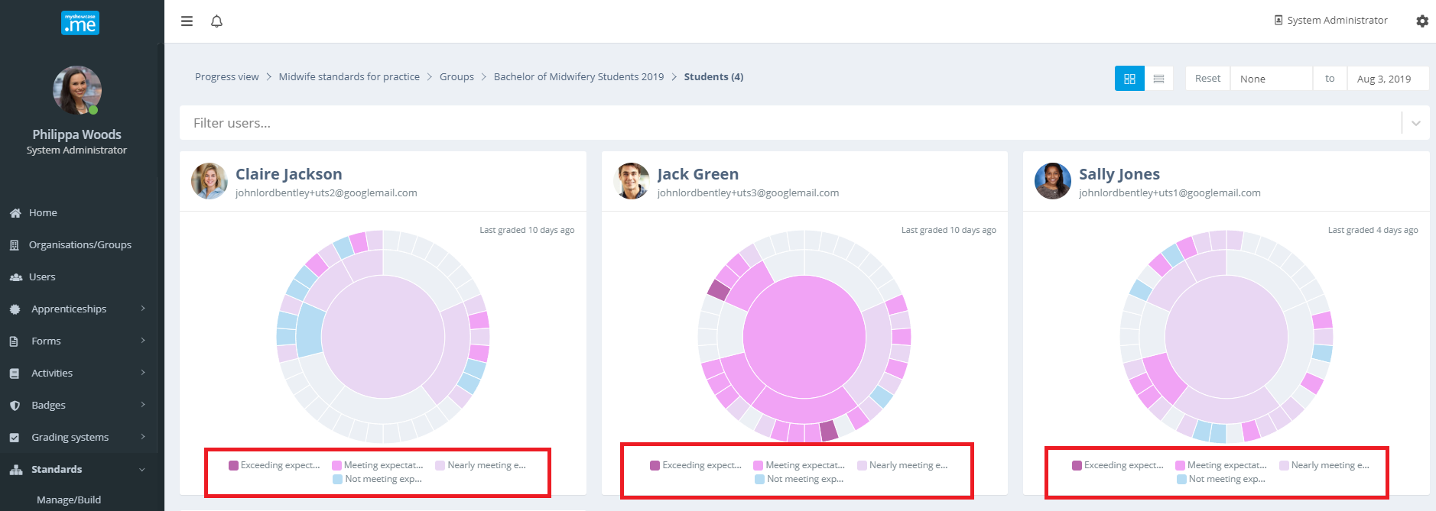

Multiple Grading Schemes can be applied at the same time to things like tasks to give rich feedback to a user on the outcome or result of the Task. In the example below, learners completing a task to map evidence against one of their Standards are evaluated using three Grading Schemes. One to measure of annotation and reflection quality, another to measure mapped evidence and a final one to give an overall grade or mark.

