

4. Activities/Journals
Activities act like journals, providing a place to record and log private and shared notes, reflections, observations, goals and outcomes, events and a myriad of any other activities
MKM
MyKnowledgemap/ 20 George Hudson Street, York, Y01 6WR, United Kingdom
Contents
Creating Activities/Journals 2
Sharing Activities/Journals 7
Adding Activity/Journal entries 9
Viewing Activity/Journal entries 11
Personal user: working with Activities/Journals 12

Creating Activities/Journals
To create a new Activity/Journal, the administrator chooses the ‘Manage’ option under the ‘Activities’ menu item.

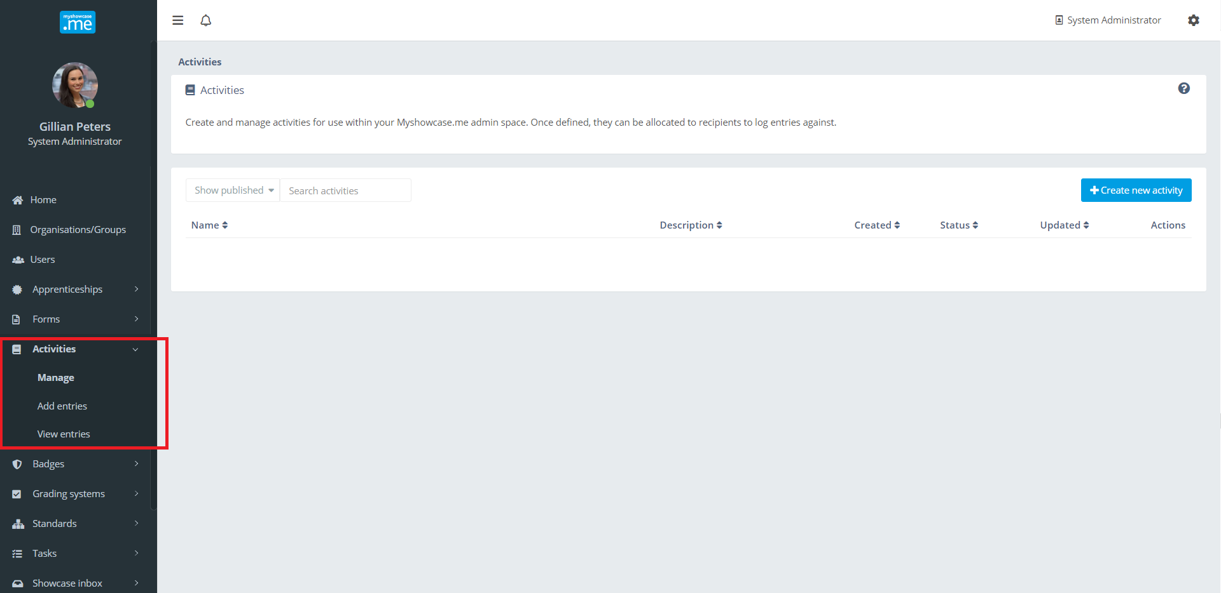
Selecting ‘Create new activity’ opens the Activity/Journal Builder tool.

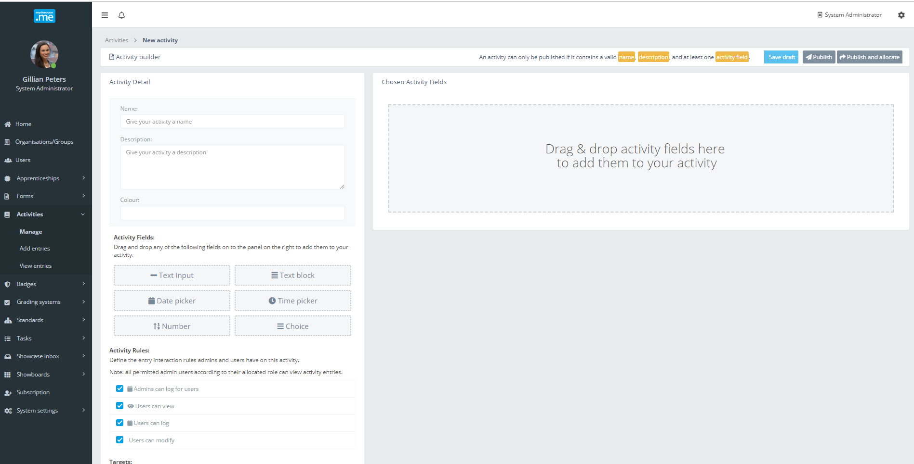

Each Activity/Journal requires a valid name and description. The colour is an optional field for use within the Myshowcase.me user interface wherever Activities/Journals are displayed.

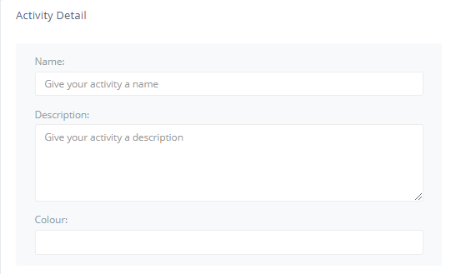

In the example below, the Activity/Journal has been named ‘Review meeting notes’ and a token colour has been added.

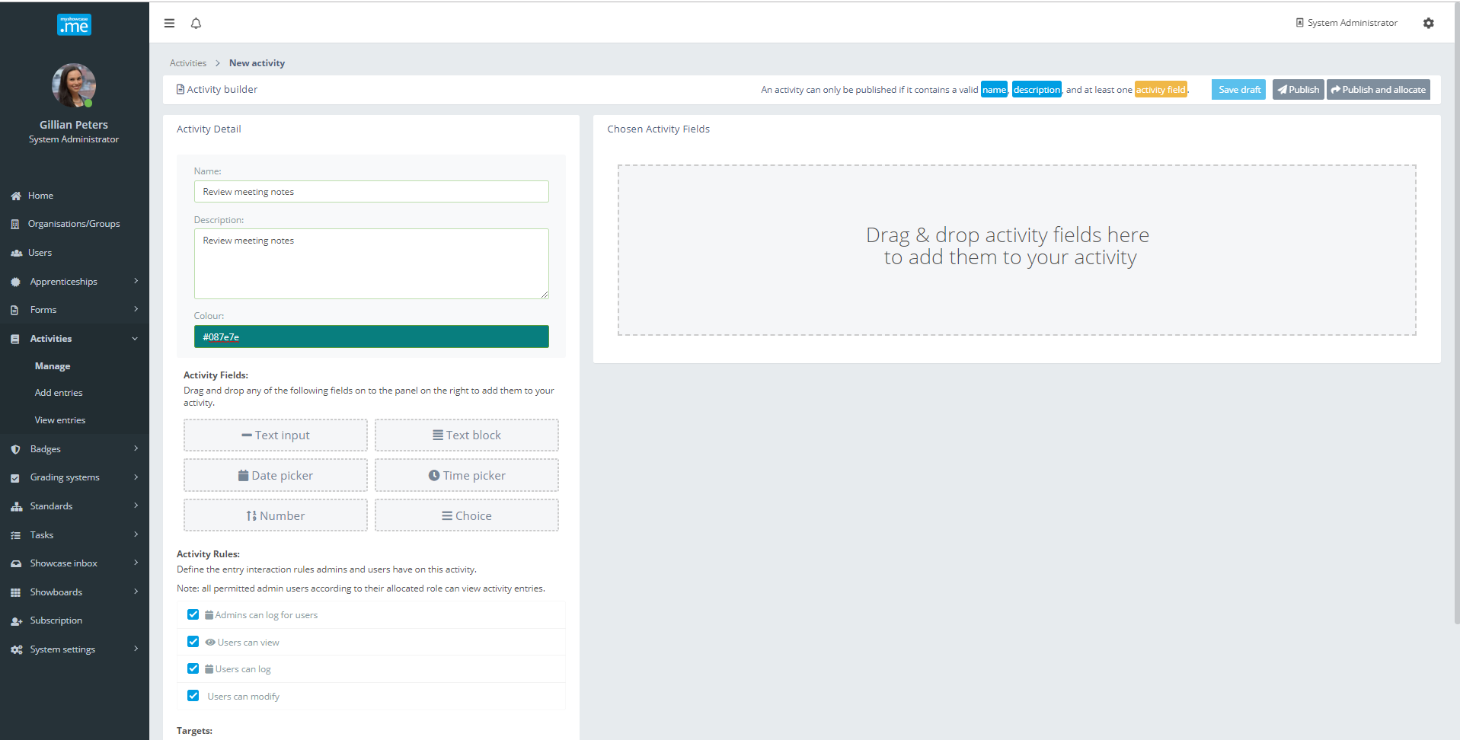

Utilising a drag and drop approach, activity fields are added onto the Activity/Journal Builder panel. These are all date input/capture fields. These form the basis of how you want to design your Activity/Journal records.

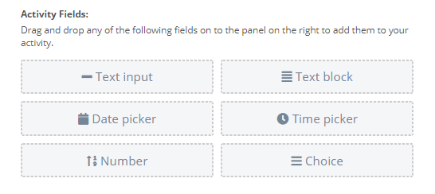

In the example below, the administrator has added some fields to the Activity/Journal: Meeting date (Date Picker), Attendees (Text input) and a yet unnamed Text block.

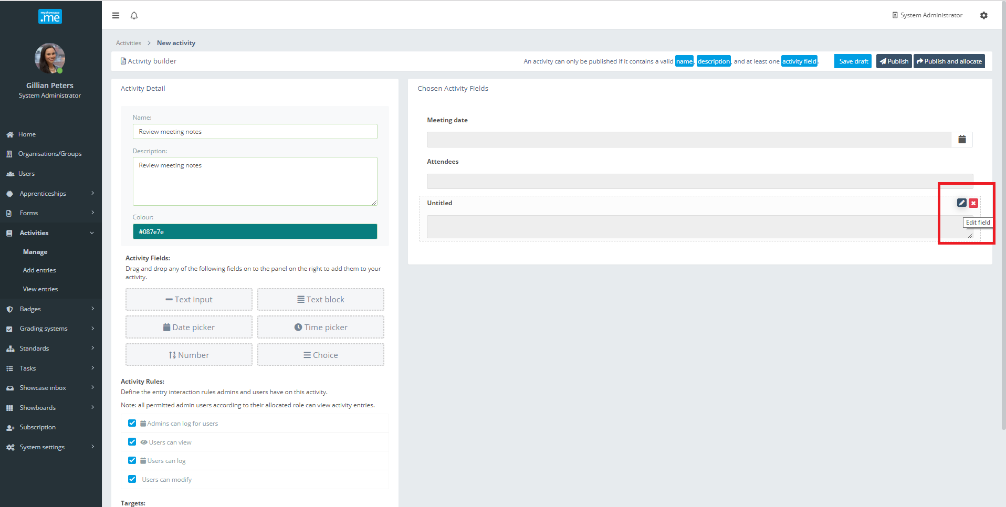

Hovering the mouse over the untitled gives the administrator the option to either ‘Edit’ or ‘Remove’ the item.

Choosing to edit the item gives the administrator a modal containing he detail of the text block.

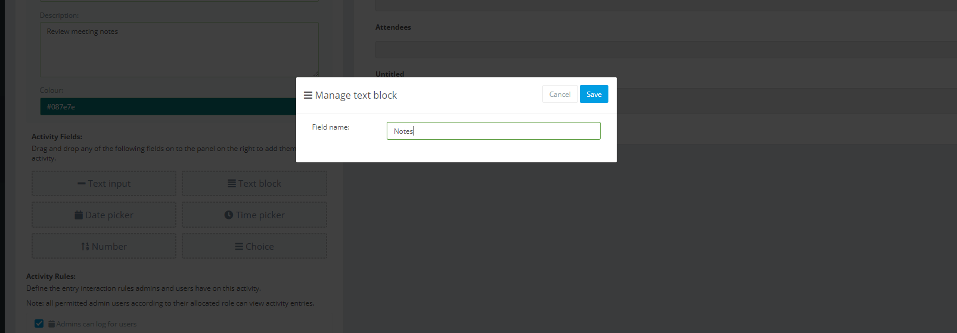
Giving the Text Block the name ‘Notes’ is immediately reflected back on the display of the Activity/Journal record.
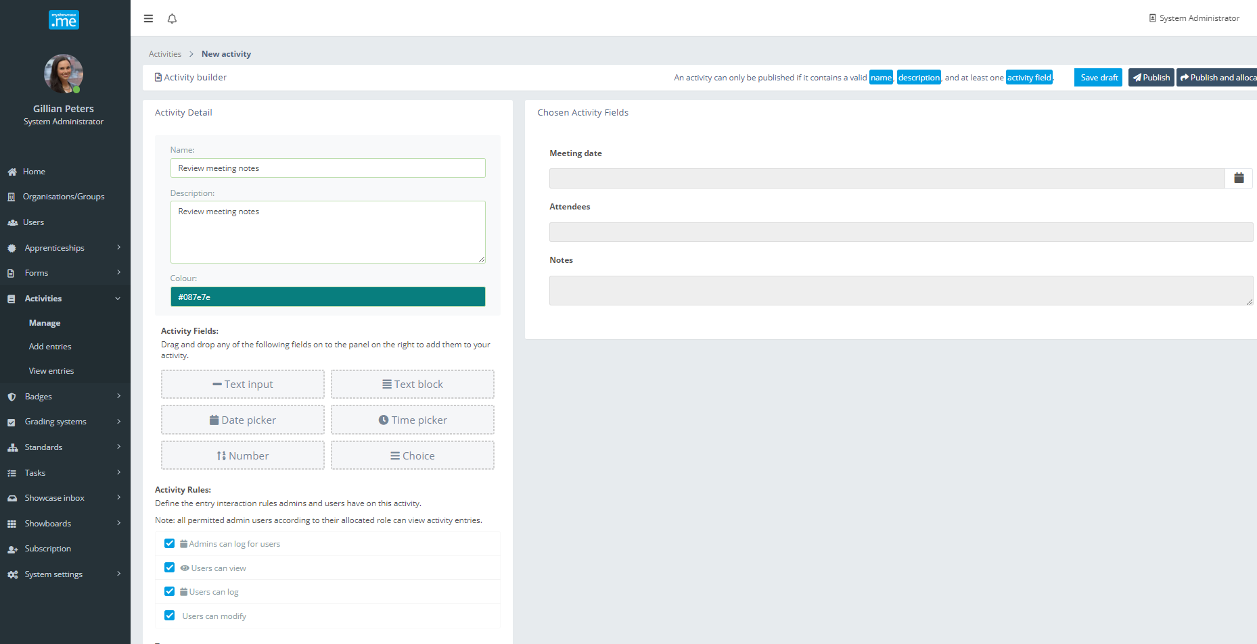
The administrator continues to work through adding the required Activity/Journal Fields onto the panel, building up the how they want the Activity/Journal record to look. At any point, the administrator can save their work as a ‘Draft’, returning later to complete it.
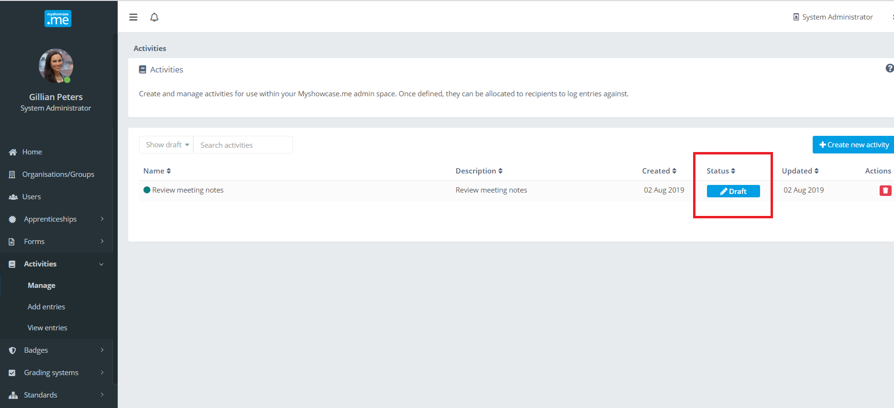

There are logging and views rules that can be set against each Activity/Journal. They define who can view, add and modify the Activity/Journal records.

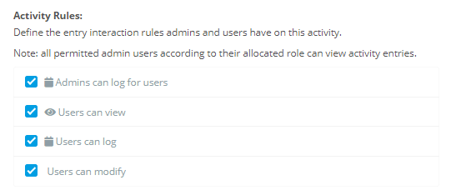

When the administrator is happy with the Activity/Journal set-up, they can ‘Publish’ it.
Once published, it immediately becomes available for sharing with any number of groups and organisations. Members of these groups and organisations will have the Activity/Journal available within their Myshowcase.me personal space for them to use.

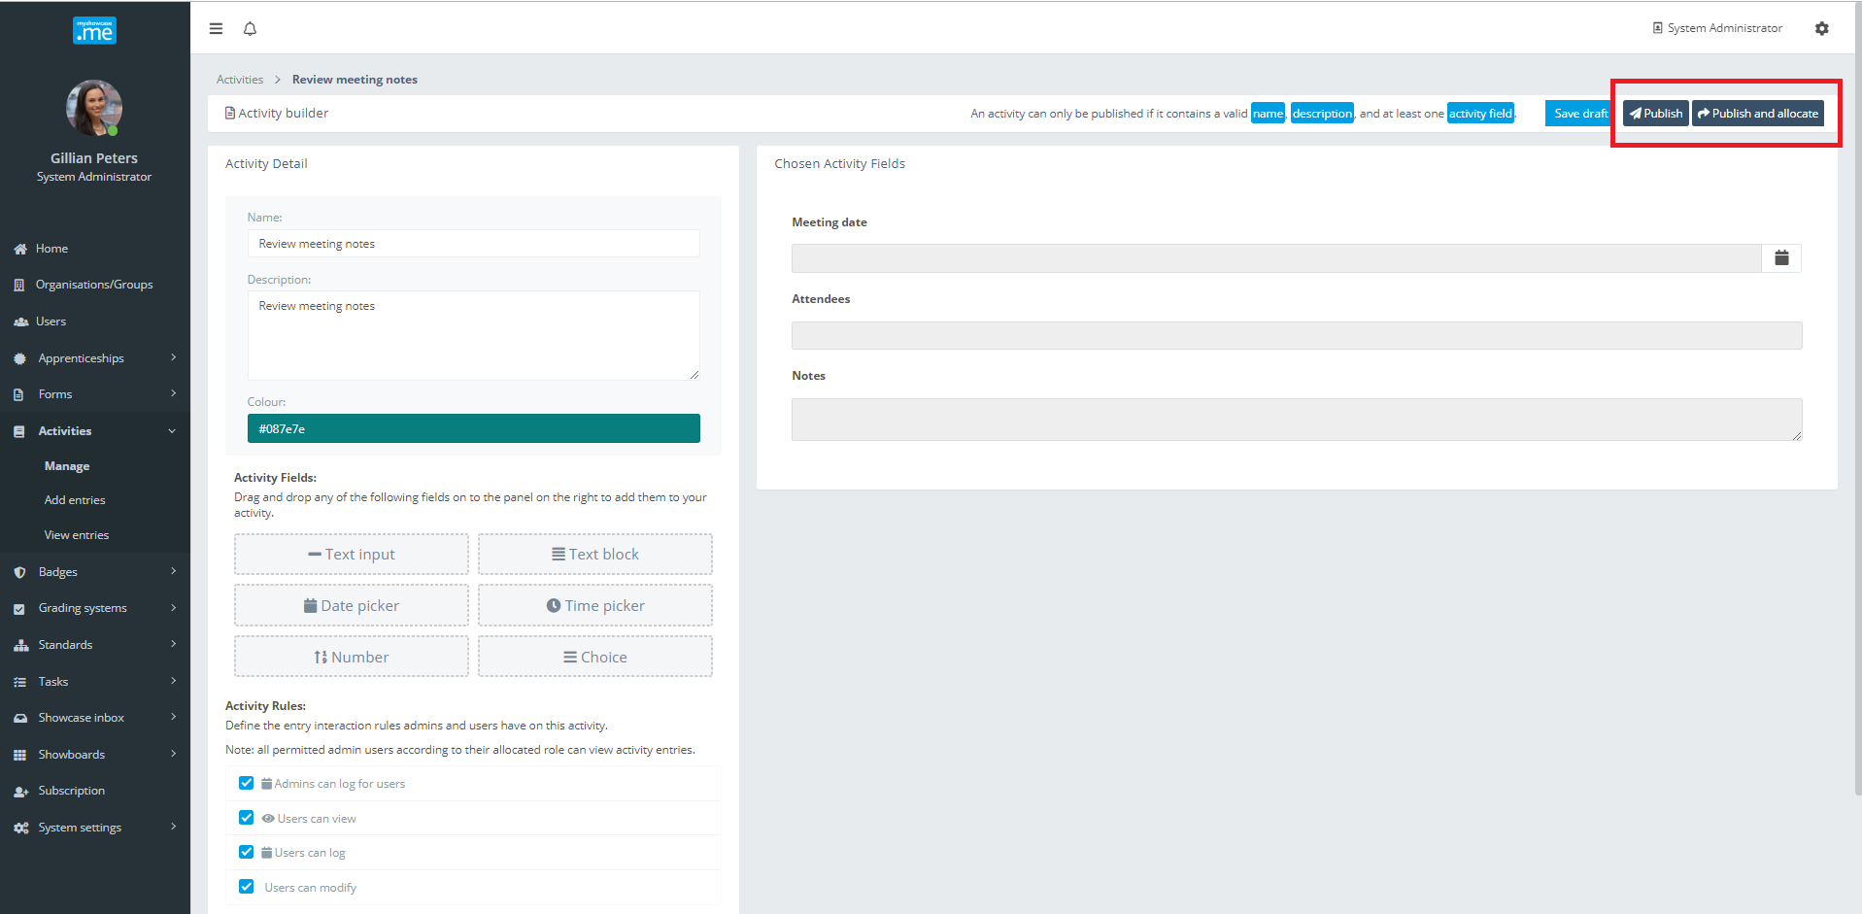

Sharing Activities/Journals
When a learner was working with a framework, there had a ‘My Frameworks’ menu option available to them.

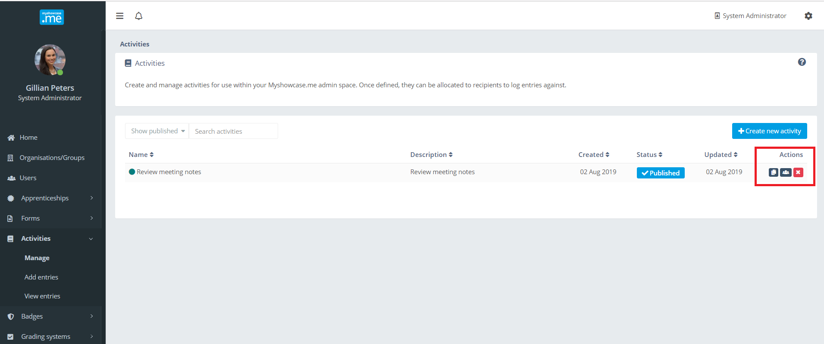

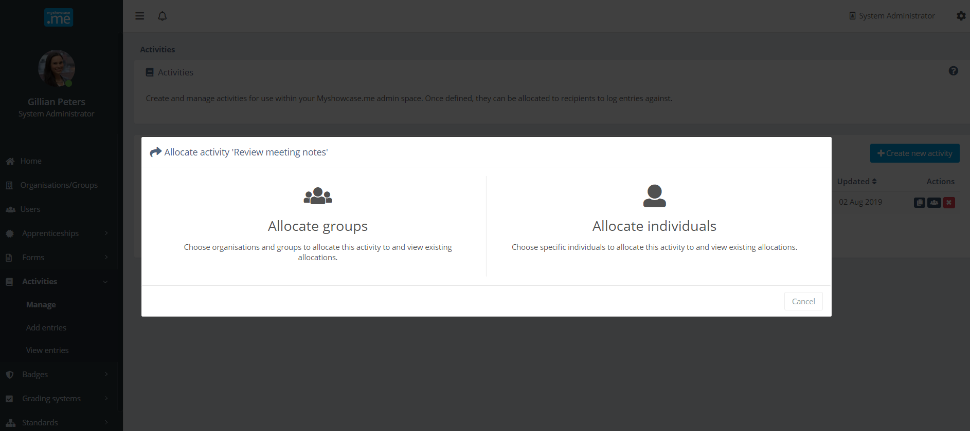

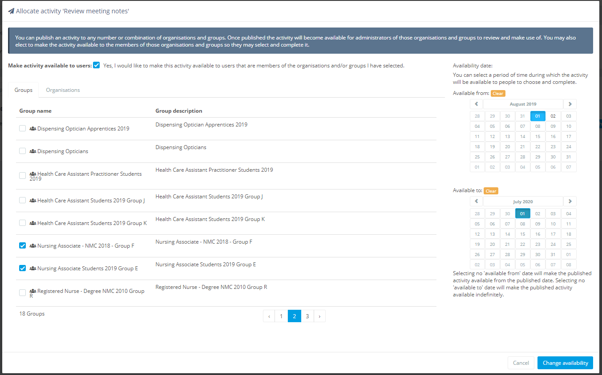

Adding Activity/Journal entries
An admin can add records into an Activity/Journal if the permissions allow them to: “Admins can log for users”.

The ‘Add entries’ option under the ‘Activities’ menu item presents the administrator a listing of Activities/Journals they can add entries to.

In the example below, Gillian can add entries into the ‘Review meeting notes’ Activity/Journal.

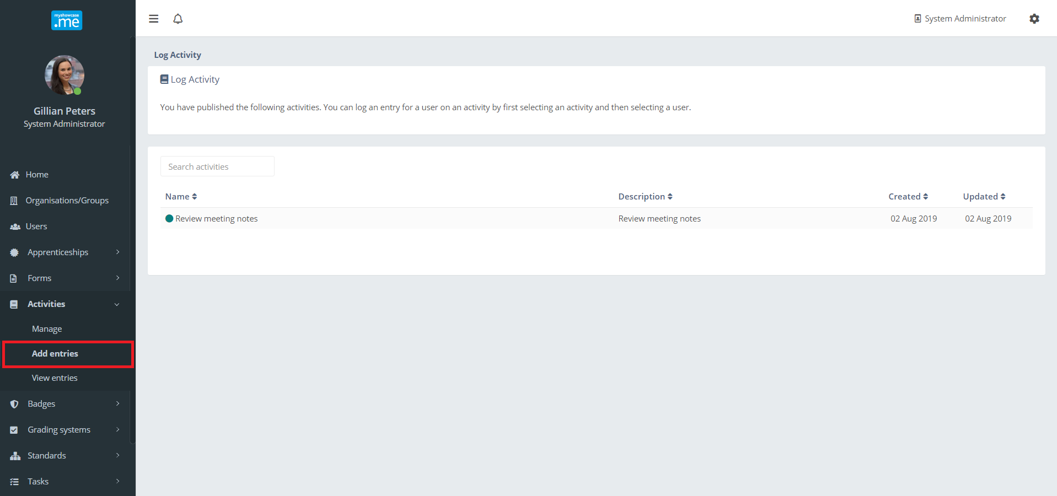

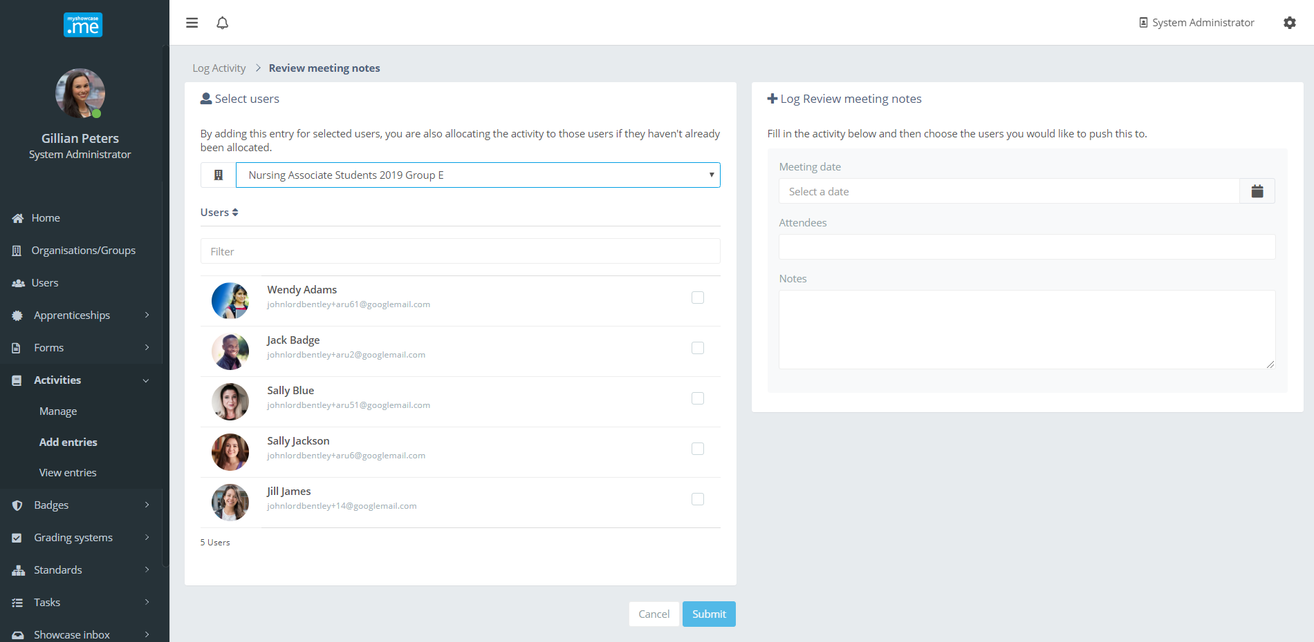

From the group ‘Nursing Associate Students 2019 Group E’ the administrator selects the Activity/Journal of Jill James to add an entry into.

If required, the admin could select multiple users to add the same entry into.

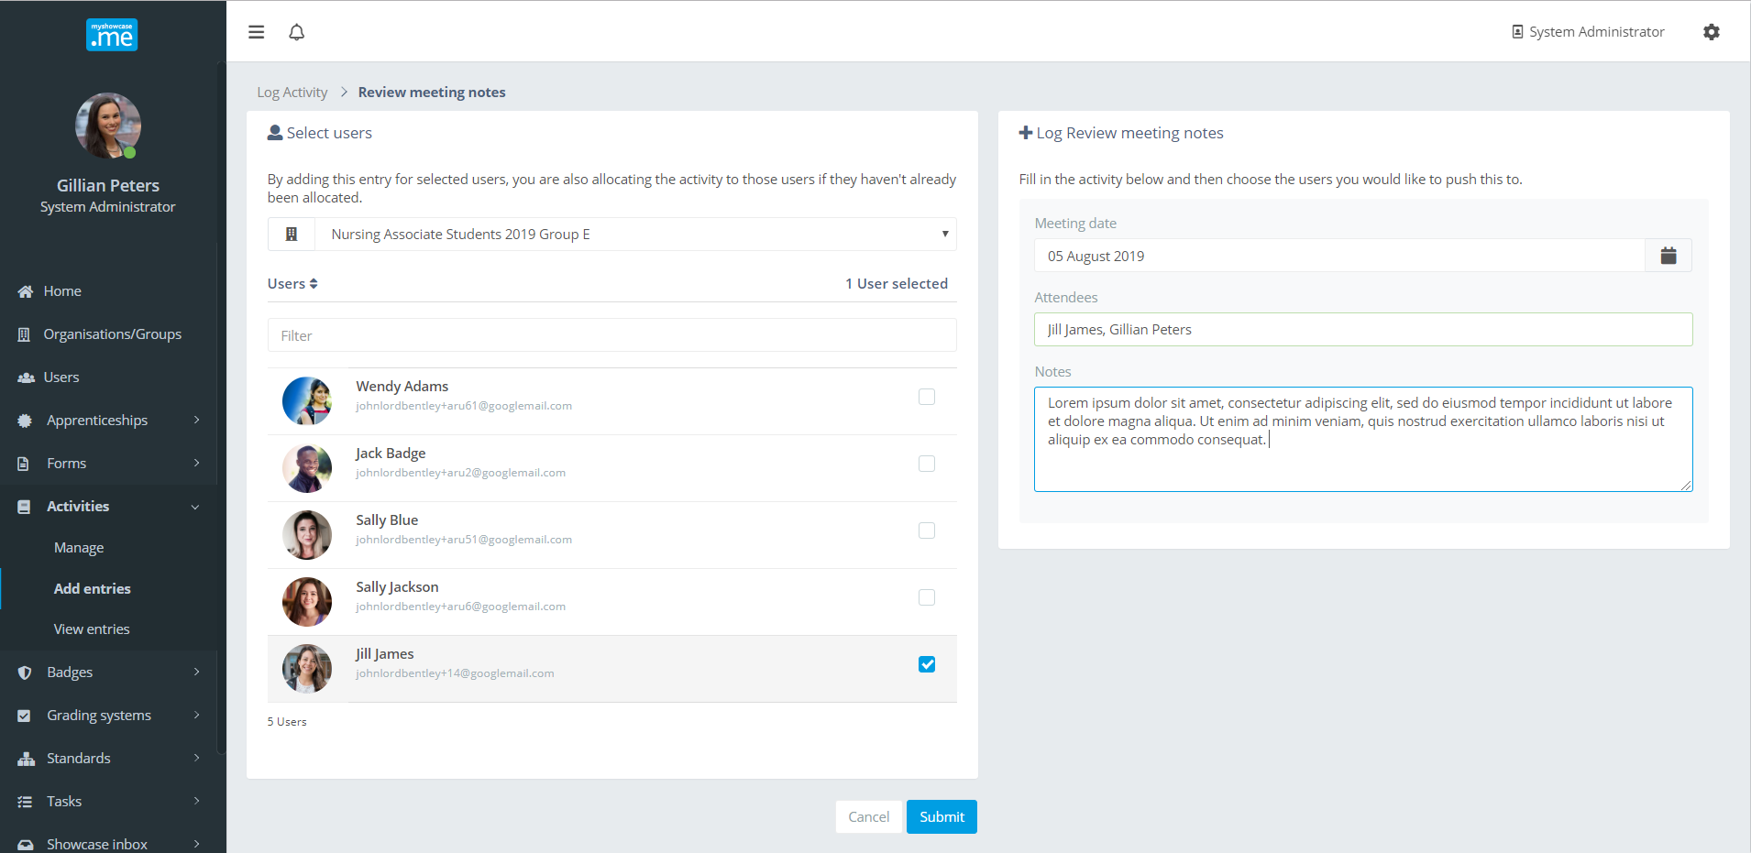

After completing the ‘Review meeting notes’ record, the administrator simply clicks the ‘Submit’ action button to add the record into Jill’s ‘Review meeting notes’ Activity/Journal.

Viewing Activity/Journal entries
An administrator can view Activity/Journal records for the groups and organisations they administer. The area to view these Activities/Journals is found under the ‘Activities’ menu item.

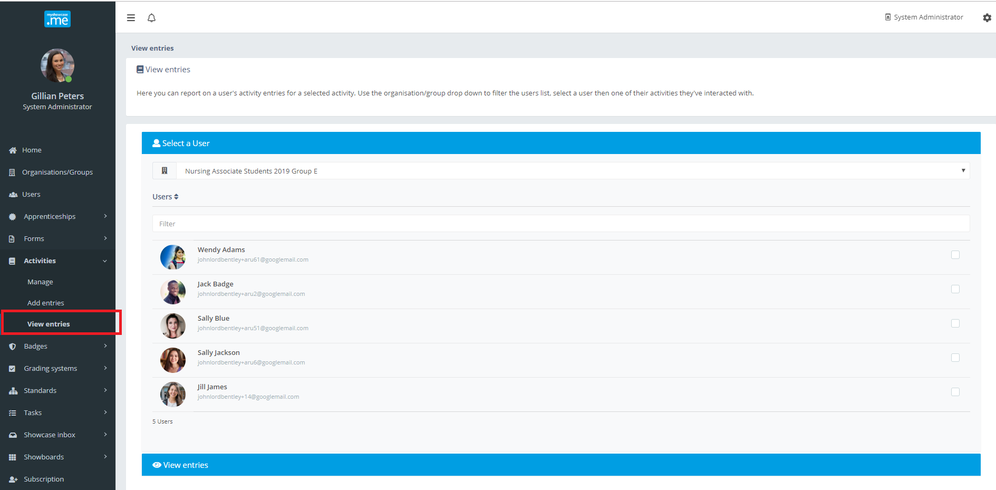

An administrator uses the user interface to select the user they are interested in. From there, they can see the users Activities/Journals they are eligible to see. Choosing an Activity/Journal will display the recorded entries.

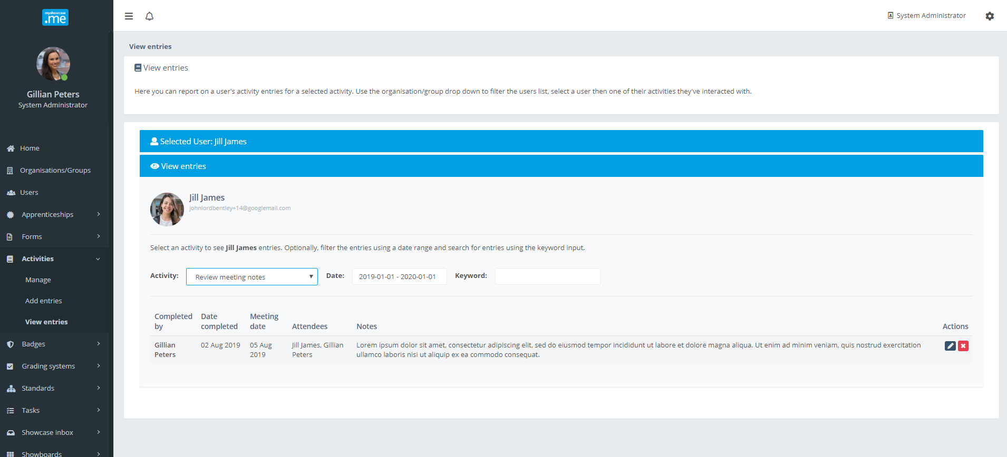

Personal user: working with Activities/Journals
When an Activity/Journal is shared with a personal Myshowcase.me user, an Activity/Journal icon appears on the Myshowcase.me menu bar. Clicking on the icon displays the Activity/Journals the user can work with. These is no limit to the number of Activities/Journals a personal Myshowcase.me user can have.

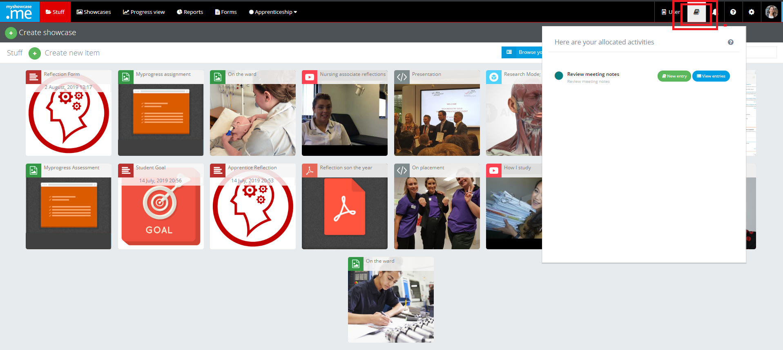

Viewing an Activity/Journal displays its contents to the user. Based upon the Activity/Journal permissions, the user may be able to modify some of the entries and add new entries.

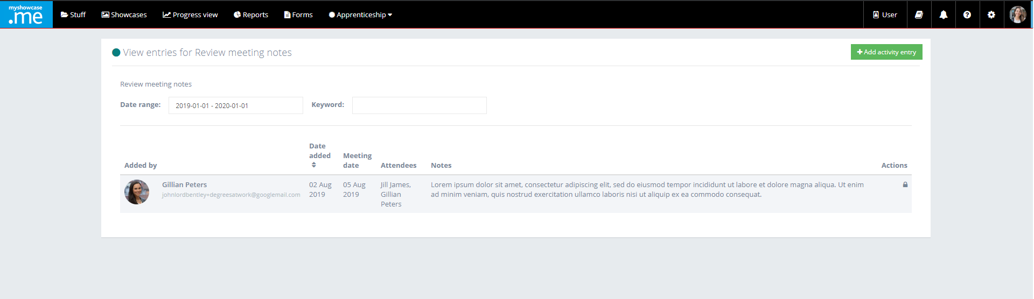

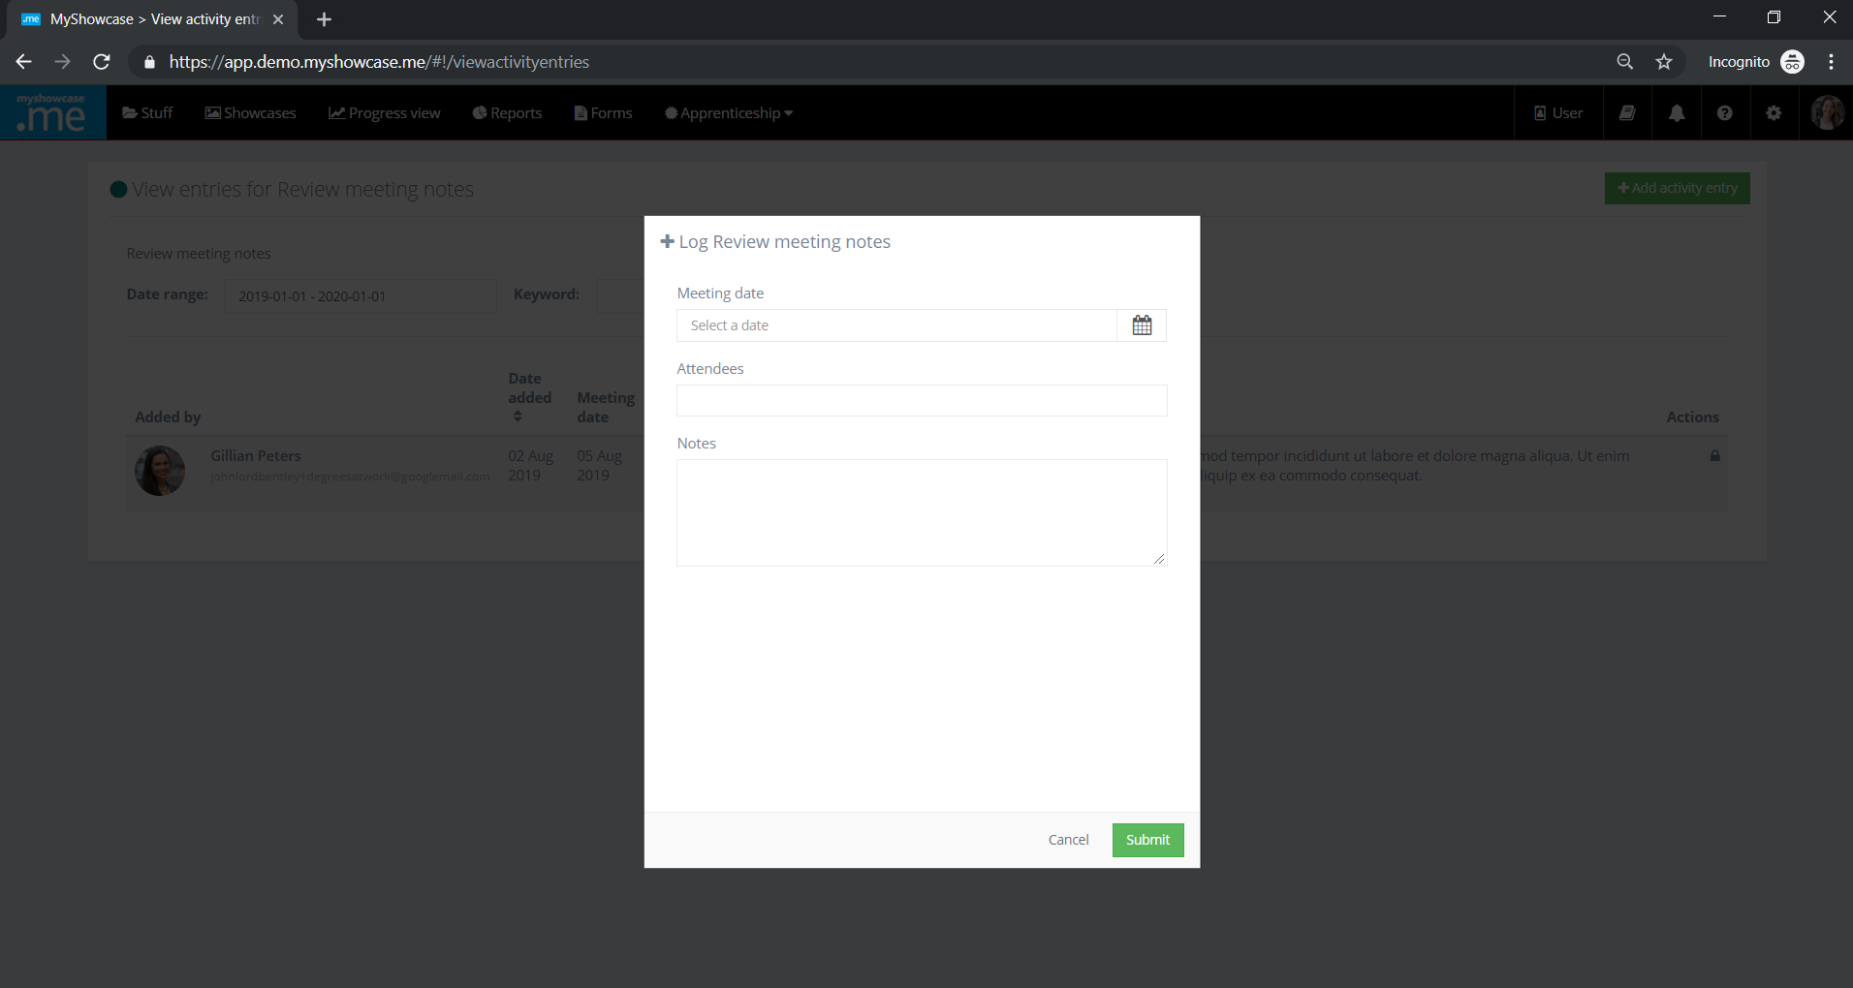

Adding a new entry is straight forward. The user completes the required Activity/Journal record fields and ‘Submits’ the entry.

