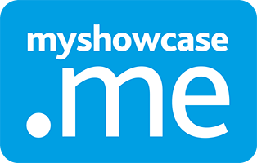
Your lifelong portfolio
Steps on how to keep and use your MyShowcase portfolio once leaving education.
MKM
MyKnowledgemap/ 20 George Hudson Street, York, Y01 6WR, United Kingdom
Contents

Overview 2
Steps 3-5

Overview

When coming to the end of your course you will need to do a few steps to ensure you can access your MyShowcase portfolio outside of university and into the future.

Steps

- Go to the settings area within your MyShowcase portfolio, it can be found by clicking the cog wheel in the top right corner.

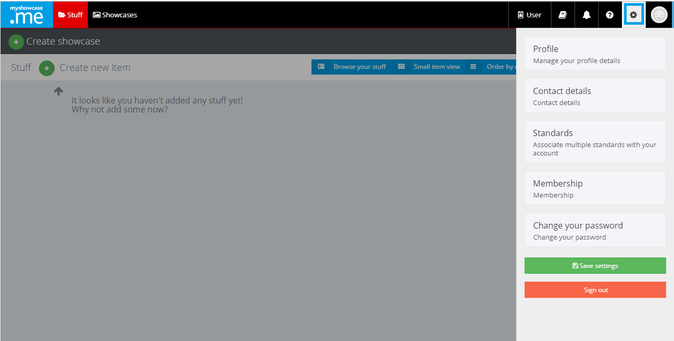

- Next you will need to change your email address. You can either change the current one you have or add another one. If you do add another email address once you have verified your email address you will need to go back into this area to ensure it is set to as the primary email address which can be done just by selecting the email address, it will have a green tick to highlight it is the primary email address. Whichever you decide to do you will still get a verification link sent to the relevant email address, you will need to click on this link to verify the email address and make it active. If you have any issues when trying to verify your account just contact the MyShowcase team.
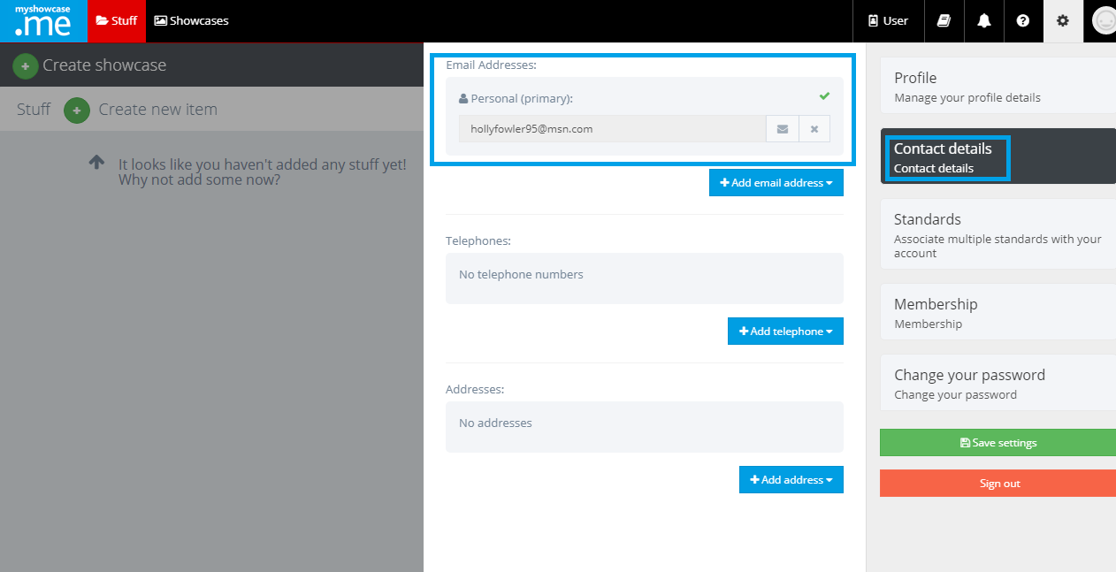

- After you will need to change your password. Enter your existing password (usually it will be your university password), select a new one and confirm this a second time. Then select ‘change password’.

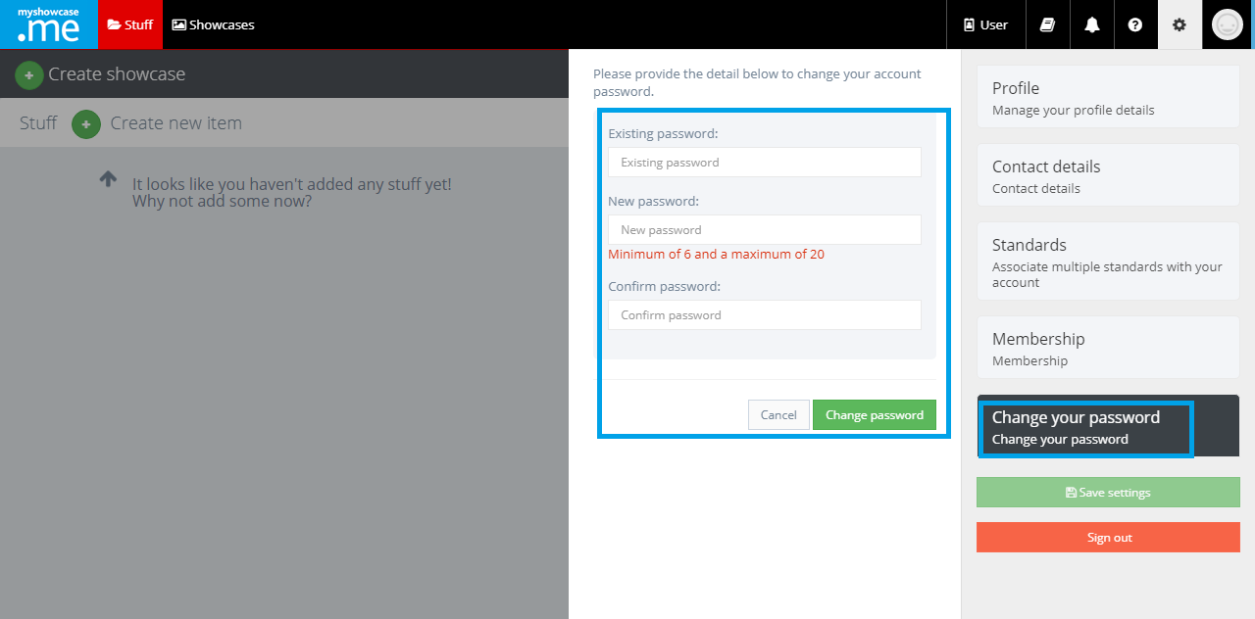

- Finally once both steps have been done select the green ‘save changes’ at the bottom of the main list.

