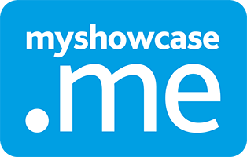

7 Standards
Myshowcase.me extensively supports working with Standards. This document illustrates how it does that.
MKM
MyKnowledgemap/ 20 George Hudson Street, York, Y01 6WR, United Kingdom
Contents
Managing standards 2
Sharing standards 12
Progress Views 15
Personal user: Working with Progress Views (Standards) 20
Progress Views with Grading Schemes 26

Managing standards

Authoring a standard
To begin authoring a new standard, the admin selects the ‘New Standard’ button found within the ‘Manage/Build’ space listed under the ‘Standards’ menu item. In the example below, the admin is creating a standard named ‘Employability Skills’. This is version 1 of the standard. The starting point. Each time the standard is published, the version number increments.

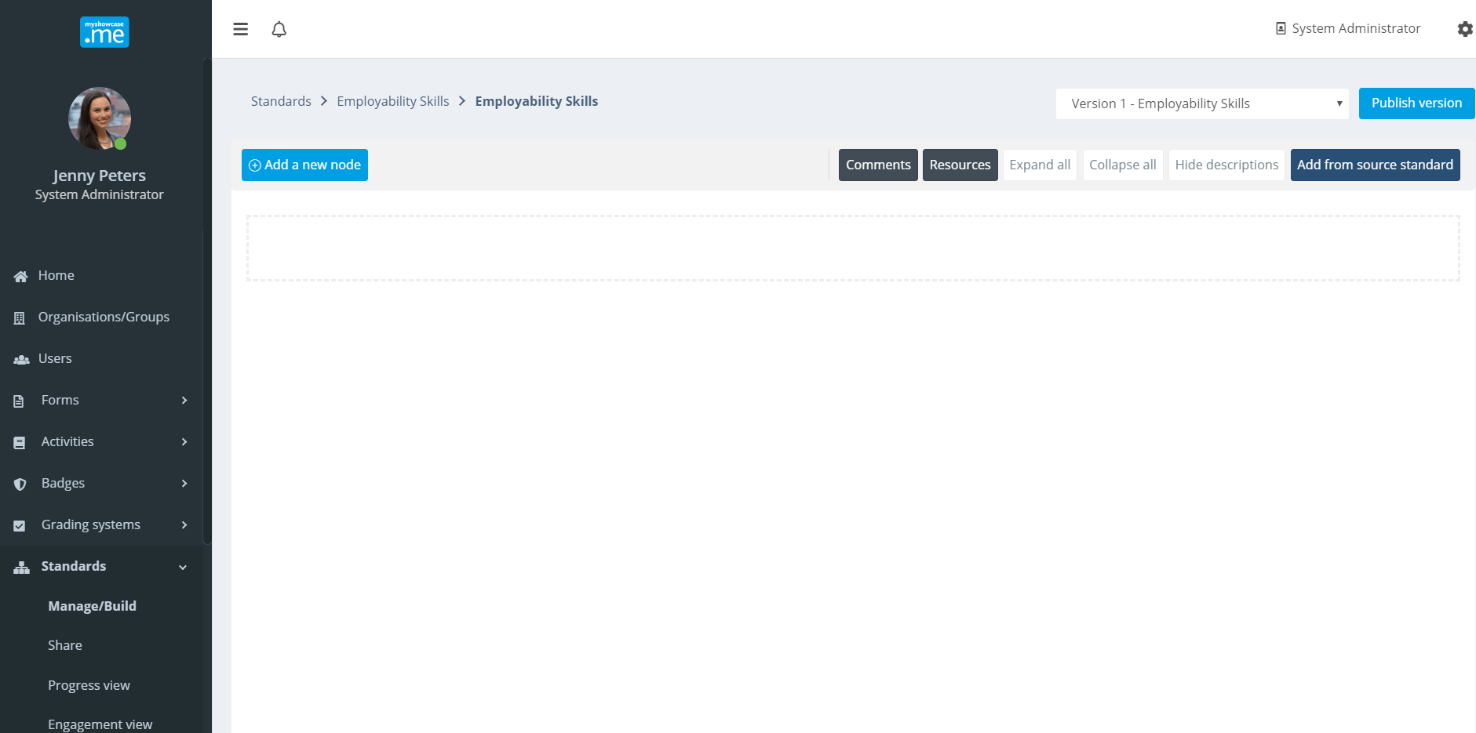

To start adding structure to the standard, the admin first selects the’ Add a new node’ action button.

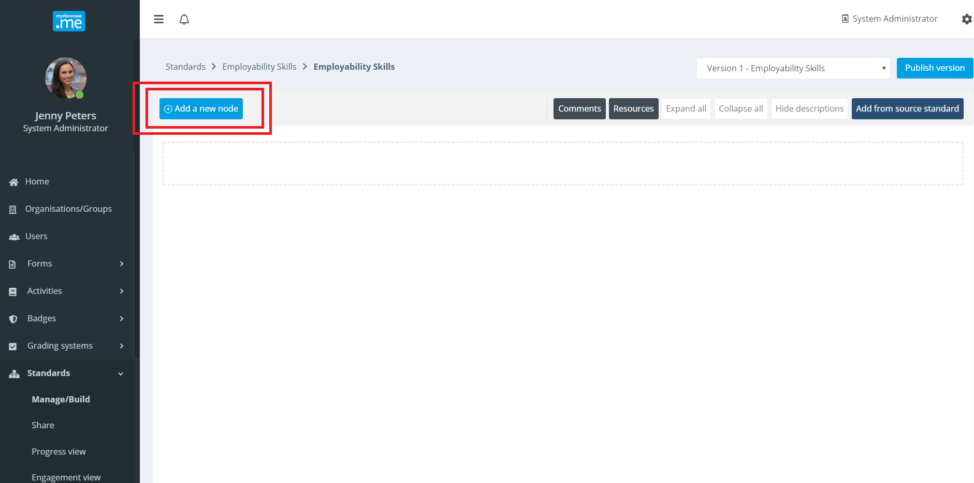
The first node in the standard is set to ‘Thinking critically’.

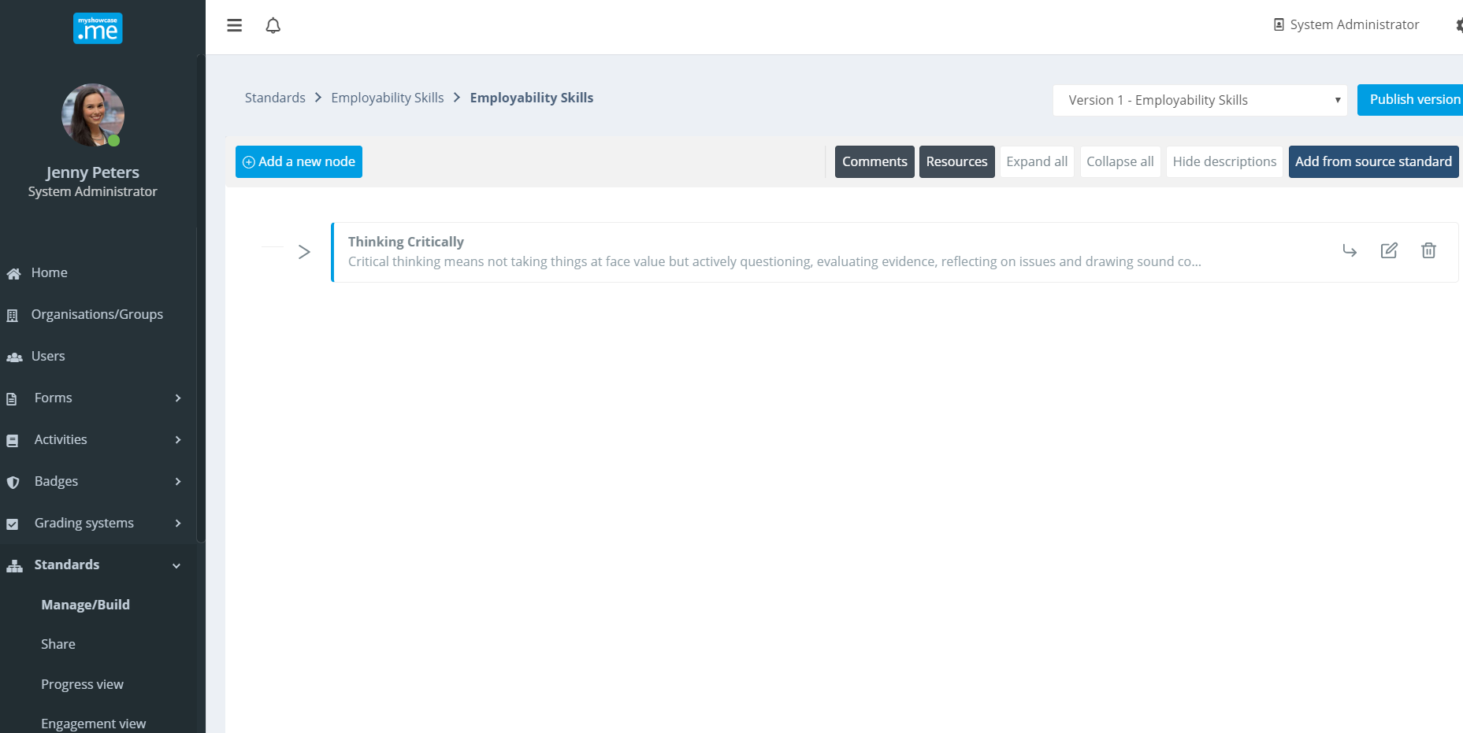
A second node ’Communicating Effectively’ is added.

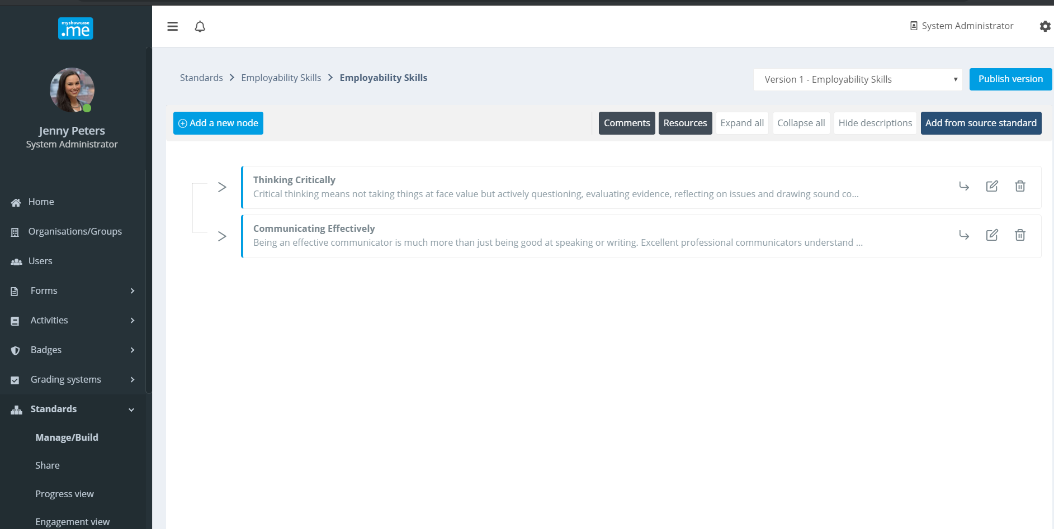
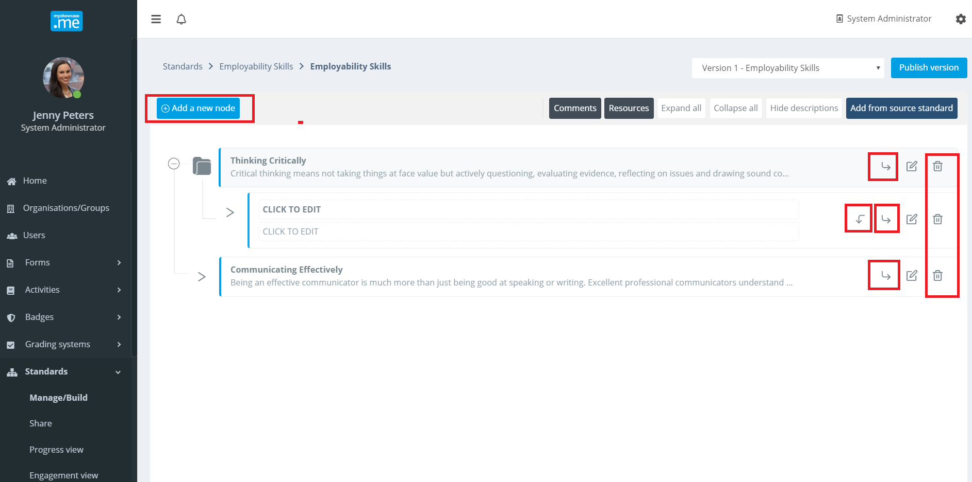
Using the editing options within the user interface, the admin works on creating the structural content of the standard.

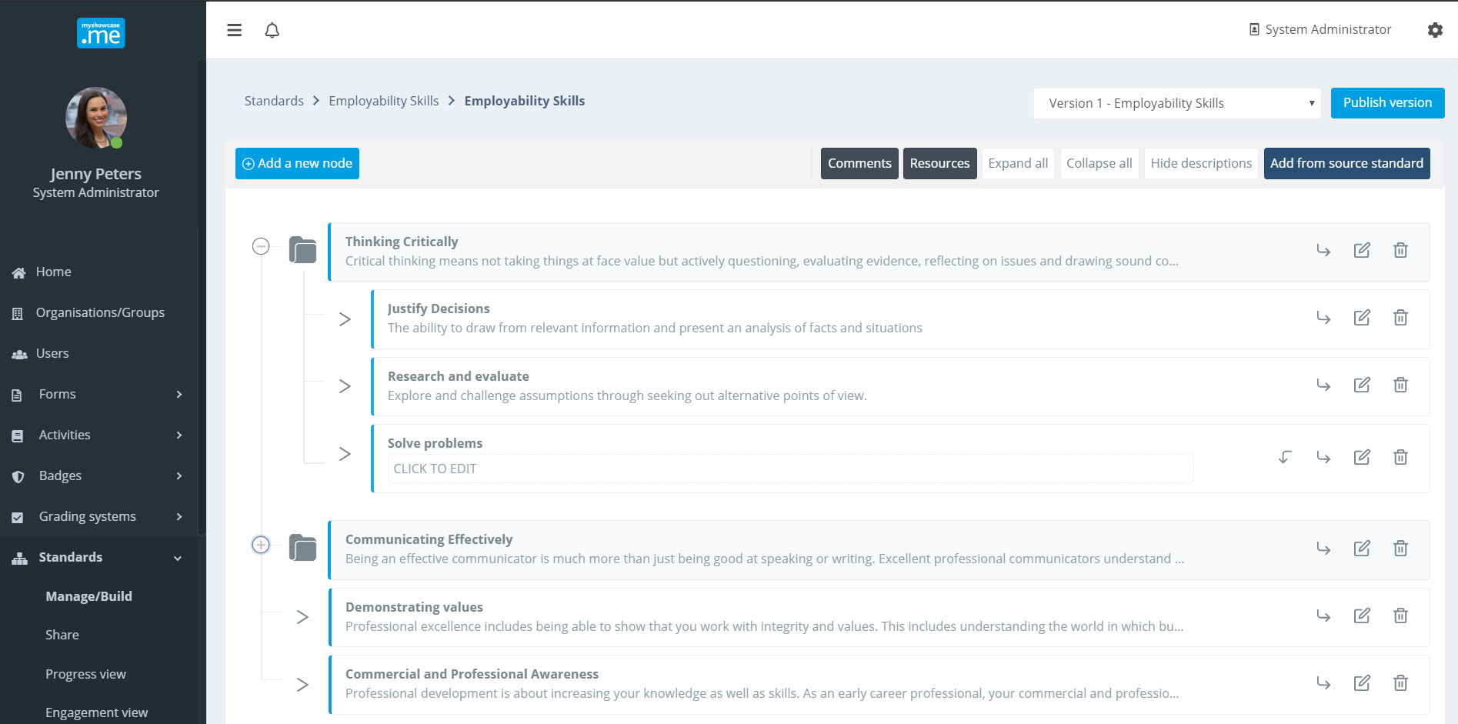

In a short while, a standard can very easily be constructed.
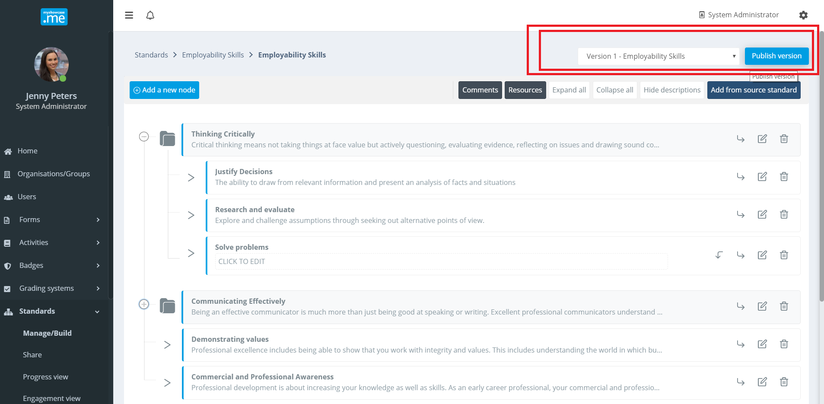
When the admin in is happy with the structure of the standard, they can choose to ‘Publish’ it, creating version 1 of the ‘Employability Skills’ standard.

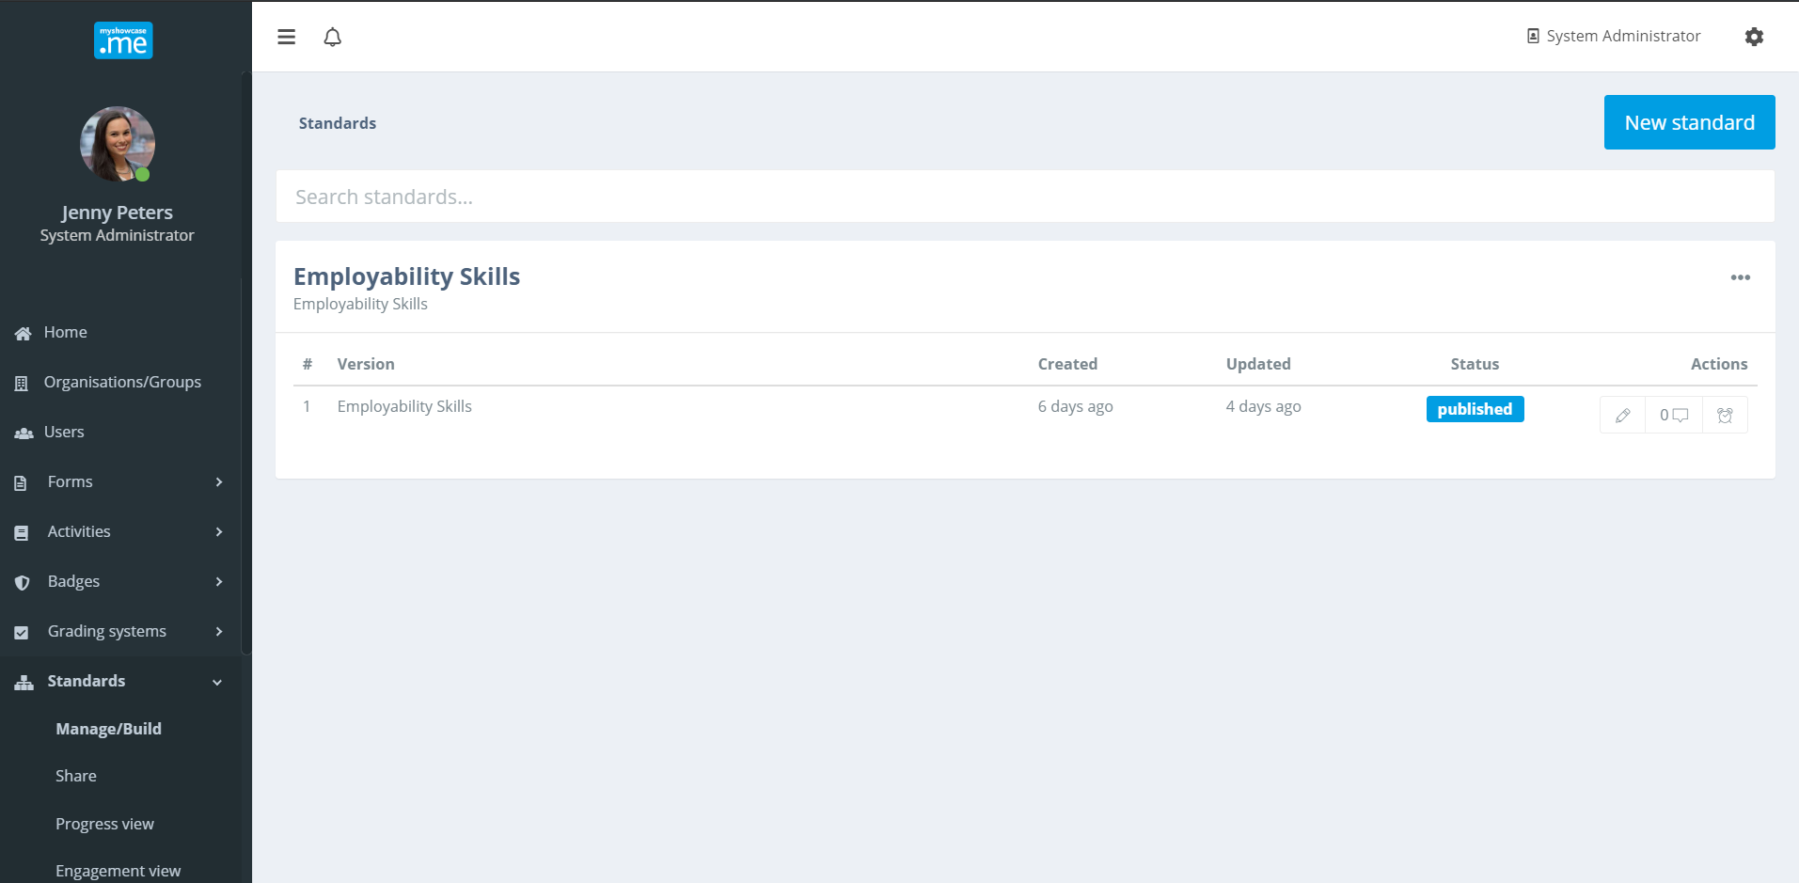

Management options
There are management options that can be used against a published version of the standard: ‘Edit details’, ‘Create version’, and ‘Edit permissions’.

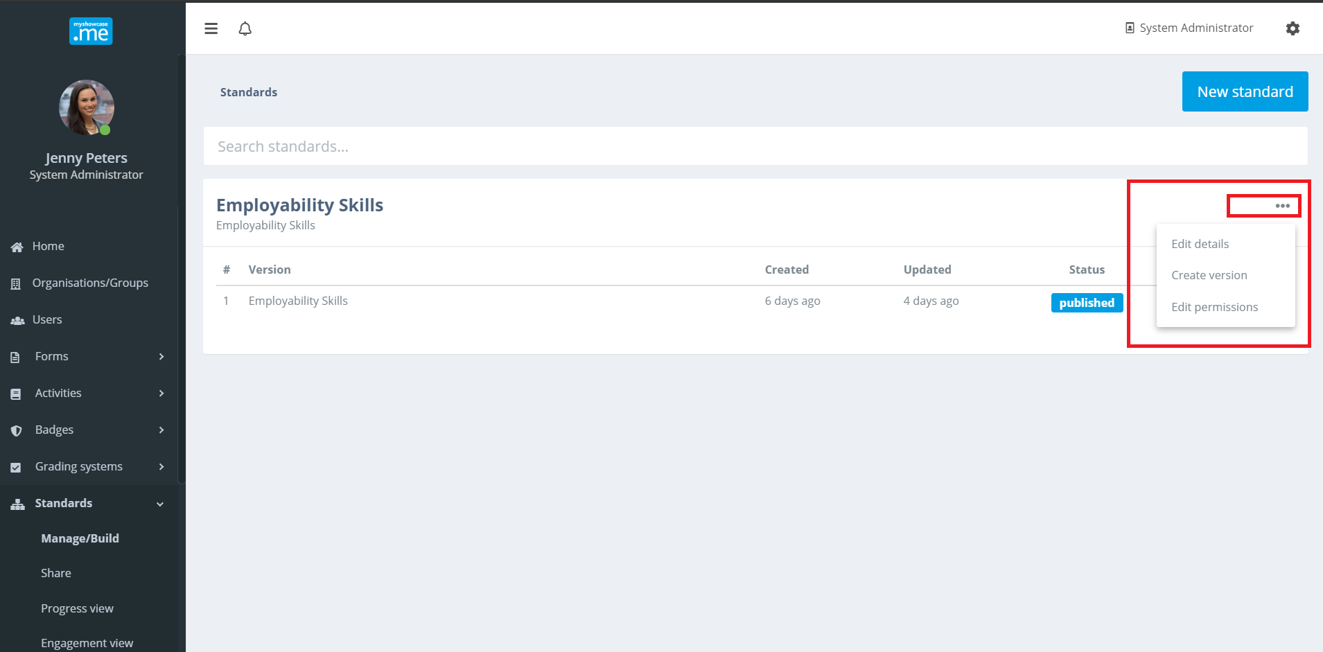
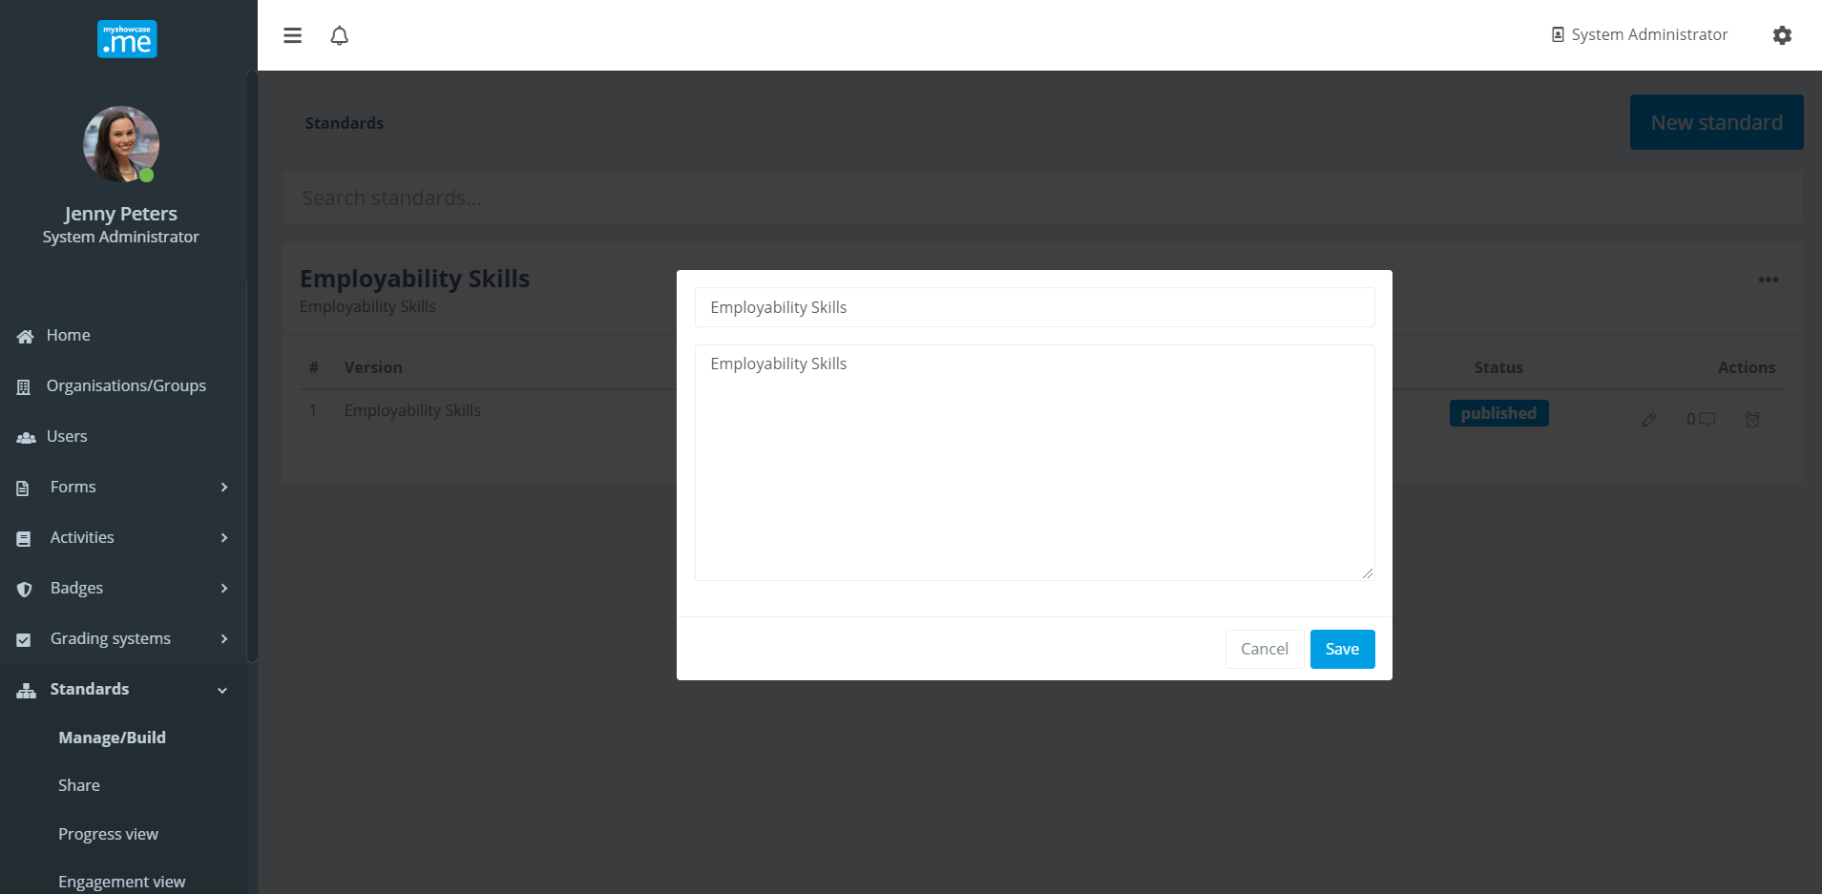
‘Edit details’ allows the admin to maintain and change the standard name and/or description.

‘Edit permissions’ allows the admin to share the management privileges against this standard with admins of other groups or select individual users.
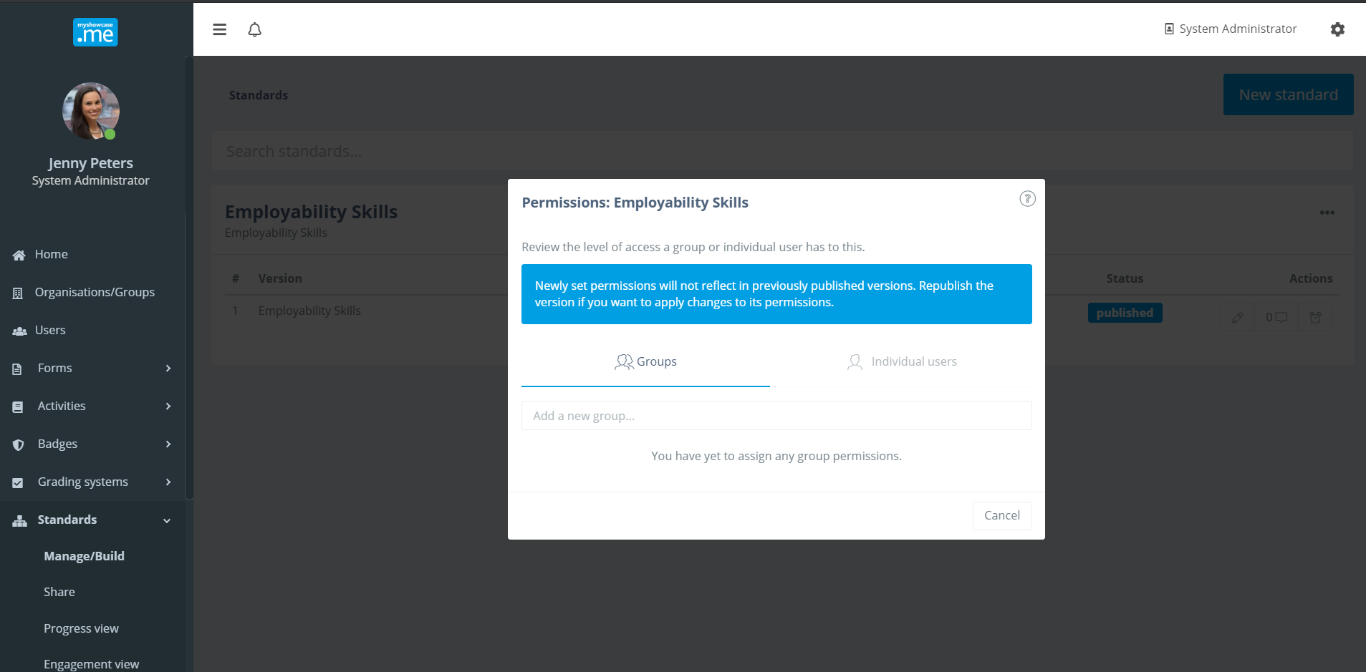
There are different levels of permissions that can be granted: ‘Reader’, ‘Contributor’, ‘Owner’ and ‘Deny’. Different groups and different users can be granted different levels of permission in the management of this ‘Employability Skills’ standard.

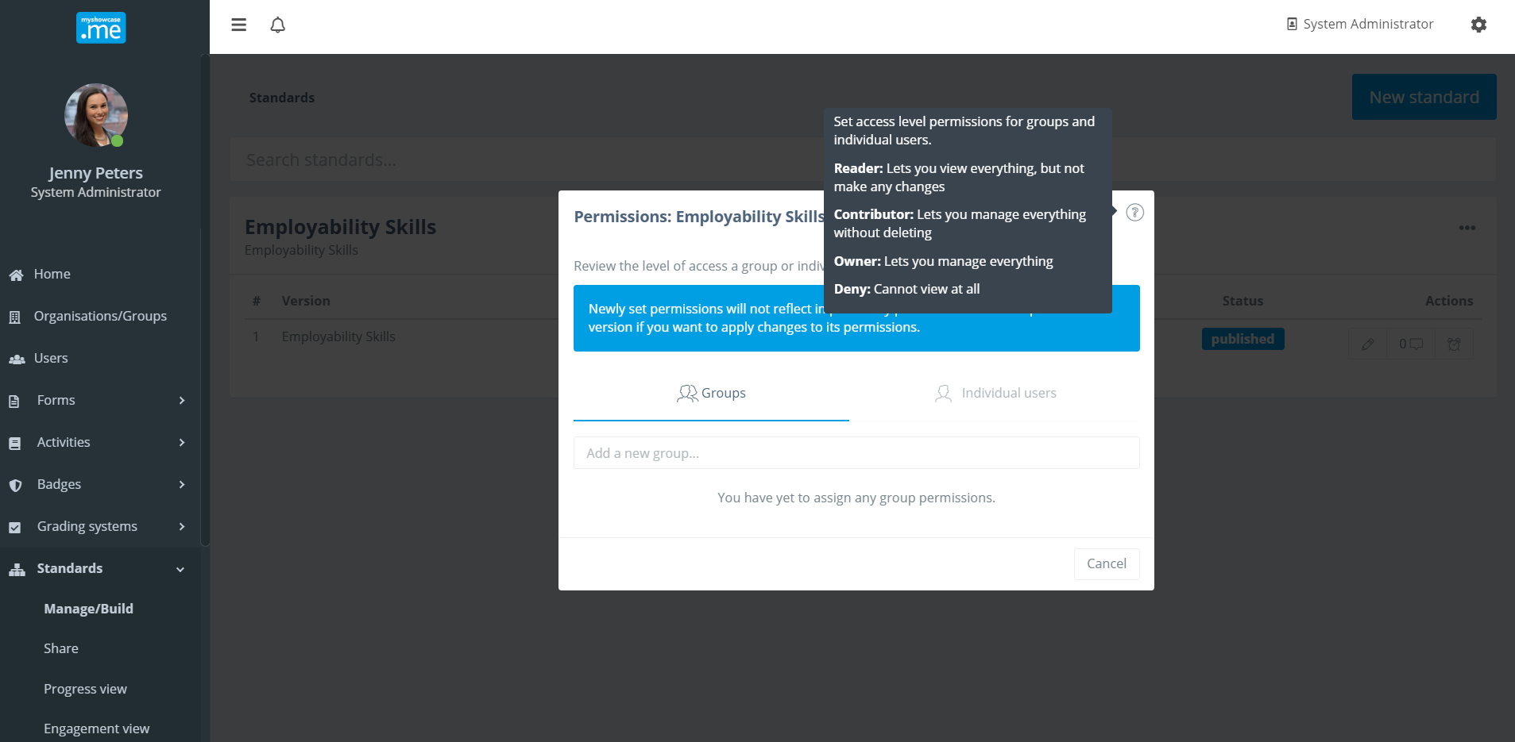

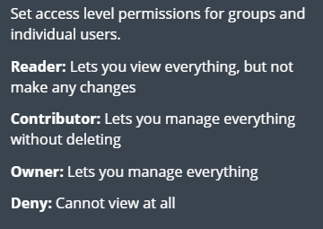

If the admin wants to start to change the structure and content of the standard, they first must create a new version of the standard by selecting the ‘Create version’ option from the actions menu.

The version number increments by one. The previous historical version is retained as a published read only version of the standard, that can be used if required throughout the organisations Myshowcase.me space.

The new version has a status of ‘Draft’ while it is being worked on. New nodes may be added. Nodes removed or restructured. As this goes on the new version, version 2 in this case, will have a status of ‘Draft’.

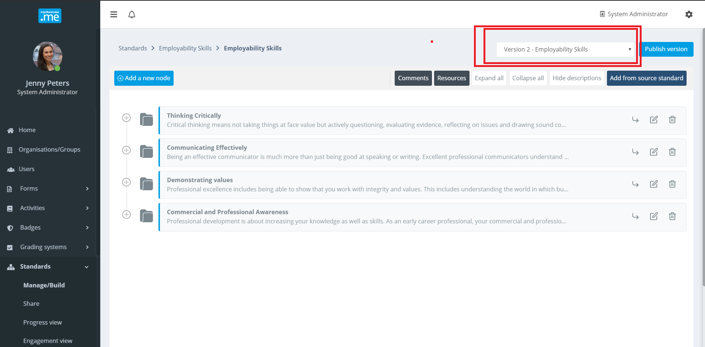

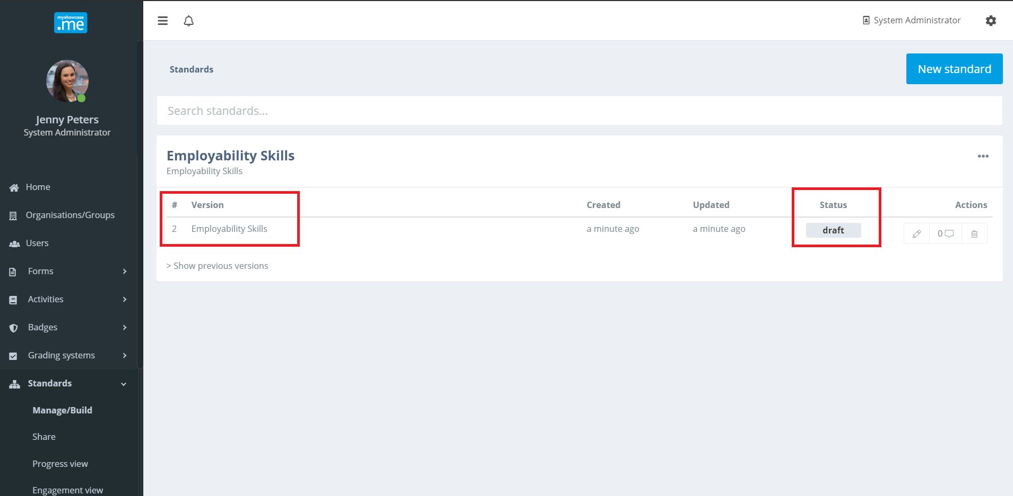

All previous version of the standard can be reviewed.

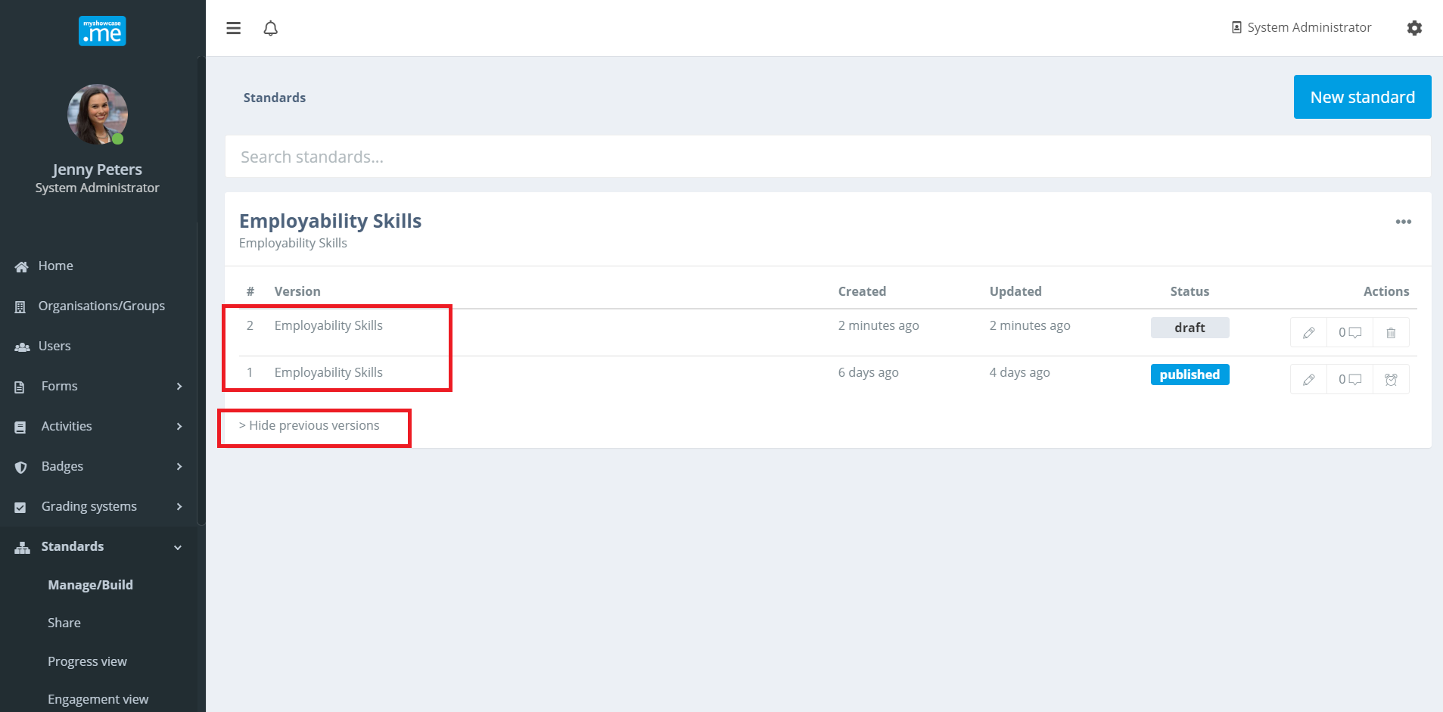

Comments and Resources

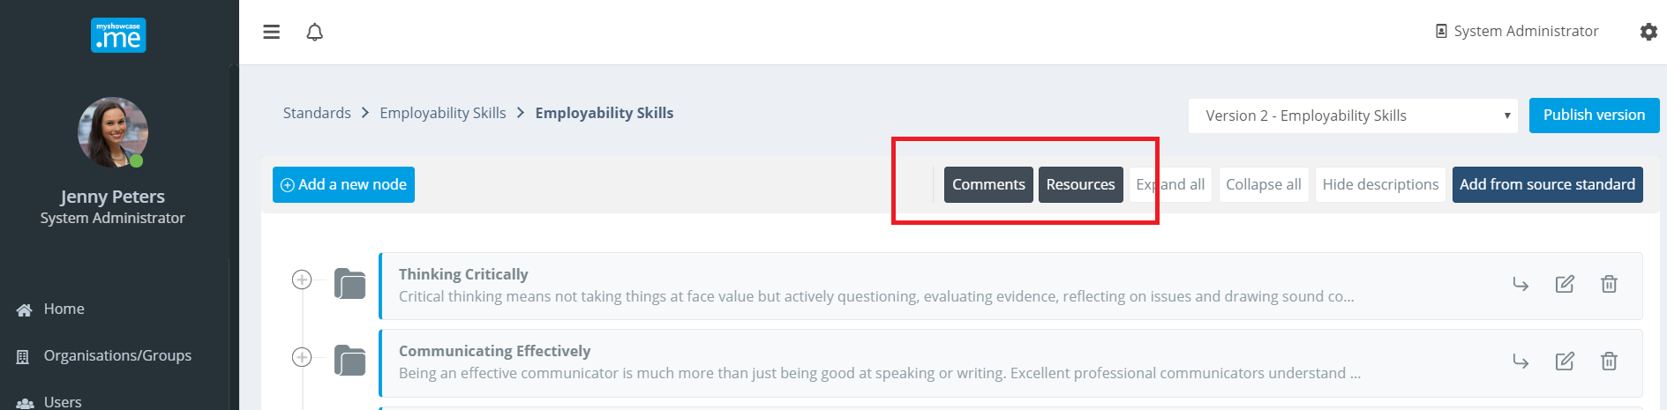

Resources can be added to the standard against any of its nodes.

Any number of files, of any type, can be scattered around the standard helping to explain parts of the standard or possibly instruct the user on how to work with the standard.

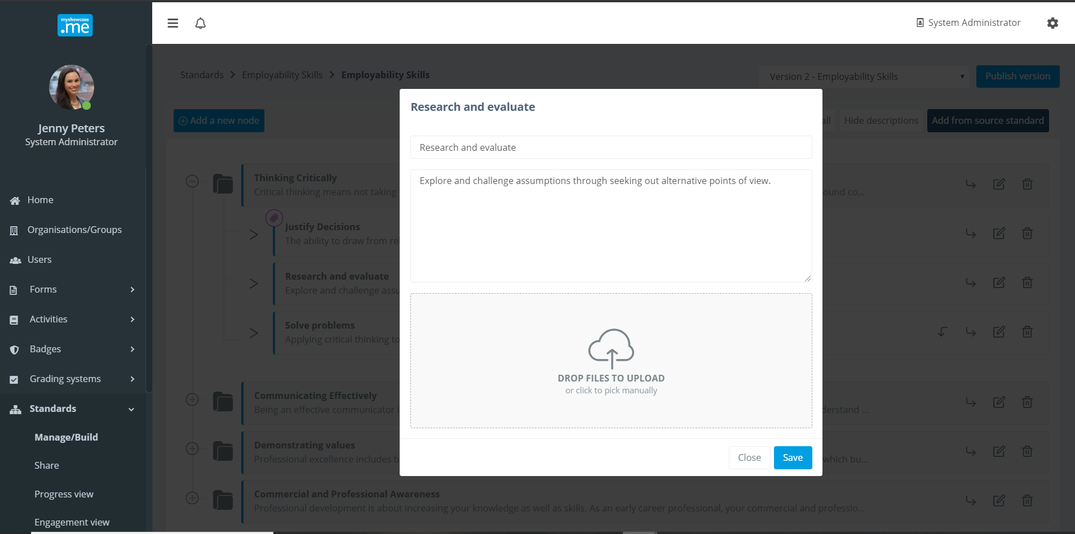

Any node containing files, is signposted with the attached file/resource icon.

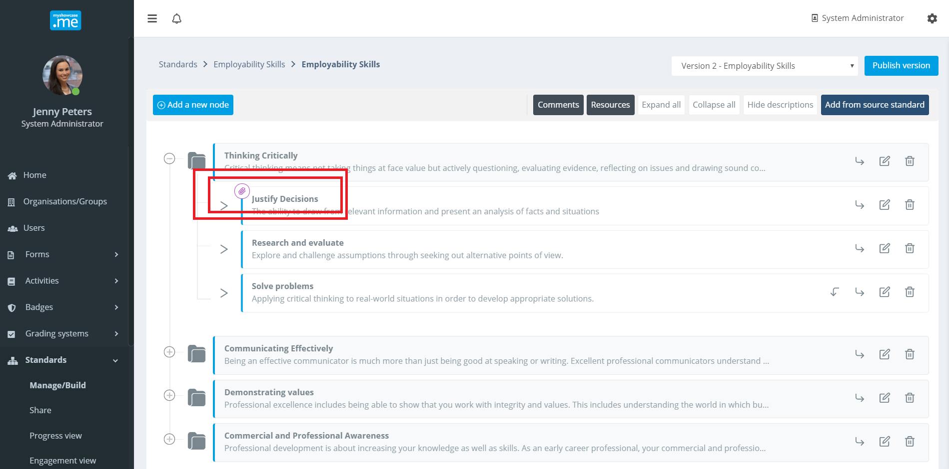

While any version is being worked on, the admin can add comments to the version explaining what they are changing and why. These comments can act as an audit log. Additionally, if more than one person has permission to ‘Contribute’ to the development of the standard, the comments provide a way to record what each admin has done. It can act as a messaging tool.

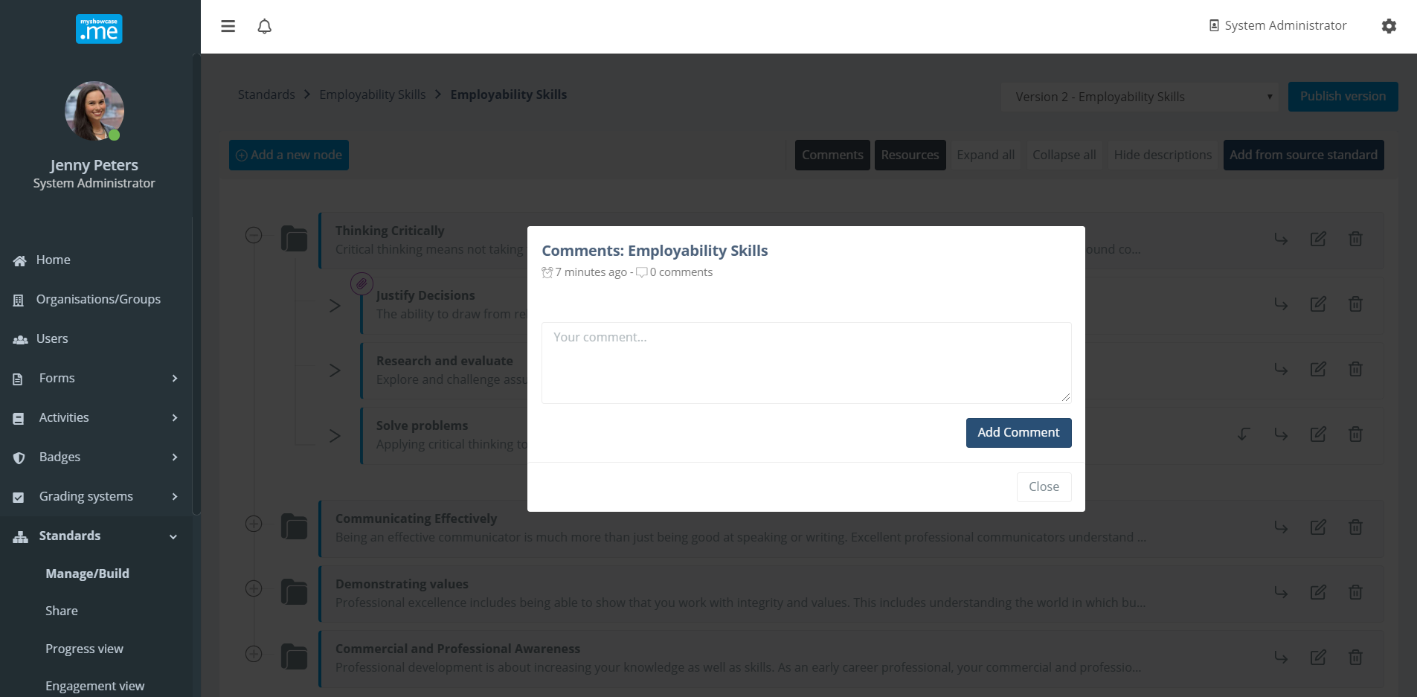

Sharing standards
Once standards have been published, they can be shared with groups of users to work with. These users may be students, learners, employees, apprentices, tutors, managers …etc Basically any group of people that would benefit from, or are required to, work with a standard.

The ‘Share’ functionality can be found under the ‘Standards’ admin menu item.
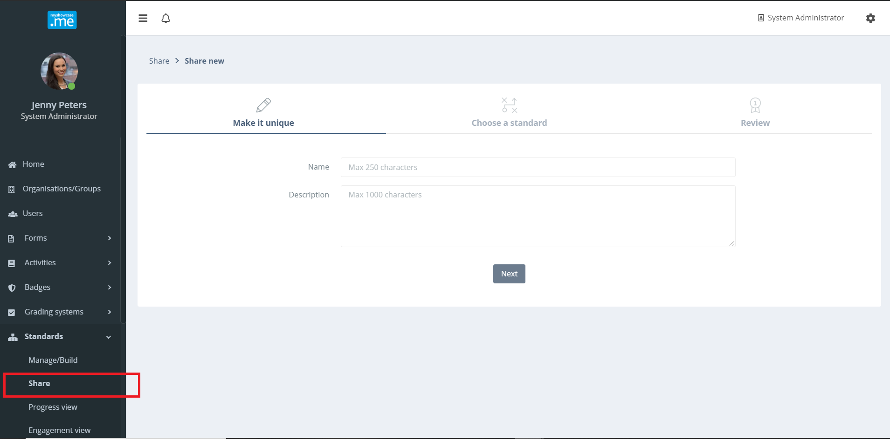
The standard is shared with groups within a delivery entity named a ‘Progress View’. Initially, progress views are going to be relatively simple, with only two flavours: without a Grading Scheme, and with a Grading Scheme. The Grading Scheme lays over the standard, allowing authorised admins to mark and grade user and group progress against a standard.

Progress Views that use the Grading Scheme option are dealt with separately later in this document. For now, we are only talking about Progress Views that contain a published standard and no associated Grading Scheme.

Each Progress View is given a name, typically the name of the standard, though not always.
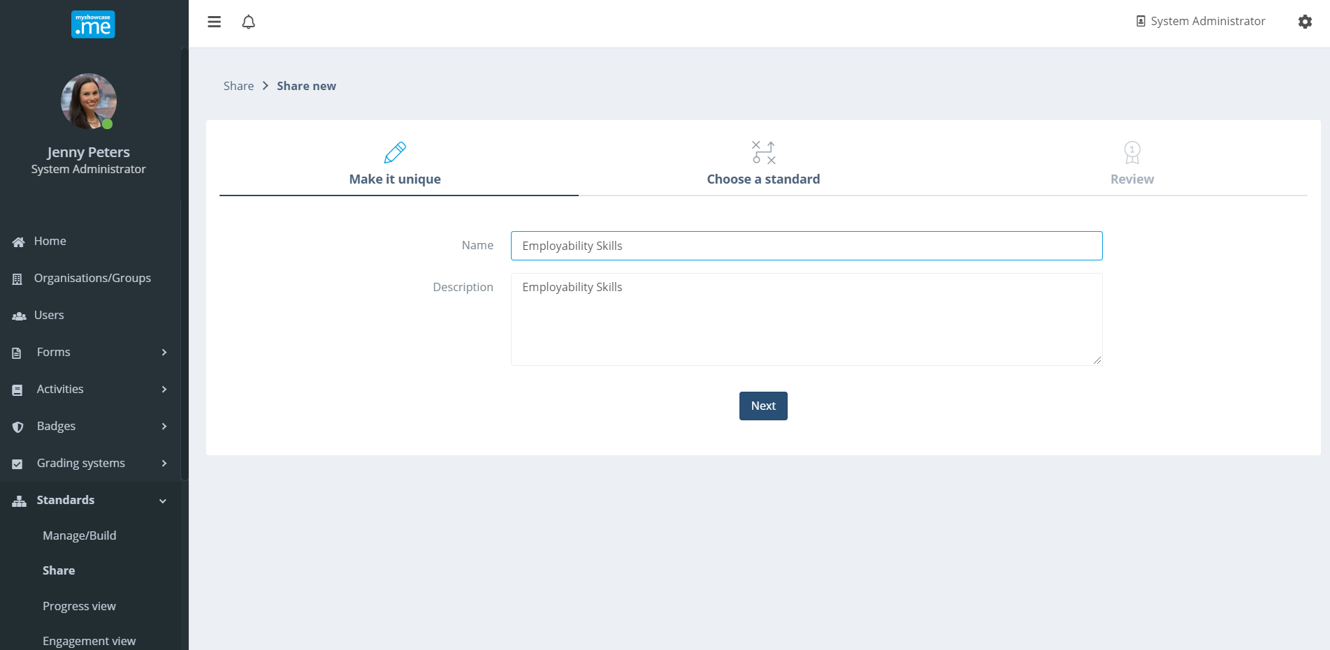

The admin selects the standard to be included in the Progress View. They have the option to select any version of any standard they have access to.

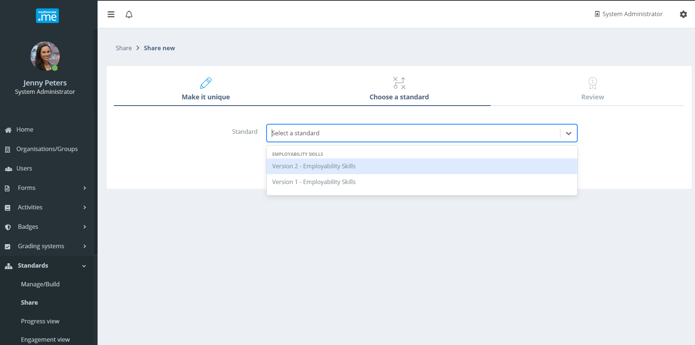
After selecting the standard to include, the detail of the Progress View is presented for review. As mentioned, as Progress Views mature the level of detail and content within Progress Views will grow. This is very much the base version.

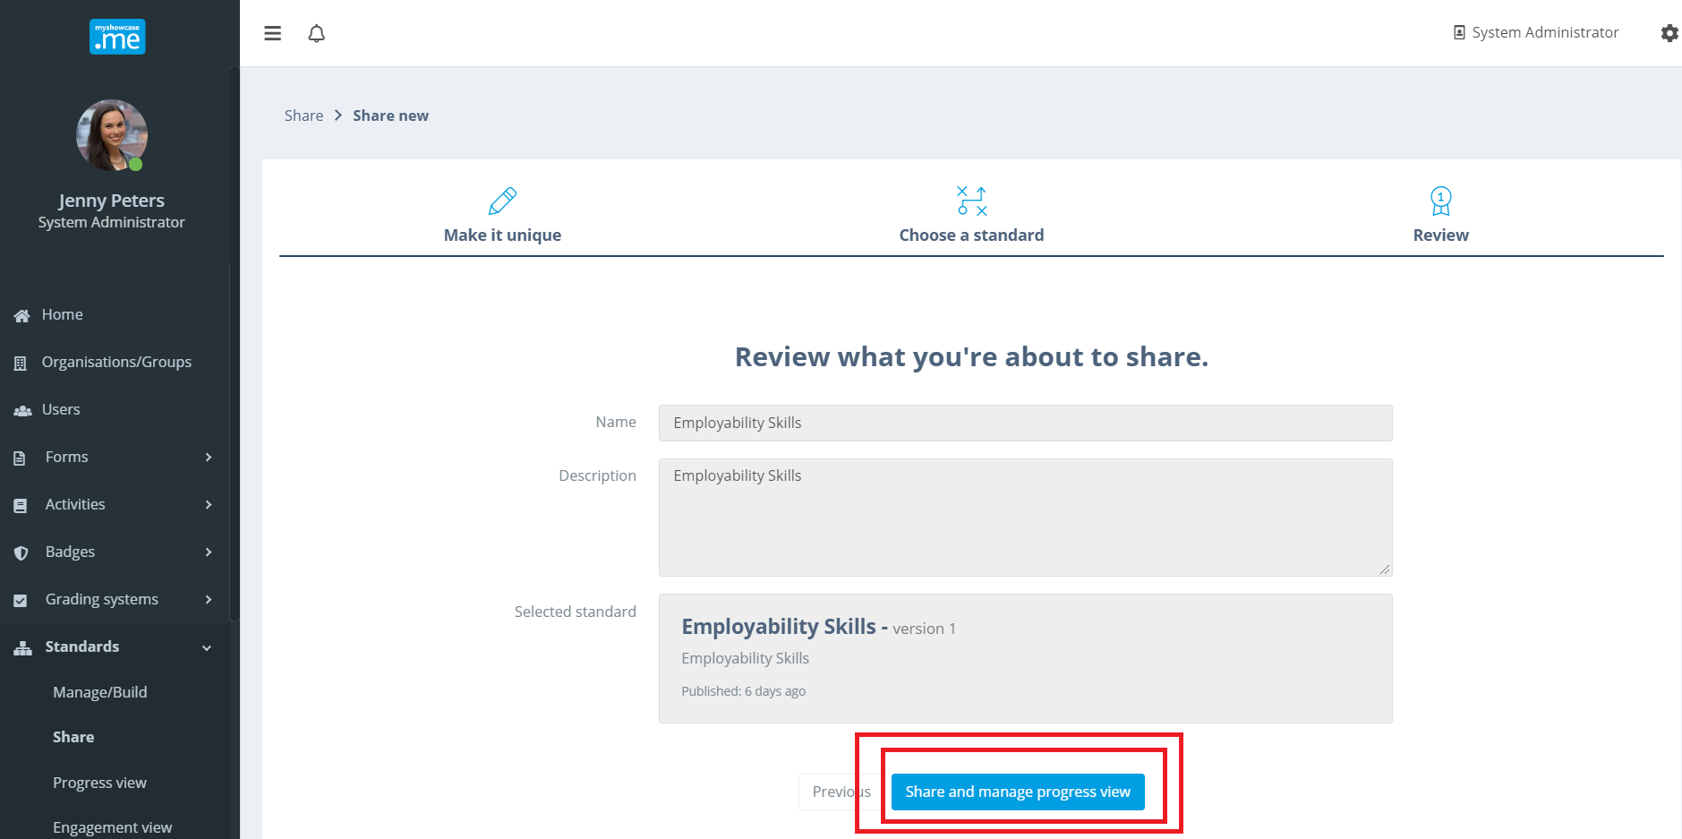

If happy with everything, the admin can them choose to ‘Share’ the Progress View with users and groups.
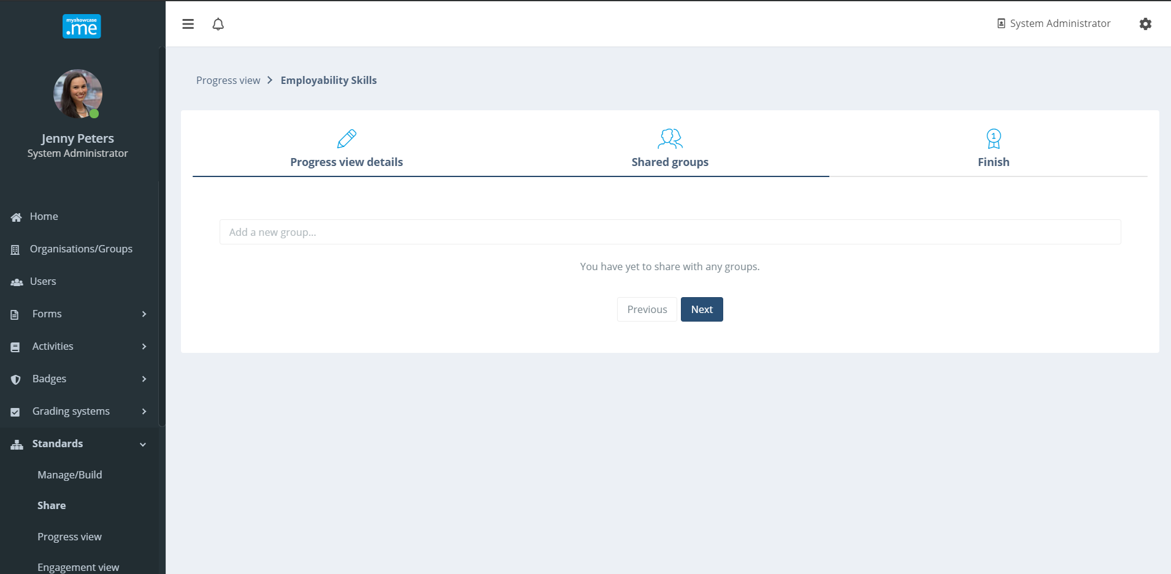

The Progress View can be shared with any number of groups before it is finally published. Once published, users within the selected linked groups will have the Progress View to work against within their personal Myshowcase.me ePortfolio space.

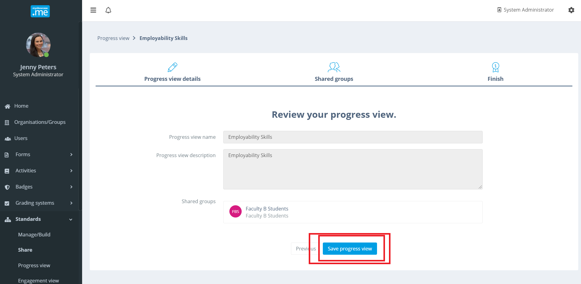

Progress Views
All published Progress Views an admin has permissions to see and mange are listed for them within the ‘Progress Views’ area, located under the ‘Standard’ admin menu item.

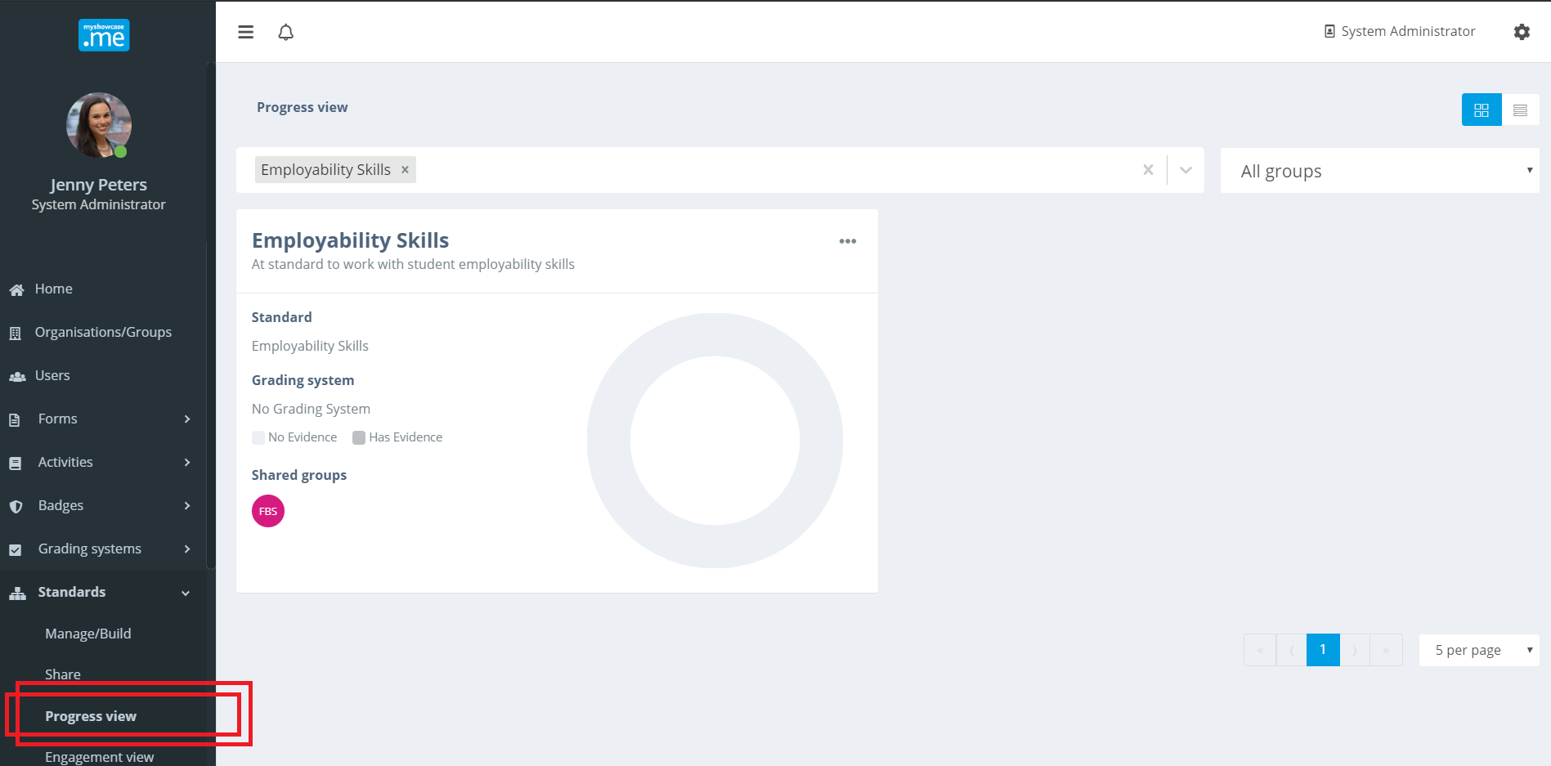
The Progress View displays the standard it contains in an interactive chart.

Clicking the Progress View will present all the individual users, extracted from the shared groups, who are now working with that Progress View.
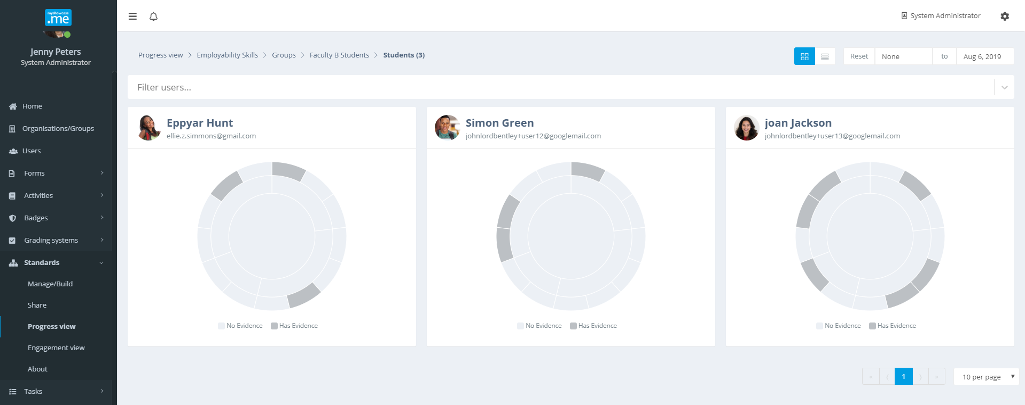

Clicking the on an individual users Progress View will present the it in greater detail, focusing solely on that individuals use of the Progress View. Potentially, an individual user may have mapped evidence of knowledge, skills, behaviours, achievement and experience stored within their Myshowcase.me account against the standard found within the Progress View. Additionally, they may have added thoughts and reflection against the standard.

Authorised admins can view most, not all, of the content a user puts against the Progress View’s standard (excludes users private reflections and comments). They can evaluate how the user is doing against the standard, offering feedback and guidance back to the user.
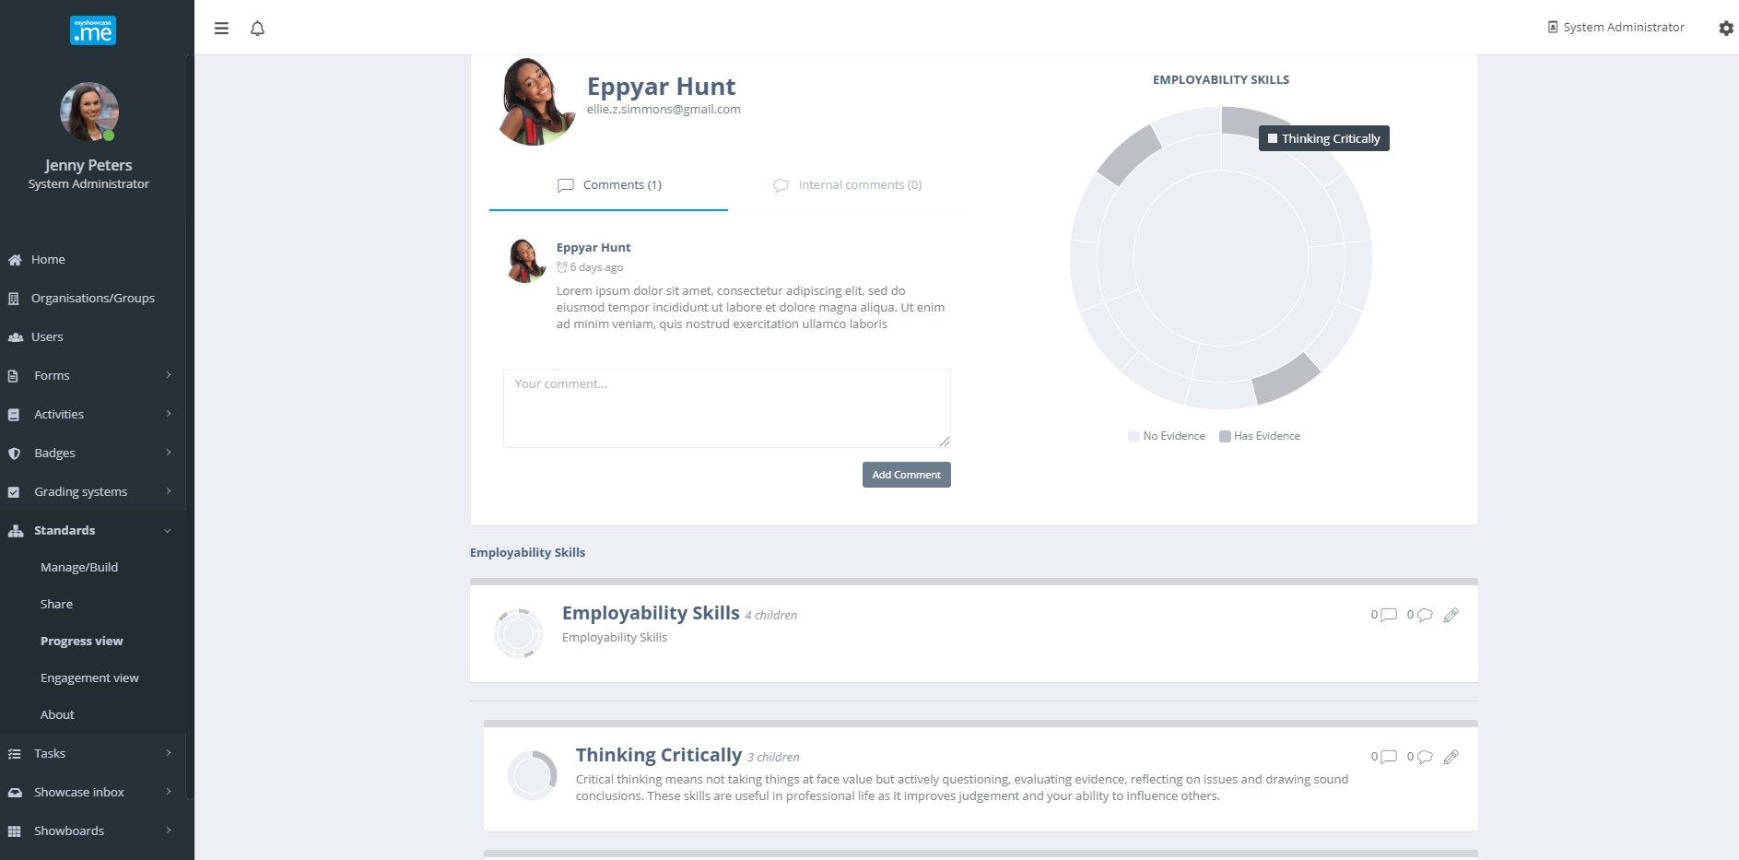
The admin can navigate around the Progress View through clicking on the interactive chart or by selecting areas of the Progress View explicitly listed below the chart.

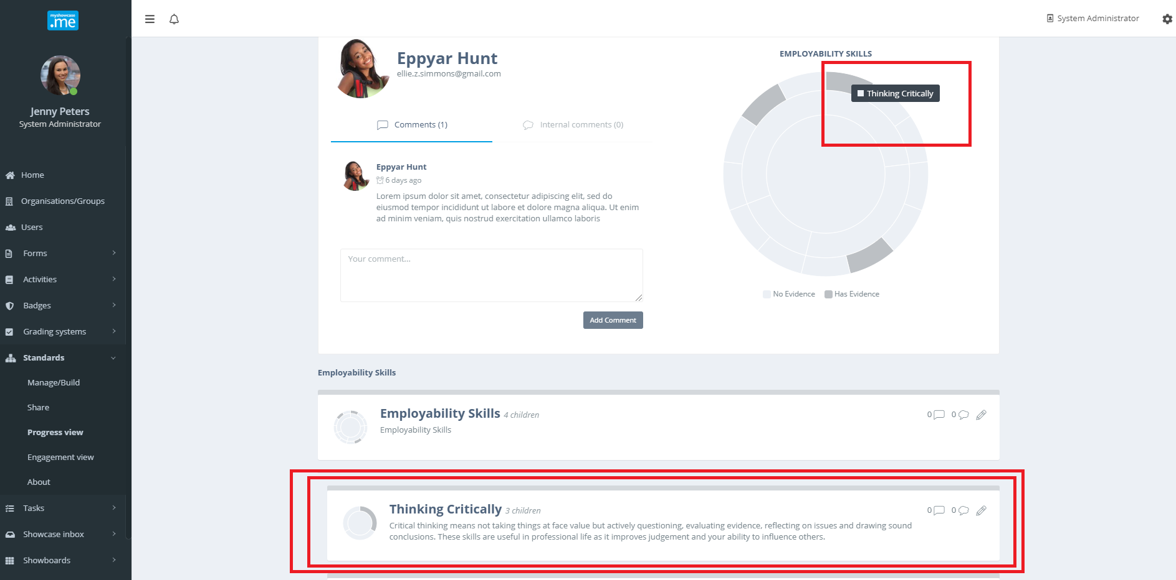

In the example below, the admin is reviewing an area about justifying decisions. Two pieces of evidence have been mapped here by the user.

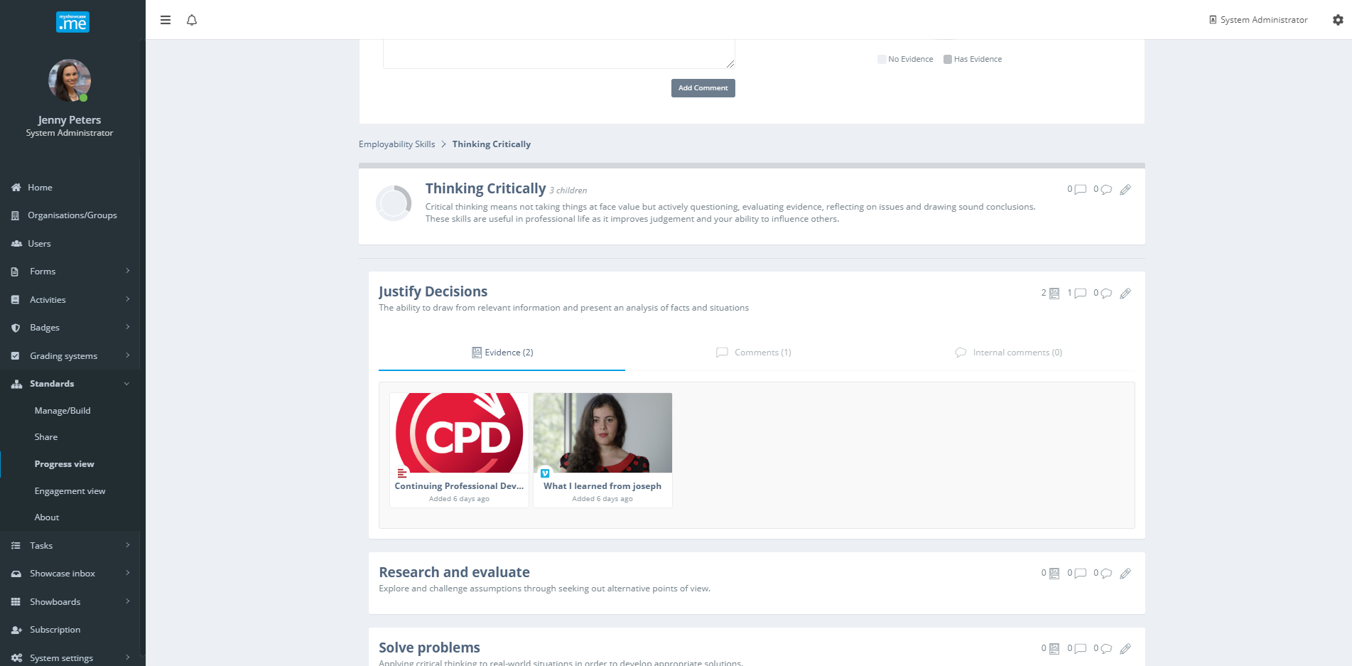

The admin can review the evidence that has been mapped, by hovering over the item and selecting the view icon. The evidence is interactive. Video can be watched. Audio can be listened to. Files can be opened.

Any public comments the user added to the item, possibly explaining why they mapped the item here, can be read by the authorised admin. They are public comments. They cannot see any private reflections the user may have added.

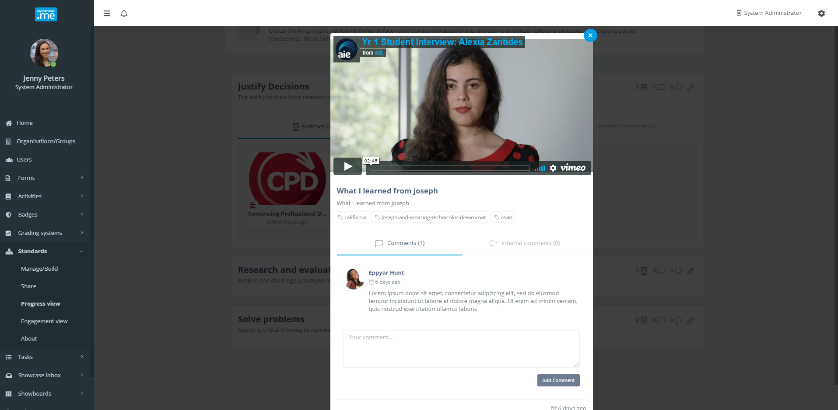

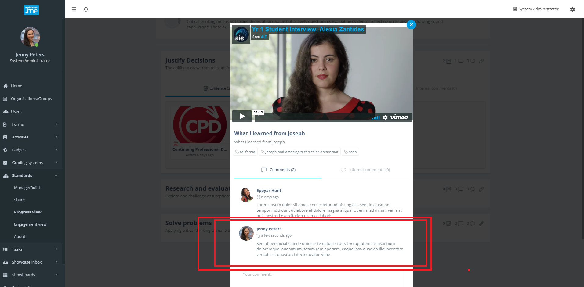
The admin can respond to any public annotations the user may have included, by adding some comments and feedback of their own to the item.

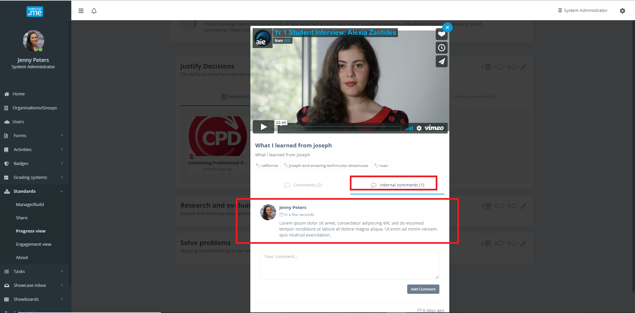
In addition, the admin can add internal comments to the item. These are comments and notes shared between the authorised admins who work with this user and their Progress Views. The user cannot see them. They are private to just the authorised administrators.
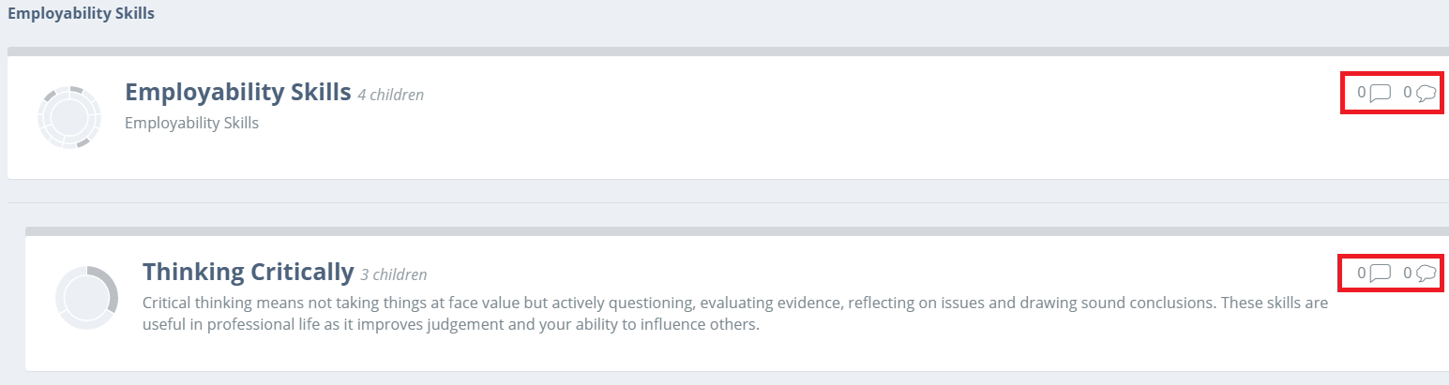

The admin can add public comment the user can see and respond to or private internal comments only administrators can see at any place within the Progress View that displays the public comment or internal comment icons.

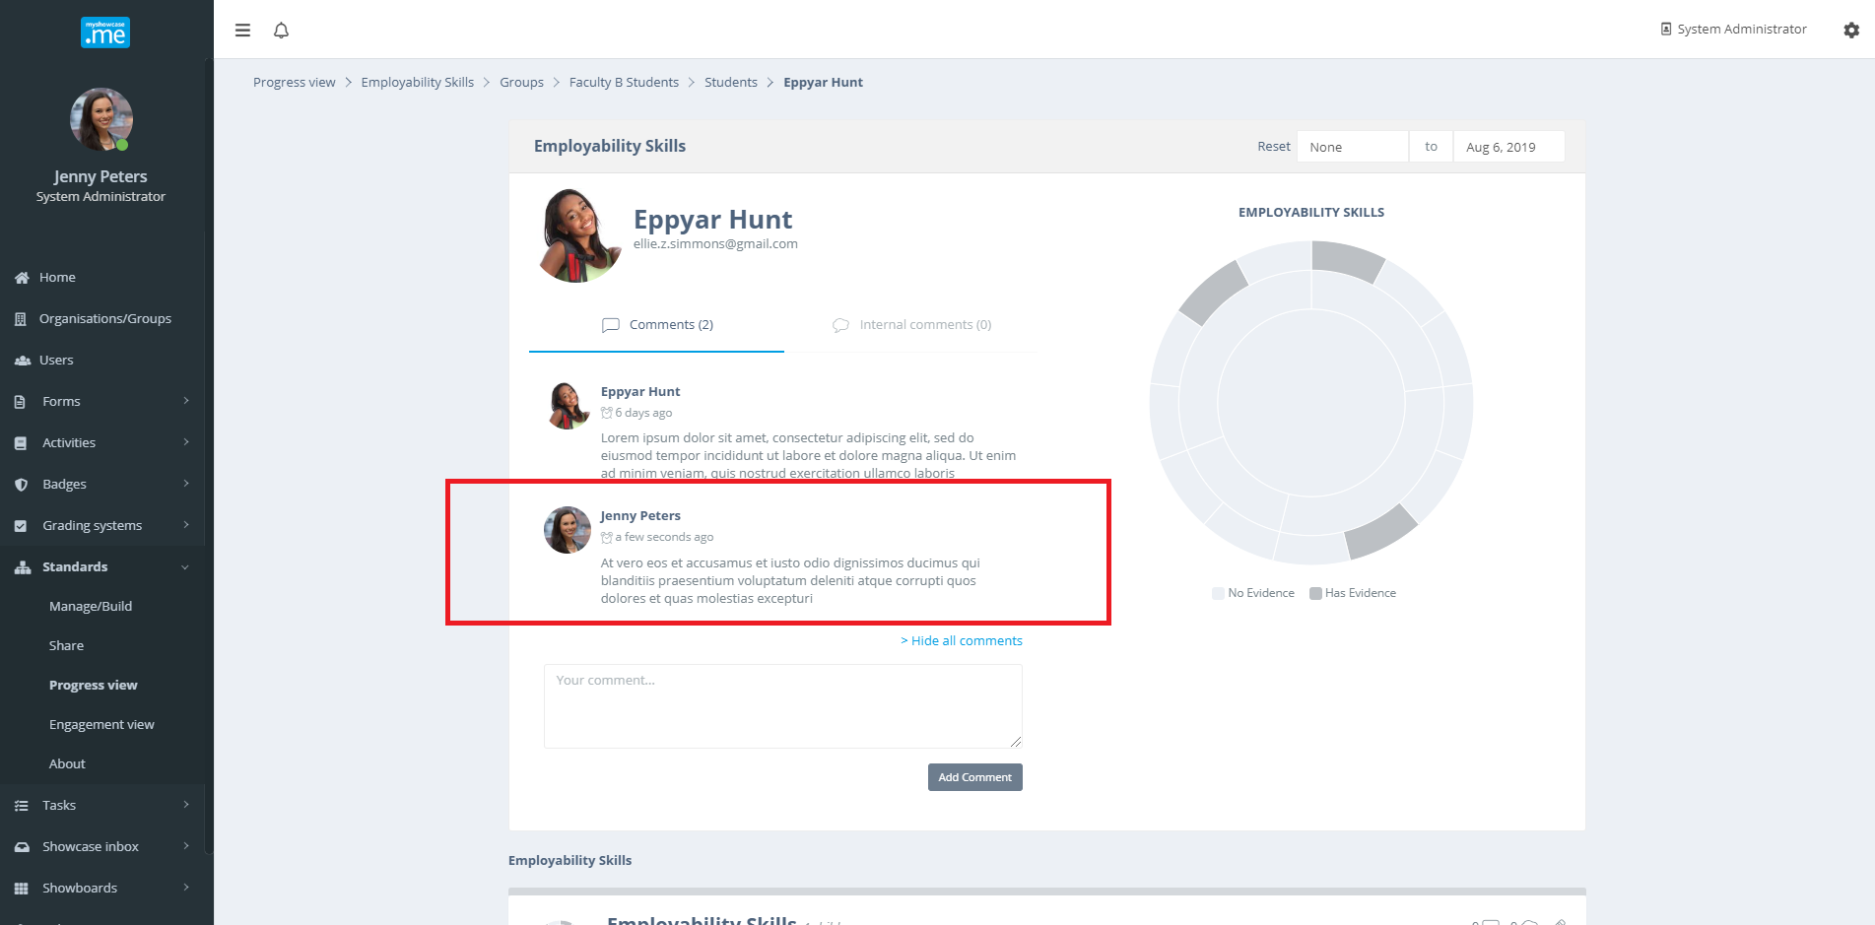

Personal user: Working with Progress Views (Standards)
If a Progress View has been shared with a personal user, possibly a student, learner, apprentice or employee, a Progress View menu option will appear on the Myshowcase.me menu bar. In the example below, selecting the Progress View menu item shows that this user is working with two Progress Views that have been shared with them.

A user can work with any number of Progress Views.

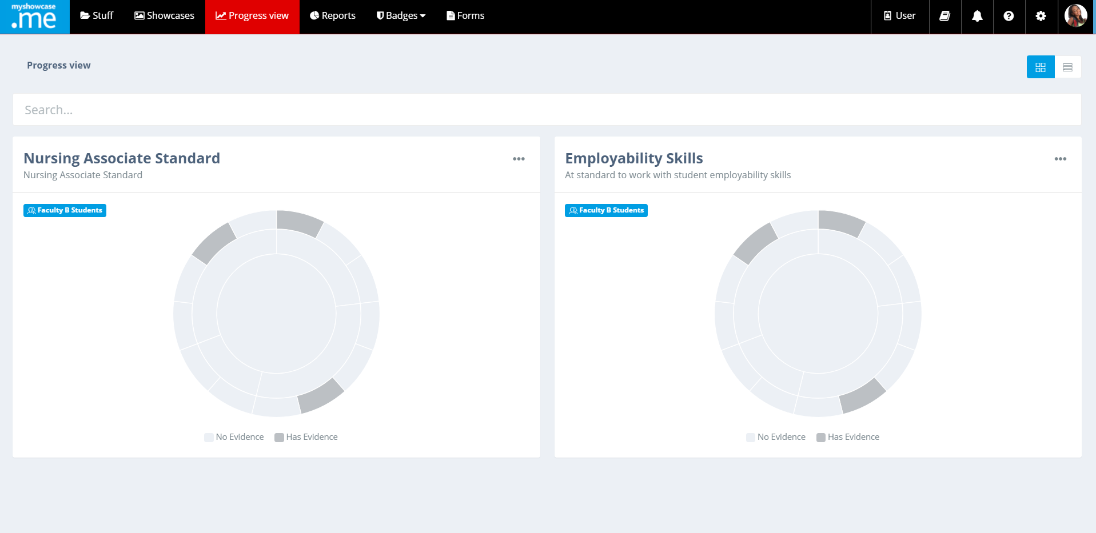

Clicking on one of the Progress Views will display it in far greater detail and user can begin to interact and work with it. In the example below, the user chose to work with the ‘Employability Skills’ Progress View.

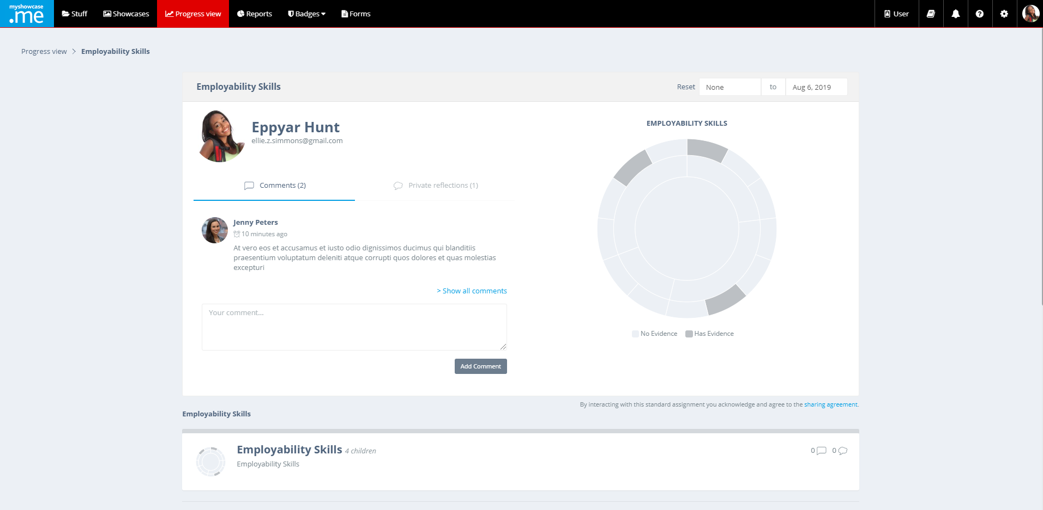

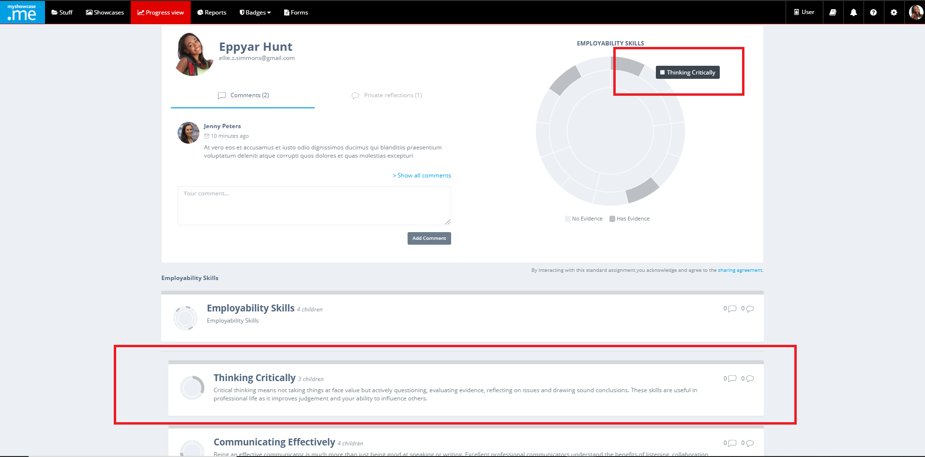

The personal user can navigate around the Progress View through clicking on the interactive chart or by selecting areas of the Progress View explicitly listed below the chart. In this instance, the user has chosen to work with an area named ‘Research and evaluate’.

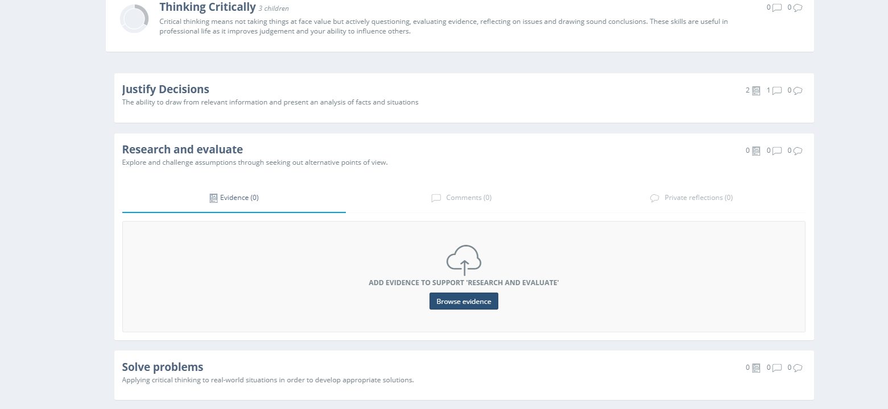

The personal user can map evidence of knowledge, skills, behaviours, achievements or experience this area. Clicking on the ‘Browse evidence’ icon provides a visual listing of all their content found in the Myshowcase.me ‘Stuff’ area.

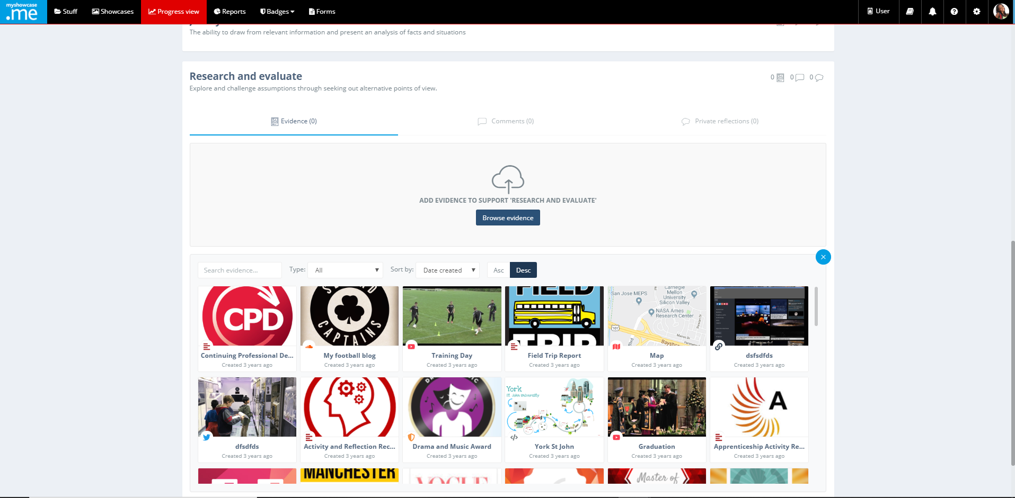

When the user hovers over one of the displayed items, they have the option to review it or map it to the area of the Progress View currently being displayed.
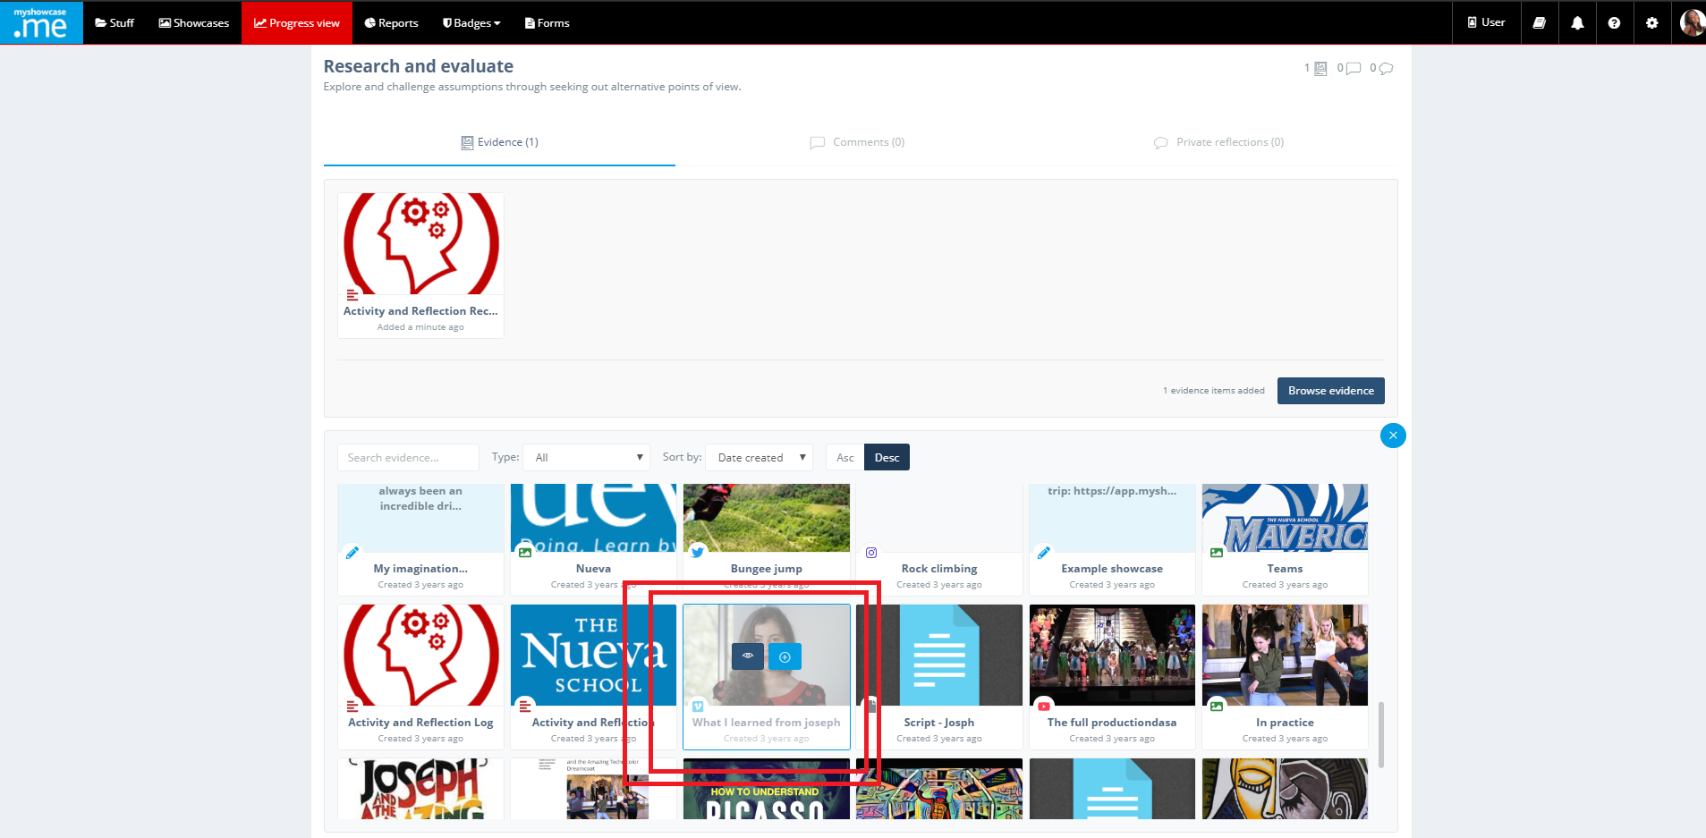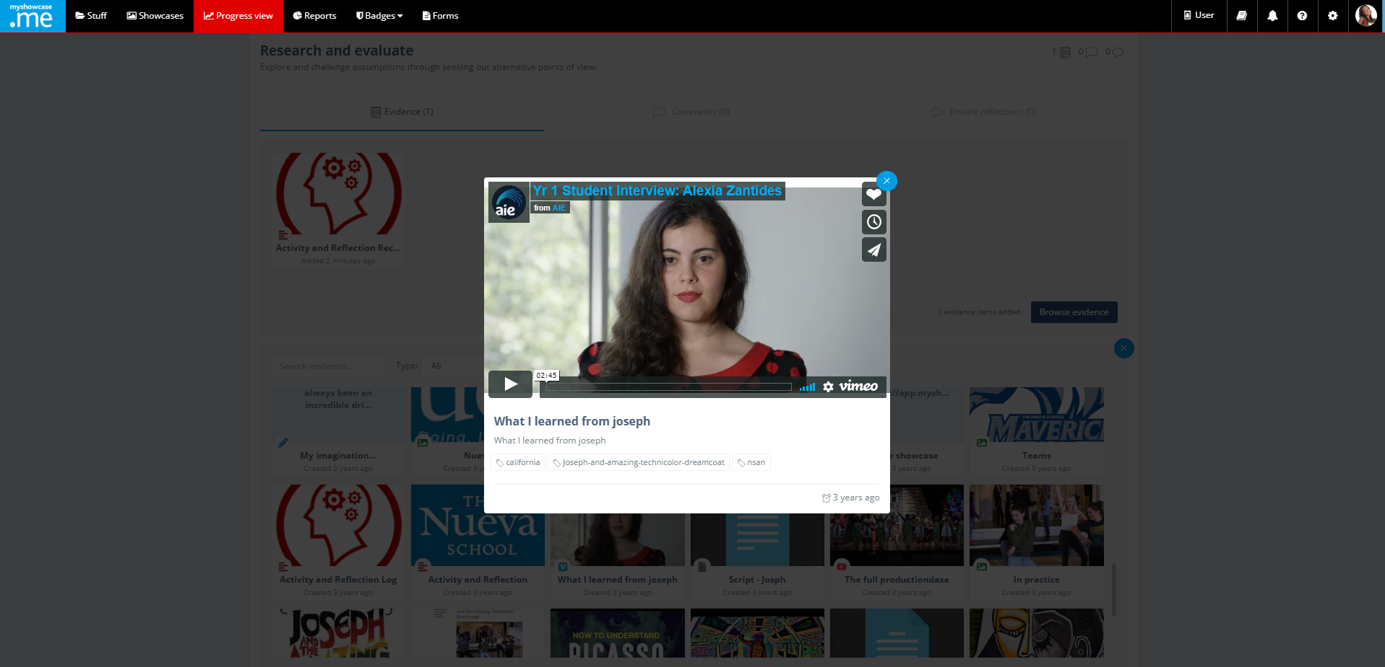
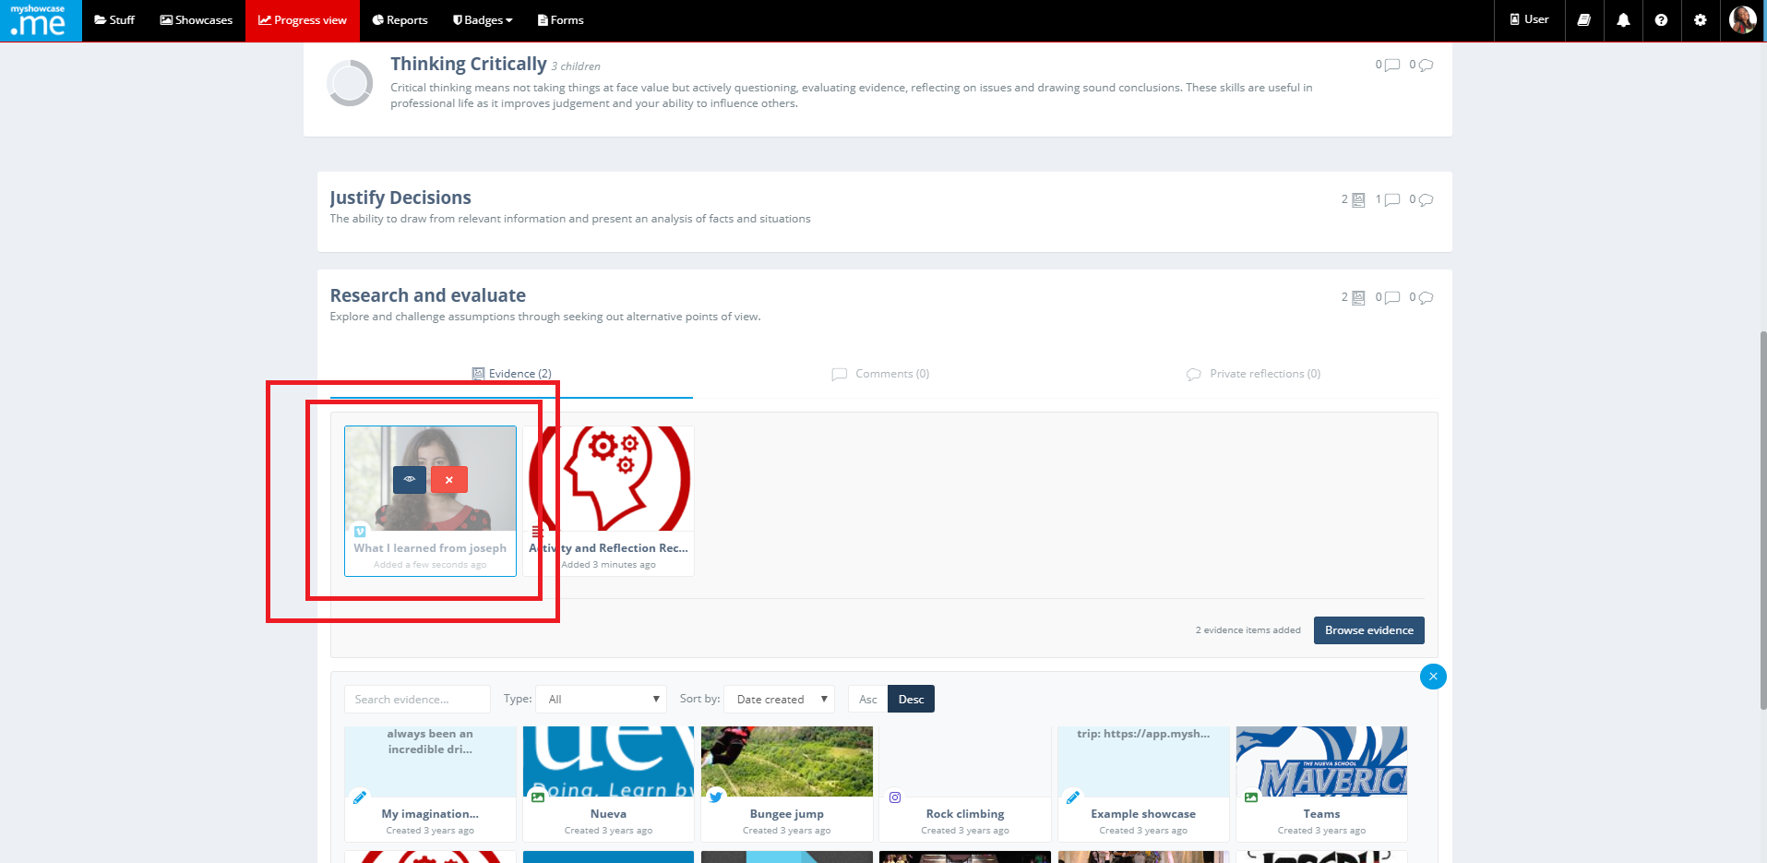
After the item has been mapped against the Progress View, it can be removed at any point, or it can be viewed and annotated with comments and/or private reflections.
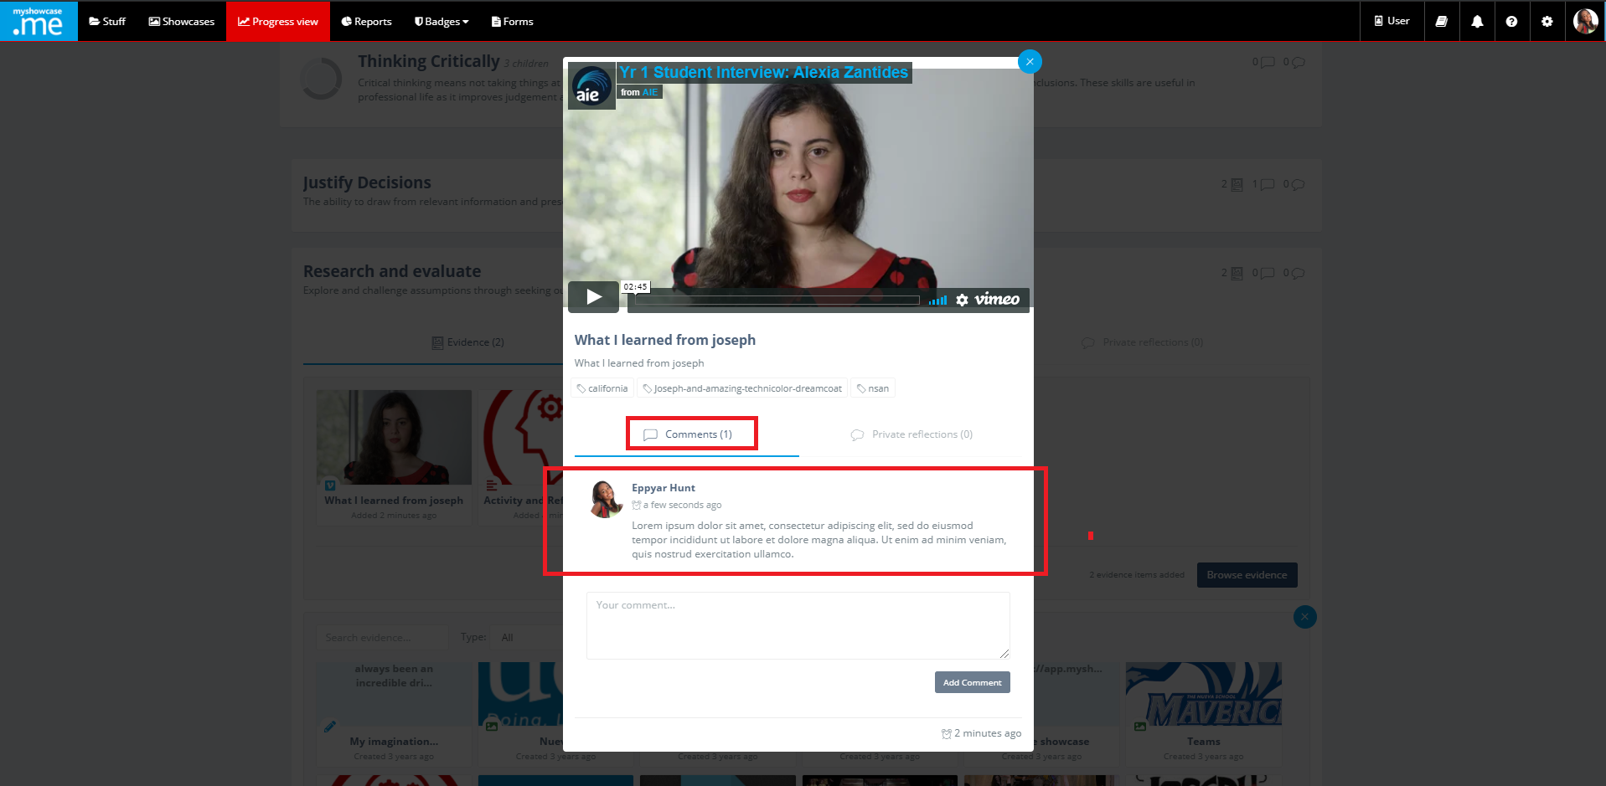

Private reflections are just that, nobody apart from the personal user can see them.

Comments can be viewed by authorised admins who may respond with comments and feedback of their own, that the user can too see.

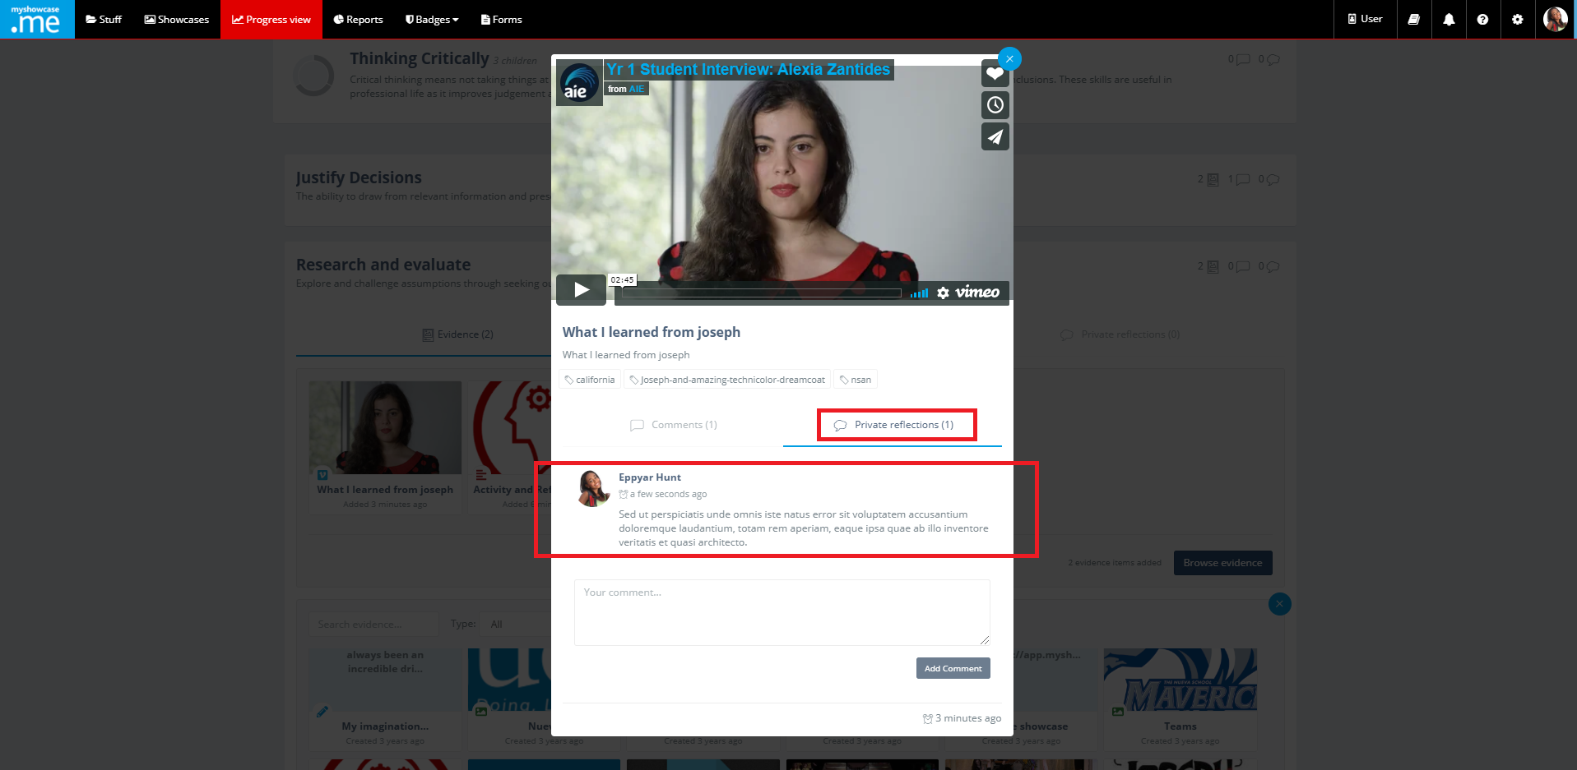

The user can add public comment authorised administrators can see and respond to or private reflections only they can see at any place within the Progress View that displays the public comment or private reflection icons.

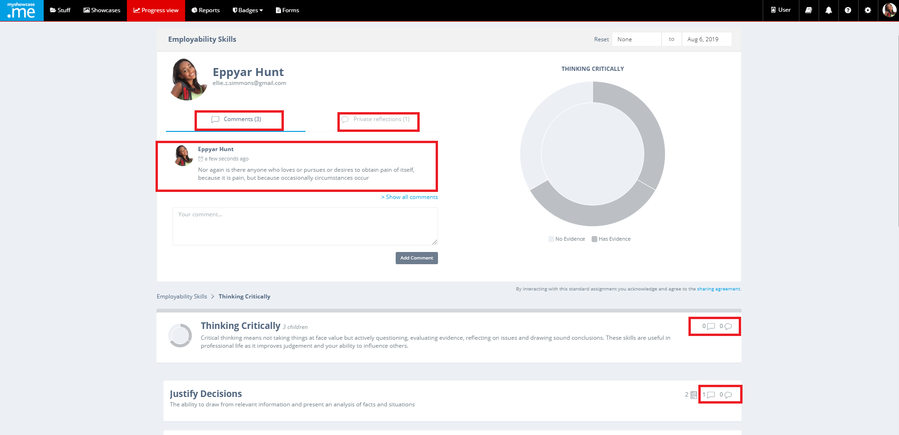

The chart can act as a gaps analysis tool for the user. As evidence is Mapped against the Progress View, on the chart that section of the Progress View turns dark grey. Sections that have no evidence appear as light grey. Very quickly, the user can visualise where they have gaps against the Progress View and where they do not.

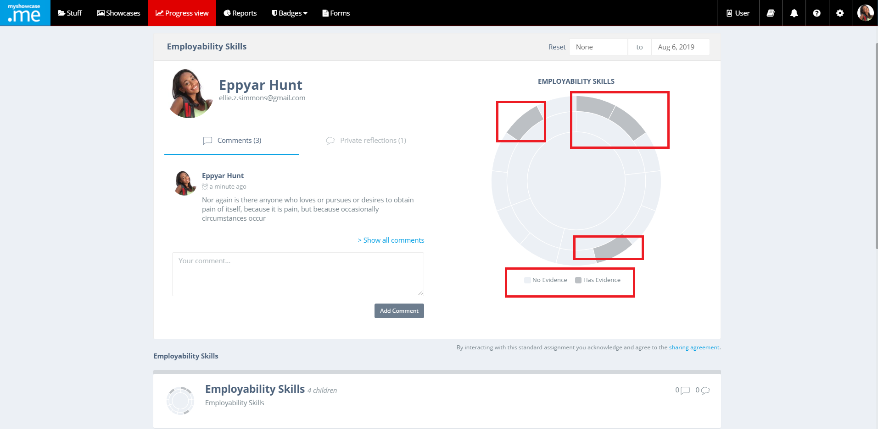

Progress Views with Grading Schemes
Some organisations can take up the option of a more powerful use of Progress Views that incorporates Grading Schemes. Layering a Grading Scheme on top of a Progress View allows admins to record, mark and visualise individual or group progress against a standard.

In the following example, the admin begins by creating a standard for a Registered Nurse.

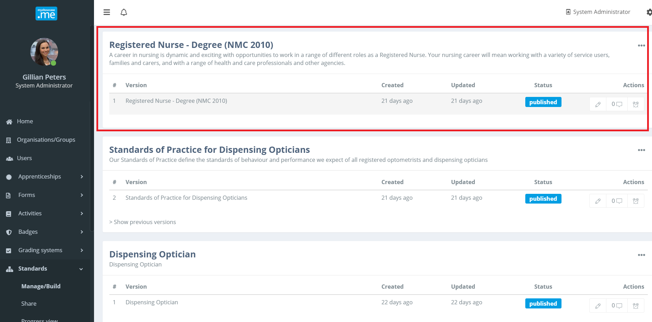

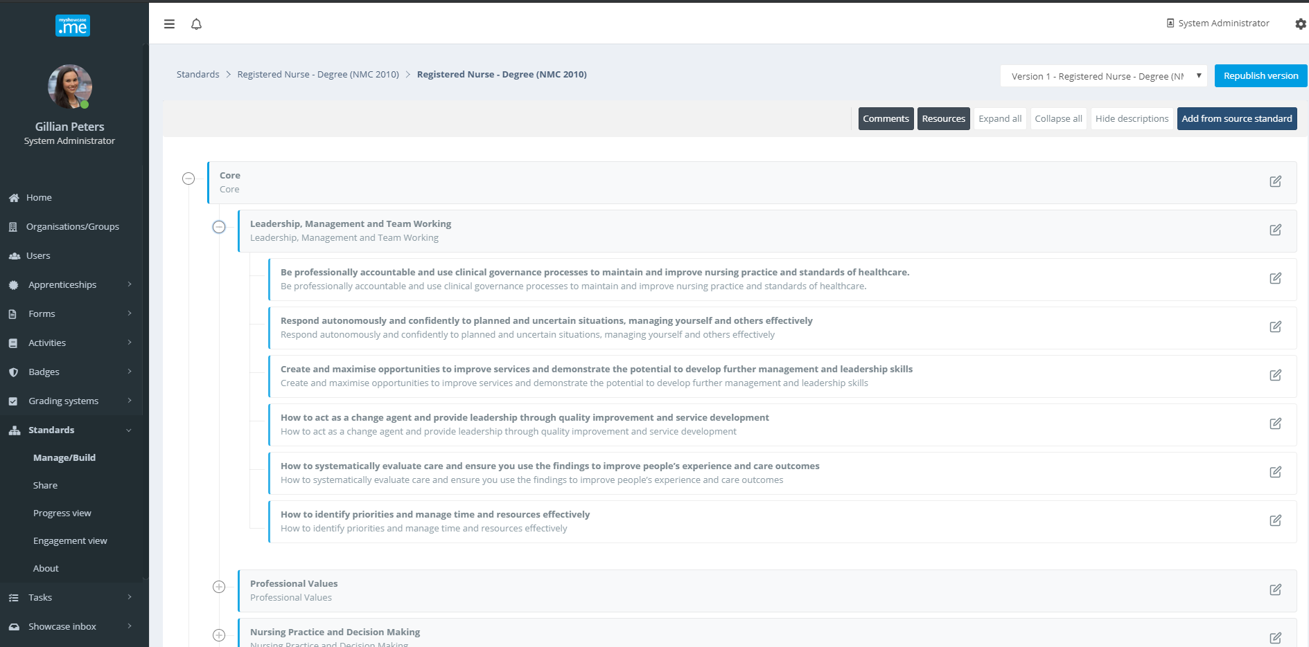

Next the create a Grading Scheme they would like to use to measure and record progress users make against that standard. A custom Grading Scheme is created ‘Registered Nurse: Progress Grading’.

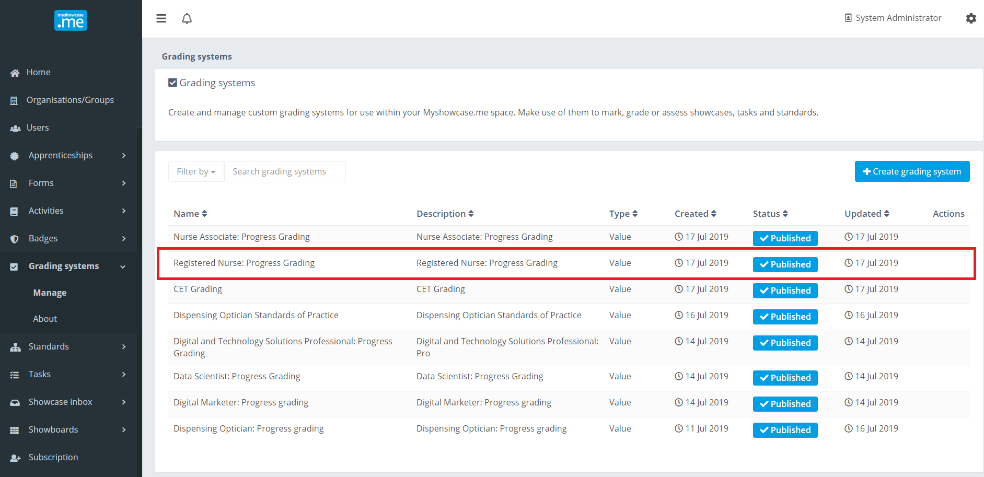

The Grading Scheme is of type ‘Value’ and has the following levels: ‘Exceeding expectations’, Meeting expectations’, ‘Nearly meeting expectations’ and ‘Not meeting expectations’. Colours are associated with each value. These are the colours that will be used on the Progress view charts to visualise user progress against the Registered Nurse standard.

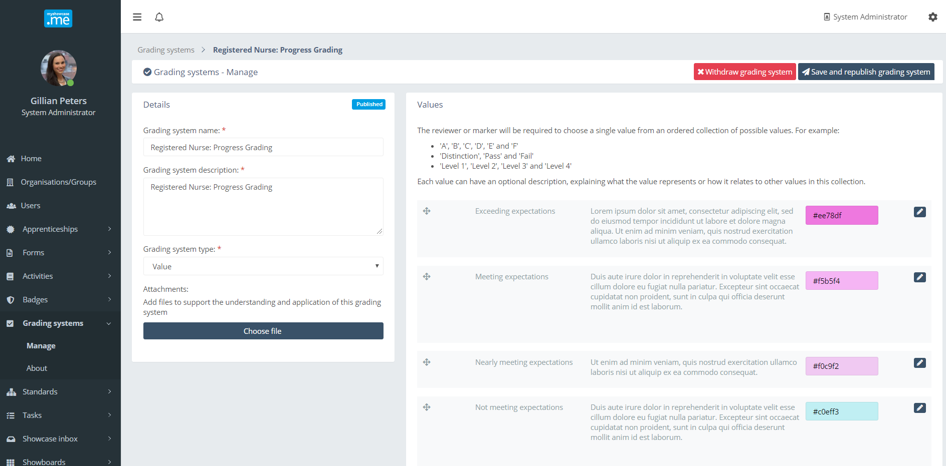

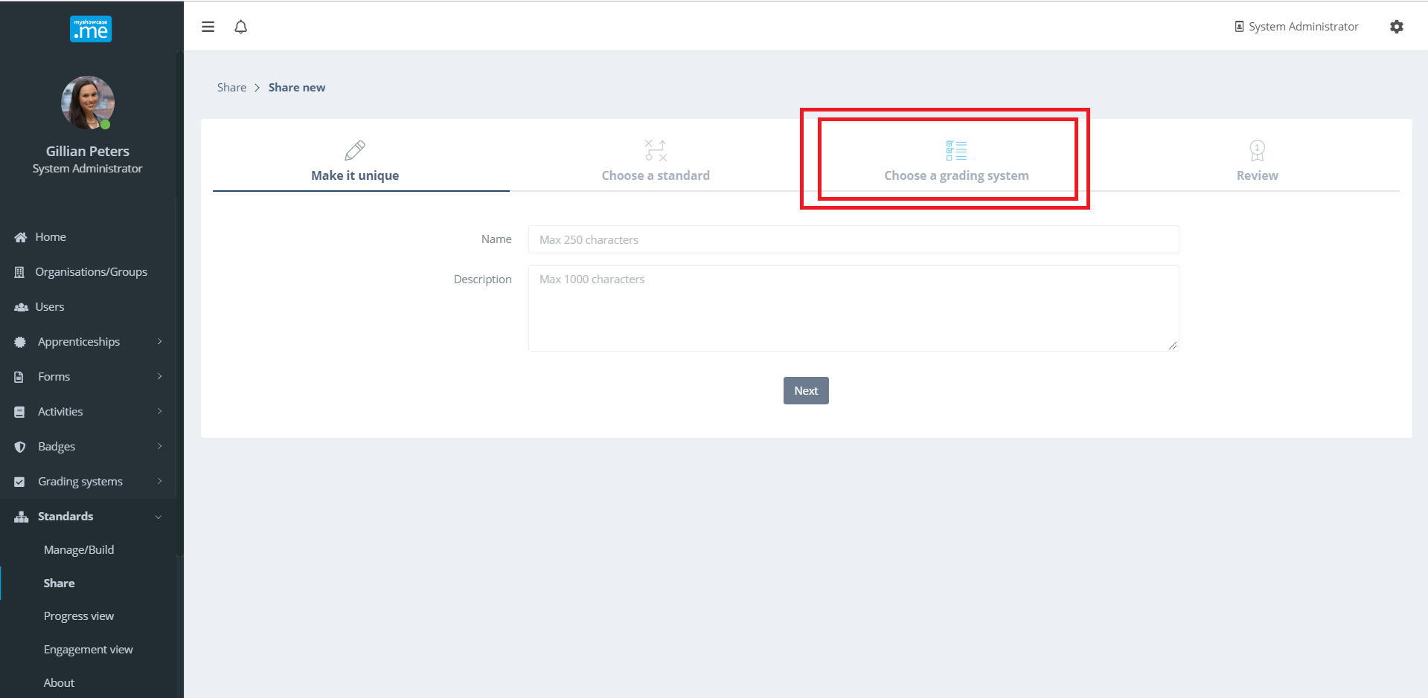

When the admin comes to share the standard and build a Progress View, they will have the option to choose a Grading Scheme for inclusion in the Progress View. In the example ‘Employability Skills’ example used earlier in the document, that organisation did not have the option to include a Grading Scheme.

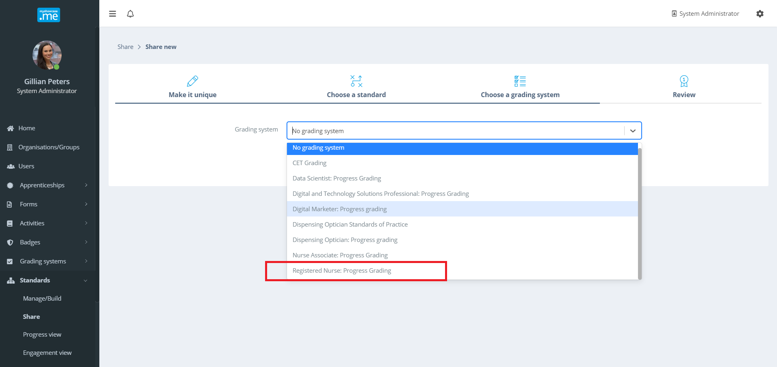

A summary of the Progress View being shared show what it contains. The Register Nurse Progress View has both a standard and a Grading Scheme inside it.

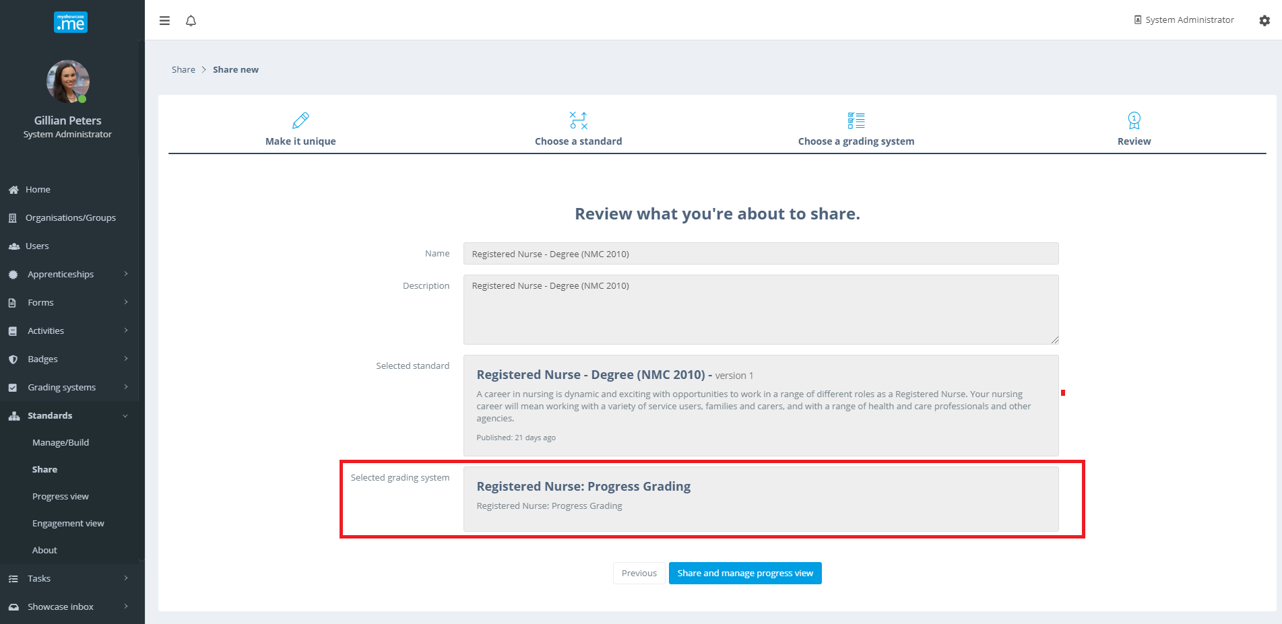

After sharing the Progress View with some groups of users, it will be listed in the ‘Progress Views’ area. As part of the detail, it displays the Grading Scheme being used.

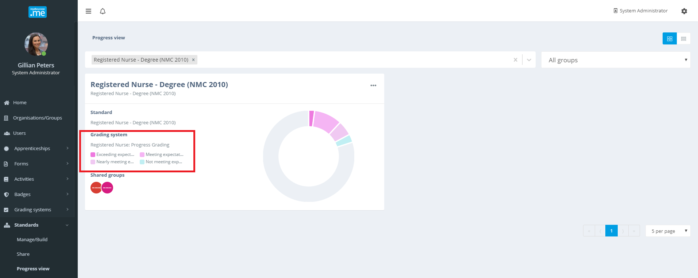

When the individual users are viewed from the Progress View, their chart and panel display also shops the applied Grading Scheme. The charts and presentation reflect the colour palette of the Grading Scheme. This colour palette can be changed real time be editing the Grading Scheme.

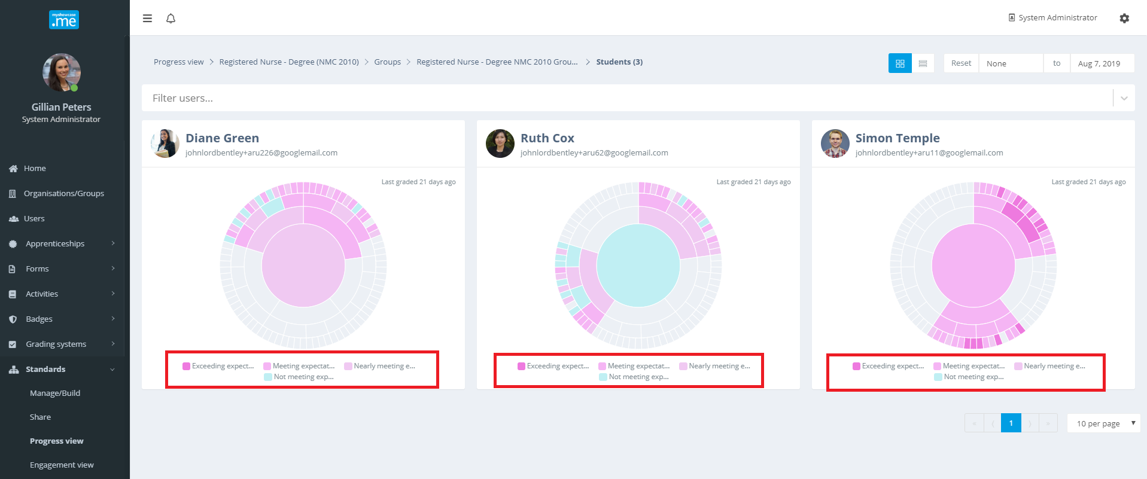

The inclusion of the Grading Scheme allows the admin to go into each users Progress View, review any evidence they may have applied and then apply a value from the Grading Scheme that they believe reflects the progress the user has made.

To illustrate how the Grading Schemes can be used, lets assume the admin selects Diane Green to review.

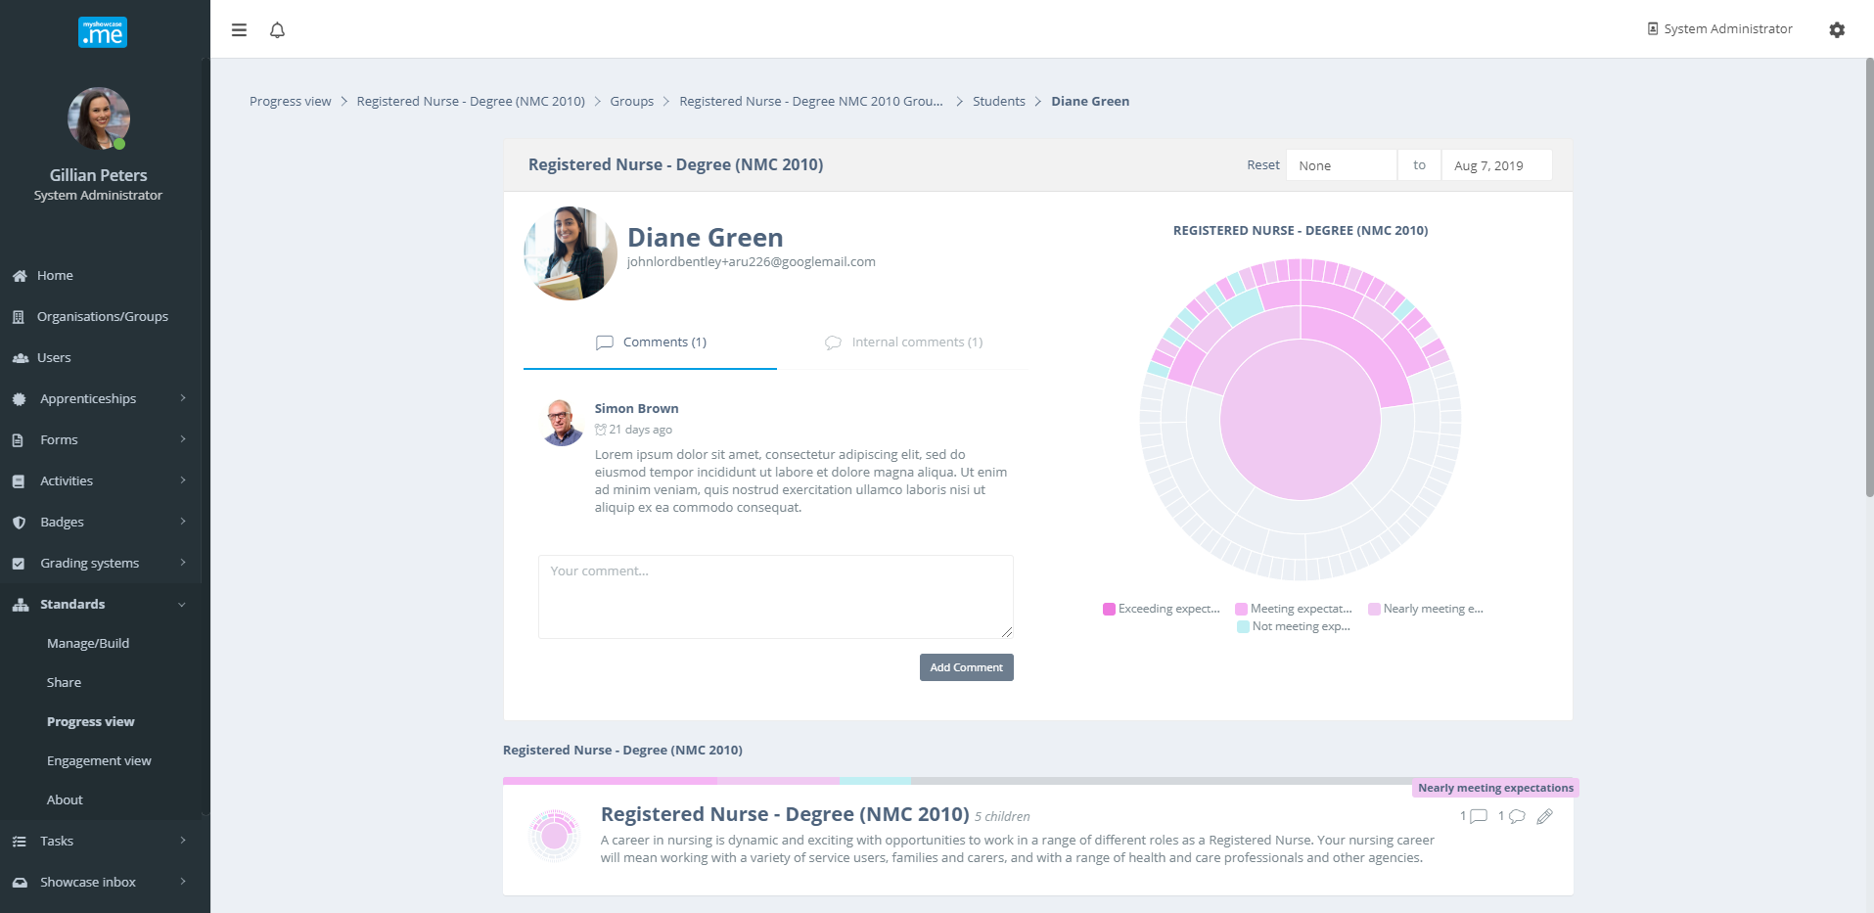

The admin chooses an area to review within ‘Leadership, Management and Team Working’.
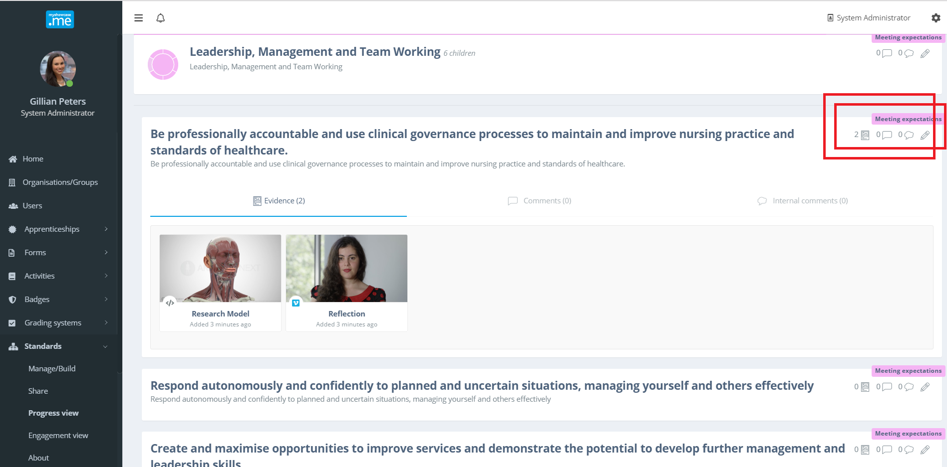

Progress has previously been evaluated and a grade of ‘Meeting expectations’ has already been applied. After reviewing the evidence (covered earlier in document), the admin decides to change the progress grade. The admin now believes that Diane is ‘Exceeding expectations’ in this area. Clicking on the [pencil icon, displays the Grading Scheme and the values that can be chosen.

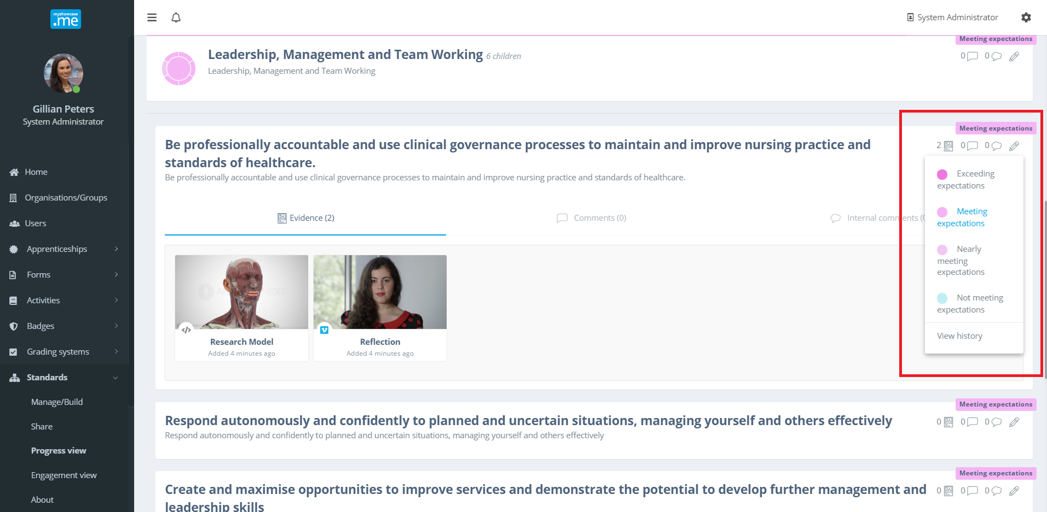

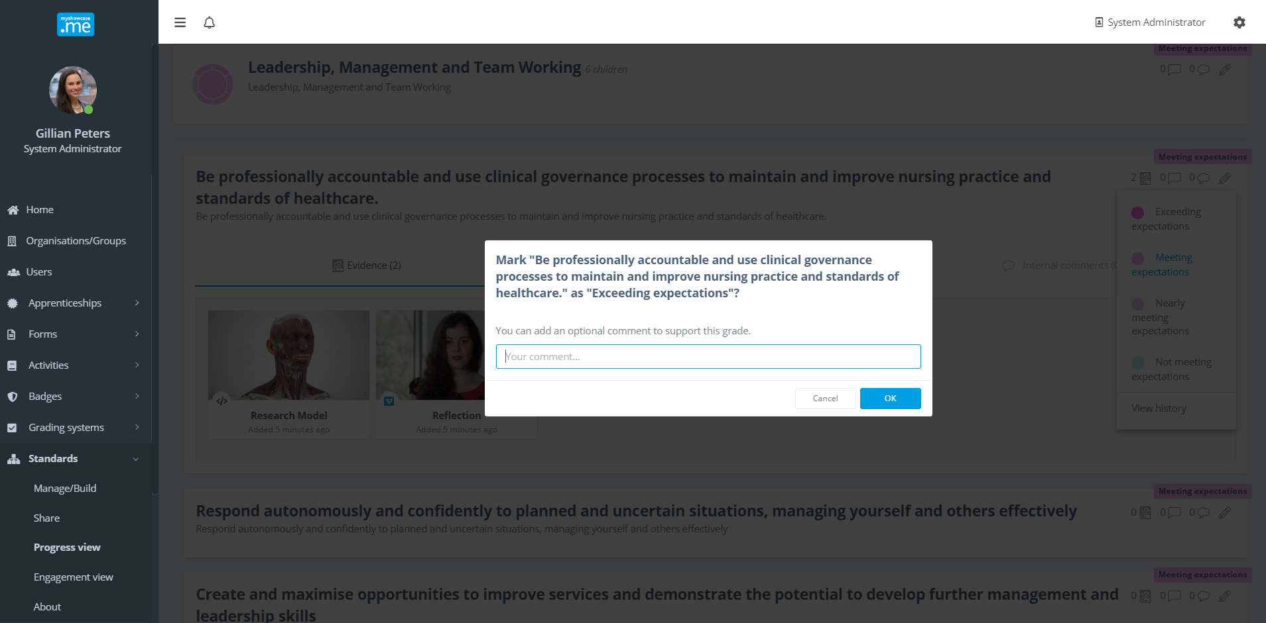

To support the new grade, the admin has the option to add a comment explaining their thoughts around their decision to apply a new grade value. All grade changes are applied real time into the Progress View. The user will also see any grade changes immediately within their Progress View UI.

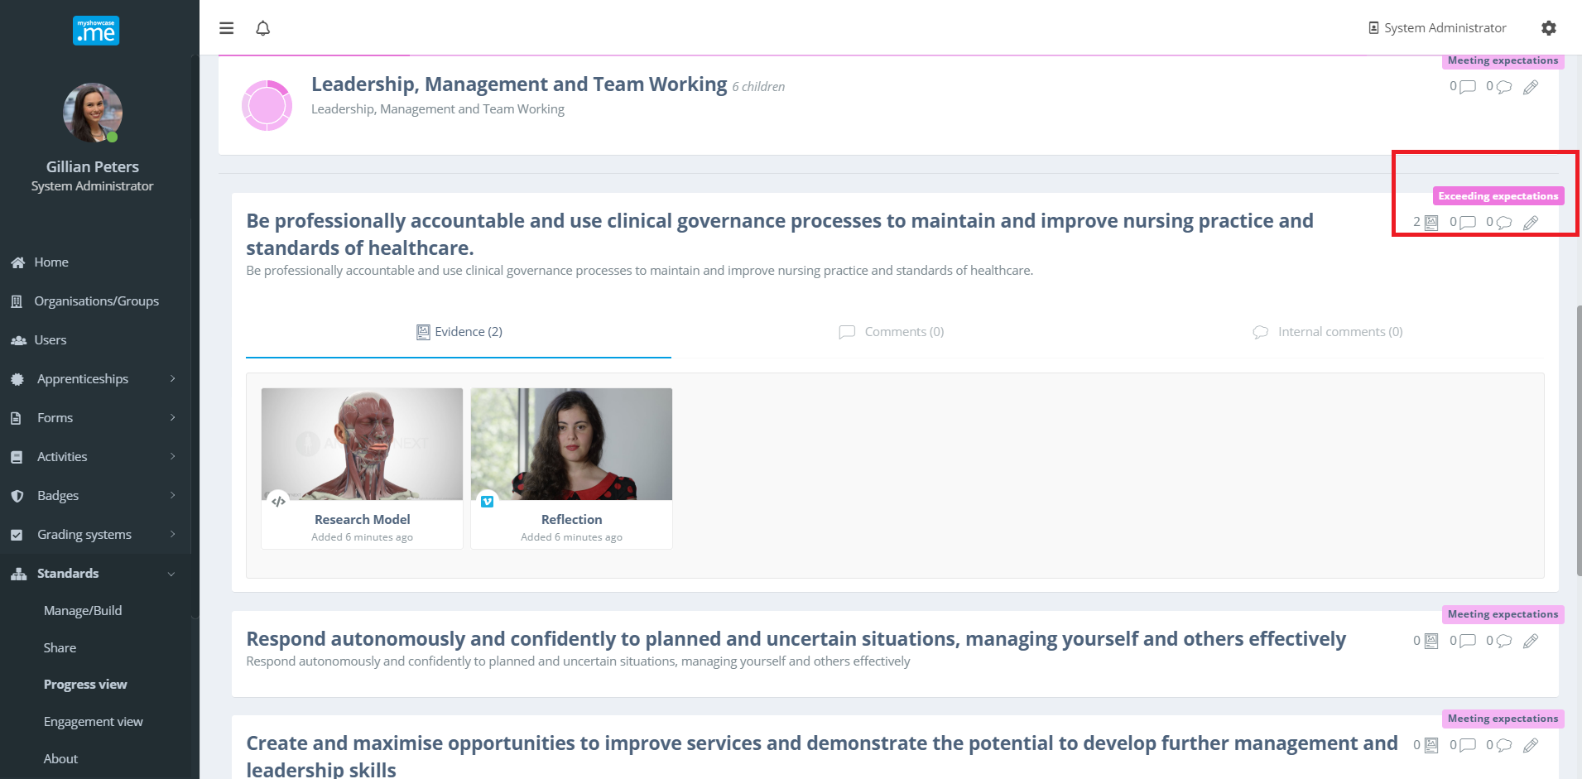

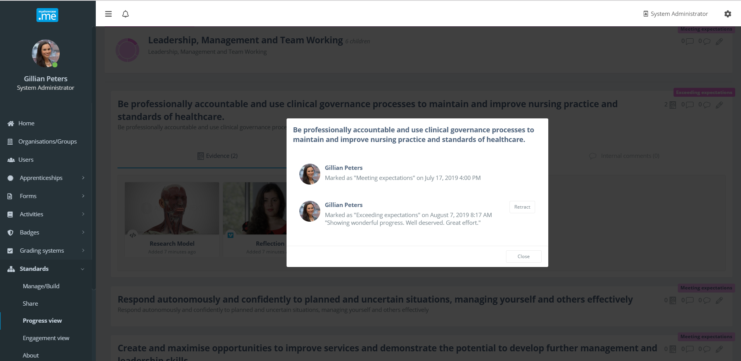

If the admin clicks on the displayed grade, a history of the grade applied at that point of the Progress View will be displayed. It shows what grade was applied, by whom, when it was applied and any supporting comments.

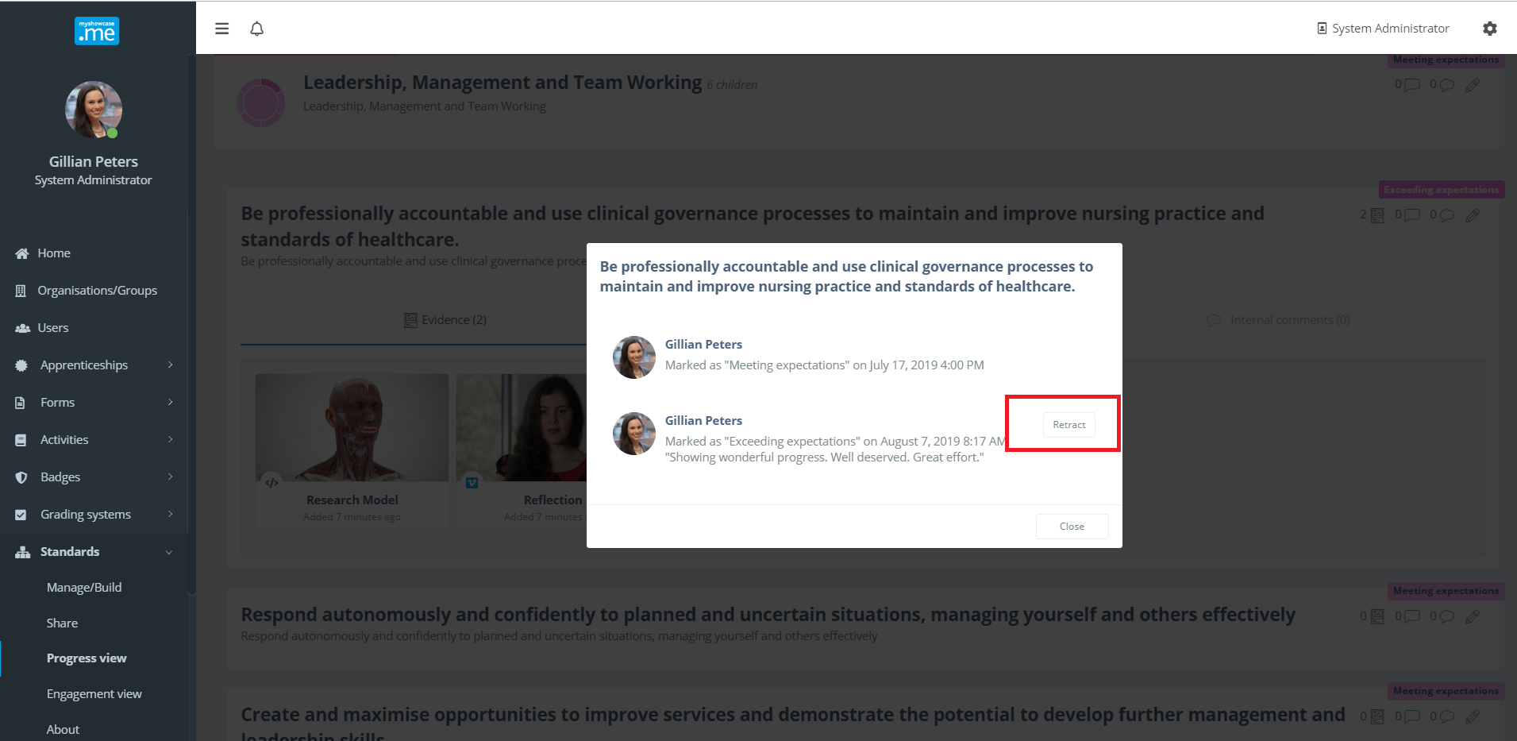
If the admin believes they have made a mistake grading the Progress View, the latest grade can be retracted. The admin must provide a reason for retracting the mark. The displayed grade will revert back to the one applied previous to the retracted grade.
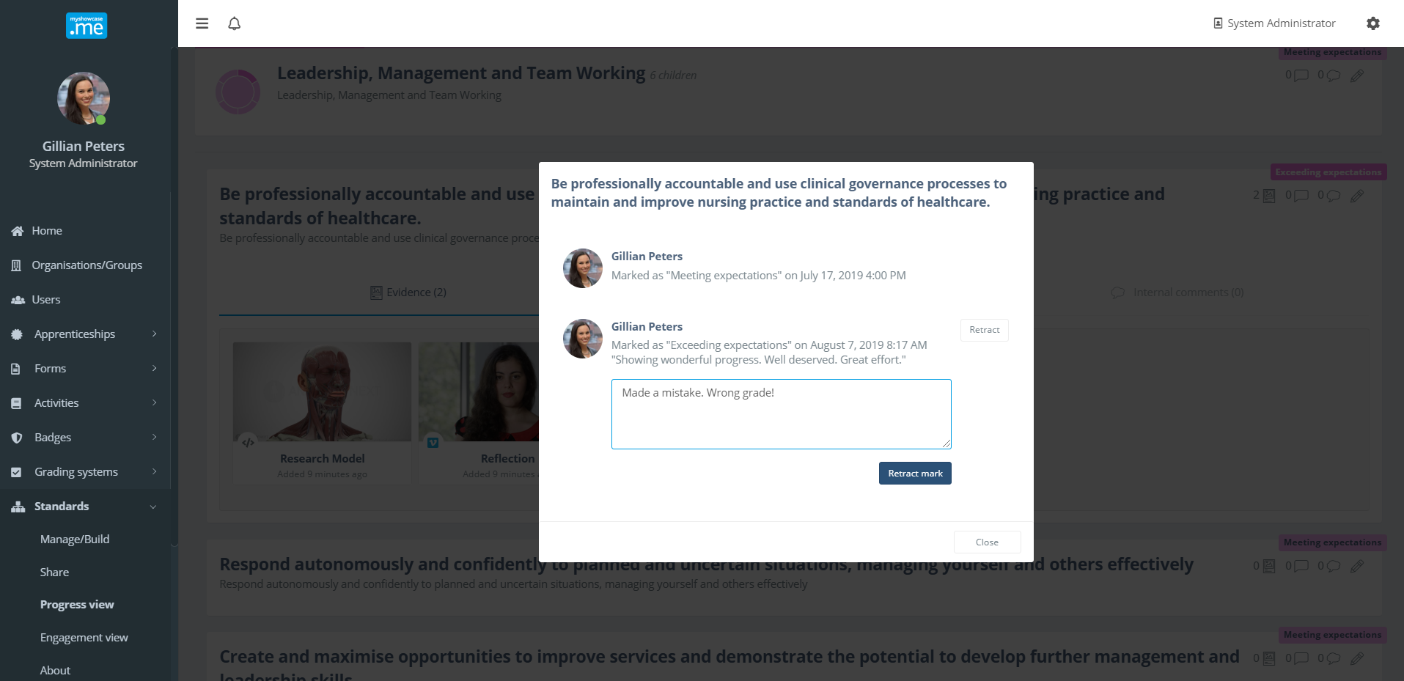

Wherever the pencil icon (grading/marking) appears within the Progress View, the admin can apply a value from the Grading Scheme.

