

3. Forms
An easy to use authoring tool, that allows organisations to create and share Forms to support life-long learning, reflective practice, goal setting and management and lots of form-based activities.
MKM
MyKnowledgemap/ 20 George Hudson Street, York, Y01 6WR, United Kingdom
Contents
Overview 2
Authoring a Form 3
Publishing a Form 10
Sharing a Form 11
Managing a published Form 12
Personal user: working with Forms 13

Overview
The Myshowcase.me admin area provides authorised users with a Form authoring, publishing and sharing tool.

Custom forms for multiple uses can be designed and then shared with Myshowcase.me personal users for use within their ePortfolio space. Forms to engender reflection, support lifelong learning, enable personal and professional goals to be set and managed, record time and activity can all be created using the Form authoring tool.

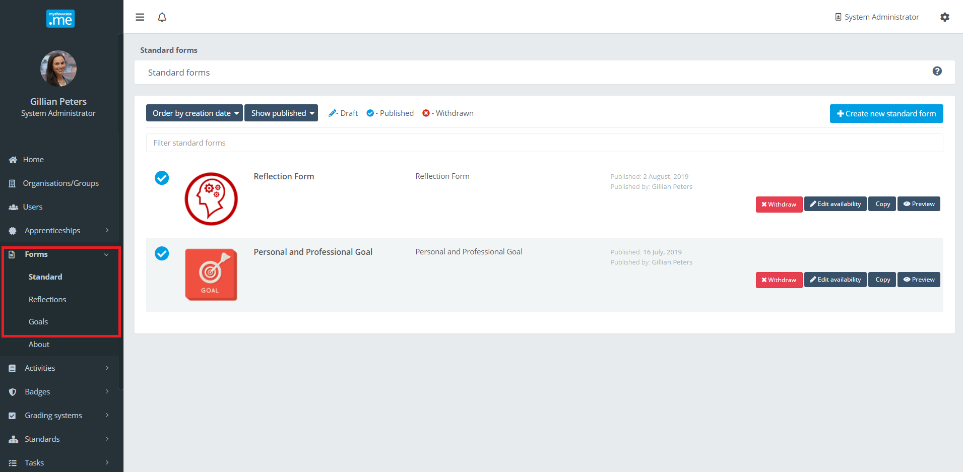

Once created and published the forms can be shared throughout the organisation and it’s groups, making them directly available to their members for use within their personal Myshowcase.me space.

Completed forms can be used as evidence items, mapped against any shared Standard or Progress View (Separate document available that outlines this use case). They can be included as part of a showcase and shared with an audience. Admins can also use them as a requested Myshowcase.me Task response type.

Forms can be used in any enabling, collaborative or instructional approach an organisation decides to adopt to support the development and growth of a personal users Myshowcase.me ePortfolio space.

Authoring a Form
Within the ‘Forms’ area inside the administrator chooses to author a Standard, Reflection or Goal Form. These are simple category tags to help organise the organisations Forms. It terms of authoring and functionality there is no difference between any of them.

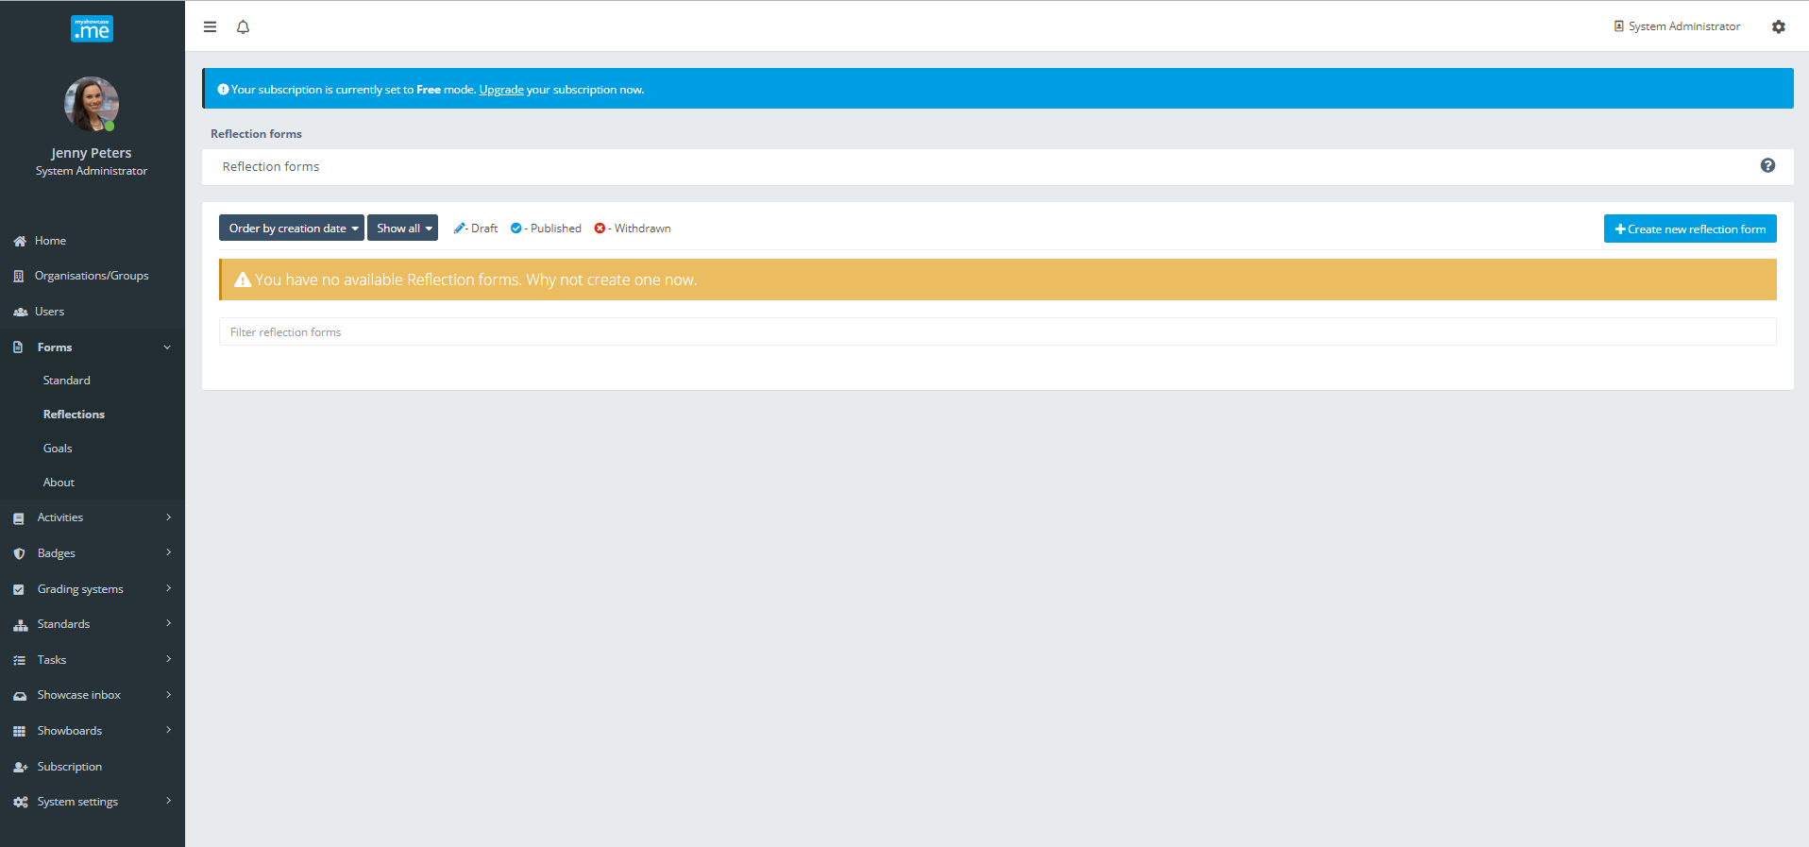

In the example below, the administrator has chosen to author a Reflection Form.

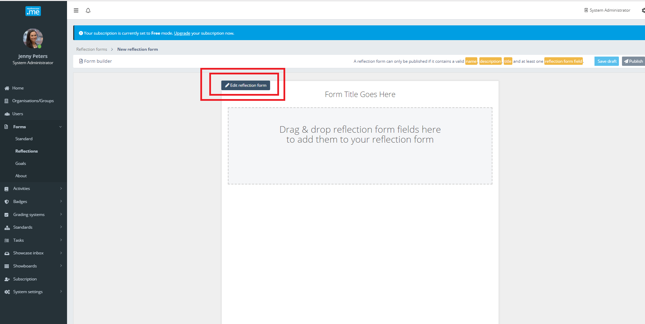

To start authoring the form, the administrator selects the ‘Edit reflection form’ action button.

A collection tabbed panels opens to the administrator. Working through these tabs, the administrator will be led through the Form authoring process.

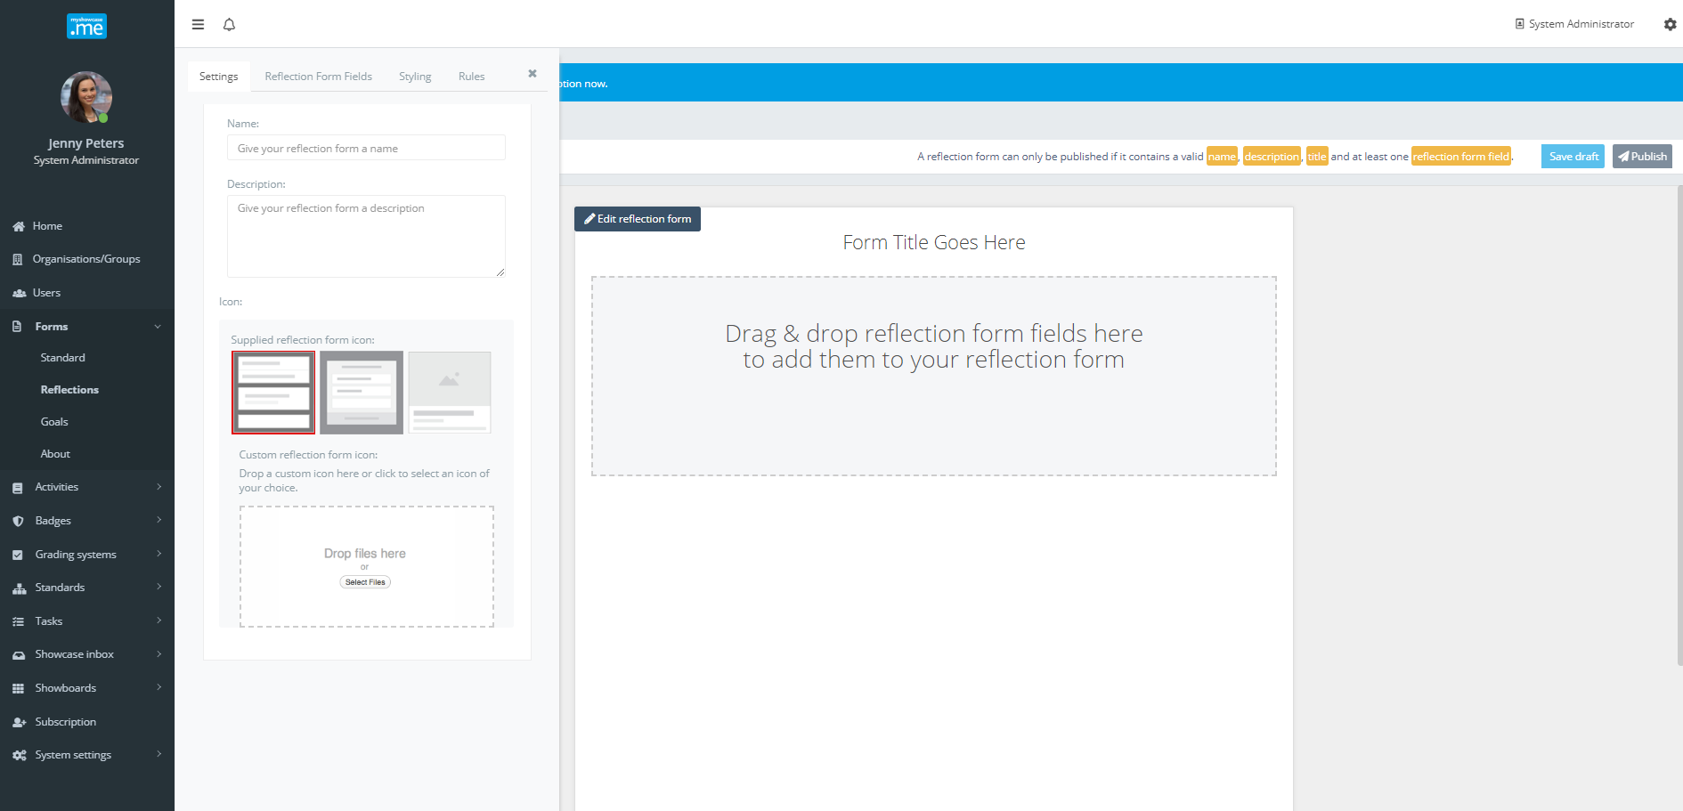

Settings
On the setting tab, the administrator gives the form a name, a description and icon that will be used to visually represent the published form throughout the Myshowcase.me user interface.

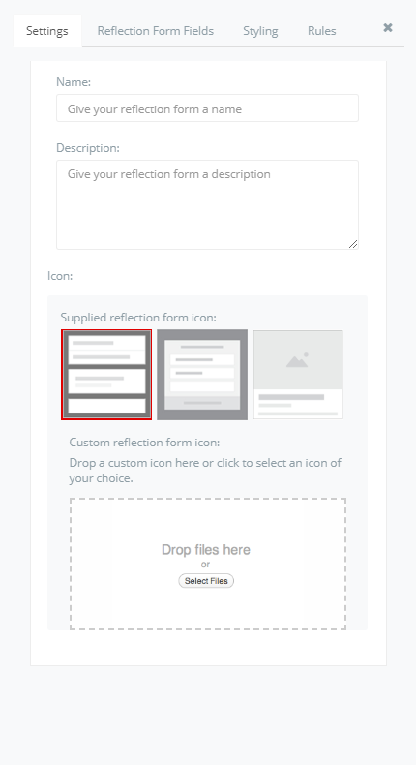
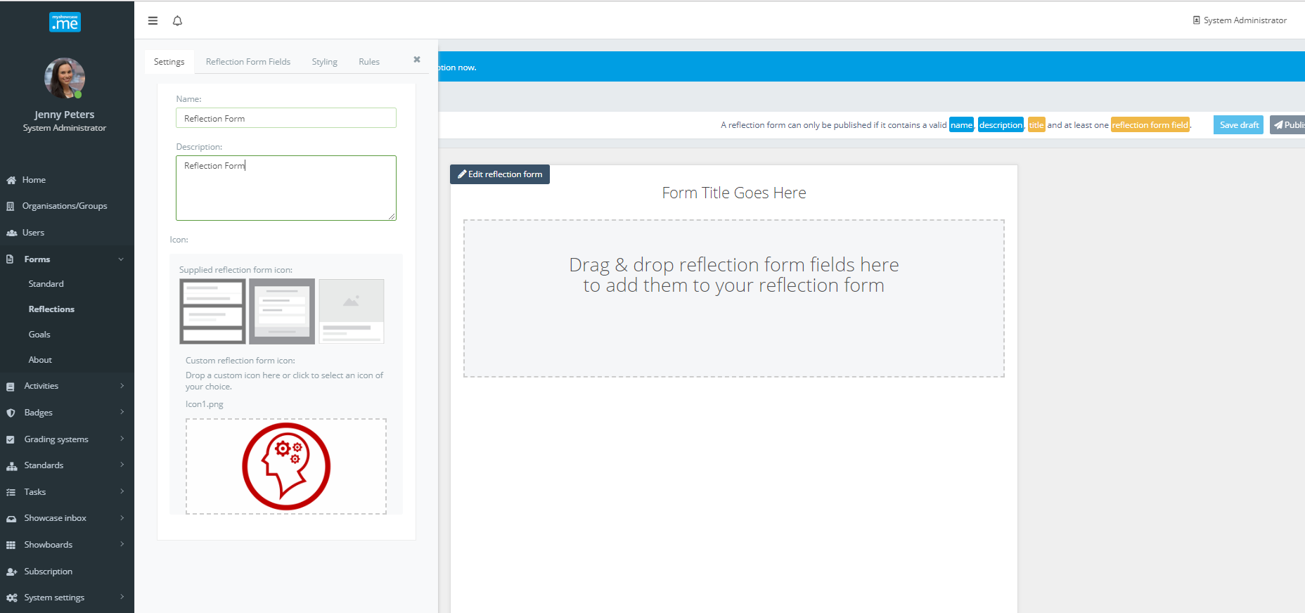

Form fields
This panels lists all the content elements that can be used to design and build the form. Some of the items give the form context: ‘Heading’, ‘Descriptive text’, ‘Image’. Others are for adding data input/capture content on the form: ‘Text input’, ‘Text block’, ‘Date picker’, ‘Rating’, ‘Choice’ …etc.
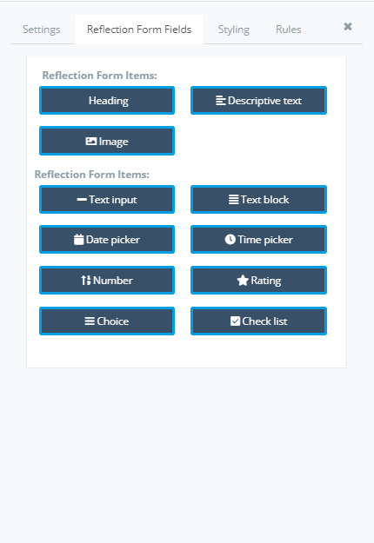

Using a drag and drop approach, form fields can be dragged onto the form authoring space.
Once added to the authoring space, each form item can be customised, reordered and moved around until the administrator has the form they need.
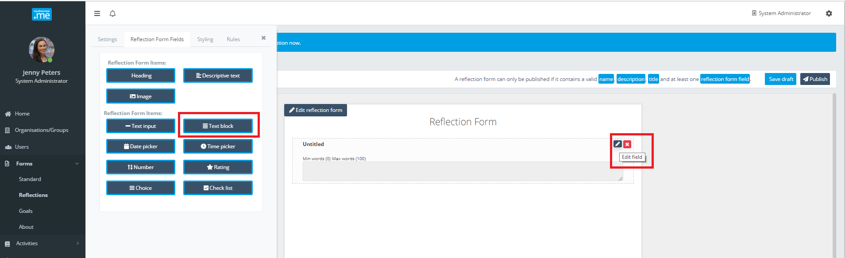
Once an item has been dragged the authoring area, the administrator can edit or remove it. Each form item has slightly different edit options. We can use the example of the ‘Text block’ to illustrate how most edits work.
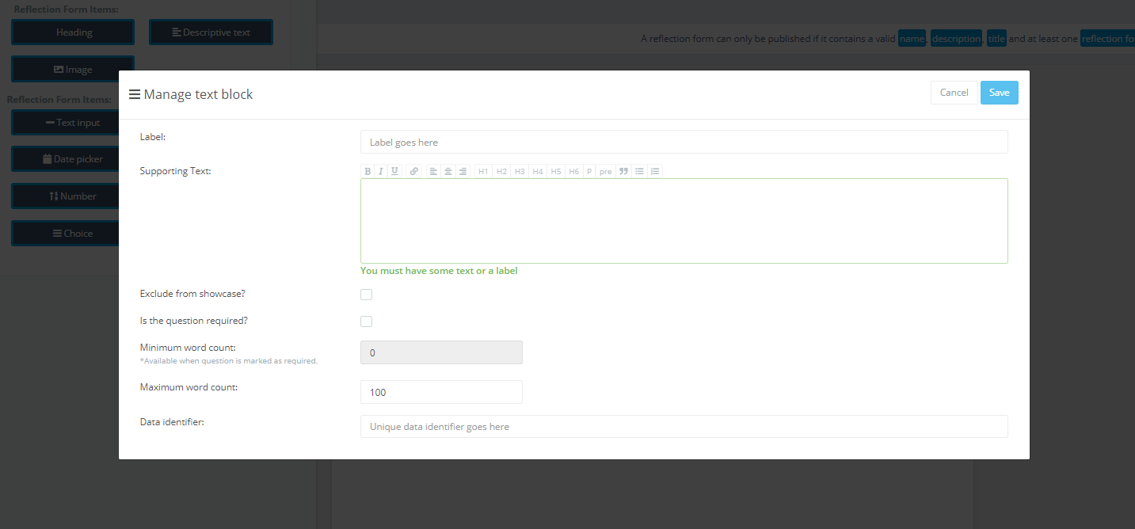

The administrator works down the definition fields entering the values to define the form field.

The ‘Data identifier’ can be ignored for now as it’s a placeholder for a future roadmap data warehousing and form reporting requirement.
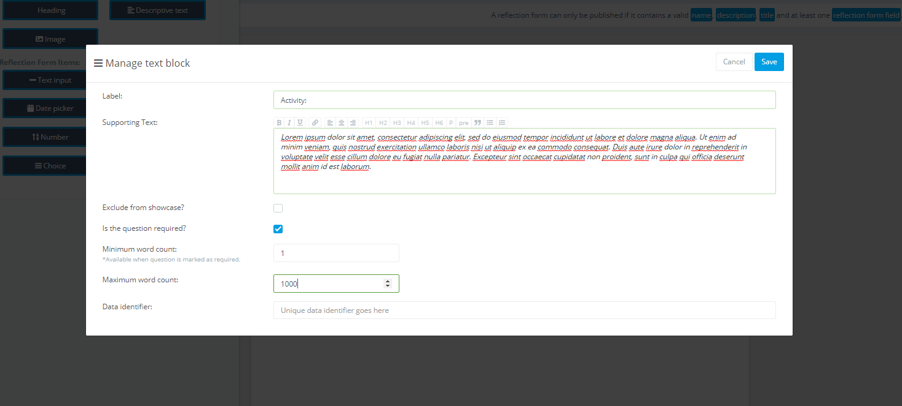
The form field can be saved at any point. The administrator can see how it displays on the
form, and if required go back into the form item and change its presentation and content.
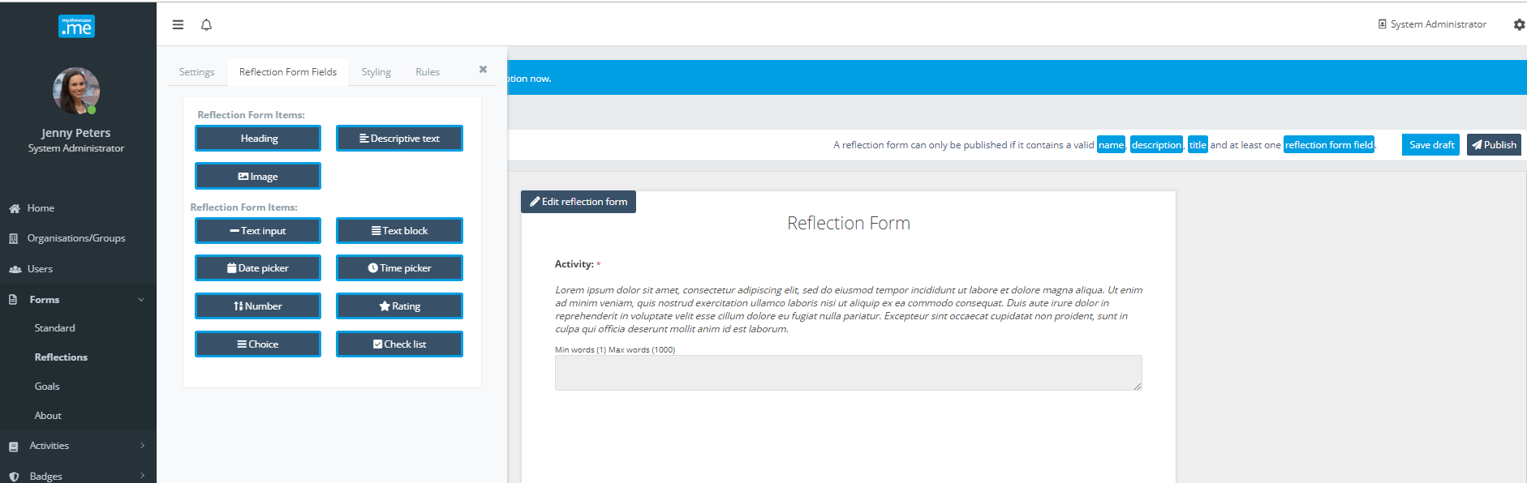
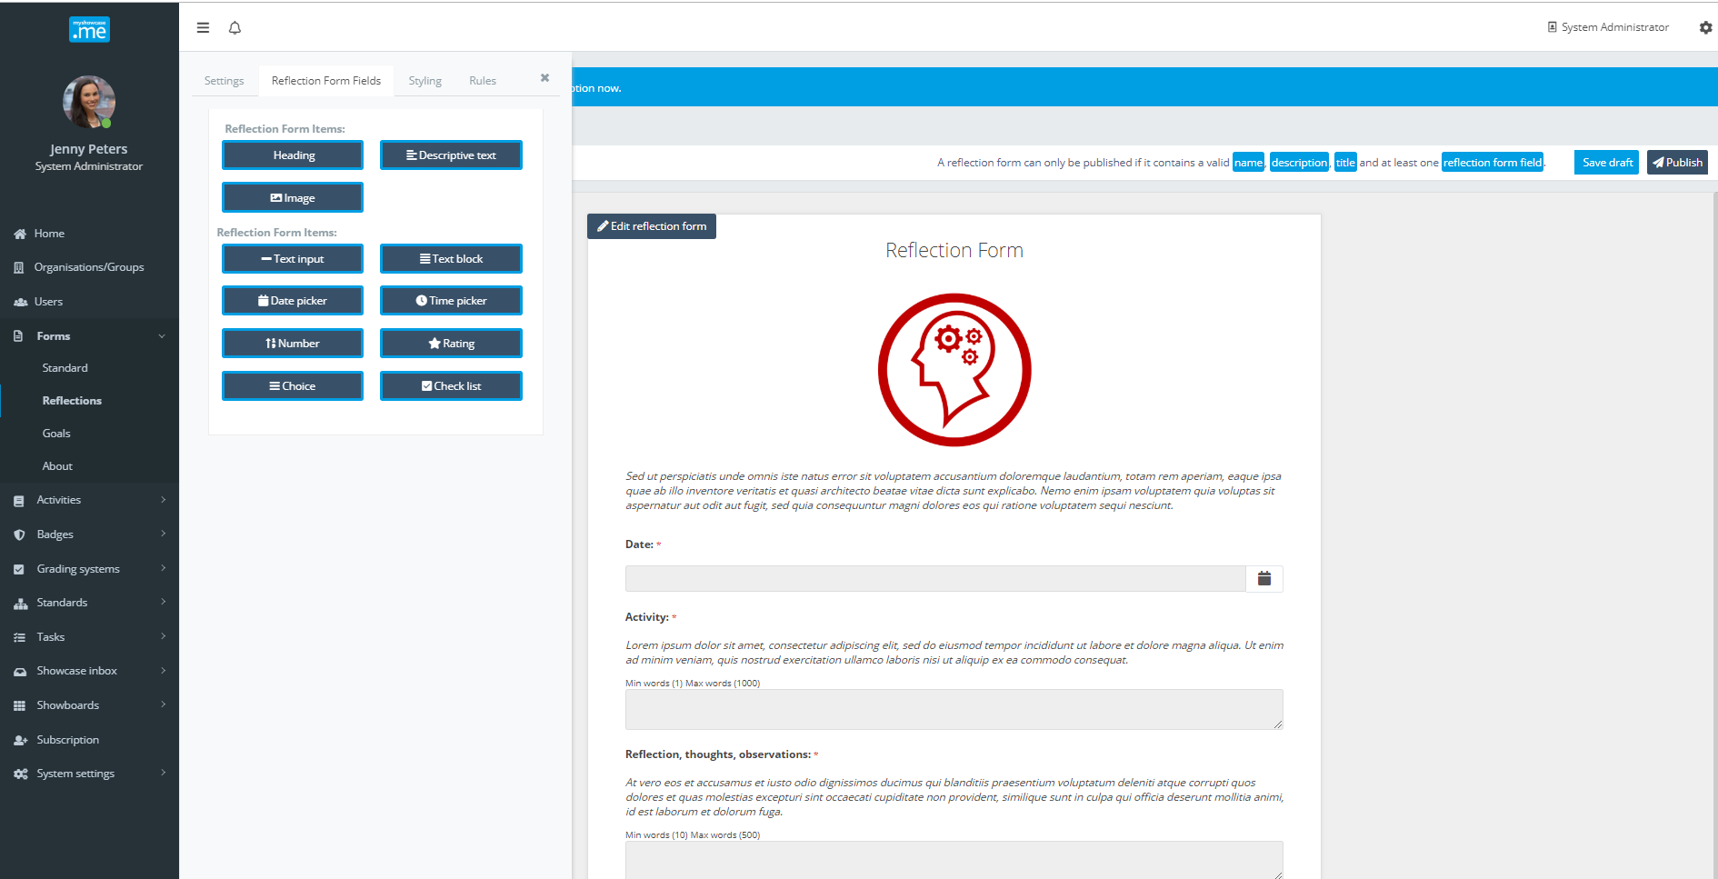

Styling
Each form can be given customised styling. Select a colour palette option will style the form background, trim, headings and some text.

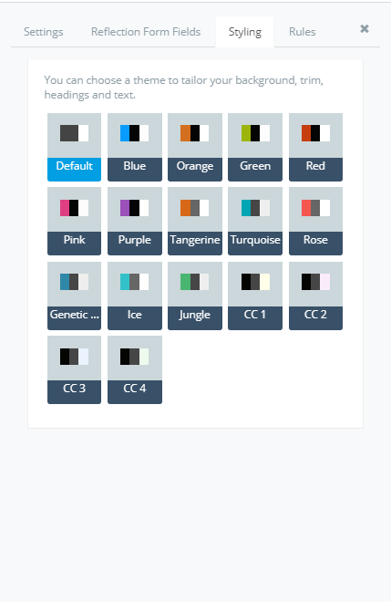

Rules
A form can be set to ‘editable’. When a personal user completed the form within their Myshowcase.me space, the form becomes an evidence item within their ‘Stuff’ area. If the form is ‘editable’, the user can continue to update that instance of the form indefinitely.

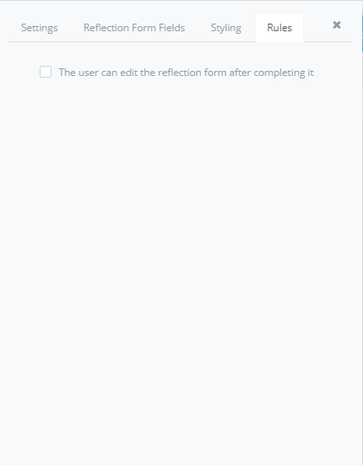

Publishing a Form
When a form is ‘Published’ it become eligible for sharing with groups of users, thus making it available for them to use within the personal Myshowcase.me space.

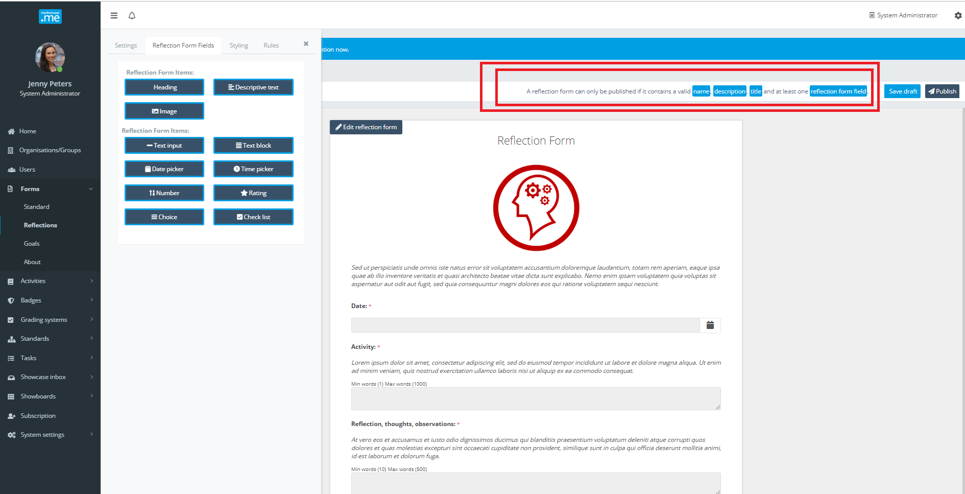
To be eligible for publishing a form must have a valid name, description, title and contain at least one form field.

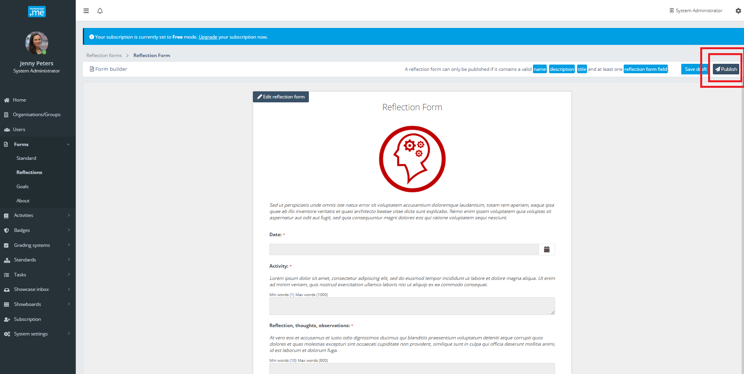

Sharing a Form
A Form can be shared with any number of groups or organisations. A cherry picker allows the administrator to select which groups or organisations to give the form to.
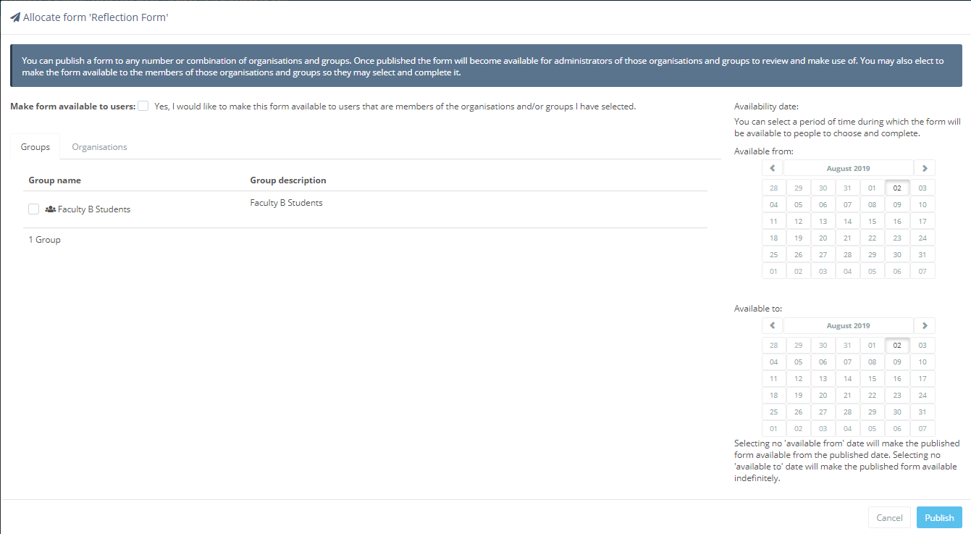

The Form is shared in two ways: admin use and personal use.

It can be shared with the administrators of the groups and organisations selected. This allows the administrators of those group to see the form and be able to decide how to use it. They may take a copy of it, share it on to further groups, organisations or personal users. They are given some administrative rights over that form.

It can be shared with the ‘users’ of the groups and organisations selected. This allows those users to see and use the form in their personal Myshowcase.me account space. There is an explicit checkbox at the top of the sharing screen (‘Edit availability’) that asks if you want to ‘Make form available to users’.

The sharing of the form can also be date scoped. An availability date range can be specific against a form. It will be available to the shared groups and organisations only inside the defined date range.

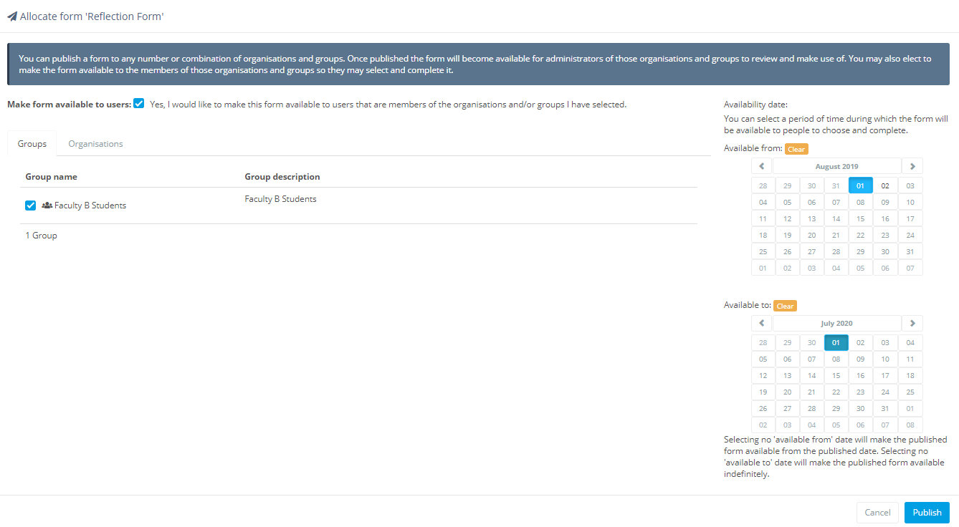

Managing a published Form
Once a Form has been published, various management options become available against the form.
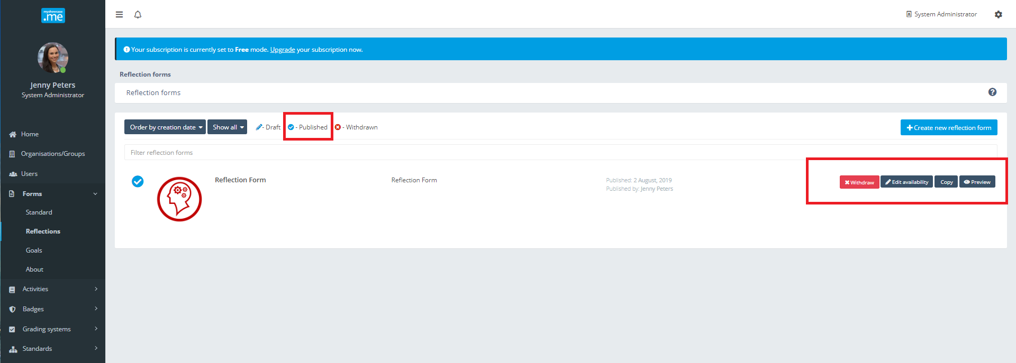

Withdraw
The Form will no longer be available for use by any of the groups and users it may have been shared with. It will no longer be available as a response option on any new Tasks.

Edit availability
Presents the administrator with the sharing options for this form.

Copy
Take a copy of the form, to become the starting point of a new form. The new form will have a status of ‘Draft’.

Preview
View the form as the end user would see it.

Personal user: working with Forms
Whenever Forms are shared with a personal Myshowcase.me user, they will see a ‘Forms’ tab appear on their Myshowcase.me main menu.

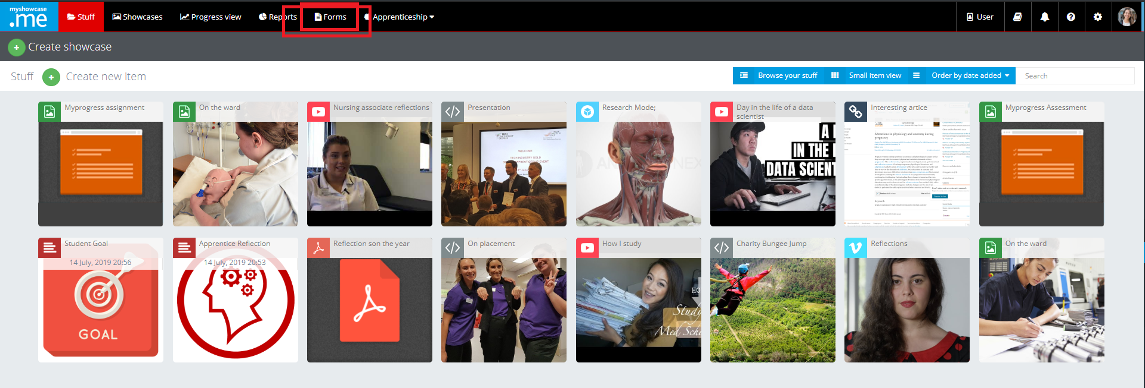

Clicking on the tab, shows a listing of the Forms available for their use.
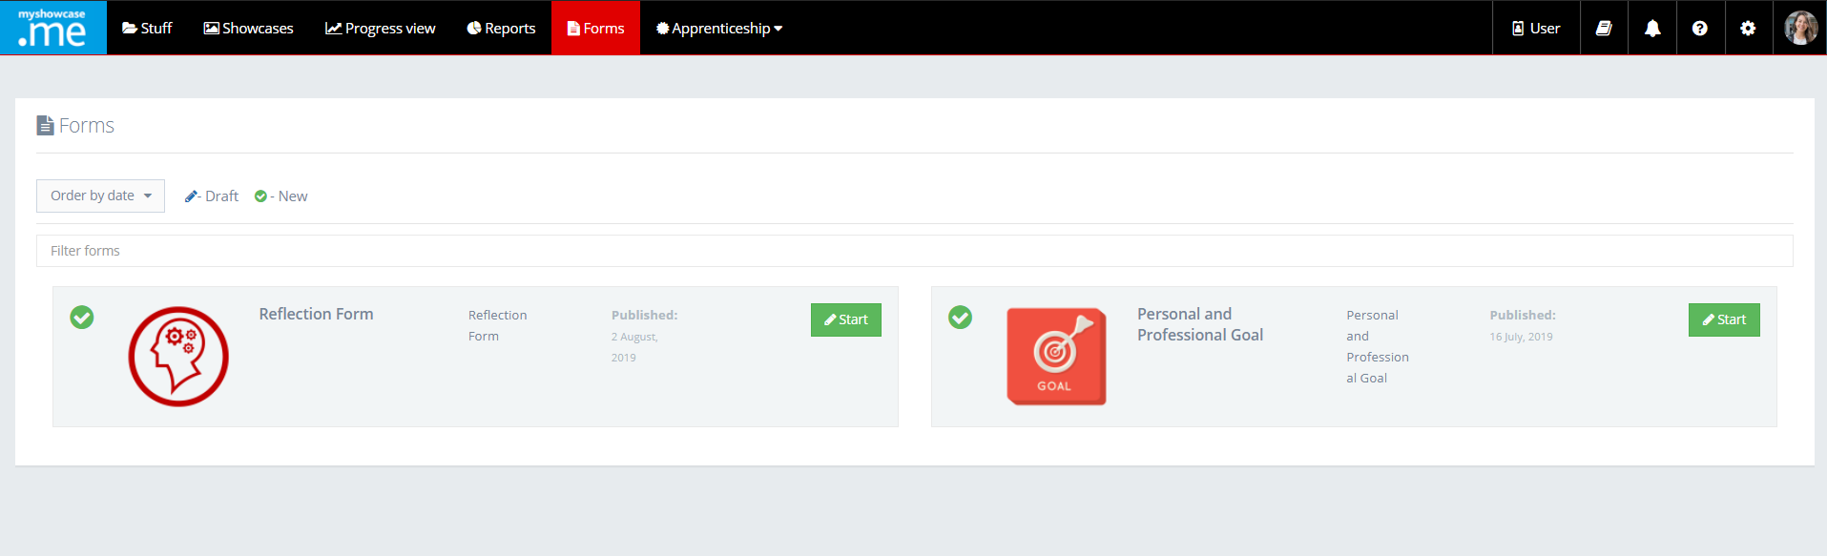
If the user chooses to complete a ‘Reflection Form’, clicking the ‘Start’ will open the form up to them to use.

As they work through completing the form, then can save and exit the form. This will hold the form in a draft status that they can be worked with later. The action button against the form changes from ‘Start’ to ‘Continue’.

When they are finished with the form, clicking the ‘Complete’ action button will complete this instance of the form, placing it as a form item within their Myshowcase.me ‘Stuff’ area.

The user can now start work on another instance of the ‘Reflection Form’ if they wish.

There is no limit to the number of times a form can be completed, and the instance used.
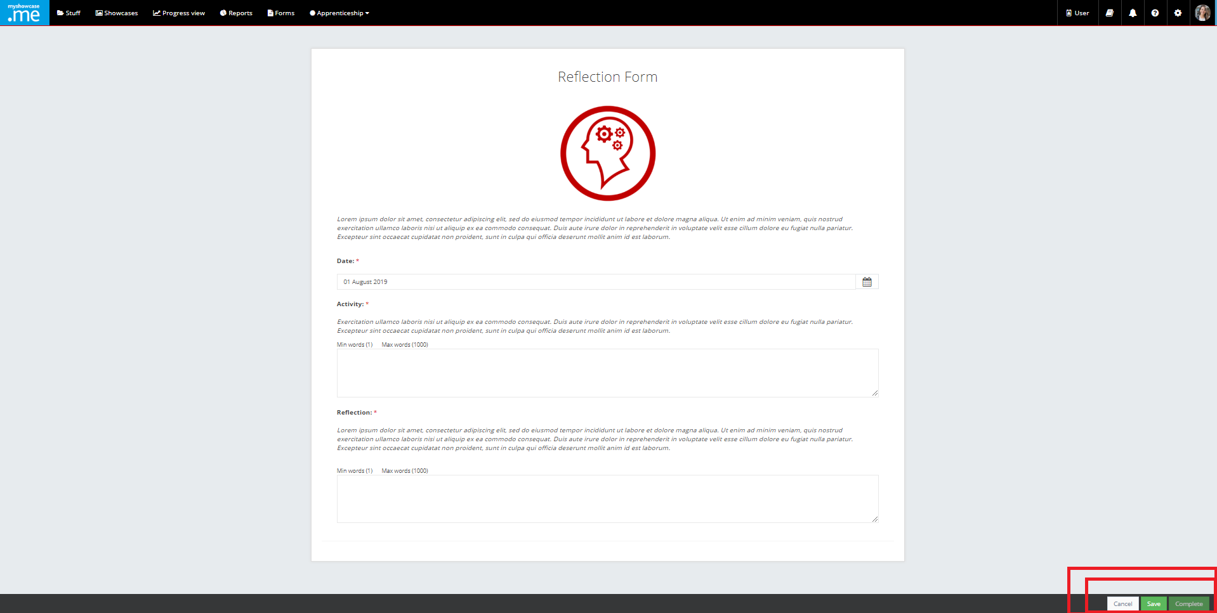

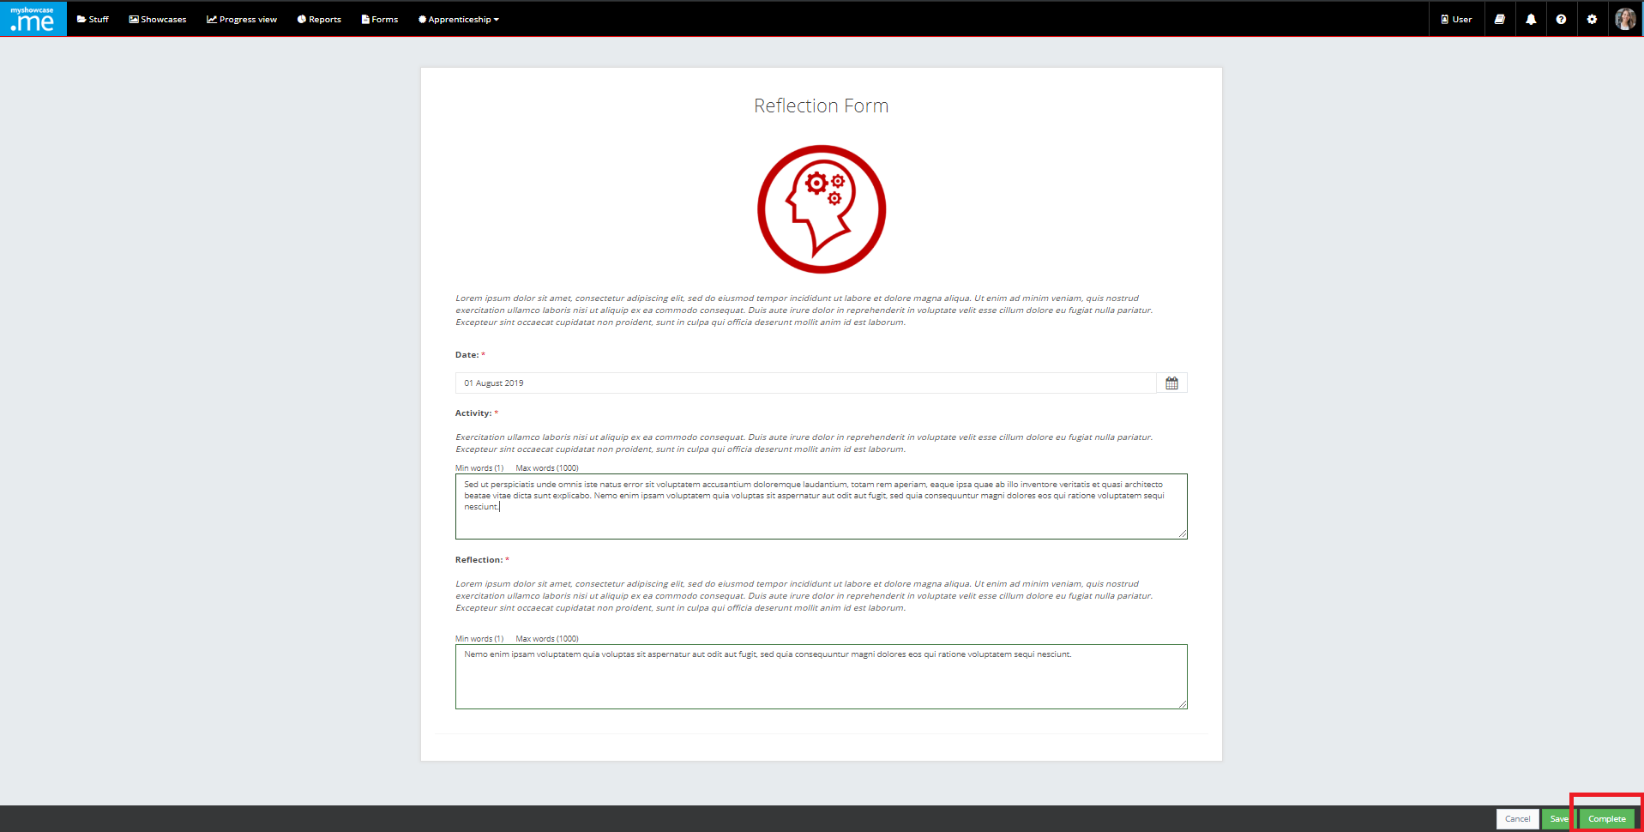

Once in their ‘Stuff’ area, the completed form behaves just like any other item. It can be included in a showcase presentation. It can be mapped as a piece of evidence against a Standard/Progress View they may be working with.

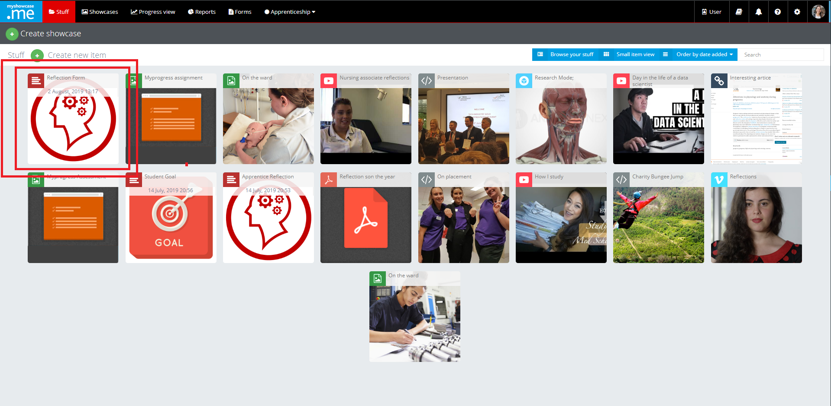

As with other items, the name and description of the form item can be amended by the user to give it more meaning or context.

If the form has the ‘Edit’ rule enabled against it, the user can continue to edit and change the contents of the form even after it has been added into their ‘Stuff’ area.

