Academic Users - What's Changed in Version 8.7

Overview
MyProgress Version 8.7, brings some exciting changes for all users; this outlines some of those features and changes which may impact your use of MyProgress.

When?
MyProgress Version 8.7 will be deployed over the 18-19th April 2026

Why?
A lot of the changes are to migrate underlying older code base; but this means we can make improvements to visuals and available data to all users - improving everyone's experience.

What?
Timesheet Dashboards
Provider Placement Dashboard
Students Homepage
To - Do Dashboard

Timesheet Dashboards
In the update there is the ability to be view a new feature called Timesheet Dashboards. This will provide an overview of the student's timesheet data with interactive charts, summary statistics, and a complete record of all of the student's entries.
To view this, use the student search to find a student. Click on their name and the button Timesheet Dashboard should appear just above where you would see the students program instance.
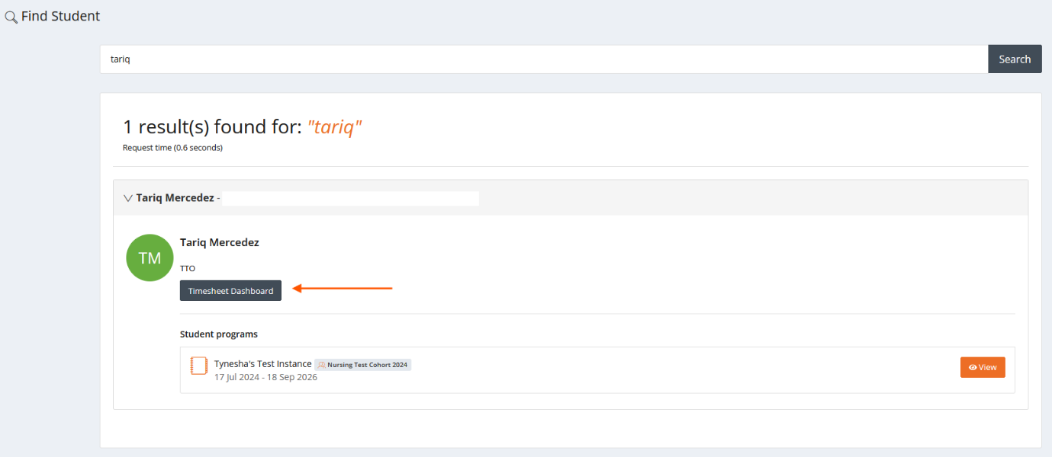

Click on the button and this will take you to the new page.
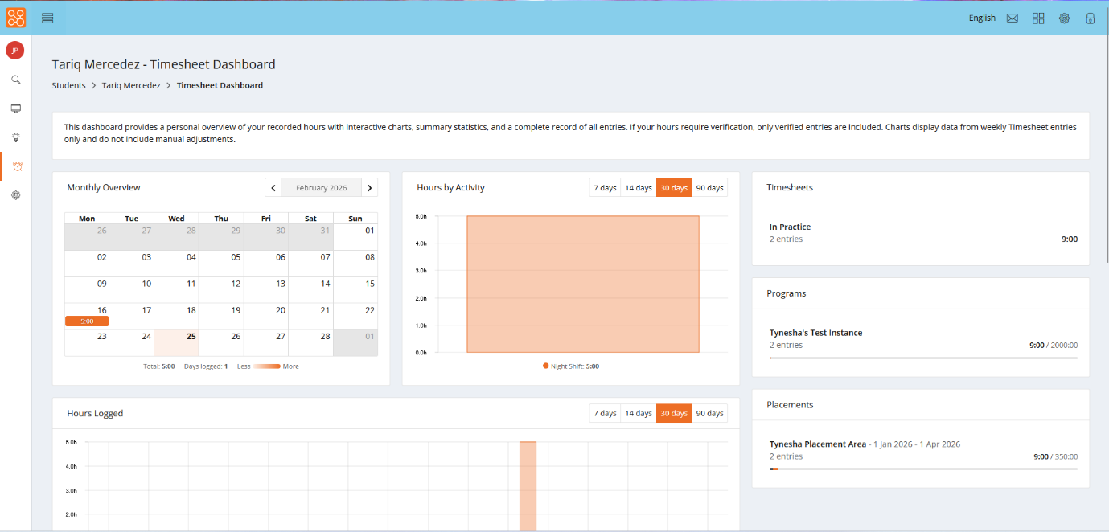

Here you'll find a variety of different elements:
Monthly Overview - this shows you all of the timesheets that have been added for that specific month.
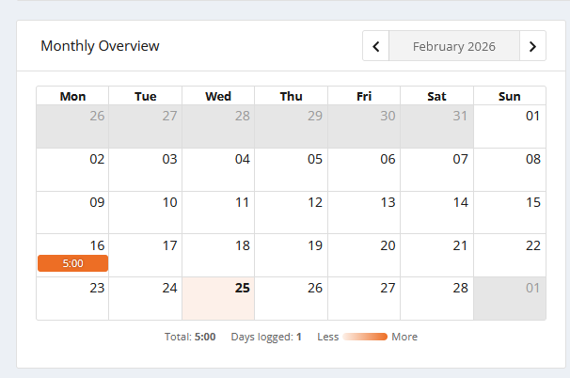

Hours by Activity - this shows you how many hours have been added against a specific timesheet activity in a graph format, across a 7, 14, 30 and 90 day period.
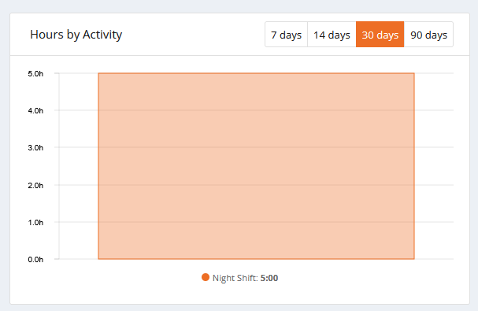

Timesheets - this shows you the total number of entries and hours for all of the students timesheets under a Timesheet Type.
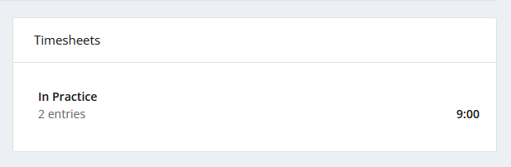

Programs - shows which program the student has submitted timesheets for, and how many entries and hours they've added to it.
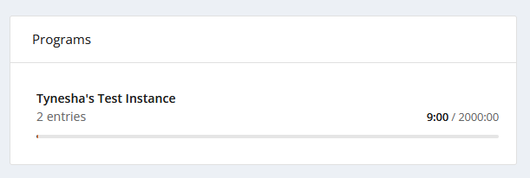

Placements - this shows you which placements the student has added timesheets to, and the total number entries and hours have been added.
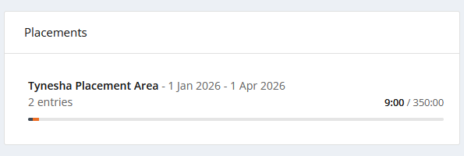

Hours logged - this shows you how many hours have been logged, on which date within the last 7, 14, 30 and 90 days.
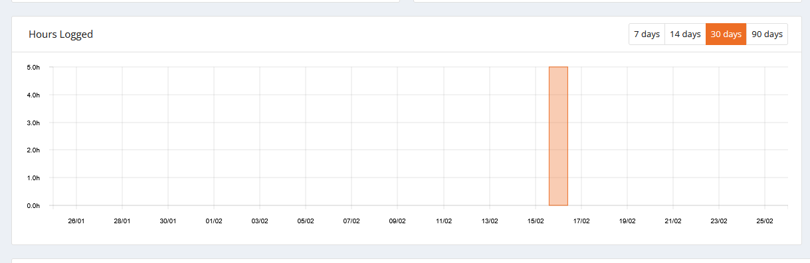

All entries - this shows you all of the students submitted timesheets, and allows you to add adjustments, or reverse the timesheets.
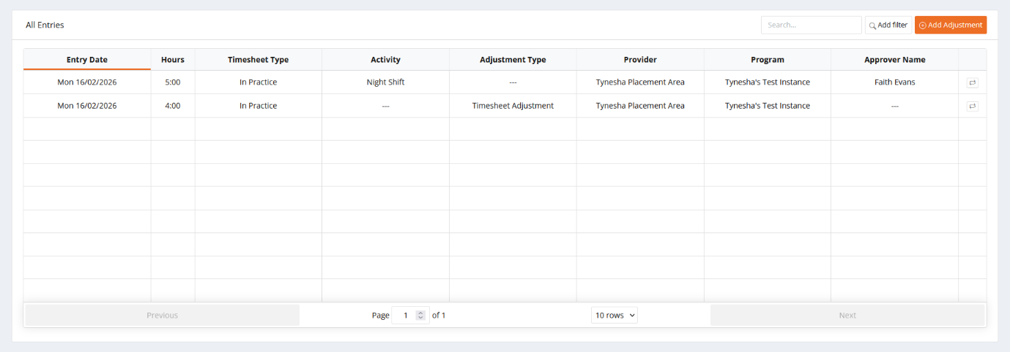

Provider Placement Dashboard
The Provider Placement Dashboard gives users a clear, provider-focused view of student placements. Note - This is meant for user by External Users who manage oversight of all placements within a Trust/Group or providers and not for users managing singular students.
You can use it to:
- Quickly identify which students are currently on placement and filter by specific ward/department/provider area
- Review or manage staff linked to placements
- Review placement coverage and activity
Note - You do not have options to edit, create or remove student placements.

Click on the left hand side menu, Provider Placements
The placement list displays comprehensive information in a sortable, paginated table. Click any column header to sort by that column or use the Search and filters to filter through or find specific items.

Root Provider - The top-level provider (for example a Trust)
Provider - The specific allocation location (for example a Ward )
Program - The student's enrolled program
Part - The current Part / Year the student is allocated to (terminology may vary)
Section - The specific program section
Student - The student's name and ID (label is configurable, for example "Learner")
Start Date - When the placement begins/began
End Date - When the placement ended/ends
Practice Staff - Number of allocated Practice Staff currently related to the student
Created - Date when the placement was created
Custom Properties - Additional columns appear for custom properties marked as "default"

You can search for specific placements/students and other options, using the Search at the top of the page. The Search will provide live results and will search on all properties displayed in the table.
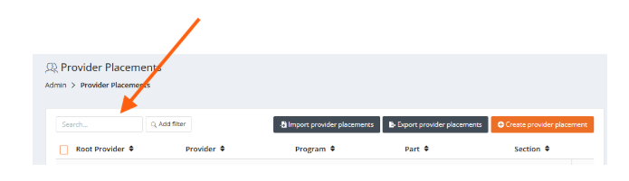

Filters can be applied to redefine the results; selecting add filter next to the Search bar and choosing from the displayed options. There is no limit to the number of filters that can be used.
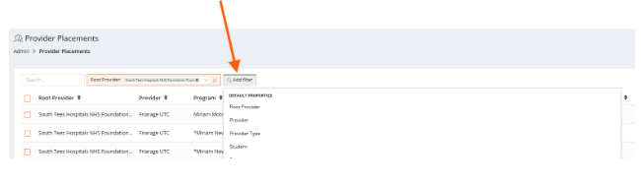
To view the students placement in detail, locate the student and their placement, click on the 3 dots far right and choose View provider placement.
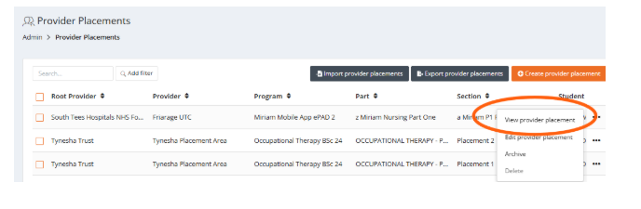
Their full details will be displayed in a pop-up window. This contains an Overview of all the details, including the provider name, Program Instance location, target hours etc. In the second tab any allocated External Users will appear with their relationship to the student. For example - External Users who have been linked/allocated to the student as Practice Educator, or Practice Assessor.
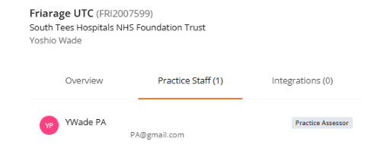

The 3rd tab shows the details of any Integrations, for example API, PEMS, InPlace or ARC, which created, updated or removed the students allocation. You wont need to worry about this, this is more for the University team to monitor.

Practice Staff can be allocated within the window - if necessary. This isnt usually required, but can be useful if managing sickness of an allocated Practice Staff member, who is supporting students. If External Users have been pre-allocated to providers, they will display on the right - but can be selected and given a relationship to the student.
For example, the bottom External User was added to the provider allocated to the student, via the Provider area. Click Add Practice Staff to manually allocate the user to the student, you can then provide a relationship role to the student - in this case "Practice Assessor" as shown at the top of the screenshot:

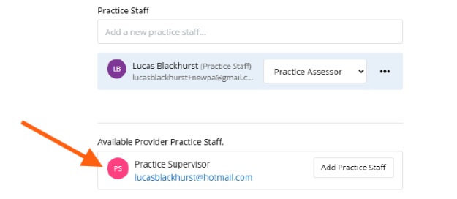
External Users, allocated to students, can also have their visibility restricted by date; by default "Use placement dates" is chosen when a relationship role is assigned. But you can also choose to set specific dates by toggling to this option.

Figure 1:
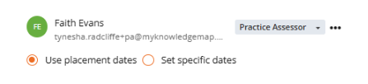
Figure 2:
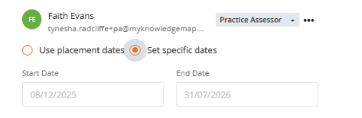

Students Homepage
Currently students Portfolio's have a "wheel" on the left, highlighting their total hours towards their specified Programme Hours. For example:

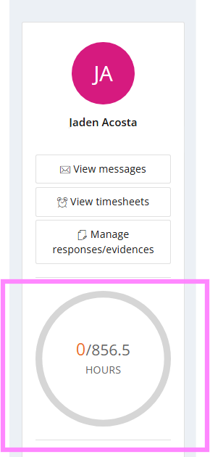

From the update; there is the option to "group" types of hours, so you may see students Portfolio's changing - to show targets towards their Programme Hours and their total hours towards a second type, as per the example below.:
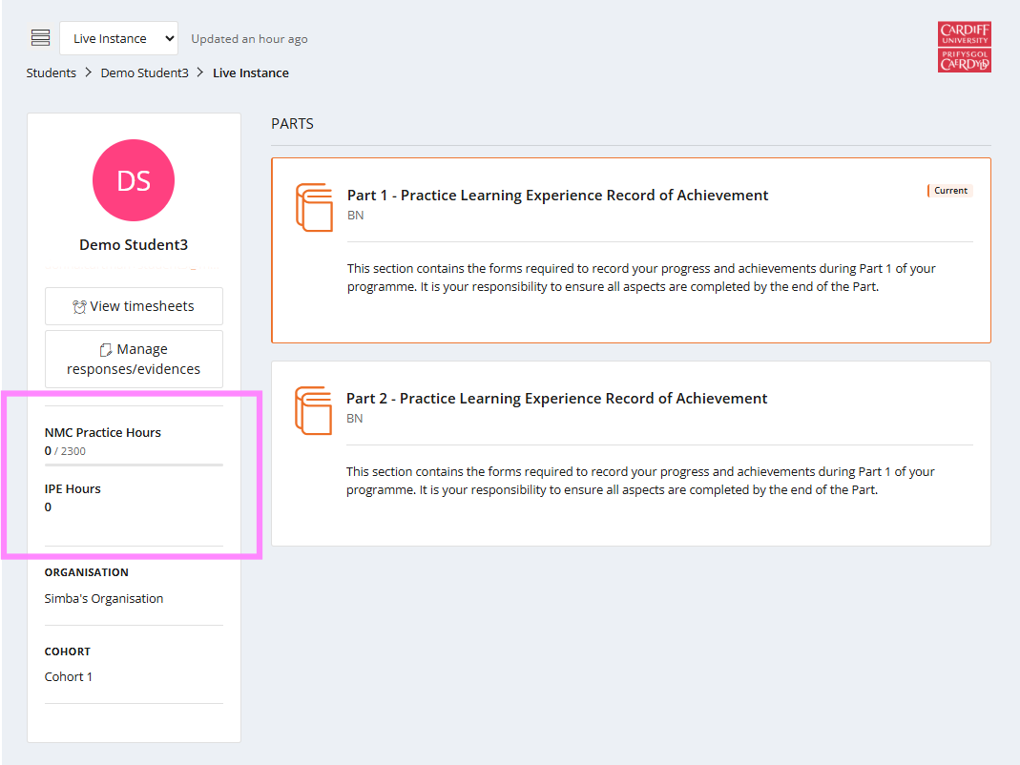

If using Timesheet Verification, hours could also show like this:
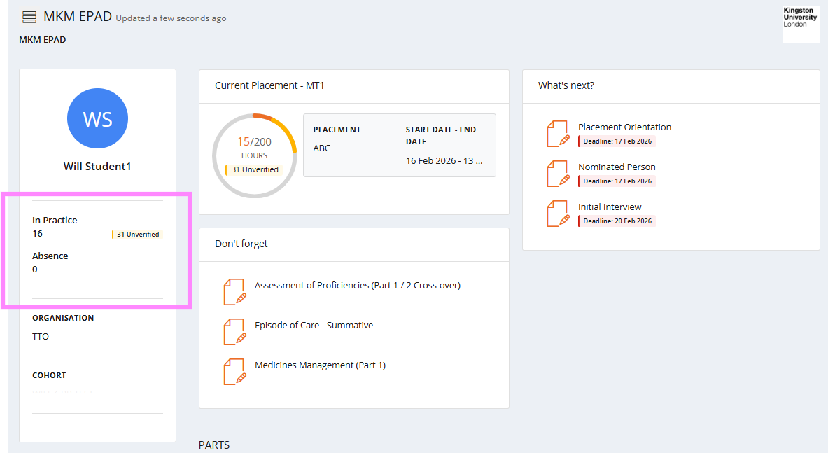

These changes do not affect the submission or verification, if used, of timesheets by students and / or yourselves.

To - Do Dashboard (Version 8.7)
Subject to final revisions, users can now have access to a "To Do Dashboard" from your left hand menu; which displays a list of forms, which need to be completed. This is managed by the allocated relationship to the student, for example:
You simply review which student you wish to complete a form for and click on the form indicated by "Complete now" or "Overdue". Note - "Overdue" does not stop completion of the form.
Clicking "View" allows you to review any responses.
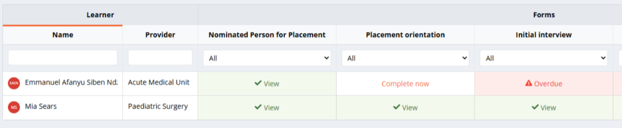

We have an updated generic guide on the MyProgress Service Desk available to any user - EXTERNAL USER GUIDE this provides a day - to - day guidance on widely used features. (Note - Not all features maybe available to your role and / or enabled by the students University)

