Students - What's Changed in Version 8.7
Overview
MyProgress Version 8.7, brings some exciting changes for all users; this outlines some of those features and changes which may impact your use of MyProgress.

When?
MyProgress Version 8.7 will be deployed over the 18-19th April 2026

Why?
A lot of the changes are to migrate underlying older code base; but this means we can make improvements to visuals and available data to all users - improving everyone's experience.

What?
Entering Timesheets
Timesheet Dashboard
Sign off Widget
Placement Additional Details
Students Homepage

Entering Timesheets
A new timesheet section has been created with new functionality. The new layout will make it easier to see what information you have entered, and prevents any issues that we have had historically such as duplicating information,
You can access the timesheet section either by the pane on the left hand side of the screen, or the widget on the bottom right of the page.
For example:

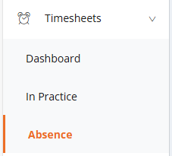

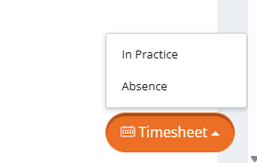

This will take you to the new timesheet section where you can submit timesheets individually or for the entire week.
Selecting 'add timesheet row' will allow you to select a placement and activity type. You can then select how many hours you would like to record for each day.
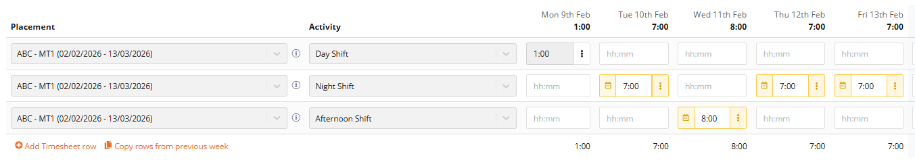

You can also add a comment to each timesheet, and send the timesheet to a different member of staff if it hasn't been verified.

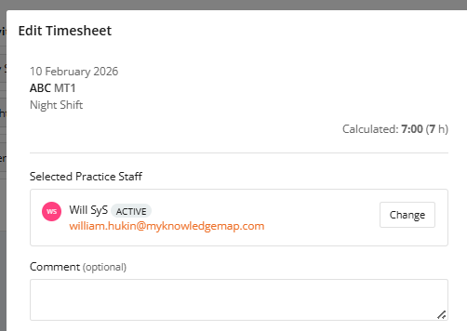

A step by step guide on how to complete timesheets can be found here
Note - Once submitted with sign off or verified by an approver - timesheet entries cannot be edited or deleted by you and you must speak to your University Administration team.

Timesheet dashboard
In the update there is a new feature called Timesheet Dashboards. This will provide an overview of your timesheet data with interactive charts, summary statistics, and a complete record of all of timesheet entries.
This can be accessed on the left hand pane on the screen
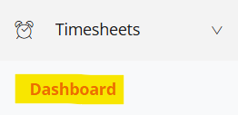

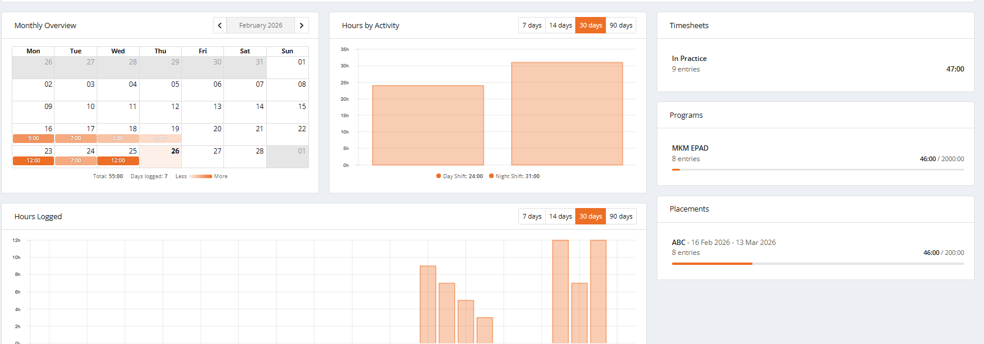
There are various boxes on this page displaying different types of data:
Monthly overview - Provides a visual representation of the timesheets you have entered month by month. You can select previous months if required.
Hours by activity - Breaks down the different types of timesheet activities you have used
Timesheets - Displays what timesheets you have used, how many entries and the total hours
Programs - Will break down how many hours have been entered for each Portfolio you are using
Placements - Will break down how many hours have been entered for each placement you have been on
Hours logged - Displays what hours have been entered for each day, can be expanded to 14/30/90 days
All Entries - Will display your timesheets in date order, with the latest one at the top of the section.

Sign off Widget
There is now a sign off widget under each Part/Year, which displays what staff member(s) have been recorded as signing off form submissions. You can filter this by placement / role

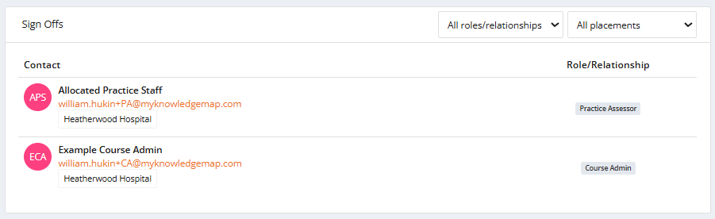

Staff you have allocated via an allocation form will be available separately inside each placement block.
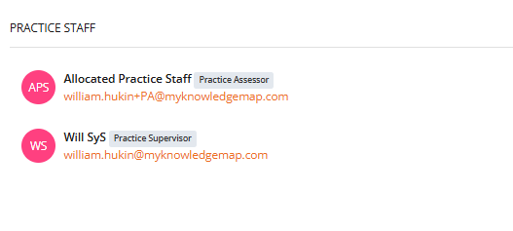

Placement Additional Details
Additional information can be added to placements, which is now reflected on the your Portfolio if relevant.
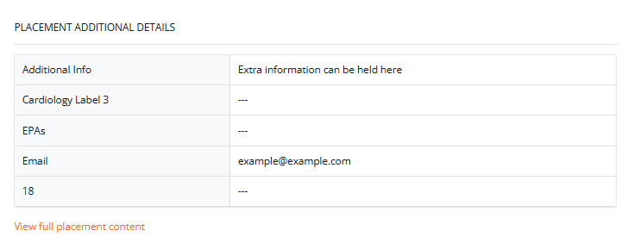

Students Homepage
Currently your Portfolio's have a "wheel" on the left, highlighting your total hours towards your specified Programme Hours. For example:

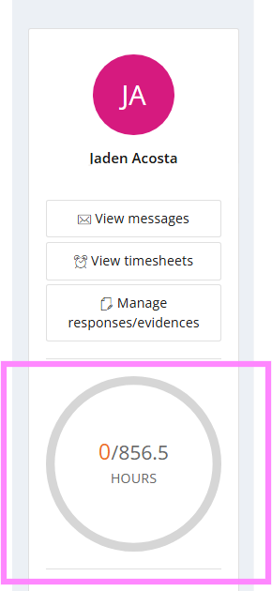
From the update; there is a new admin option to "group" types of hours, so if this has been configured by your Universities admin team, your layout may now look like this:
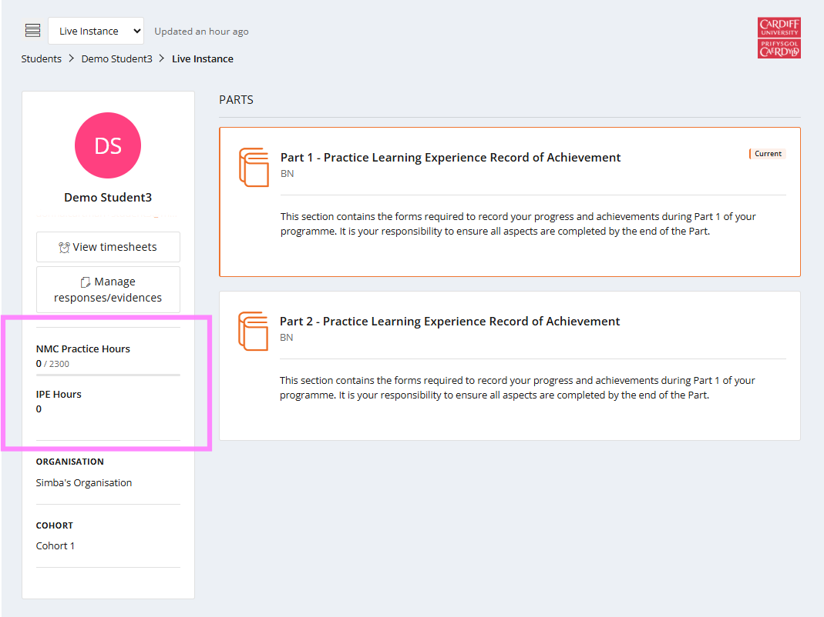
If using Timesheet Verification, hours could also display like this:
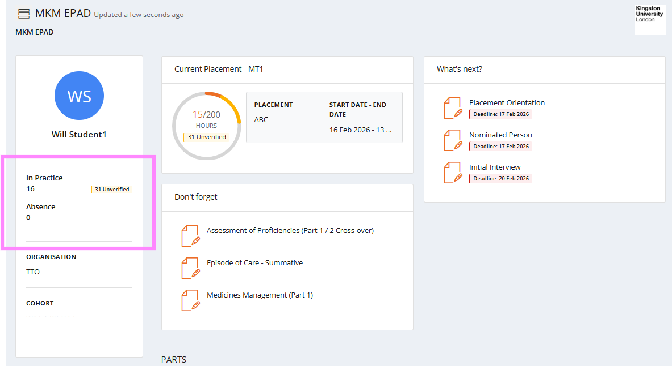

These changes do not affect the submission or verification, if used, of timesheets by yourselves or staff members.

