Academic Users - What's Changed in Version 8.7

Revision Log
Version Number | Date of Change | Change
1 | Released 27/02/2026 | N/A
2 | 03/03/2026 | Added Timesheet Ledger and Adjustments

Overview
MyProgress Version 8.7, brings some exciting changes for all users; this outlines some of those features and changes which may impact your use of MyProgress.

When?
MyProgress Version 8.7 will be deployed over the 18-19th April 2026

Why?
A lot of the changes are to migrate underlying older code base; but this means we can make improvements to visuals and available data to all users - improving everyone's experience.

What?
Timesheet Dashboards
Timesheet Comments
Timesheet Ledger & Timesheet Adjustments
Provider Placement Dashboard
Students Homepage

Timesheet Dashboards
In the update there is the ability to be view a new feature called Timesheet Dashboards. This will provide an overview of the student's timesheet data with interactive charts, summary statistics, and a complete record of all of the student's entries.
To view this, use the student search to find a student. Click on their name and the button Timesheet Dashboard should appear just above where you would see the students program instance.
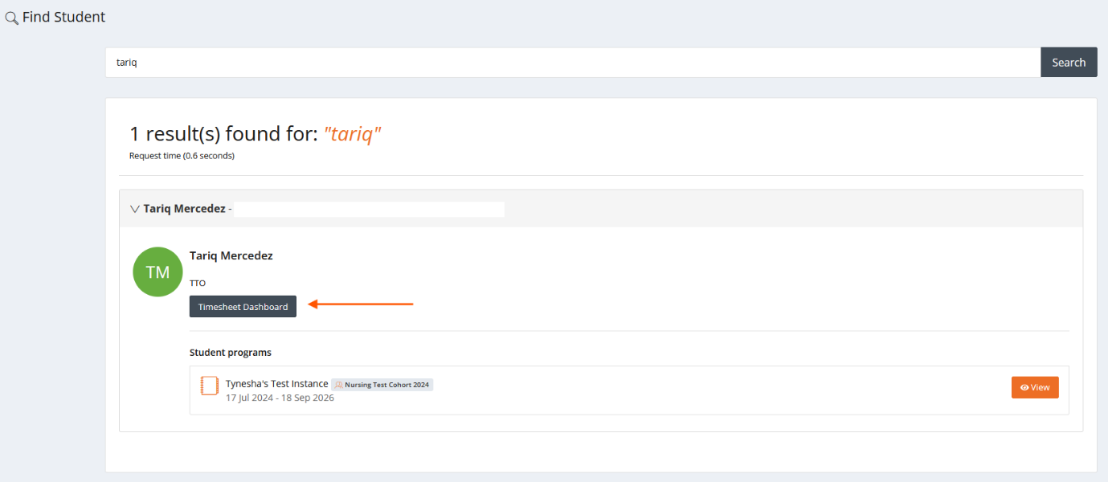

Click on the button and this will take you to the new page.
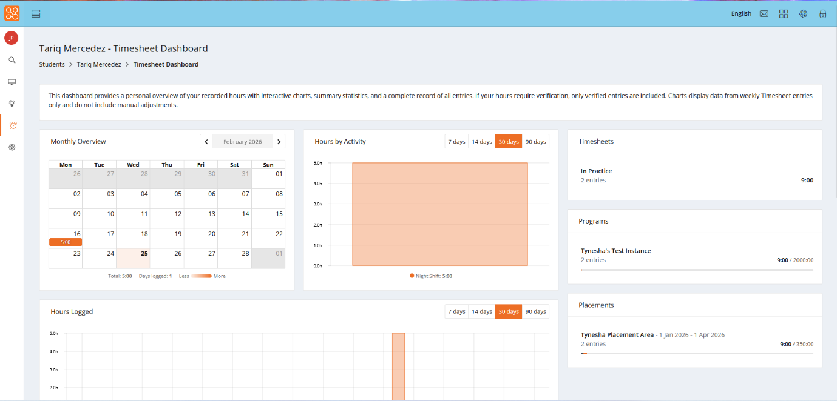

Here you'll find a variety of different elements:
Monthly Overview - this shows you all of the timesheets that have been added for that specific month.
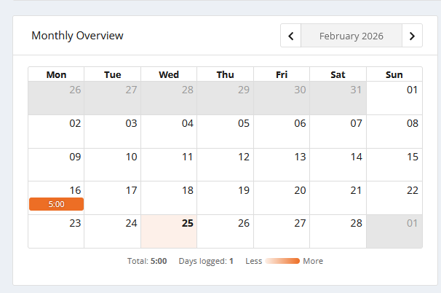

Hours by Activity - this shows you how many hours have been added against a specific timesheet activity in a graph format, across a 7, 14, 30 and 90 day period.
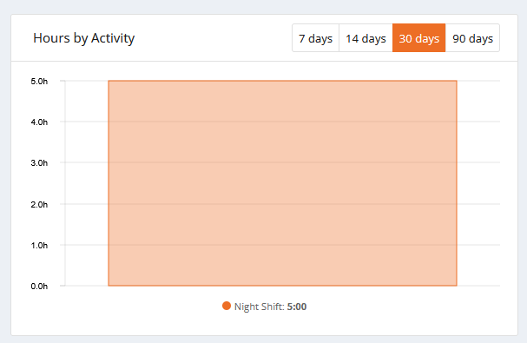

Timesheets - this shows you the total number of entries and hours for all of the students timesheets under a Timesheet Type.
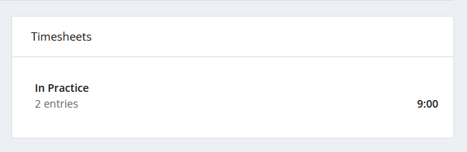

Programs - shows which program the student has submitted timesheets for, and how many entries and hours they've added to it.
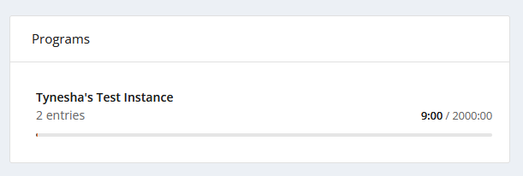

Placements - this shows you which placements the student has added timesheets to, and the total number entries and hours have been added.
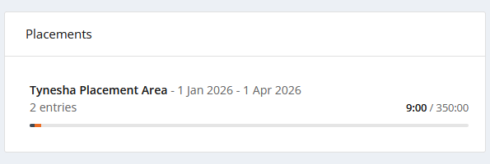

Hours logged - this shows you how many hours have been logged, on which date within the last 7, 14, 30 and 90 days.
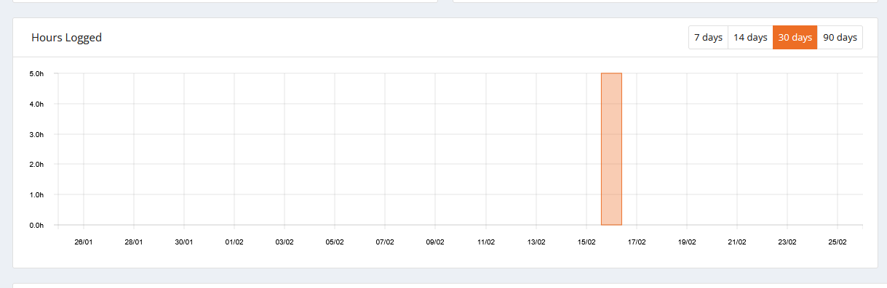

All entries - this shows you all of the students submitted timesheets, and allows you to add adjustments, or reverse the timesheets.
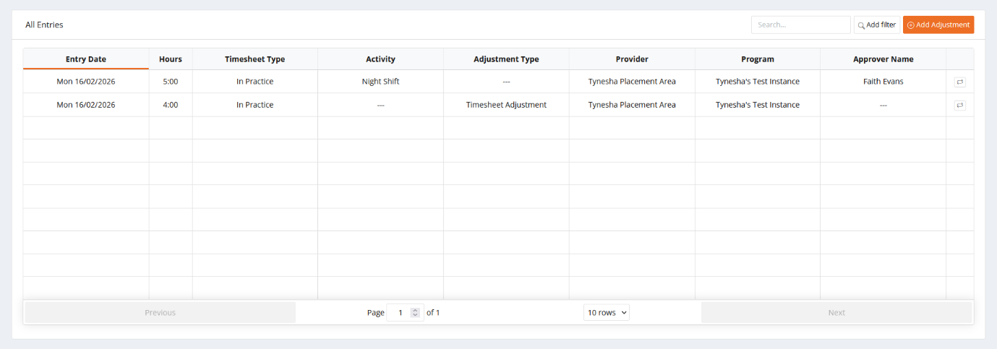

Timesheet Comments
Students are now able to add comments to timesheet entries; these can be viewed either when verifying unverified entries or via their Timesheet area.

Timesheet Ledger and Adjustments
Previously you may have been able to delete and/or edit students timesheet entries with little to no audit trail being recorded in the UI. Within Version 8.7, we have removed the ability to directly edit individual timesheet entries and instead introduce a Timesheet Ledger and the ability for Administrators (or other users like Academic Staff - Tutors etc) to make "Adjustments", which records more accurately any changes made within a students Portfolio.
Note - Your role may not have this feature, check with the parent University if you believe you should have access and dont.

Timesheet Ledger
The Timesheet Ledger provides users with a comprehensive view of all hour records across all users in the organisation (depending on role visibility options). This is essential for auditing, reporting, and making manual adjustments.
Note - Adjustments and Reversals are permeant entries in the ledger. The Ledger uses an append-only pattern. Entries are never modified or deleted. Corrections are always made by adding new entries. This ensures a complete audit trail for compliance and reporting purposes.

Accessing the Timesheet Ledger
To access the Timesheet Ledger:
1. Go to the left hand side menu and click Admin → Timesheet Ledger
2. The page displays a description of the ledger's purpose, a filter toolbar, optional summary cards, and a paginated table of all hour entries:
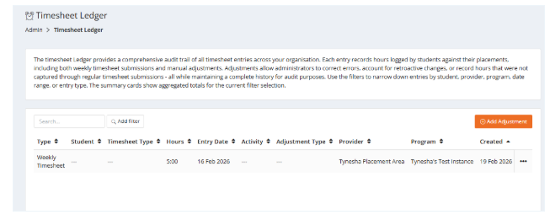

Column Descriptions
Type - Indicates how the timesheet entry was made including "Timesheet" – From verified or signed-off timesheet entries or "Manual Adjustment" – Admin-created adjustments.
Student - The student's name
Timesheet Type - The category of hours (e.g., NMC Practice Hours)
Hours - The number of hours recorded (displayed as decimal hours; negative values)
Entry Date - The date the hours apply to
Activity - The specific activity, if applicable
Adjustment Type - For manual adjustments, the type of adjustment made
Provider - The placement provider name
Programme - The programme instance name
Created - When the entry was added to the ledger

Filtering the Timesheet Ledger
Use the filters; to narrow down the displayed entries. The filters can be "stacked" to further filter the options.
The filters available are:
Entry Type - Filter by Weekly Timesheet or Manual Adjustment
Timesheet Type - Filter by category of hours
Student - Search and select a specific student (typeahead search, minimum 3 characters)
Entry Date - Filter by the date range the hours apply to
Date Created - Filter by when the ledger entry was created
Verified By - Search and select the user who verified the entry
Verified On - Filter by verification date range
Provider - Search and select a specific provider
Placement - Search and select a specific placement allocation
Programme - Instance Filter by programme name
Activity - Filter by specific activity
Adjustment Type - For manual adjustments, filter by the specific adjustment type

Summary Cards
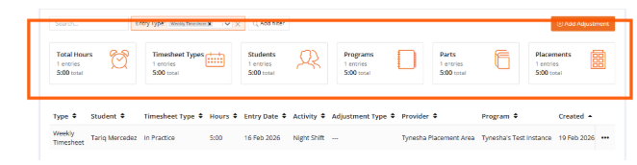
When you apply filters to the ledger, summary cards appear at the top of the page showing aggregated totals. These cards provide at-a-glance metrics grouped by:
Grand Total: Overall total hours and entry count for the filtered results
By Timesheet Type: Breakdown of hours per type
By User: Breakdown of hours per student
By Programme Instance: Breakdown per programme
By Programme Part: Breakdown per part
By Allocation: Breakdown per placement allocation
Each card shows the group name, entry count, and total hours. The summary cards automatically refresh when you change filters.

Filtering Ledger Entries
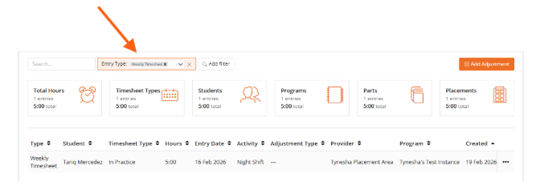
Use the filter toolbar to narrow down the displayed entries:
Entry Type - Filter by timesheet entry or manual adjustments
Timesheet Type - Filter by Timesheet Types (group)
Student - Search and select a specific student (min 3 characters)
Entry Date - Filter by date range the hours apply to
Date Created - Filter by when the entry was created
Verified By - Filter by who verified the entry
Verified On - Filter by Verification Date
Provider - Filter by a specific provider
Placement - Search by specific placement allocation
Programme Instance - Filter by Programme
Activity - Filter by specific timesheet activity
Adjustment type - Filter by specific manual adjustment type

Viewing Entry Details
To view further details of the entry; click on the entry line within the Ledger or click the 3 dots far right and click View Details.
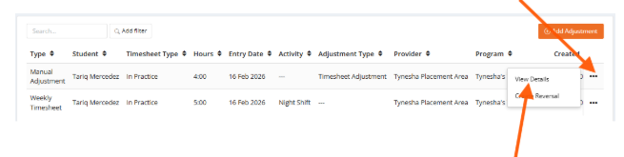
Note - The Timesheet Ledger entries are read only; no changes can be made via the entry itself. To correct entries, adjustments must be made.
The detail view shows:
- Student name, timesheet type, entry type, hours (with minutes), entry date, effective date, date created
- Activity and/or adjustment type (with code if present)
- Provider allocation details: provider name, programme instance, programme part, programme section
- Assessor name and email (if applicable)
- Verified by (name) and verified on date (if applicable)
- Source type, source reference, adjustment reason, and created-by user
- An "Excluded from totals" warning banner if the entry does not count towards targets

Creating Manual Adjustments
Administrators (or any user with it enabled on their role) can create manual adjustments to add or correct hours (to reverse an entire timesheet entry - see Creating Reversals below):
- From the left hand side menu, navigate to Admin and Timesheet Ledger
- Click the Add Adjustment button
- Select the Student using the typeahead search (minimum 3 characters to begin searching)
- Select the Timesheet Type for the hours
- Select the Adjustment Type (options are filtered based on the selected timesheet type)
- A rules panel is displayed showing the selected adjustment type's configuration (which fields are required, whether negative values are allowed, maximum hours, etc.)
- Complete the required fields (which vary based on the adjustment type settings):
  - Minutes: The number of minutes to add (or subtract if negative adjustments are allowed)
  - Entry Date: The date the hours apply to (if required by the adjustment type)
  - Provider Allocation: Link to a specific placement (if required; options are loaded based on the selected student)
  - Reason: Explanation for the adjustment (if required by the adjustment type)
  - Source Reference: Optional external reference for traceability
- Click Save to create the adjustment
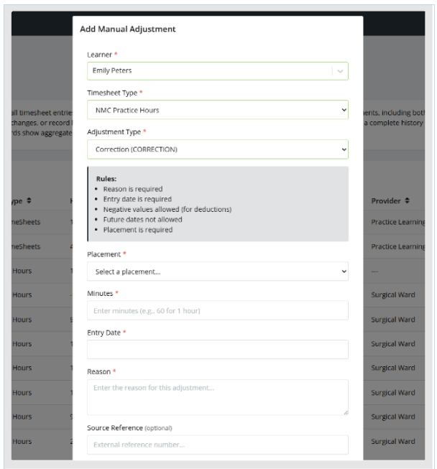
Note - Cascading Dependencies - Changing the timesheet type resets the adjustment type selection. Changing the student reloads the available provider allocations. This ensures only valid combinations can be selected.

Creating Reversals
To reverse an existing ledger entry; for example if the student entered the wrong date on an entry.
- Search for the the entry you wish to reverse in the ledger table; this can be done by searching for the student name or using the filters.
- Once located, click the 3 dots to right on the row and select Create Reversal
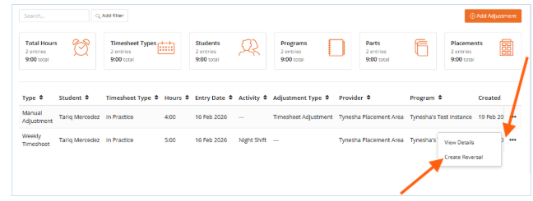

- The adjustment form opens pre-populated with the original entry's details:
- The student, timesheet type, and entry date are copied from the original
- The minutes are automatically negated (e.g., +120 becomes −120)
- The reason is auto-generated (e.g., "Reversal of entry [ID]")
- A source reference links back to the original entry

4. Review and modify the details if needed
- Click Save to create the reversal

Note - Adjustments and Reversals are permeant entries in the ledger. The Ledger uses an append-only pattern. Entries are never modified or deleted. Corrections are always made by adding new entries. This ensures a complete audit trail for compliance and reporting purposes.

FAQ:
How do I delete or edit a timesheet entry?
Users need to make manual adjustments. Individual timesheet entry edits are no longer possible. This is to help create an audit trail of changes and track who edited what and why.

How do I add hours to a students Portfolio?
Hours are primarily added by the student, if however they cannot, you can add them via the Timesheet Ledger as an Adjustment.

Provider Placement Dashboard
The Provider Placement Dashboard gives users a clear, provider-focused view of student placements. Note - This is meant for user by External Users who manage oversight of all placements within a Trust/Group or providers and not for users managing singular students.
You can use it to:
- Quickly identify which students are currently on placement and filter by specific ward/department/provider area
- Review or manage staff linked to placements
- Review placement coverage and activity
Note - You do not have options to edit, create or remove student placements.

Click on the left hand side menu, Provider Placements
The placement list displays comprehensive information in a sortable, paginated table. Click any column header to sort by that column or use the Search and filters to filter through or find specific items.

Root Provider - The top-level provider (for example a Trust)
Provider - The specific allocation location (for example a Ward )
Program - The student's enrolled program
Part - The current Part / Year the student is allocated to (terminology may vary)
Section - The specific program section
Student - The student's name and ID (label is configurable, for example "Learner")
Start Date - When the placement begins/began
End Date - When the placement ended/ends
Practice Staff - Number of allocated Practice Staff currently related to the student
Created - Date when the placement was created
Custom Properties - Additional columns appear for custom properties marked as "default"

You can search for specific placements/students and other options, using the Search at the top of the page. The Search will provide live results and will search on all properties displayed in the table.
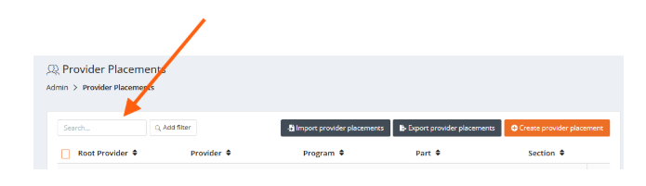

Filters can be applied to redefine the results; selecting add filter next to the Search bar and choosing from the displayed options. There is no limit to the number of filters that can be used.
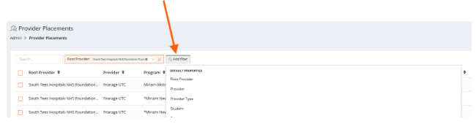
To view the students placement in detail, locate the student and their placement, click on the 3 dots far right and choose View provider placement.
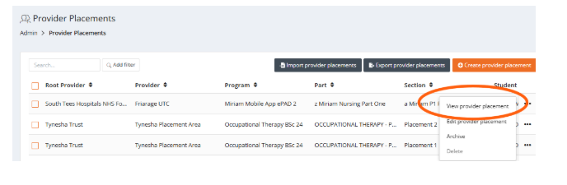
Their full details will be displayed in a pop-up window. This contains an Overview of all the details, including the provider name, Program Instance location, target hours etc. In the second tab any allocated External Users will appear with their relationship to the student. For example - External Users who have been linked/allocated to the student as Practice Educator, or Practice Assessor.
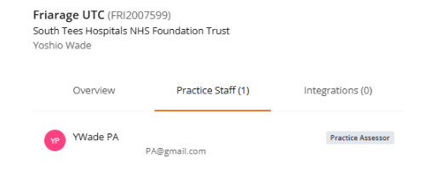

The 3rd tab shows the details of any Integrations, for example API, PEMS, InPlace or ARC, which created, updated or removed the students allocation. You wont need to worry about this, this is more for the University team to monitor.

Practice Staff can be allocated within the window - if necessary. This isnt usually required, but can be useful if managing sickness of an allocated Practice Staff member, who is supporting students. If External Users have been pre-allocated to providers, they will display on the right - but can be selected and given a relationship to the student.
For example, the bottom External User was added to the provider allocated to the student, via the Provider area. Click Add Practice Staff to manually allocate the user to the student, you can then provide a relationship role to the student - in this case "Practice Assessor" as shown at the top of the screenshot:

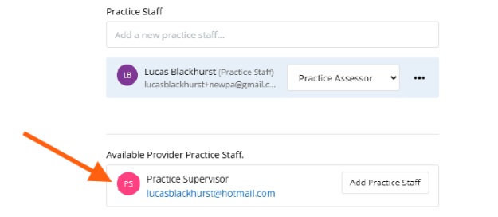
External Users, allocated to students, can also have their visibility restricted by date; by default "Use placement dates" is chosen when a relationship role is assigned. But you can also choose to set specific dates by toggling to this option.

Figure 1:
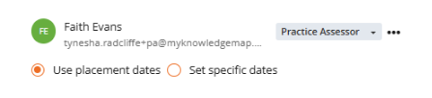
Figure 2:
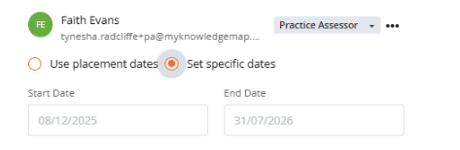

Students Homepage
Currently students Portfolio's have a "wheel" on the left, highlighting their total hours towards their specified Programme Hours. For example:

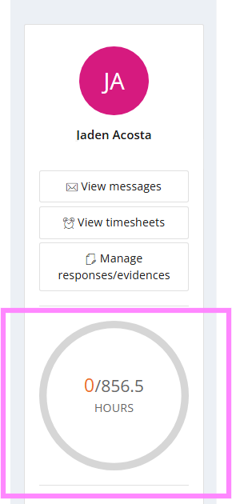

From the update; there is the option to "group" types of hours, so you may see students Portfolio's changing - to show targets towards their Programme Hours and their total hours towards a second type, as per the example below.:
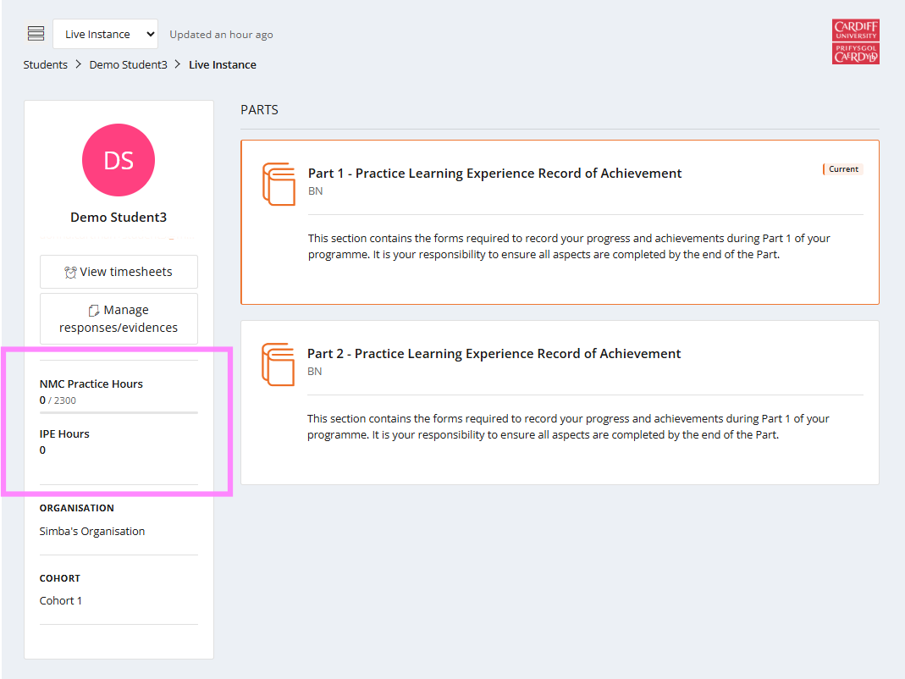

If using Timesheet Verification, hours could also show like this:
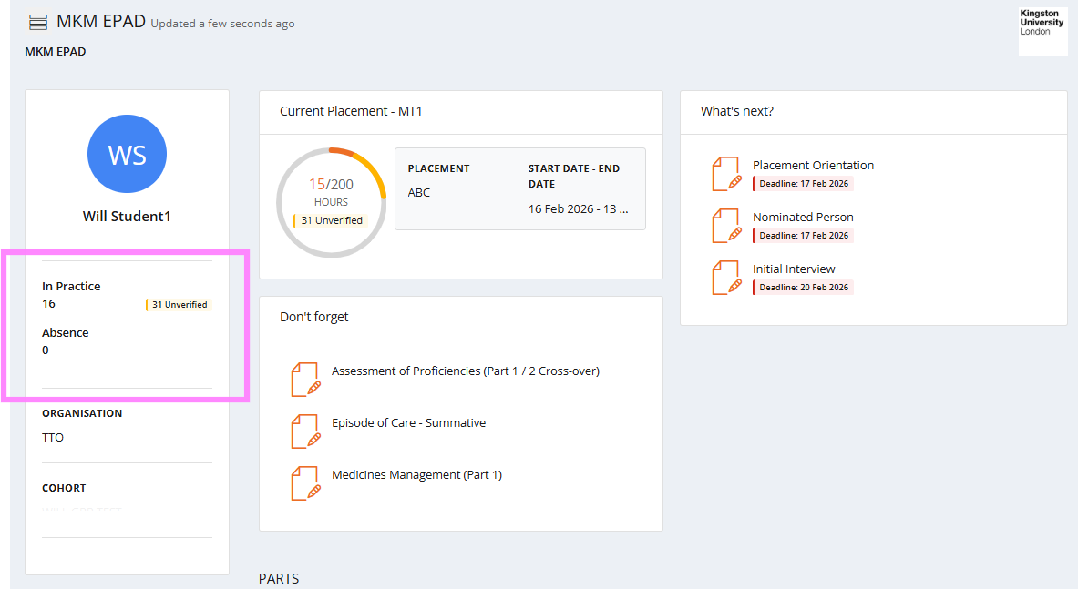

These changes do not affect the submission or verification, if used, of timesheets by students and / or yourselves.

We have an updated generic guide on the MyProgress Service Desk available to any user - ACADEMIC USER GUIDE this provides a day - to - day guidance on widely used features. (Note - Not all features maybe available to your role and / or enabled by the students University)

